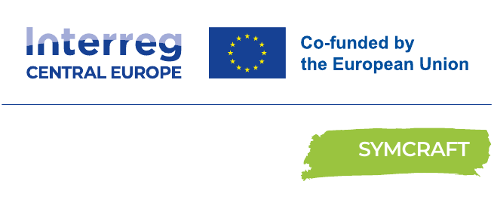

CREATION OF MODELS OF AGREEMENT
From a cooperation opportunity to an arrangement on re-use of waste
Replication Guideline



FOREWORD

Foreword / Introduction
SYMCRAFT – Creative craft for industrial symbiosis in circular economies – builds bridges between industrial material providers, crafts, designers and intermediary organisations. Eleven partners from eight countries and nine regions implemented three linked pilots that move from reuse opportunities through business models to structured cooperation.
Pilot Action 3 translated the previous pilot experience into practical cooperation instruments for industry and handicraft actors. It produced three sector-specific Cooperation Framework Models: Agro-food, Textile, and Wood & Furniture. These are adaptable framework models and should not be described automatically as three signed contracts. Each model helps the parties clarify the material stream, intended use, transfer point, roles, logistics, costs, quality criteria, legal and safety questions, liability, intellectual property and fallback arrangements. Practical annexes support material specification, delivery checks, problem handling and evidence retention. Partner feedback favoured a modular and initially non-binding approach, followed by a small test batch and formalisation only when the case is sufficiently mature. Solution 3 converts this experience into a six-step pathway from selecting the case to an adapted or signed cooperation arrangement.
Scope  3 sectors • transnational transferability | Core outputs  3 sector cooperation framework models | Practical logic  Green / Yellow / Red readiness | End point  adapted or signed arrangement, where appropriate
GRAPHICAL IMPLEMENTATION TO-DO LIST Follow in order • adapt the checks, not the agreed outputs
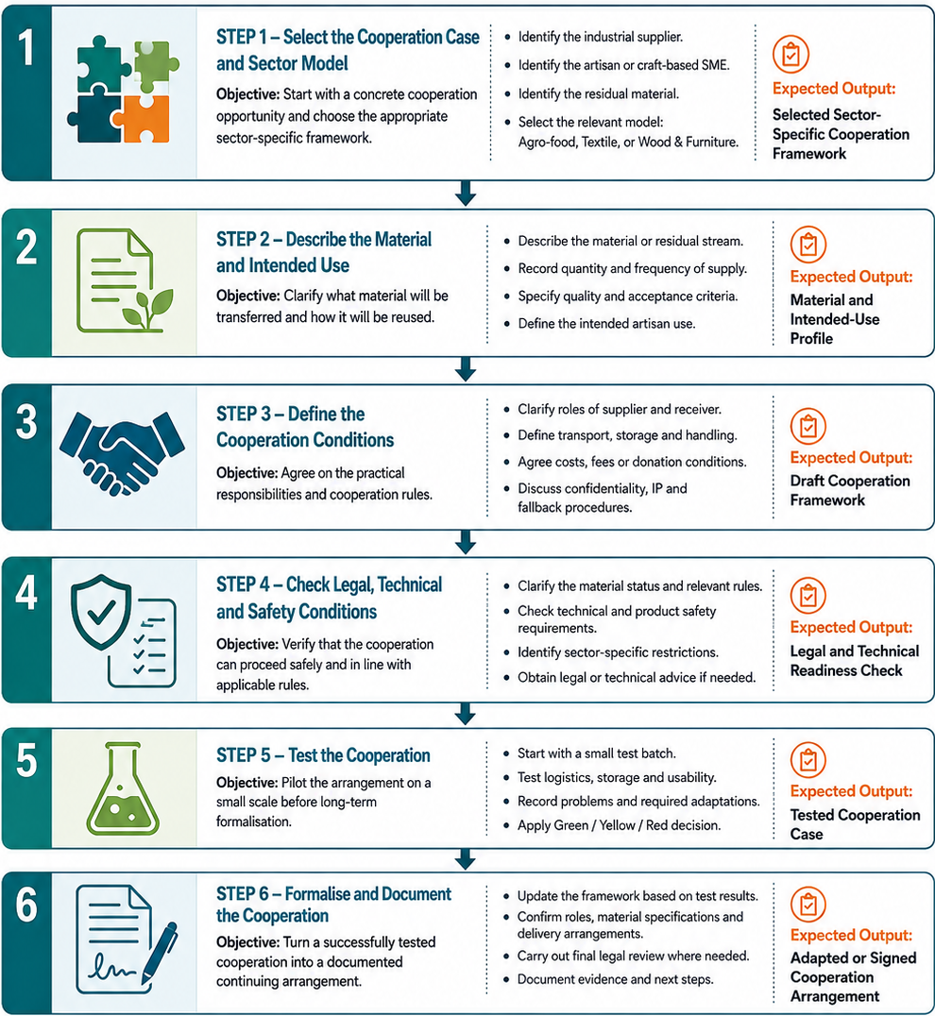

IMPLEMENTATION PACK people • evidence • decisions • companion tools

Who does what
Industrial supplier  Describes the material and confirms transfer conditions. | Artisan / craft receiver  Defines intended use, acceptance criteria and practical needs. | Facilitator / adviser  Guides the framework, evidence trail and referrals for review.

Minimum readiness and evidence
✓ Concrete parties, material stream and intended use identified
✓ Acceptance, transfer, logistics, costs and fallback agreed
✓ Legal/technical questions classified Green, Yellow or Red
✓ Small test batch completed before scaling
✓ Final arrangement reflects test evidence

Sector adaptation
Agro-food: legal status, hygiene, traceability, perishability and allergens. Textile: fibre composition, treatments, sorting, safety, confidentiality and branding. Wood & furniture: moisture, coatings, adhesives, hazardous treatments, liability and final use.

Digital tools and separate System Map
Tool 3 helps identify cooperation, legal and contractual questions; it does not determine legal status or replace qualified review. Tool 4 formats reviewed content only.
Use this guideline together with the separately maintained SYMCRAFT Solution 3 System Map – open separate document. The graphical To-Do List is reproduced on page 2, while the System Map remains a separate companion file and is not counted within the three content pages of this guideline.
DO  Start with one concrete case • verify critical facts • test proportionately • record decisions and open questions. | DON’T  Assume feasibility or legal status • treat digital output as validation • scale before testing • hide unresolved risks.
Working rule: use the graphical To-Do List for the operational sequence, the System Map for the wider relationships, and this guideline for method, evidence and decision logic. Keep the System Map separate but distribute it with the guideline.

Method in practice and evidence to retain
METHOD IN PRACTICE  Begin with one concrete supplier–receiver case and the correct sector framework. • Describe the material and intended use before negotiating detailed clauses. • Apply Green/Yellow/Red logic and test a limited batch. • Formalise only after responsibilities and material conditions reflect test results. | EVIDENCE TO RETAIN  Cooperation and material/status sheets • Delivery and material checks • Problem, fallback and test-batch records • Reviewed/adapted framework and signed text if used

Sector lens for replication
AGRO-FOOD  Clarify legal status, hygiene, traceability, storage, temperature, allergens, acceptance and fallback before transfer. | TEXTILE  Specify fibre/finish, sorting, hygiene, quality, packing, confidentiality, branding and acceptance conditions; sensitive items such as lingerie require respectful handling and clear end-use rules. | WOOD & FURNITURE  Specify species/material, dimensions, grade, moisture, coatings, adhesives, hazardous treatments, liability and final use.

Benefits from taking over (Why to join) adapted from the source Replication Guideline

Clearer cooperation  Creates shared language for material, use, roles, logistics, costs and fallback. | Lower uncertainty and risk  Makes legal, technical, safety and product-use questions visible early.
Safer learning  Uses a small test batch before wider or repeated transfer. | Accessible uptake  Offers a modular and initially non-binding route for SMEs and artisans.
Stronger trust  Clarifies responsibilities, checks and fallback procedures between partners. | Circular value creation  Connects residual materials with craft and design capabilities.
Evidence for scaling  Builds a trail of material sheets, delivery checks, tests and adaptations. | Transferability  Applies a common logic across three sectors and different regions.

How to start
Select one residual stream, one industrial supplier and one craft/creative receiver; choose the relevant sector framework and complete the first two steps. Test on a small scale and formalise only when the evidence supports proceeding.
Important limitation. Solution 3 provides a cooperation structure; it does not guarantee legal status, technical feasibility, commercial success or economic returns.
Use together with: SYMCRAFT Solution 3 System Map (open separate document), the relevant SYMCRAFT digital tool and the detailed source instruments referenced in the full Solution.

From interest to uptake
Start: Select one supplier–receiver case and sector model. | Mobilise: Agree material information, intended use and responsibilities.
Demonstrate: Test a limited batch and update the framework from evidence. | Continue: Formalise when appropriate; archive the cooperation record.
Source basis: D.2.4.1 Pilot Action 3 report; Solution 3; three sector Cooperation Framework Models; Tool 3, Tool 4 and the approved System Map.

Uptake and monitoring questions
Who benefits?  Industrial suppliers, artisans, craft SMEs, facilitators and qualified technical/legal advisers. | What to monitor?  Specifications completed; deliveries checked; deviations resolved; test batches assessed; frameworks revised; agreements used where appropriate.
When to proceed?  Only when the case is Green, or Yellow issues have been resolved and recorded. | Next decision  Continue, adapt, formalise or stop the affected material transfer.

FREQUENTLY ASKED QUESTIONS

PURPOSE
What does Solution 3*** organise?  The conditions for a tested, documented cooperation between an industrial supplier and a craft receiver. | Which framework should we choose?  Use the Agro-food, Textile or Wood & Furniture model that fits the material and intended use.

FIRST AGREEMENT
What is the minimum starting point?  Name one supplier, one receiver, one residual stream, an intended use and a sector framework. | Is the framework already a contract?  It can guide early discussion; binding use needs adaptation and case-specific national review. | Can a one-off transfer use it?  Yes; record the conditions even without plans to repeat the transfer.

MATERIAL & LEGAL STATUS
What material information is essential?  Specify origin, composition, quality, variability, treatments, safety issues and acceptance criteria. | Who determines the material status?  The parties establish it from evidence and applicable national rules, with qualified advice where needed.

TRANSFER & RESPONSIBILITIES
What must be agreed before transfer?  Acceptance, ownership or possession, delivery point, transport, storage, costs and fallback. | What if a batch fails the specification?  Record the deviation, isolate it if needed, then apply the agreed correction, return or stop procedure.

SMALL TEST & DECISION
Why start with a small batch?  To check quality, handling, usability, costs and roles before repeated or larger transfers. | What do Green, Yellow and Red mean?  Green: proceed as documented. Yellow: resolve open conditions first. Red: suspend the affected transfer or use. | What follows a Yellow decision?  Assign the open issue, evidence, owner and deadline; resolve it before proceeding.

FORMALISATION & RECORDS
When should cooperation be formalised?  After the test, once material conditions, responsibilities and necessary reviews are settled. | Which records should be kept?  Material/status sheet, delivery checks, test results, problem and fallback notes, revisions and signed text if used.

*** Solution 3 - One solution for the collaborations between Industry and Handicraft for the re-use/recycling of waste

SYSTEM MAP Solution 3 • cooperation pathway, readiness decisions and supporting tools
