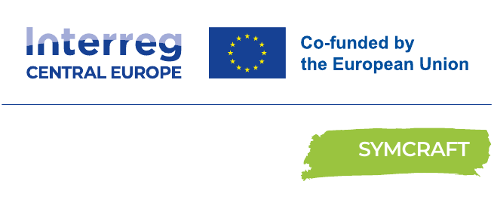

CREATION OF BUSINESS PLAN
From idea to a functional eco-business model of new product or service
Replication Guideline
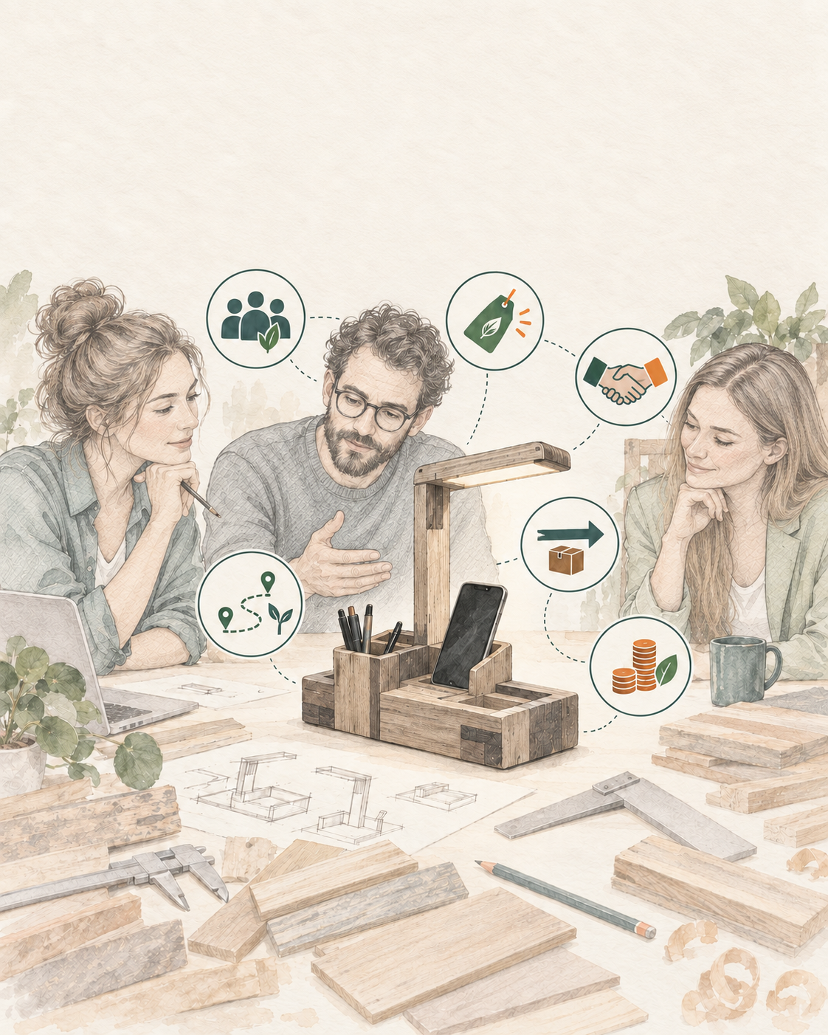


FOREWORD

Foreword / Introduction
SYMCRAFT – Creative craft for industrial symbiosis in circular economies – connects industry, crafts, design and business-support organisations to develop practical circular value chains. Its 11 partners from eight countries and nine regions implemented three linked pilots on material reuse, eco-business models and cooperation frameworks.
Pilot Action 2 built on material-product opportunities generated in the first pilot and examined whether they could become viable eco-business propositions. The project documentation records 46 applications to specific products or services across the participating contexts; these are applications, not a count of unique companies. Facilitated workshops and follow-up work helped participants define customers, value propositions, partners, activities, resources, channels, costs and revenues. The pilot used a five-stage engagement and facilitation method, while the replication guideline expresses the final implementation logic through six operational steps and outputs. Particular attention was given to separating verified facts from assumptions and to testing market interest, production feasibility and partner commitment. Solution 2 therefore ends with a validated market opportunity and an actionable implementation plan rather than merely a completed canvas.
Scope  8 countries • 3 sectors | Applications  46 product/service applications | Pilot method  5 engagement/facilitation stages | Replication method  6 operational steps and outputs
GRAPHICAL IMPLEMENTATION TO-DO LIST Follow in order • adapt the checks, not the agreed outputs
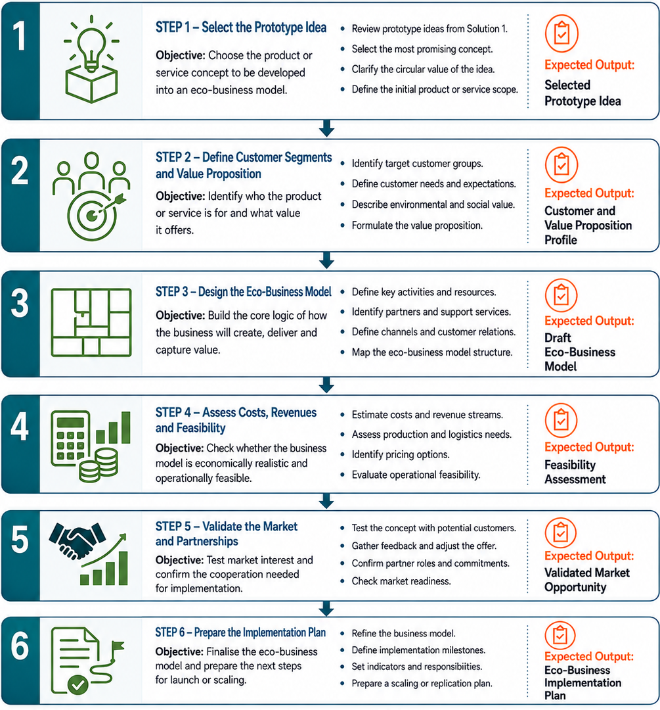

IMPLEMENTATION PACK people • evidence • decisions • companion tools

Who does what
Business owner / artisan  Owns the offer, production logic and learning decisions. | Industry / supplier  Confirms material supply, quality, conditions and partnership role. | Intermediary / mentor  Facilitates ECO-BMC work, validation and access to expertise.

Minimum readiness and evidence
✓ A defined product/service opportunity and intended customer
✓ Evidence separated from assumptions
✓ Costs, revenues, supply and capacity considered
✓ Feedback recorded and the business model revised
✓ Named actions, owners and next validation milestone

Sector adaptation
Use the same ECO-BMC logic across sectors, but adapt evidence: Agro-food cases may require hygiene and perishability checks; textile cases fibre/treatment and supply checks; wood & furniture cases coatings, adhesives, safety and logistics checks.

Digital tools and separate System Map
Tool 2 supports structured eco-business-model development. Tool 4 formats reviewed Markdown content. Digital outputs are working hypotheses until verified with customers, suppliers and qualified experts.
Use this guideline together with the separately maintained SYMCRAFT Solution 2 System Map – open separate document. The graphical To-Do List is reproduced on page 2, while the System Map remains a separate companion file and is not counted within the three content pages of this guideline.
DO  Start with one concrete case • verify critical facts • test proportionately • record decisions and open questions. | DON’T  Assume feasibility or legal status • treat digital output as validation • scale before testing • hide unresolved risks.
Working rule: use the graphical To-Do List for the operational sequence, the System Map for the wider relationships, and this guideline for method, evidence and decision logic. Keep the System Map separate but distribute it with the guideline.

Method in practice and evidence to retain
METHOD IN PRACTICE  Start from the selected prototype idea and one priority customer segment. • Mark every statement as fact, assumption, unknown or next test. • Test the riskiest market and feasibility assumptions first. • Revise the ECO-BMC after feedback; do not preserve an attractive but unsupported story. | EVIDENCE TO RETAIN  ECO-BMC versions and assumption log • Customer/partner validation notes • Feasibility, cost and revenue estimates • Implementation actions, owners and milestones

Sector lens for replication
AGRO-FOOD  Test customer acceptance, shelf-life/logistics assumptions, compliance costs and the credibility of circular claims. | TEXTILE  Test design desirability, sizing or hygiene concerns, fibre/finish information, production time and market positioning—including sensitive streams such as discarded lingerie. | WOOD & FURNITURE  Test material consistency, tooling and labour needs, transport costs, product safety, price and scalable supply.

Benefits from taking over (Why to join) adapted from the source Replication Guideline

Clearer route to implementation  Turns a promising idea into staged customer, feasibility and implementation decisions. | Stronger customer clarity  Makes target groups, needs and the case-specific value proposition explicit.
Earlier visibility of risks  Surfaces production, logistics, resources, pricing, cost and revenue assumptions. | Evidence-based decisions  Separates verified facts from assumptions, unknowns and next tests.
Stronger partner alignment  Creates a shared model for suppliers, artisans, intermediaries and support actors. | Better market validation  Encourages direct feedback and recorded adjustment of the offer.
Accessible uptake  Uses a lightweight shared canvas before a full conventional business plan. | Implementation readiness  Produces responsibilities, milestones and a trigger for Solution 3 when needed.

How to start
Select one promising prototype idea, identify the target customer and value proposition, and complete a first ECO-BMC with the supplier, artisan and intermediary. Validate assumptions step by step before preparing the implementation plan.
Important limitation. Solution 2 structures eco-business-model development and validation; it does not guarantee demand, profitability, scalability, legal classification, environmental performance or implementation success.
Use together with: SYMCRAFT Solution 2 System Map (open separate document), the relevant SYMCRAFT digital tool and the detailed source instruments referenced in the full Solution.

From interest to uptake
Start: Select one promising prototype idea. | Mobilise: Bring customer, supplier, artisan and intermediary perspectives together.
Demonstrate: Complete and validate the ECO-BMC and feasibility assumptions. | Continue: Launch the plan or use Solution 3 to structure cooperation.
Source basis: D.2.3.1 Pilot Action 2 report; Solution 2; approved six-step To-Do List/System Map; Circular ECO-BMC Tool and Tool 4 descriptions.

Uptake and monitoring questions
Who benefits?  Artisan entrepreneurs, craft SMEs, suppliers, business advisers, chambers and technology-transfer actors. | What to monitor?  Assumptions tested; customer feedback; cost/revenue updates; partner commitments; model revisions; implementation milestones.
When to proceed?  When critical feasibility and market assumptions are sufficiently evidenced for the next investment. | Next decision  Implement or scale; use Solution 3 when cooperation conditions need documentation.

FREQUENTLY ASKED QUESTIONS

PURPOSE
What does Solution 2** produce?  A tested circular eco-business model and an action plan for a specific product or service opportunity. | Who should participate?  The artisan or business owner, material supplier and intermediary, with customer and technical input as needed.

GETTING STARTED
What do we need before starting?  A defined opportunity, an intended customer, a material source and a team able to explore delivery. | Is a finished prototype required?  No. The concept must be clear enough to test its value, production logic and main risks.

ECO-BUSINESS MODEL
What goes into the ECO-BMC?  Customers, value, channels, activities, resources, partners, costs, revenues and circular impacts. | How do we handle unknowns?  Mark facts, assumptions and unknowns separately; test the riskiest points and revise the canvas. | When do we update it?  After testing changes an important assumption, cost or partner role.

CUSTOMERS & MARKET
How do we test customer value?  Use interviews, concept or sample feedback and price discussions with the priority customer group. | What if customers like it but reject the price?  Revisit the offer, production cost, customer segment or channel, then test the revised model. | Does circularity guarantee demand?  No. Check customer need, access and willingness to pay.

SUPPLY & FINANCES
What if material supply is irregular?  Record variability and usable volumes; reflect them in capacity, costs and promises to customers. | Which financial figures matter first?  Estimate key costs, price, likely revenue, minimum viable volume and major capacity or funding gaps.

DECISION & NEXT STEP
When is the model ready to move forward?  When critical customer and feasibility assumptions have evidence, partners are credible and actions have owners. | When do we use Solution 3***?  When material transfer, quality, logistics, costs or responsibilities need a documented cooperation framework.

** Solution 2 - One solution to create business/incomes for handicraft with waste from industry
*** Solution 3 - One solution for the collaborations between Industry and Handicraft for the re-use/recycling of waste.

SYSTEM MAP Solution 2 • eco-business model pathway, validation and supporting tools
