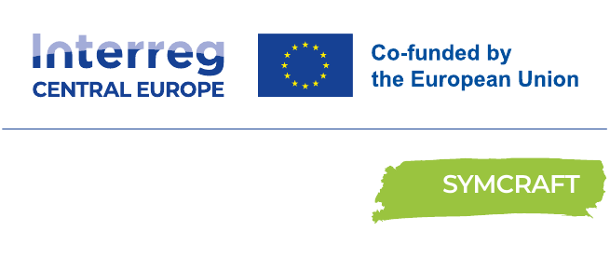

RECOVER WASTE TO NEW PRODUCT
From industrial residual material to a jointly selected prototype idea
Replication Guideline
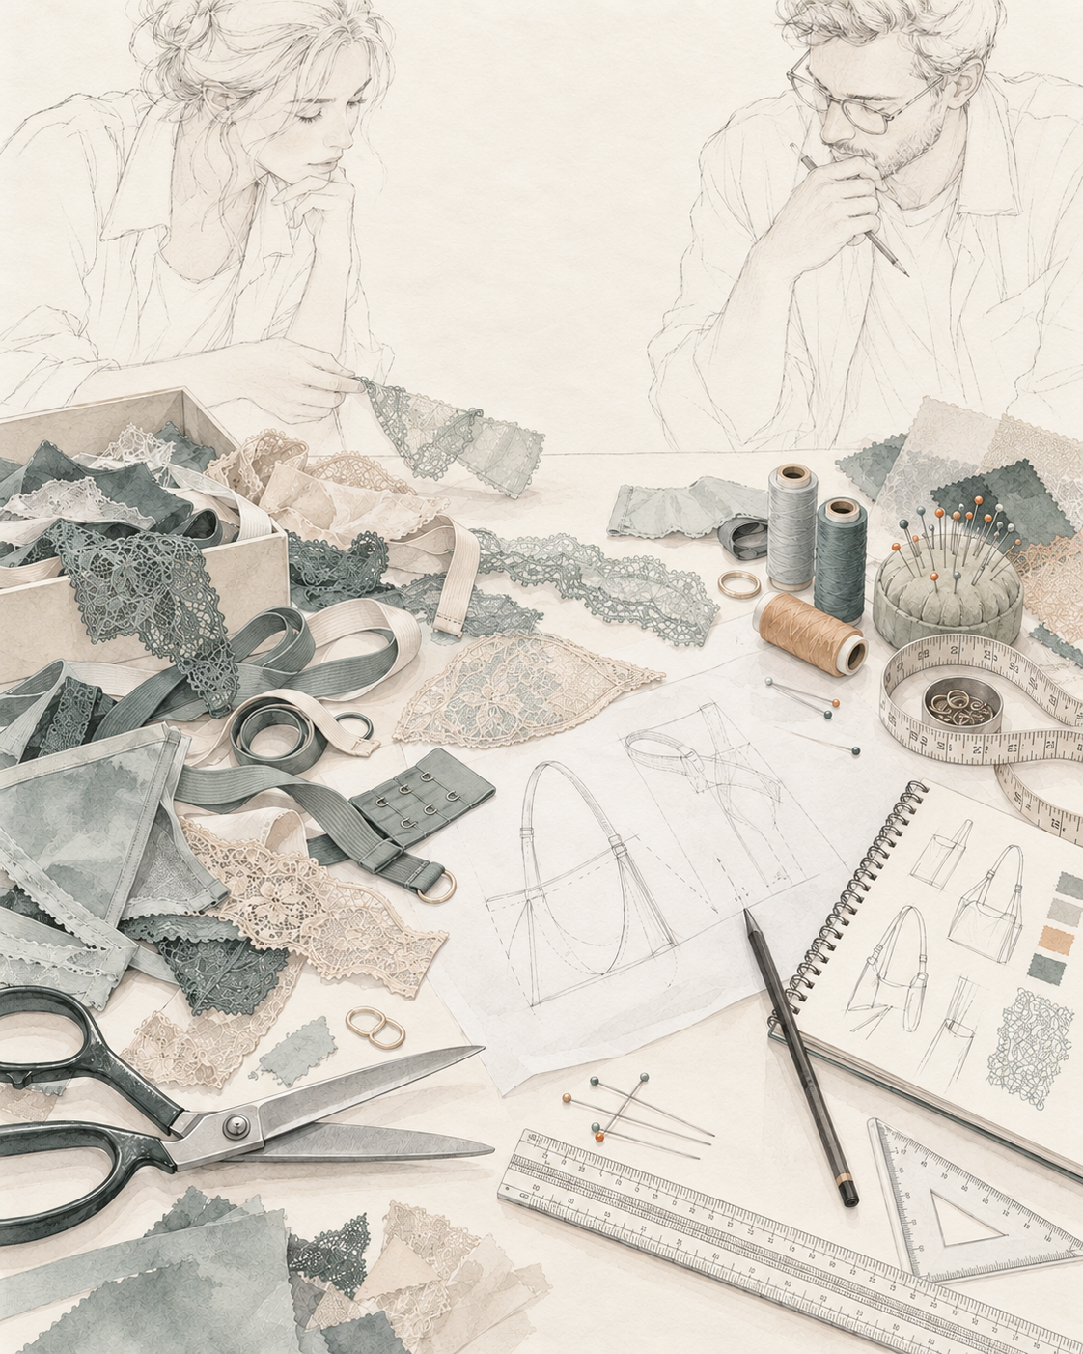


FOREWORD

Foreword / Introduction
SYMCRAFT – Creative craft for industrial symbiosis in circular economies – connects industry, crafts, design and intermediary organisations to turn residual materials into circular products, services and cooperation. The Central Europe partnership brings together 11 partners from eight countries and nine regions and tests the approach through three linked pilot actions.
Pilot Action 1 concentrated on identifying reusable industrial residual streams and connecting them with artisans, designers and craft-based SMEs. The reported implementation mobilised 181 stakeholders across agro-food, textile and wood/furniture activities. It created more than 40 tandem or cooperation cases and aimed to translate them into around 40 prototypes, digital twins or feasibility studies. Co-creation workshops and transnational exchanges combined industrial material knowledge with practical craft capabilities. The pilot also exposed recurring barriers: material variability, legal classification, logistics, safety, scale mismatch and continuity after the first meeting. Solution 1 converts that experience into a replicable five-step pathway ending with a documented prototype idea.
Scope  8 countries • 3 sectors | Participation  181 stakeholders reported | Cases  40+ tandem/cooperation cases | Outputs  around 40 prototypes, digital twins or feasibility studies
GRAPHICAL IMPLEMENTATION TO-DO LIST Follow in order • adapt the checks, not the agreed outputs
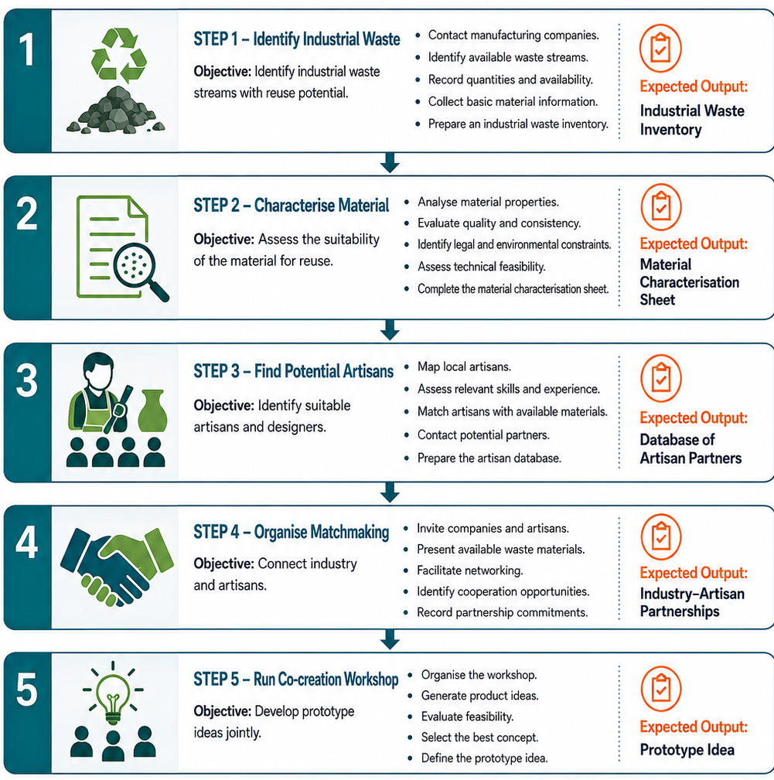

IMPLEMENTATION PACK people • evidence • decisions • companion tools

Who does what
Industry  Provides residual material, source data and practical constraints. | Artisan / designer  Assesses transformability and develops realistic product ideas. | Intermediary  Finds partners, facilitates co-creation and keeps evidence visible.

Minimum readiness and evidence
✓ A real and sufficiently described residual stream
✓ Material risks and variability made visible
✓ Capabilities confirmed directly with partners
✓ Prototype idea recorded with assumptions and open questions

Sector adaptation
Agro-food: hygiene, contamination, perishability and regulated uses. Textile: fibre mix, treatments, cleanliness and irregular supply. Wood & furniture: coatings, adhesives, moisture, dust and hazardous treatments.

Digital tools and separate System Map
Tool 1 supports material assessment, inspiration and matchmaking. Tool 4 formats reviewed Markdown content. Neither tool validates technical, legal or safety claims.
Use this guideline together with the separately maintained SYMCRAFT Solution 1 System Map – open separate document. The graphical To-Do List is reproduced on page 2, while the System Map remains a separate companion file and is not counted within the three content pages of this guideline.
DO  Start with one concrete case • verify critical facts • test proportionately • record decisions and open questions. | DON’T  Assume feasibility or legal status • treat digital output as validation • scale before testing • hide unresolved risks.
Working rule: use the graphical To-Do List for the operational sequence, the System Map for the wider relationships, and this guideline for method, evidence and decision logic. Keep the System Map separate but distribute it with the guideline.

Method in practice and evidence to retainSector lens for replication
METHOD IN PRACTICE  Begin with verified material facts, not an abstract sustainability claim. • Use physical samples wherever practical. • Let intermediaries translate industrial constraints into craft opportunities. • Select the concept transparently and record why alternatives were not chosen. | EVIDENCE TO RETAIN  Waste inventory and material characterisation • Partner profiles and matchmaking record • Co-creation record and concept comparison • Selected prototype idea, assumptions and referrals

AGRO-FOOD  Describe origin, hygiene, contamination, perishability, traceability and the intended non-food or regulated use. | TEXTILE  Record fibre composition, finishes, cleanliness, sorting and supply variability; discarded lingerie components can be carefully dismantled and tested for suitable accessory or material applications. | WOOD & FURNITURE  Check wood or board type, dimensions, moisture, coatings, adhesives, treatments, dust and higher-risk end uses.

Benefits from taking over (Why to join) adapted from the source Replication Guideline

Better visibility of residual materials  Turns hidden waste and by-products into described material streams. | More informed reuse decisions  Makes quality, variability, logistics and unresolved constraints visible early.
Faster access to craft capabilities  Connects materials with relevant skills, equipment and creative experience. | More effective matchmaking  Focuses exchange on real materials, constraints and credible cooperation.
Concrete innovation  Moves networking toward co-created concepts and selected prototype ideas. | Accessible uptake  Works for small cases without requiring a complete business plan at the start.
Evidence for later decisions  Creates a traceable basis for Solution 2, reporting and replication. | Stronger circular value chains  Can connect residual streams, prototypes, business models and partnerships.

How to start
Select one real residual stream, describe its constraints, identify relevant artisan skills and organise one focused matchmaking/co-creation session. Carry the strongest prototype idea and open questions into Solution 2.
Important limitation. Solution 1 structures the identification, matching and development of reuse opportunities; it does not guarantee legal status, technical feasibility, partner commitment, market demand or commercial success.
Use together with: SYMCRAFT Solution 1 System Map (open separate document), the relevant SYMCRAFT digital tool and the detailed source instruments referenced in the full Solution.

From interest to uptake
Start: Select one real residual stream. | Mobilise: Confirm supplier, artisan/design and intermediary roles.
Demonstrate: Complete the five steps and record the selected prototype idea. | Continue: Transfer the evidence package to Solution 2.
Source basis: D.2.2.1 Pilot Action 1 report; Solution 1; approved five-step To-Do List/System Map; Tool 1 and Tool 4 descriptions.

Uptake and monitoring questions
Who benefits?  Material providers, artisans, designers, craft SMEs, chambers and innovation intermediaries. | What to monitor?  Materials described; partners contacted; matches confirmed; co-creation completed; concepts selected; open questions referred.
When to proceed?  When material evidence and partner capabilities support a credible prototype concept. | Next decision  Develop customer value and the eco-business model through Solution 2.

FREQUENTLY ASKED QUESTIONS

PURPOSE
What does Solution 1* deliver?  A documented prototype idea, digital twin or feasibility study based on a real industrial residual stream. | Who should take part?  An industrial material provider, an artisan or designer, and an intermediary to organise the match and evidence.

STARTING POINT
Where do we begin?  Choose one residual stream; record its origin, quantity, frequency and intended reuse possibilities. | Can we begin with an artisan idea?  Yes. Define the properties the idea needs, then find and describe a suitable residual stream. | Can we screen several streams?  Yes; document each selected stream and its constraints separately.

MATERIAL & SAFETY
Which material facts matter most?  Composition, treatments, dimensions, cleanliness, variability, storage and known restrictions. | Who checks whether reuse is allowed?  The parties verify the material status, safety and intended use under national rules; seek qualified advice where needed.

MATCHMAKING & CO-CREATION
How do we choose an artisan partner?  Match the material to real skills, equipment, capacity, location and willingness to test. | What happens at the workshop?  Compare material evidence and samples, develop possible uses, then select one concept with a recorded rationale. | What if the volume is too large?  Test smaller batches, add partners or consider another reuse route.

TESTING & EVIDENCE
Is the selected concept already feasible?  No. Check technical, safety, regulatory and market assumptions before committing to production. | What should we keep?  The material sheet, partner and match notes, sample or test findings, workshop record and open questions.

DECISION & NEXT STEP
When should a case pause or stop?  When critical safety, legal, technical or supply questions cannot be resolved proportionately. | Where does a promising idea go next?  Take the selected concept and evidence into Solution 2**; use Solution 3*** to define cooperation terms.

* Solution 1 - One solution to recover waste for new product/service
** Solution 2 - One solution to create business/incomes for handicraft with waste from industry
*** Solution 3 - One solution for the collaborations between Industry and Handicraft for the re-use/recycling of waste

SYSTEM MAP Solution 1 • detailed replication relationships and decision pathway
