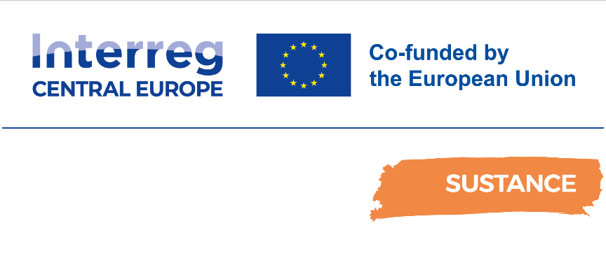

D.2.3.1. Pilot action 1 (PA1) Cross-border train connection IT-SI-HR – Trieste V.O.-Divaca – Pivka – Rijeka
Ex-post Pilot Action Report

Final
042025

Table of contents
Abbreviations 6
1 Overview 7
2 Pilot Action activities. Key results and SWOT analysis 7
2.1 Pilot key results and reached expectations 7
2.2 Pilot action SWOT analysis 8
3 Pilot Key results 12
3.1 Final KPIs assessment 12
3.2 Pilot action evidence and communication/promotional strategies 14
3.2.1 Pilot action evidence 14
3.2.2 Pilot action communication and promotional strategies 19
4 Pilot action key outcomes 24
4.1 Lessons learned and replicability suggestions 24
4.2 Strategies for the Sustance pilot action follow-up after the project conclusion 26
4.3 Pilot Action influence on local, regional and national policies 28
5 Conclusions 30
6 Co-design and peer-review process 31
6.1 Co-design 31
6.2 Stakeholder engagement 32
6.3 Peer-review key results 33

Abbreviations
AF Application Form
WP Work Package
PT Public Transport
SPAG SUSTANCE Pilot Advisory Grout
TCM Technical coordination meetings
SZPP Slovenian Railways-Passenger transport
SZ Slovenian Railways
PSO Public service obligation
PA1 Pilot action 1

- Overview
This report is related to the Sustance pilot action ex-post monitoring and assessment phase foreseen in Activity 2.2 “Solutions setting up: monitoring, peer review, assessment and dissemination”. In this report, each partner describes the key impacts and results of the Sustance pilot action implementation. The key goal is to assess from a qualitative and quantitative point of view the key effects of the pilot action in terms of environmental, social and economic impacts at local/regional/national levels.
In this report, it is possible to find relevant information on pilot implementation and testing key results, influence at local/regional and national levels and key impacts in terms of improvement of public transport offer in the testing areas. Moreover, it is possible to find information on the different strategies/solutions adopted for the continuation of the measure after the Sustance project conclusion.
- Pilot Action activities. Key results and SWOT analysis
  - Pilot key results and reached expectations
In this paragraph, a brief description of the pilot's key results and main impacts at local, regional and national levels are presented. Moreover, each partner, starting from the objectives defined in the ex-ante and interim reports, is called to describe if the defined expectations are reached and if not why it is not possible.

Implementation of Pilot Action 1 (PA1) resulted in better accessibility of PA1 area, involving the regions: Italian Friuli Venezia Giulia (Trieste) region, Slovenian Littoral–Inner Carniola region and Croatian Primorje-Gorski Kotar County region. These are the most important impacts:
- Introducing a new PT service, a direct train from Trieste/Villa Opicina (IT) to Rijeka (HR), that is connecting three cross-border regions. The new motor unit Stadler operated as direct cross-border service for the first time. Namely, before the implementation of PA1, the trains only crossed the borders as so called “classic trains” – in the form of passenger’ wagons pulled by locomotives. Effectively, this entailed changing of locomotives at the borders, which consequently turns out as longer trip duration. By using motor units, changing locomotives was no longer needed, therefore the running times were shorter and more attractive.
- PA1 direct train proved a sustainable transport mode in comparison to car and thereby positively contributed to the environment. Since 2024 Slovenian Railways have purchased electric power for complete fleet of electric trains from 100% renewable sources, which results in 100% green energy and virtually zero CO2. The new train service adds to continuous striving of Slovenian Railways to reduce the carbon footprint produced by the trains.
- The new train connection was seasonally even more attractive transport option than a car on the same route, on the account of road traffic jams in the summer season.
- The PA1 offered the cyclists the opportunity to travel with a bicycle on the international train although the capacity of the train to carry bicycles onboard is fairly limited.
Nevertheless, there are still some opportunities that need to be pursued in the future that will improve user experience. One of the most important is online purchase of international/cross-border railway tickets that are currently available only at the counters. International tariff is regulated by UIC railway standards, which European railway undertakings are obligated to follow. One of the SZPP’s future plans is implementation of online cross-border/international tickets, for which upgrading of existing ticketing system is needed.
Most of European railways have already faced some challenges in better acceptance of bicycles on the train, which is more and more popular by users. PA1 train has 10 bicycle stands. To enable passengers with bicycles place for their bicycle on the train, introducing reservation system for bicycles has been considered.
PA1 focused on improving PT accessibility by improving passenger services on the railway route between Trieste/Villa Opicina (IT) – Divača (SI) – Pivka (SI) – Rijeka (HR). The impact of the implementation of PA1 on the PT accessibility was tested by the SUSTANCE PT accessibility methodology. For using the methodology, a definition was provided for: the pilot area, the observed origins and destinations of the line, target groups to use the pilot service. The applied SUSTANCE methodology was adapted to PA1 by selection of optional parameters. For accessibility assessment of all PA regions on the Trieste-Rijeka route, the actual transport performance data were collected, local experts were selected that were engaged in defining the ideal transport performance. The accessibility results for the pilot area, along with their interpretation are available in the report.
The PA1 key objectives were:
- Introduction of first electro motor unit direct cross-border train
- Better PT connection in rural, peripheral and cross-border areas
- Improve railway passenger service
- Reduce travelling time due to direct train and less stops
- Enable passengers with bicycles to travel without changing trains
- Redirect car users to use sustainable, eco-friendly transport mode – train
All the objectives were achieved. With implementation of PA1, we have introduced first electro motor unit direct cross-border train. PA1 contributed to better connection of Italian region Friuli Venezia Giulia (Trieste), Slovenian region Littoral–Inner Carniola and Croatian region Primorje-Gorski Kotar County, which improved railway passenger service in this area. With PA1 train passenger’s travelling time shortened. Before that, passengers were asked to change trains at Pivka station, which resulted in longer travelling time. Passengers of PA1 train, travelling with bicycles could travel without changing trains. Each passenger who used PA1 train instead of car saved 185 g CO₂.
  - Pilot action SWOT analysis
In this paragraph, using the SWOT methodology, each partner is called to summarize the pilot action's key strengths, weaknesses, opportunities and threats. In particular, each partner is called to focus on the pilot action development and implementation phases in order to analyse the key internal and external factors influencing the successful development of the pilot action. Moreover, the key pilot action problems are analysed and adopted solutions are described.

Table 1. Pilot Action SWOT analysis
Internal factors
Strengths | Weaknesses
- First cross-border direct passenger train connecting three regions, without changing a train or a locomotive at the border  - Using a new Stadler electro motor unit for PA1 train service enabled carrying bicycles on-board  - New multi-system electro motor units have permits to operate on other parts of the Croatian railway network and are fully-fledged to provide cross-border transport service also on other cross-border railway lines between Slovenia and Croatia (e.g. Ljubljana - Pula, Ljubljana – Zagreb etc.)  - Operating costs relating to the operation of the new SUSTANCE pilot train on the Slovenian network are partly covered by PSO contract  - Very good launching promotion resulted in raising of public awareness on this new PA1 train | - Low utilization of the electro motor unit; the unit, used for PA1 service was dwelling in Rijeka from 10.00 until 18:40, out of operation  - The service was not particularly focused on daily commuters  - The service was not focused on passengers originating in Rijeka; the limitation on the EU funded budget, limited the possibility to introduce more trains, resulting in an asymmetric service/timetable (departure in the morning only from V. Opicina).;  - Only 1 pair of trains daily – with limited increase in PT accessibility  - Tourist potential of intermediate train service stations should cast more focus to additionally raise the train service attractiveness, for example tourist attractions around Divača, Pivka, Opatija Matulji, accessible by micromobility (rental of bicycles, scooters, electric cars) or shuttle bus service  - Online ticket purchase was not available, only over the train station counter or on the train  - Limited number of bicycles stands and impossibility to book the bicycle stand
External factors
Opportunities | Threats
- Contribution to raising of public awareness of sustainable railway transport to attract additional passengers to environmentally sustainable transport  - Good example or “good practice” for raising efficiency on other train cross-border services  - Incentive for revival of train cross-border lines by a specific EU programme to assure long-term sustainability through long-term financial and organisation support  - PA1 has a potential to attract additional tourists originating in Rijeka and also for commuters if the timetable provided have been adapted to those target groups  - Attract local tourists and mobility providers to provide service for the passengers entering or exiting the train service at intermediate stations in Slovenia and Croatia  - Impetus for covering cross-border lines operating costs pertaining to Croatian network by Croatian PSO contract | - Coping with technical compatibility issues; since 2012, all train connections between Slovenia and Italy have been suspended, as Trenitalia imposed obligatory installation of additional traction safety devices, which made running SZPP trains without substantial additional investment in equipment no longer possible as a result the cross-border connection from Slovenia only operates to the Italian Villa Opicina border station.  - Extensive railway upgrade works could divert passengers from using railway service; increased works in year 2024 on the stretches of the PA1 train service could result in additional delays or even bus service replacing train)

- Pilot Key results
  - Final KPIs assessment
In this paragraph, the key pilots' results are summarized (number of users, number of PT travels, etc.). Starting from the KPIs defined in the ex-ante and interim reports, each partner is called to describe both from the qualitative and quantitative point of view the key results reached by the pilot action.
Table 2. Pilot KPIs

KPI | Value | Target (from ex-ante report) | Final KPIs | Reaching targets
KPI 1. Number of users using the service | Number of users / month | 2.000 users per month | Number of users:  - April (from 24/04): 492  - May: 1302  - June: 1634  - July: 1218  - August: 1565  - September: 2.062 | Targeted number of users per month was reached only in September.  One of the most important reasons of not achieving targeted number in other months is that it takes time for new cross-border service to fully reach its market potential.
KPI 2. Number of bicycles carried on the PA1 train | Number of bicycles on the train / month | 50 bicycles per month | Number of bicycles:  - April (from 24/04): 27  - May: 67  - June: 83  - July: 66  - August: 123  - September: 59 | Number of bicycles per month (KPI 2) reached targeted number. Only in April, 27 bicycles were reported, because the train ran only a few days (24. – 30. April). Nevertheless, months from April until September are popular months for cyclists and enabling passengers to travel by train with their bicycles is an advantage, which will also be promoted in the future
KPI 3. Number of weekend users | Average number of weekend users on the train / day (weekend) | 50 weekend users / day (weekend) | Average number of weekend users/train:  - April (from 24/04): 33 – 34  - May: 31 – 33  - June: 36 – 43  - July: 20 – 26  - August: 22 – 32  - September: 45 - 53 | Number of weekend users (KPI 3) did not reach targeted number in almost every month, except in September, when average number of weekend users/day were 53 users and that is on the train from Rijeka to Villa Opicina. The reason is the same as for KPI 1.
KPI 4. Number of sold tickets for route Villa Opicina-Rijeka and back | Number of tickets / month | 500 tickets/month | Number of sold tickets:  - April (from 24/04): 316  - May: 896  - June: 1.092  - July: 783  - August: 1.129  - September: 1.206 | Number of sold tickets reached targeted number almost every month. In April train ran only a few days.  More than half of all passengers transported by SUSTANCE train were not using SUSTANCE tickets, but another ticket for international or national tariff.
KPI 5. CO₂ saving | Saved kgCO2e /passenger kilometre | 100gCO2e | The saving when driving the Stadler electric multiple unit is 185 gCO2e. Since the beginning of 2024, Slovenian Railways have ordered electricity for all electric trains from 100% renewable sources, which means 100% green energy and virtually zero CO2. This represents a significant additional reduction of the carbon footprint for the mentioned train and for Slovenian Railways’ rail transport in general | CO2 savings (KPI 5) reached targeted number. The saving when driving the Stadler electric multiple unit is 185 gCO2e. Since this year, however, Slovenian Railways has ordered electricity for all electric trains from 100% renewable sources, which means 100% green energy and virtually zero CO2.

  - Pilot action evidence and communication/promotional strategies
    - Pilot action evidence
In this paragraph, the pilot action key implementation and testing evidence are described and shown. In particular, photos showing the pilot implementation and testing phases are presented.

News about SUSTANCE train (number MV 1801 and MV 1812) was published on the SZ website.

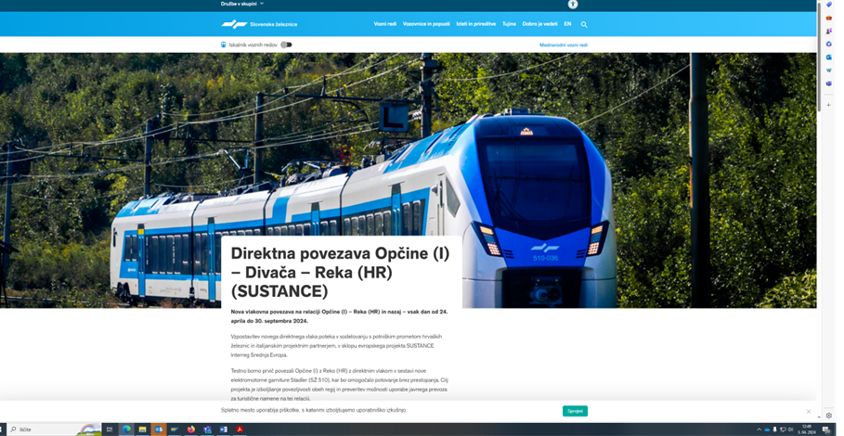

Photos from launch event 24/04/2024 – first ride of SUSTANCE train.
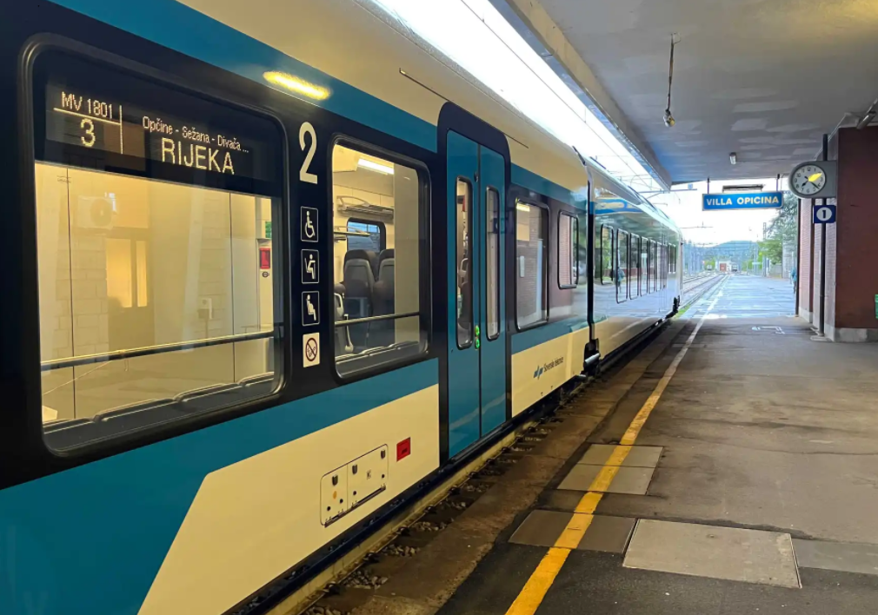
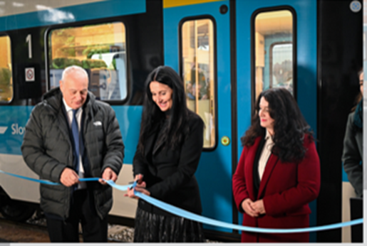

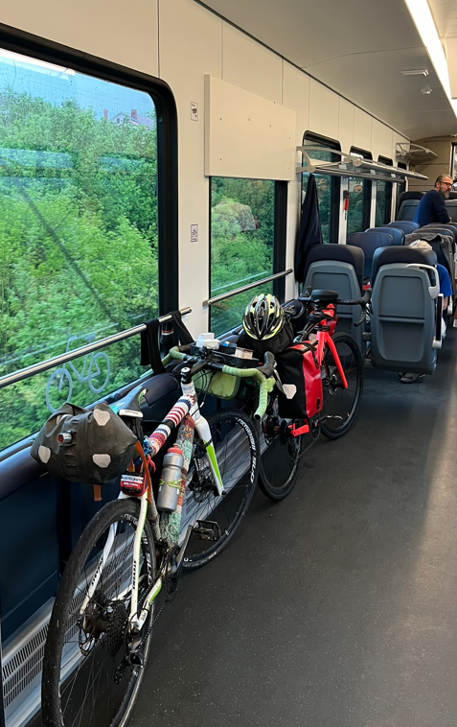
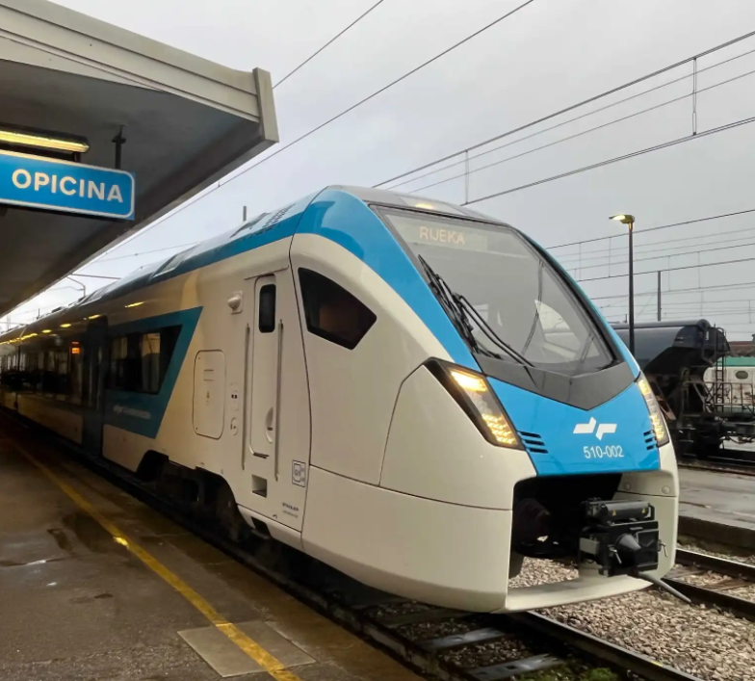

Print screen from SZ information system – evidence that SUSTANCE train (number MV 1801 and MV 1812) ran on an example day 01/06/2024.
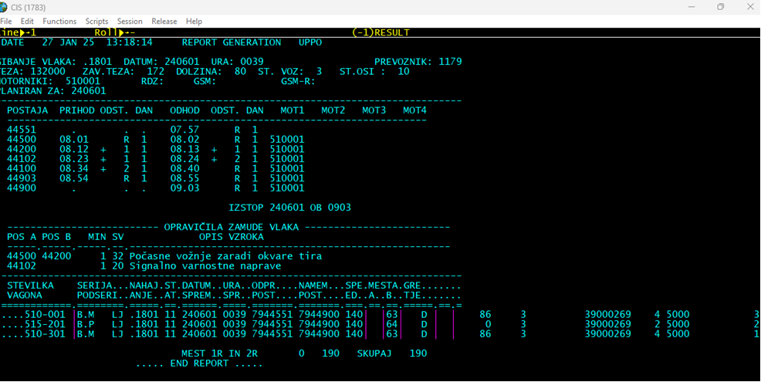

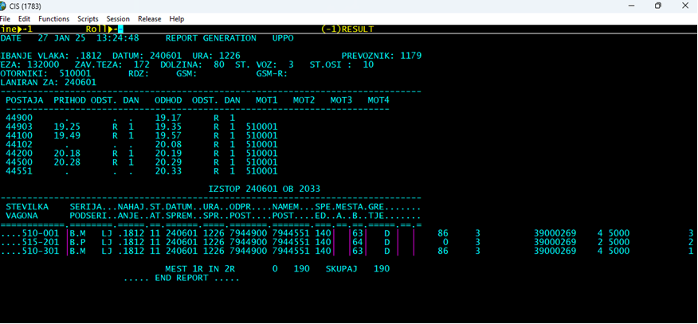

Confirmation of reserved train path from PCS system.
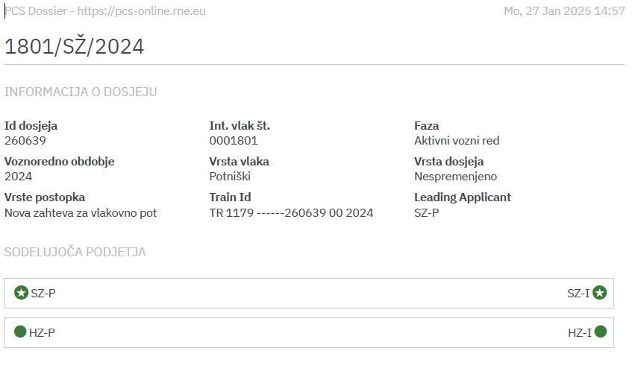
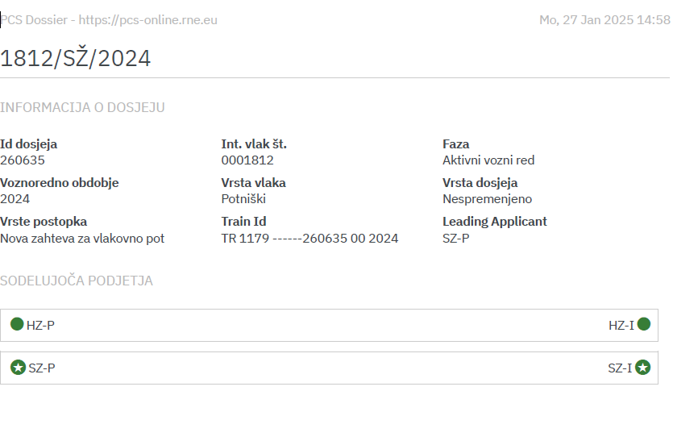

    - Pilot action communication and promotional strategies
In this paragraph, the pilot action communication and promotional strategies and tools are presented.

Besides press releases after launch event 24/04/2024, there were almost 50 different press releases about launch event from Italian, Croatian and Slovenian media, also 4 influencers have written and spoken about the event and the PA train on their YouTube channels or podcasts.
In the following, there are promotional channels used to disseminate PA1 in running months:
- On SZPP Facebook Grem z vlakom with reach, likes, comments and shares

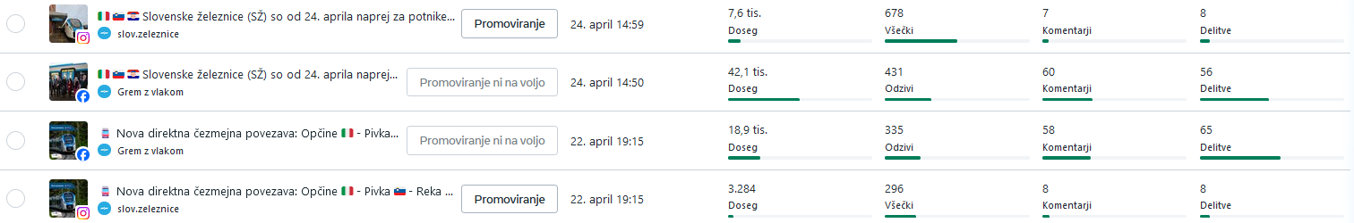

- On Facebook Grem z vlakom – paid promotion for targeted users in Trieste area from 4th – 16th July 2024. 331 likes, 54 shares and 80 comments.
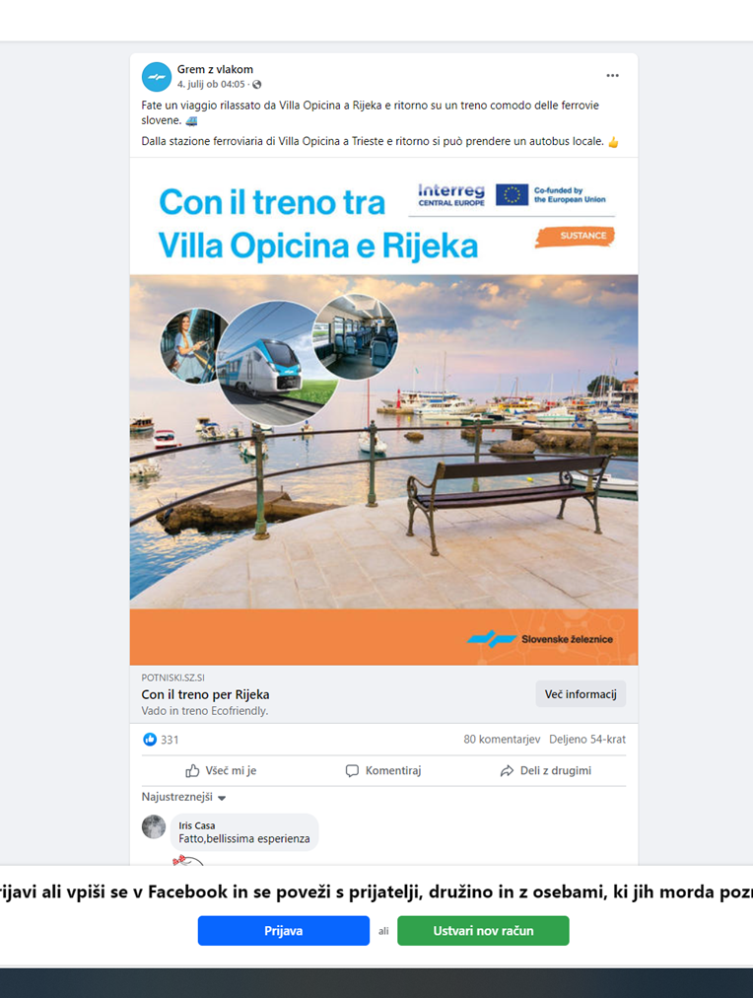

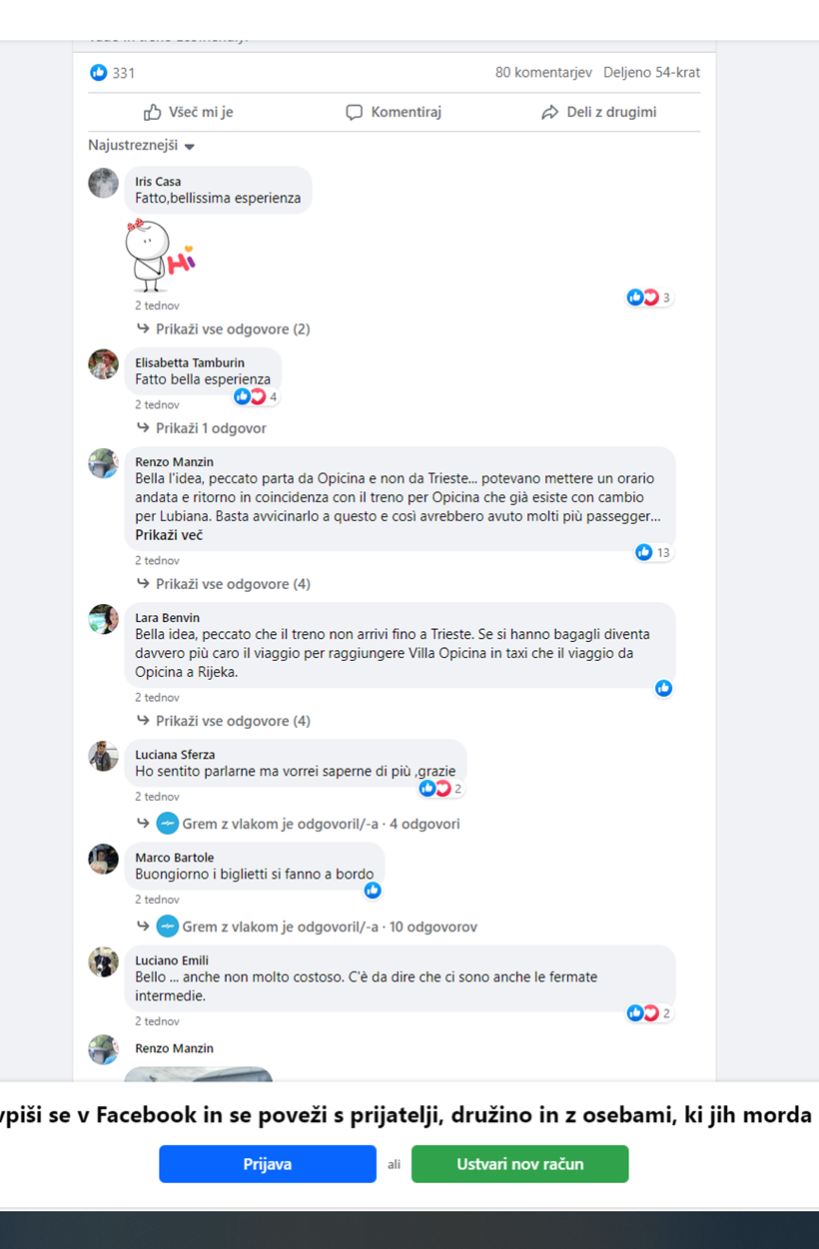

- Brochure and leaflets about PA1 delivered in Villa Opicina book store and Trieste library, touristic centres and train stations along the route

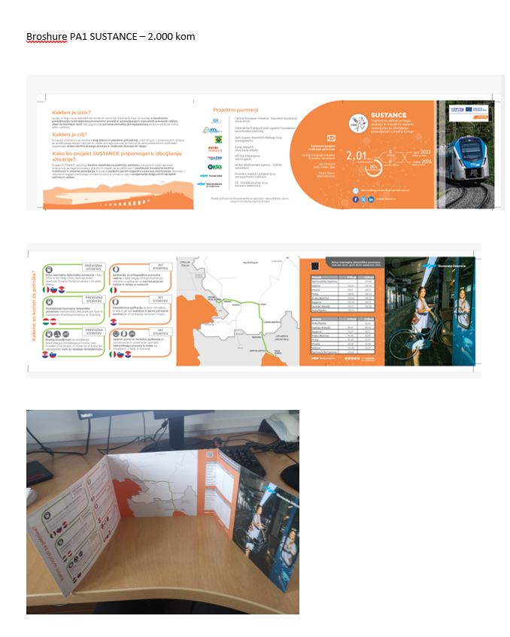

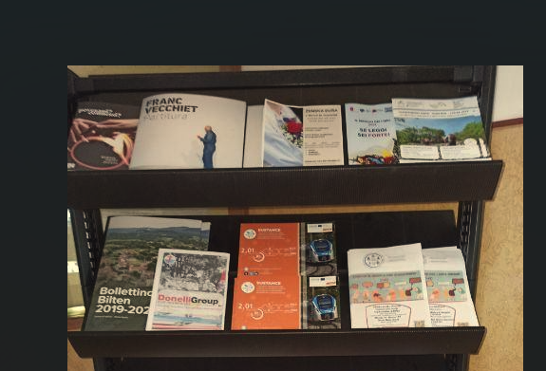
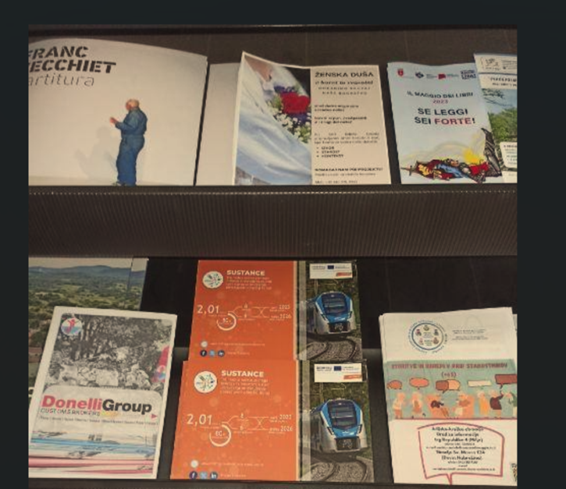
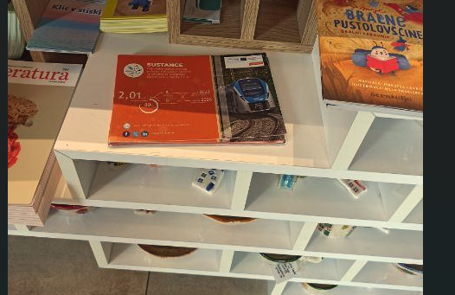

- Pilot action key outcomes

  - Lessons learned and replicability suggestions
In this paragraph, each responsible pilot action partner presents the main lessons learned during the pilot development, implementation and assessment. A specific focus is dedicated to the provision of relevant information and suggestions to external stakeholders interested in developing similar initiatives in other territorial contexts.

What is the key legacy of the pilot action?
The key legacy of Pilot Action 1 “cross border train connection Trieste (Villa Opicina)-Divača-Pivka-Rijeka” is producing a model of introduction of the motor unit direct cross-border train that is technically approved to run on railway networks on both sides of the border. The key advantage to that train service is a reduction of border-crossing operational time. There is no locomotive changing at the border. Reduction of the border crossing operational time finally results in train service travel time which is shorter. Shorter travel time will in turn attract more passengers.
Moreover, as expressed by the municipality leaders, this train service is a political indicator of the re-connection of the separated communities across the borders and along the train route that share common historical, economic and even genealogy background.
The new service boasts good passenger occupancy and shows potential for further extensions since more passengers used the service in direction from Rijeka to Triste, although the timetable was more suitable for the passengers starting the ride from Trieste (Villa Opicina).

What are the suggestions for other stakeholders interested in replicating your pilot action?
- The attractive, modern motor unit train that can comply with the technical and safety requirements and standards applied at the rail networks along the route and across the borders is a baseline for a direct train service.
- The owner of the train should consider long procedures to obtain the certifications for technical and safety conformity of the motor unit train by the authorised notified national bodies, in all the countries passed by the train line.
- Furthermore, obtaining certification of the motor unit trains can be quite costly, which represents an additional hindrance for the implementation of a cross-border service. This could be one of the main obstacles for the extension of the train service from the Italian border station at Villa Opicina, further to Trieste or even beyond. According to Mr Giovanni Longo, professor of transportation at the university of Trieste it was ssuggested “to cancel (or at least reduce drastically) the issue of safety devices requirements in Italy. It is precisely to overcome these issues that ERTMS was developed with standard devices and operations rules in order to improve the interoperability among Countries in Europe. This Italian requirement appears well-aligned within the European framework, and it is considered inappropriate to question it further”.
- Good cross-border cooperation and taking decisions are also needed when it comes to consolidating ticketing systems and tariffs among different networks. Custom ticketing systems are expected in terms of technology. It is recommended that one existing ticketing system is adopted by all parties along the route and a trustworthy clearing service established. Also, tariff schemes might be complex or special statuses overlapping. A simple tariff scheme, added by a specially agreed promotional product is advised.
- Maintaining communication with relevant stakeholders from neighbouring countries is of great importance for development of new cross border services. Excellent cooperation with FVG region was pointed out as a good example.
- Since EU has recognised cross-border services relevant for connection and cohesion of cross-border regions, a further step might be necessary at the European level to ensure sustainability of the cross-border services. To initiate supportive cross-border communication and overcome possible inhibitory interests induced by national railway undertakings, expressed by the hard-to-meet financial conditions or other hindrances one of the suggestions could be establishing rail passenger cross-border corridors modelled by the European rail freight corridors. The rail passenger cross-border corridors would pursue to implement EU policy at the relevant railway cross-border routes by providing political support as well as organisational and financial means for long-term service operation.

If you could re-do your pilot action differently, what would you do?
The PA1 pilot action would perform much better if there were additional timetable departures and better technology supporting ticket purchase and validation.
The timetable merely caters to daily passengers from Trieste who leave in the morning and return back from Rijeka in the evening. The same should be an option for the passengers from Rijeka to pay a daily visit to Trieste. Additional departure is bound to one additional motor unit train that should be available for this service. Two motor unit trains could extend the timetable even further, based on the identified passenger demand. Differently defined timetable according to the needs of the various potential demand segments (including commuters) should be examined, which could increase train occupancy.
On the other hand, we saw the motor unit train from Villa Opicina dwelling over the day at the Rijeka station. Under-exploitation is not sustainable. Additional departures for the unit train should have been agreed upon among the railway undertakings on the pilot service or other routes.
The option to purchase tickets online was not available. This option would bring the train service even closer to the passengers, in particular to the more active younger passengers who might want to take the train by carrying bicycles with them in order to explore the locations around the stations on the route of the train. In order to ensure that bicycle stand is available on the train reservation system to book a bicycle stand should be considered.
There was a time lack before starting the pilot action and the pilot operation was too short to agree and organize better connections to local mobility services at the intermediate stations. Interesting tourist sites as Divaška jama, Lipica or Opatija would be accessible by the pilot train service by shared mobility service (bikes, electric cars …) or a shuttle bus.

If you could give advices to another city/stakeholder implementing your pilot action, what would it be?
Implementation of new cross-border train services needs to be planned at least 1 year in advance in order to achieve consent and official confirmation to implement the new service by the involved institutions.
Involvement in the railway undertaking, taking part in train service implementation, is mandatory in every planning step, already from the beginning. Also, the involvement of political and regional institutions is important to support the new service and for the future continuation of the service.
Lastly, a communication campaign to inform public and relevant stakeholders should be planned before implementation of new service. Well organized launch event with major media invited can have a good impact on the public and potential users of new service.

  - Strategies for the Sustance pilot action follow-up after the project conclusion
In this paragraph the adopted strategies and strategies for the pilot action continuation after the project conclusion are described.

How the pilot will live on?
Operation of the pilot train service merely depends on the funds put in financing of the train operation. This particularly applies to Croatian railways that don’t fund cross-border services through the PSO contract.
To overcome the funding issue, an EU approach could be one of the solutions in the form of cross-border passenger train corridors authority that would cover development of the railway passenger cross-border corridors as well as bear or put a cap to the excessive expenses imposed to the railway undertakings.
EU funding approach could also overcome the technical issues imposed to the Slovenian train by the Italian railway network and thereby allow Slovenian train to obtain the necessary technical certificates.
Also, one of the possibilities to improve cross-border connectivity was given by the agreements introduced by the “Commission notice on interpretative guidelines concerning Regulation (EC) No 1370/2007 on public passenger transport services by rail and by road (2023/C 222/01)" Point 2.1.3 Article 1(2). Application of Regulation (EC) No 1370/2007 to international public transport services.

There are synergies with other local/regional/national/EU projects/initiatives?
Modelling and implementation of the efficient direct cross-border train service contributes to better connection and accessibility and consequently cohesion of the regions along the railway route and across the borders. The train service also contributes to better environmental sustainability of passenger’s mobility and tourist development of the locations around the railway route.
Introduction of the new direct train services is consistent with the cross-border development programmes, namely with the Italy – Slovenia 2021-2027 programme and Slovenia-Croatia 2021-2027 cross-border programme, respectively. Both programmes underline the issue that a cross-border commuting, especially in remote areas, is presently mostly carried out by private transportation. This situation is merely caused by the lack of adequate cross-border public transport services, non-harmonized time-schedules and few last-mile solutions. Many rail connections have been cancelled in the past and now commuters in the cars struggle in the queues at the border crossings due to transport congestion, in particularly at tourist season peaks. Therefore, both cross-border programmes see new or improved railway links between Italian, Slovenian and Croatian cross-border regions as an important measure to improve public transport offer in the area.
Similarly strategic project MIMOSA Interreg Italy-Croatia conducted research Quantitative analysis of the existing demand, which showed that there is the potential (number of car users travelling Italy – Croatia) and that most effective long-term solution in reducing car use would be train, however currently travelling by train is not a relevant option for travellers. “A possible railway line connecting North-Eastern Italy with Istria and Primorje-Gorski Kotar would certainly be able to change not only the tourist flows but also the permeability of the borders between the two countries, creating the conditions for a significant increase of excursionists in both directions, as well as for the reduction of travellers by car.” (MIMOSA, Interreg Italy-Croatia).
In 2024 Republic of Slovenia and Autonomous Region Friuli-Venezia Giulia from Italy concluded a framework agreement for planning and implementing sustainable cross-border mobility, where they defined the improvement of the accessibility of the Slovenian-Italian cross-border area and access to the public transport system as a common goal. The first step of this cooperation is to determine relevant cross-border links and create a cross-border public passenger transport service plan, which will represent the basis for planning in national, regional and local strategic policies in this area.
Synergies of the pilot action can also be seen with FORTIS project, where territorial needs in the Italy-Slovenia cross-border area were assessed. The project analysed and highlighted several missing links in public transport connectivity, among them also the Trieste (IT)-Rijeka (HR) railway connection.
Potential uptake and synergy of the pilot action can also be found in the European Green Deal and the Sustainable and Smart Mobility Strategy. They put rail transport, especially long-distance and cross-border passenger transport, at the heart of efforts to green the mobility systems in EU. Concrete actions to reach the goals, which are ambitious, are defined in an EU Action plan for boosting long-distance and cross-border passenger rail services (), mainly focused on the promotion and support of development of sustainable transport services and for piloting of new or enhanced railway services that involve interested stakeholders.
There is also a potential synergy with the INTERREG project named T4RAIL IT-SI, which aims at reducing losses of time in cross-border stations by solving, through technological devices and proper procedures, another potential issue related to the use of different languages in different Countries.
  - Pilot Action influence on local, regional and national policies
In this paragraph, starting from the stakeholder's engagement strategies analysed in the ex-ante and interim reports, a brief description of the key pilot action influence on local, regional and national policies is presented.

How does your pilot impact on local/regional/national policies?
Local, regional and national policies in Italy, Slovenia and Croatia also impact implementation of new cross-border train links and related environmental sustainability and tourist development.
Both, Regional Development Programmes of the Primorje-Notranjska Region and the Coastal-Karst Region for the period 2021-2027, respectively, identify public transport in the area of western Slovenia as underdeveloped and scarce, which is reflected in a strong rise of personal mobility in the area. Owing to that, it is necessary to improve the accessibility of public transport and improve its offer in terms of frequency and quality of transport services in both regions.
Also, according to Primorje-Gorski Kotar County development plan 2022-2027, maritime transport is the backbone of development for the City of Rijeka. The document recognizes the potential of railway system development and the significance of railway connections with the rest of Croatia (primarily Zagreb), not only from a local and regional, but also national and international aspect.
The adopted local strategies of municipalities in Slovenia also highlight importance of new transport connections, of promotion of sustainable modes of mobility, as well as strengthening of public transport. This will particularly contribute to better in connection of rural areas, as a key to curbing the trend of increasing use of personal transport. Introduction of the new pilot railway service effectively implement local strategies development goals by increasing the offer of public transport, bringing sustainable transport option and improving the overall accessibility of public transport in western Slovenia.
Transport development strategy of the Republic of Croatia (2017-2030) hypothesizes that the international rail passenger traffic is mainly related to the corridor RH1 (Slovenia and Serbia, via Zagreb). It concludes that the potential of regular international passenger transport is limited.
For Italian part of cross-border connections, FVG region is responsible for Cross-border public transport and the main strategic documents are presented in the following.
Regional plan for Local public transport (adopted in 2013 in accordance with art. 13 and 14 of Regional Law 23/2007) and more particularly Chapter 6.2 “Cross-border rail services” which highlighted the main routes of interest for cross-border rail services as follows
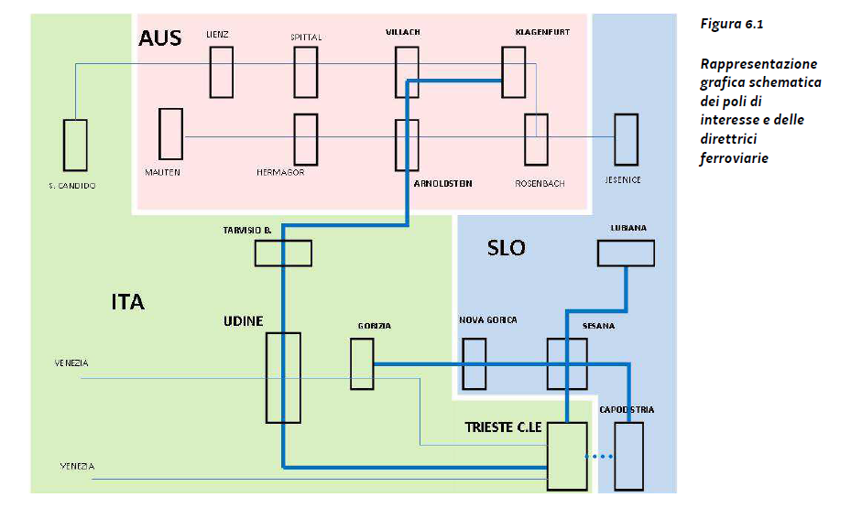

The “Operational Agreement between the Friuli Venezia Giulia region and the Republic of Slovenia for the planning and implementation of a sustainable cross-border mobility system” was signed on 22 March 2024 between FVG region and the Republic of Slovenia. In this agreement, the inclusion of specific provisions regarding the identification of specific cross-border routes (also for experimental services) is mentioned. Innovative cross border services can be introduced through extension of existing lines, new services or timetable harmonization. In addition, a cross-border Masterplan is planned to be developed in agreement by the parties. However, this agreement is only related to the Cross border Public transport IT-SI and does not include services that are extended to the Primorje-Gorski Kotar County or to Istria Region.
In this sense, the key element to support possible new connections is institutional dialogue among the three countries, taking into account the rules set out in Reg. 1370/2007 and the very recent Interpretative guidelines concerning Regulation (EC) No 1370/2007 on public passenger transport services by rail and by road 2023/C 222/01. The latter is relevant in particular as regards point 2.1.3, which specifies that Regulation (EC) No 1370/2007 applies also to the international operation of public passenger transport services, and that subject to agreement of the competent authorities of the Member States on whose territory the services are provided, public service obligations may concern services at cross-border level, including those covering local and regional transport needs.
While Article 1(2) specifically refers to local and regional transport needs, the notion of international public service covers also long-distance public passenger services. The pre-requisite for the establishment of an international public service is the agreement of the competent authorities of the Member States on whose territory the services are provided. Such competent authorities remain free to decide whether to recognise the public service status of the proposed service on the territory under their jurisdiction.
- Conclusions
This final paragraph provides a synthesis of the SUSTANCE pilot key results, lessons learned, replicability factors and all the other relevant information related to the pilot development, implementation and assessment.

PA1 focused on improving PT accessibility by improving passenger services on the railway route between Trieste (I) – Divača (SLO) – Pivka (SLO) – Rijeka (CRO). All objectives set at the beginning of PA1 implementation were met. The electro motor unit was introduced as direct cross-border train, which was a novelty for the Slovenian railway. With PA1 railway passengers service improved overall, but mostly traveling time was reduced due to direct train and less stops, which also improved service for passengers with bicycles to travel without changing trains. Furthermore, PA1 contributed to the improvement of environmental factors by redirecting car users to use sustainable, eco-friendly transport mode – train. Travelling with electric multiple units on Slovenian Railways has been carbon-free since 2024. Last year, Slovenian Railways ordered electricity that is 100% obtained from renewable energy sources. This enables carbon-free transport of passengers and freight with all-electric trains in passenger and freight transport.
PA1 tested the possibility of using public transport for tourism purposes on this route. Passengers from all three countries were given the opportunity to explore tourism in places along the route, such as Divača, Pivka, Sežana, Ilirska Bistrica, Opatija, Rijeka and V. Opicina or Trieste, which offer numerous natural and other attractions.
8,273 passengers were transported by PA1 train, of which 425 were passengers with bicycles. Slightly more passengers travelled from Rijeka to V. Opicina. Passengers mostly used the train on weekends and holidays. Thus, in September, which is the busiest month in terms of the number of passengers transported, the train had an average of 46 to 53 passengers per day. During the entire period of the train's operation, 5,422 tickets were sold, of which 2,044 were sold at Croatian railways. Tickets were mostly sold from the staff on the train, most often for the V. Opicina-Rijeka route. Most tickets were sold at regular price for adults and to a lesser extent for children up to 12 years of age.
The pilot train was introduced to test the market potential of such a service and according to beforementioned results, this can be confirmed. It was the first direct cross-border train connection with a Stadler electric motor unit, which was a novelty for Slovenian Railways. In 2024, Slovenian Railways obtained a permit to operate Stadler multiple units in Austria and Croatia.
After analysing results and technical advancement of PA1 lessons learned were studied in case of PA1 train continuation: the train would run only at weekends and national holidays during summer season; based on statistics another train in opposite direction from Rijeka to Opicina and back should run, which would enable Croatian tourists to travel to FVG region and technically, improve usability of motor unit. Also, online tickets or mobile app tickets should be available, which wasn’t possible during the PA1.
According to Mr. Giovanni Longo, professor of transportation at the University of Trieste, “the strategic and political importance of the results of this project is remarkable, as it demonstrated the possibility of running rolling stock across multiple European Countries, through the co-operation among Railway Infrastructure Managers to operate an attractive schedule. This is an extraordinary result because this service has effectively connected these Countries with a competitive timetable. This result may become even more effective if rail passenger cross-border corridors (similar to the European rail freight corridors) are established.”
The pilot train is not running in the 2025 timetable, mainly due to extensive work on the railway infrastructure, which could worsen the transport service. In the coming years, when most of the rolling stock will be modernized and the railway infrastructure improved, more cross-border railway connections are expected, as well as the possibility of re-introducing the aforementioned train. A new railway transport strategy is being prepared, which is being prepared together with a new timetable concept, taking into account rolling capacities and improved railway infrastructure.
Lastly, cooperation with neighbouring railway undertakings and competent institutions (ministries, regions, etc) responsible for cross-border connections is very important to be considered regarding re-introducing PA1 train. Their interest and strategic documents regarding cross-border connectivity can represent basis and are relevant for development of new cross-border connections.
- Co-design and peer-review process
  - Co-design
In this paragraph, a brief description of the co-design activities updates are provided. In particular, are presented the updates about the information provided in the interim report.

The co-design meeting was organised on-line on 7th of December 2023. Co-design partners for PA1 addressed some issues that could improve PA1 planning.
They pointed out high price for bicycle tickets and compared it to tickets for children. However, the tariff for international transfer of bicycles differs from national one and it is agreed by cooperating railway undertakings. This cannot be changed within the duration of pilot action. Maybe this can be considered if the train would run in the future.
Not enough bike stands on the train were mentioned; however, the results show that not more than 10 bicycles were transferred on the train.
Regarding permits for PA1, permit to run the train to Croatia was already obtained, which means that in case if Stadler trains would run to Rijeka in the future, this would be still valid.
For the period of experimental train, bus stop at Villa Opicina train station was reactivated by FVG region, which meant that passengers could enter the bus to Trieste right in front of Villa Opicina train station. This would need to be discussed with FVG in case of reintroducing train again.
At Villa Opicina train station, there is no ticket office there, therefore SZPP had to upgrade their ticketing system to enable selling of tickets on the train for the (SZ) stations along the route where no ticket office is available. Online tickets would be a more attractive solution, which is in the future plans of SZPP.
It was mentioned that commercial benefits from the proximity of the Škocjan caves to attract tourists and Divača station as a transfer point for tourists in the cross-border area should be considered. If the train would run in the future years, re-activation of shuttle bus from Divača train station to Škocjan caves and back would possibly attract more tourists using the train.
Launch event on the start date of the new experimental train on 24th April 2024 with the involvement of stakeholders, media and institutions was organized and it was very well attended. More than 60 people from important European, international, national and local institutions attended the event.

  - Stakeholder engagement
Please briefly list here the main recommendations/suggestions that emerged during the third round table discussion with Stakeholders (D.3.3.3) and summarize the key strategy you intend to adopt in order to integrate these suggestions in the pilot development/implementation phase.

3rd stakeholders' consultation was organized on 11th of March. The event took place in Divača in Museum of famous Slovenian actors. The event participated representatives from Ministry for infrastructure (AP), Ministry for environment, climate and energy, Public Passenger Transport Management Company, Municipality of Divača Tourist institute from municipality of Pivka, Geographic institute and media. Regional development agency Green Karst as representative of cross-border services was invited but unfortunately nobody attended the event.
The event began with speeches from a new director of Slovenian railways Passenger transport (SŽPP), representative of associated partner Ministry of infrastructure and mayoress of Divača. They all expressed great interest for PA1 train and that the results of PA1 will provide a new perspective on this connection and possibly to future continuation and development of similar services. They mentioned that PA1 train is also important from a tourist perspective, and that this train has attracted many passengers and tourists to visit stations along the route and the surrounding areas with tourist attractions.
After the speeches general information about project SUSTANCE was presented and projects activities and documents that were already carried out, followed by what still needs to be prepared with emphasis on what is to be expected from stakeholders. Then implementation of PA1 with results was presented.
The event ended with a discussion. They all agree that the results of PA1 are positive and would prefer for train to operate in the future. In the following stakeholders feedback is presented:
- Cooperation with institutions from neighbouring countries is important for cross-border cooperation. An example of good practice is cooperation with the Friuli Venezia Giulia region, with which an agreement between the region and Slovenian state was signed last year to improve cross-border connectivity. Therefore, it would be necessary to do the same with other neighbouring countries.
- PA1 train timetable is more adapted to the Italian side and not so for Croatians, there is a need for morning trains from the direction of Rijeka to Trieste.
- Online platform for rail passenger travel was established at EU level a few years ago, bringing together ministries, carriers, travel agencies, travel organisations, etc. for the establishment of TEN-T corridors, the revival of night trains etc. This platform is used to help with joint projects of cross-border trains.
- Technical requirements (infrastructure and for rolling stock) have become more stringent, which may hinder development of new cross-border services. Countries are required to ensure compatibility with technical standards (each country has its own variants of the ETCS system) and adaption to these standards takes time and additional finances. For example, Hungarian Railways is in talks to revive a direct train via Hodoš, connecting Budapest and Venice. The Budapest-Venice train was popular with passengers, as it covered the entire 5th corridor. The train was also connected to Romania and even Russia. However, the installation of expensive safety devices which are required by Italian standards on the trains (approximately 800,000 EUR per train) is deterring Hungarian Railways from establishing this train.
- Better integration of international and domestic transport is needed. Cross-border trains and stations across the border should be included in the cross-border PSO (not just for kilometres within the country) with enabling passengers to travel with the same, national tickets outside the borders. It was suggested to establish cross-border ticket, which would be valid to the first major town in neighbouring country with additional integrated city ticket to this town. However, they agreed that harmonization of international tariffs is complicated because there are very different categories of discounts in tariff systems and ticketing systems which would need to be upgraded, that this could be proposal for a new EU project.
- Timetable of cross-border trains should be included in national timetable system, so that they are accessible to users of the SIMO (Slovenian national journey planning system) and will also be available to other platforms that obtain data.
CEI organized 3rd stakeholders’ consultation on 03/04/2025 in Trieste, where results of PA1 were presented by CEI. Representatives of Friuli Venezia Giulia Region (FVG region), Trenitalia (associated partner of CEI), cross-border organization GECT GO and Municipality of Trieste attended the consultation. Their feedback was:
- FVG region sees positive signals for a possible relaunch of the service and confirms the FVG Region's interest in the reactivation of this cross-border connection in the years to come.
- Long-term agreements are important between states and operators, as exemplified by the implementation within GO!2025 and masterplans for cross-border mobility. These experimentations and pilot projects build the foundations for sustainable mobility collaborations with a broader perspective, not limited to single events.
- The importance of territorial marketing linked to public transport and the connection with existing cycling routes was highlighted.
- Trenitalia identified three fundamental requirements for the effective implementation of cross-border transport: long-term strategic planning, adequate infrastructure and digital platforms, especially for online sales.
- Trenitalia also highlighted the need for a public-private partnership, emphasizing how operators like Trenitalia are the "backbone of the regional mobility system," while also stressing the necessity to actively identify opportunities that can contribute to cost coverage.
- GECT GO mentioned as an example the Transalpine railway, a historic railway line connecting Central Europe with the Adriatic Sea crossing four countries: Austria, Slovenia, Italy, and Croatia. Together with the upcoming reactivation of Campo Marzio Trieste railway station, it represents a unique railway axis that, although relatively isolated from the main commercial routes over time, offers significant potential for sustainable tourism and regional connections. A potential strategic axis of Central Europe, highlighting that its position outside the main commercial lines constitutes an advantage for developing a slow and sustainable travel experience enhancing the historical-cultural and food and wine heritage of the territories crossed. This could be the case for line Rijeka-Jesenice or Pula-Jesenice.
- Municipality of Trieste emphasized the importance of carefully studying tourist and local demand to calibrate service offerings, highlighting the potential positive impact of integrating these experimentations with other tourism offerings in the territory.
- Regarding the connection of Trieste to Villa Opicina for the valorisation of PA1 the Trieste's orography is very peculiar. It creates two separate cycling tourist routes (coastal and plateau) without interconnections, making access to the Karst difficult for inexperienced cyclists. The Villa Opicina tram does not meet the needs of these users, while the cable car project, if equipped with bicycle transport capacity, could constitute an effective solution and a significant stimulus for cycling tourism.
  - Peer-review key results
Please briefly list here the main recommendations/suggestions that emerged during the third peer-review event and summarize the key strategy you intend to adopt in order to integrate these suggestions in the pilot assessment phase.

On Wednesday, 02/04/2025, the third and last Sustance peer review event was held online. During this event, the three selected external technical experts provided their suggestions and comments on the pilot actions.
Mr. Simon Fletcher, an expert on the cross-border railway services, reviewed the ex-post report and presented his feedback. In the following, there are his comments and suggestions:
- It is worth highlighting that the introduction of this service, albeit only 1 return journey per day, was undertaken at a very sensible price to the user.
- Since Slovenian Railways introduced traction energy from 100% renewable sources, this service and (presumably) any others in the future are operating as almost entirely carbon-neutral. This is an excellent achievement and is worthy of prominence. It would be an excellent opportunity for the project and for SZ for any press releases issues are able to highlight this important topic. Rail is the least polluting mode of land transportation, and this goes to prove that point. Based on the significant carbon emission reductions, a business case should be possible, and a regular service introduced. The success of this trial should not be overlooked, and it is excellent once again to reiterate the carbon neutrality of the service brought about largely by the provision of sustainable energy.
- In terms of passengers carried, it would be of interest to be able to understand what the total revenue was and how near that was to the total cost of operating the train. This is of course a relevant marker for the calculation of an eventual extension of the service.
- Motor unit should be better utilized. Could the unit and crew be used for a shorter out and back service from Rijeka rather than having this asset sitting idle for 8 hours? It would be interesting to know if it were possible to introduce a second unit and find the crews to make two round trips per unit per day. This would significantly enhance the service but would need to be balanced again cost versus income.
- Regarding KPI 1 & KPI 3. A slow ramp up is going to have to be expected every year. This is a symptom of not running the train regularly enough. That said of course, significant advanced publicity of likely start date might be a significant plus in getting good ridership from the beginning. Regarding KPI 5 the comments relate to already mentioned comments in point 2.
- Mr. Fletcher agrees with most of the comments in section 4.1. Lessons learned and replicability suggestions as being very sensible and worth developing.
- Seeking EU funds is one route to prolongation. However, as the railways are a business, a business approach should be taken. Just because something is not funded by a PSO contract is not an excuse to do nothing. It should be possible to calculate the cost versus benefit and use that to simulate the provision of a service funded by the partners with the fare basket shared on a proportional basis.
- The 2024 framework agreement between Slovenia and the Italian Friuli-Venezia Giulia region for planning and implementing sustainable cross-border mobility, is an excellent catalyst to once and for all remove barriers such as the continued lack of access to Trieste.
- It is also good to see that tri-national dialogue appears to be on the table. It should be an ambition that this cross-border service is seen as one that can be perpetuated. It is noted that this refers to Regulation (EC) No 1370/2007 on public passenger transport. Such regulations are also known to be barriers, and it is on the partner railways to develop the traffic because it makes good business sense.
- It is very disappointing to learn that there will be no train in 2025. The rationale is understood but there will be a need to manage expectation of potential travelers. Public information should be made to maintain interest for 2026. Or better still, start running the train as soon as the work is completed.
- The train should not be training only for tourists but for year-round mobility of local citizens too.
- The project team should be encouraged to develop a business case that makes this an attractive ‘must do’ service.
- Regarding feedback from stakeholders in section 6.2, Mr. Fletcher asked, what are the safety devices that are perceived as a barrier in this report. Also, he commented that in identifying the ticketing concern, whilst calling for an EU project (why not at UIC project?) this must not become a barrier to future evolution. There are clever minds involved who should be able to develop and apply a local solution to overcome barriers to interoperability. Finaly, integration of the PA 1 train into the national timetable makes very sound, far-reaching common sense and to be applauded.

key strategies to adopt to integrate these suggestions

The implementation of pilot action was to test if there is market potential for this direct cross-border service. Two trains operated daily at a promotional price which could be better highlighted in a promotional campaign and more targeted campaign should be conducted that would include information about 100% renewable energy in case using PA1 train. However, news about virtual zero CO2 green energy was published on SZPP web page https://potniski.sz.si/slovenske-zeleznice-pomembno-prispevajo-k-varovanju-okolja-od-letos-z-brez-ogljicnim-prevozom-potnikov-in-tovora-z-vsemi-elektricnimi-vlaki/. In future continuation of this direct train this would be considered. Because this would lead to better results (more users).
Also better utilized motor unit is going to be considered with adding another pair of trains in between running from Rijeka to Villa Opicina and back. This would enable Croatian users to travel to V. Opicina. Taking into account results of PA1 train, which showed that the train was more occupied during the weekends and national holidays, and limited number of motor units, only weekend train is considered in the future operation. Stadler motor units are planned to be used on other routes and for other services. Mobility of local citizens on the PA1 route will be ensured by other local trains and harmonized timetable with cross-border trains.
National and cross-border trains operating on Slovenian railway network are co-financed by public service obligation (PSO) from the governmental funds managed by Public Passenger Transport Management Company. Approximately half of all costs are covered by PSO. Without this co-financing it would not be possible to set an optimal price of tickets and have a financially feasible service.
For the period of PA1 train operating online or mobile app tickets were not possible to purchase. SZPP is in the process of to upgrade ticketing system with the possibility to purchase cross-border tickets online. Therefore, in future continuation of the train hopefully this will be possible. Also, uploading of cross-border timetables in SIMO (Slovenian national journey planning system) will be considered, which would promote cross-border trains even better.
Regarding safety standards regulations that have been introduced by Italian safety national institution mentioned as a threat in SWOT table in section 2.1 current situation is, that SZPP has a valid single safety certificate for the area of operation on the Slovenian railway network and also to the traffic interchange station in Italy (Villa Opicina). Before the introduction of the IV. railway package, rail transport to the traffic interchange station in Italy (Villa Opicina) was carried out based on a contract between the operators with annexes (SZPP-RFI) and the safety certificate obtained by SZPP. With the introduction of the IV. Railway package, the procedure for obtaining a single safety certificate has become lengthier and more complex, which makes it more difficult for railway administrations to develop cross-border services.
SZPP currently does not have a vehicle authorization for placing on the market for STADLER motor units to the Villa Opicina interchange station, although Commission Implementing Regulation 2018/545/EU, in the eighth paragraph of Article 4, specifies that it may, if the intended area of use of the vehicle or type of vehicle includes stations of neighboring Member States with similar network characteristics and if these stations are close to the border, which is the case for the Villa Opicina interchange station. In this case, the Italian national safety authority should issue a certificate stating that the relevant notified national standards are met. Since the Italian national safety authority did not issue such a certificate for the STADLER motor units, exceptionally a pilot activity was carried out during the SUSTANCE project, testing a direct train (STADLER motor unit) from the Villa Opicina station to the Rijeka station.
The problem that SZPP faces when obtaining a vehicle authorization to place a vehicle on the market for STADLER motor units to the traffic interchange station in Italy (Villa Opicina), is that the national safety authority of Slovenia and the national safety authority of Italy have not yet concluded an agreement on how to proceed in the aforementioned cases, as defined in Commission Regulation 2018/545/EU in the eighth paragraph of Article 4, or what requirements the applicant must meet if it wants to operate to stations near the border with similar network characteristics. The European Railway Agency (ERA) responded to SZPP, that if there is no agreement between the national safety authorities, the applicant (vehicle type owner – manufacturer STADLER) must submit an application for the extension of the area of use to Italy and not only to the traffic interchange station, in this case to the Villa Opicina station. This would represent a significant financial investment for SZPP, which is disproportionate to the benefits it would gain from it.
It is currently difficult to determine the exact year when the train will run again. As already mentioned, extensive work on the railway infrastructure is underway and is planned for the coming years. In the meantime, a new timetable concept is being prepared, which takes into account the upgraded railway infrastructure and the same time we will be working on the railway passenger transport strategy. Until then, we will continue discussions with key stakeholders with the aim of better cross-border connectivity.

First number represents average number of weekeng users on the train V.Opicina-Rijeka, second on in opposite direction
Mr Giovanni Longo, professor of transportation at the university of Trieste is the CEI technical assistance team for the Sustance project reviewed PA1 report and prepared comments.
Communication from the Commission to the European Parliament and the Council: Action plan to boost long distance and cross-border passenger rail (COM(2021) 810)

