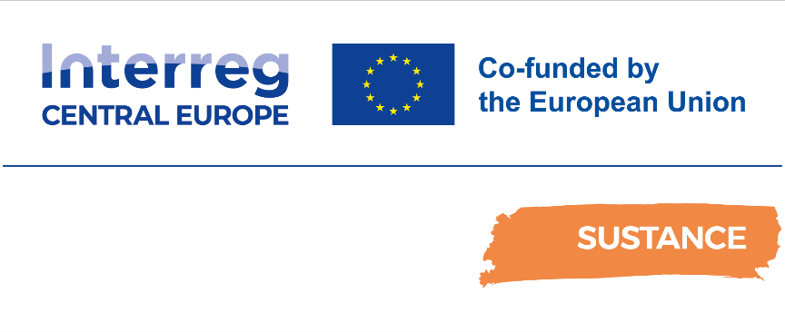

D.2.4.3. PA6. New IT tool for bike and rail in HR and neighbouring regions
Ex-post Pilot Action Report

Final
04/2025

Table of contents
Abbreviations 2
1 Overview 3
2 Pilot Action activities. Key results and SWOT analysis 3
2.1 Pilot key results and reached expectations 3
2.2 Pilot action SWOT analysis 4
3 Pilot Key results 6
3.1 Final KPIs assessment 6
3.2 Pilot action evidences and communication/promotional strategies 6
3.2.1 Pilot action evidences 6
3.2.2 Pilot action communication and promotional strategies 8
4 Pilot action key outcomes 12
4.1 Lessons learned and replicability suggestions 12
4.2 Strategies for the Sustance pilot action follow-up after the project conclusion 12
4.3 Pilot Action influence on local, regional and national policies 13
5 Conclusions 13
6 Co-design and peer-review process 14
6.1 Co-design 14
6.2 Stakeholder engagement 15
6.3 Peer-review key results 15

Abbreviations
AF Application Form
WP Work Package
PT Public Transport
SPAG SUSTANCE Pilot Advisory Grout
TCM Technical coordination meetings

- Overview
This report is related to the Sustance pilot action ex-post monitoring and assessment phase foreseen in Activity 2.2 “Solutions setting up: monitoring, peer review, assessment and dissemination”. In this report, each partner describes the key impacts and results of the Sustance pilot action implementation. The key goal is to assess from a qualitative and quantitative point of view the key effects of the pilot action in terms of environmental, social and economic impacts at local/regional/national levels.
In this report, it is possible to find relevant information on pilot implementation and testing key results, influence at local/regional and national levels and key impacts in terms of improvement of public transport offer in the testing areas. Moreover, it is possible to find information on the different strategies/solutions adopted for the continuation of the measure after the Sustance project conclusion.
- Pilot Action activities. Key results and SWOT analysis
  - Pilot key results and reached expectations
The SUSTANCE project pilot action no 6 is based on the digital promotion of green mobility in Croatia, Slovenia and four regions of northern Italy (Trento Alto Adige, Friuli Venezia Giulia, Veneto and Emilia Romagna) and improving relations between the countries involved. The idea of this pilot action was to promote and increase railway transportation and to position it to frequent travellers and tourists as a modern, attractive way of travelling between Croatia and bordering countries. Instead of driving cars or travelling by bus (both of which most often use gas and pollute the environment), the pilot is trying to position travelling by train with bicycle on board as a healthier, favourable and environment-friendly option.
The pilot action aim is to provide publicly available information on the HŽPP website on the options of "cross-border green mobility", through a dedicated new section named “Train ‘n Green” (https://prodaja.hzpp.hr/hr/Ticket/Sustance). Visitors of the HZPP website are in large number rail transport users who, in addition to the current possibilities of transporting bicycles on the train, are now informed about other sustainable options in one place.
SUSTANCE information are available grouped by defined countries and available content that depends on countries and regions. The links available on the website will redirect the user to external content that offers more detailed information with photos, descriptions, interactive maps and informative content about cultural sites.
The SUSTANCE project pilot includes publicly available information on public transport options, cycling routes and official EuroVelo routes, cycling service information, available accommodation facilities, local sights recommended by tourist boards and other societies.

The aim of this pilot action is to continue feeding the web domain with additional data and continue maintaining web page in the future. Public urban transport is one of the most important elements of overall transport, and with the help of advanced technology it will be developing faster and faster. By providing to everyday users as well as tourists with proper information that is on the spot, railway transport would become first choice of transport mean by many residents. The key is in valid, prompt and up-to-date information as well as fast, reliable and safe services. By combining two different services (bike and train) and providing useful information at one place in more than one language, HŽPP has begun new trend and providing a steppingstone at national as well as international level. In order to contribute to the main project motto: “Sustainable public transport solutions and innovative governance schemes for improving connectivity in Central Europe” this pilot action and its final result will try to influence on lacking efficient and sustainable public transport solutions in peripheral and cross-border areas of Central Europe with an idea that is practical and user friendly.

  - Pilot action SWOT analysis
In this paragraph, using the SWOT methodology, each partner is called to summarize the pilot action's key strengths, weaknesses, opportunities and threats. In particular, each partner is called to focus on the pilot action development and implementation phases in order to analyze the key internal and external factors influencing the successful development of the pilot action. Moreover, the the key pilot action problems are analyzed and adopted solutions are described.

What problems did you face and how did you overcome them?
Problems influencing the development of this particular pilot action were mostly regarding enormous amount of information. It was necessary to classify them according to categories and relevance. Also, the facts that information for database were coming from three different countries, additional classification was also in order, following rendition of some parts of the categories and their description. These were all small impediments for finalization of action. Crucial problem was data migration from old to new CMS within HZPP web domain. This was an action which affected not only HZPP pilot action, but also other articles/news published earlier at HZPP web page. Due to that reason, classification of number of views/individual visits of the TRAIN’N’GREEN domain wasn’t available. Considering the situation in which the google analytics for entire HŽPP web page didn’t work properly and stopped with collecting relevant data, it was necessary to upgrade web page. This includes google analytics necessary for identifying targeting groups of SUSTANCE project which was initially posing a problem for partnership in general because it doesn’t allow us to monitor pilot action progress as anticipated by the AF. Considering that this informative web page will not be suspended with project closure, this might not seem like a crucial issue.
What are the key internal and external factors favoring the correct development of the pilot action?
Internal factors:
- Cooperation with external stakeholders by different HZPP business units
- Communication between Management board and different HZPP business sectors
- Dedication of tasks and reallocation of priorities
- Administration procedures
External factors:
- External experts’ opinions
- External experts’ work reallocation
- External experts’ influence on contracting third parties.

Table 1. Pilot Action SWOT analysis
Internal factors
Strengths | Weaknesses
- Grouping information by country  - View data by region  - Promoting sustainability and green mobility  - Promotion of tourist boards websites and local cycling societies  - Providing external links for different attractions | - Not enough interesting information  - Not visible destinations attractiveness  - Too manny clicks to retrieve information  - Not enough variety of content
External factors
Opportunities | Threats
- Attracting more passengers and tourists  - Cross border connections  - Involvement of local societies  - Marketing measures for different accommodation facilities | - Requesting additional access from different service providers  - Information delay  - Not prompt info  - Maintenance problems

- Pilot Key results
  - Final KPIs assessment
In this paragraph, the key pilots' results are summarized (number of users, number of PT travels, etc.). Starting from the KPIs defined in the ex-ante and interim reports, each partner is called to describe both from the qualitative and quantitative point of view the key results reached by the pilot action.
Table 2. Pilot KPIs
KPI | Brief description | Value | Target reached | Measure methodology
KPI 1.  Number of page visitors | With the help of analytics gained by service provider it was possible to calculate the number of visitors TRAIN’N’GREEN domain.  This particular data will be collected and provided by the end of the project. | Available statistics for February ’25 only and the number of clicks on the page was 1873, corresponding to 230 unique users in a month. | Goal 30.000 users per year | Number of clicks
Explanation: KPI 1 for pilot action 6 was classified as the “Number of page visitors” amounting to 30,000 as target value. Considering that HŽPP´s webpage (www.hzpp.hr) is under construction regarding visual elements and other operational functionalities, CMS data exchange and shifting of all data from one base to another is still in progress. The same goes for TRAIN’N’GREEN domain. Due to the above-mentioned issues, despite the TRAIN’N GREEN web page was published online on 22/04/2024, the available statistics regarding the number of clicks are limited to the month of February 2025. Based on available data the KPI1 for 1 month was 1.873 individual clicks and 230 unique users.
KPI 2.  Survey results | Due to lack of Google analytic we have relied on, we created a survey in Croatian and English language to be able to retrieve opinions form users regarding web page and data provided. | 56 CRO  17 EN | 100 | Number of replays
Explanation: When creating pilot action and trying to reach first results, it wasn’t possible to use google analytics. For that purpose, survey was published and will be available during whole project lifetime. Survey was also sent to stakeholders and answers were gathered. Although we have collected positive and negative feedback, we consider every answer as valuable information on how to proceed further with pilot activity development. More in chapter 3.2.1.

  - Pilot action evidence and communication/promotional strategies
    - Pilot action evidence
In this paragraph, the pilot action key implementation and testing evidence are described and shown. In particular, photos showing the pilot implementation and testing phases are presented.

Picture 1: HŽPP web portal (www.hzpp.hr)
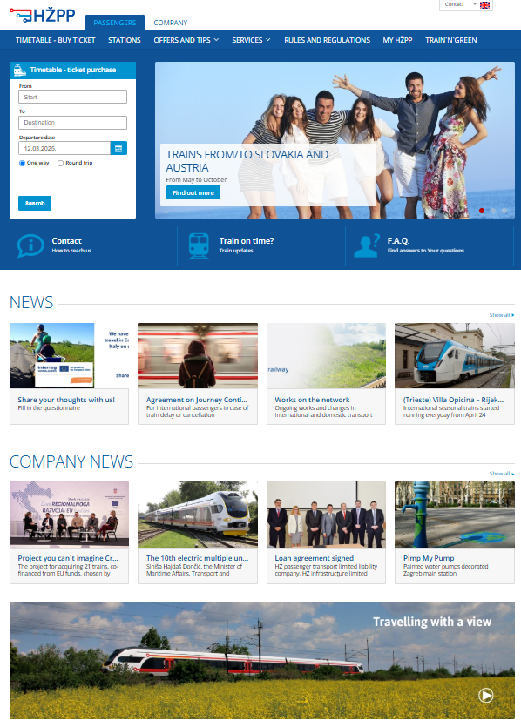

The SUSTANCE project pilot includes publicly available information on public transport options, cycling routes and official EuroVelo routes, cycling service information, available accommodation facilities, local sights recommended by tourist boards and other societies.
Within pilot action No 6, there was a potential for the development of a specific bike system in relation to e-mobility. The use of e-bikes has a great potential for the development of bike systems in the cities with unfavourable morphology. This could also help and cause potential to change travel behaviour in favour of bicycles, public transport, e-mobility etc., which would bring a significant reduction of greenhouse gas emissions and enable the application of multi-modal transport systems. In comparison with other EU cities, this leads to a conclusion that better integration of the bike system in public transport and the improvement of infrastructure offers a big potential for improving the modal split in favour of bikes not only in Croatia but can serve as best practice example to neighbouring countries as well.
SUSTANCE information are available grouped by defined countries and available content that depends on countries and regions. The links available on the website redirect the user to external content that offers more detailed information with photos, descriptions, interactive maps and informative content about cultural sites.

Picture 2. Appearance of “Train ‘n Green” web domain
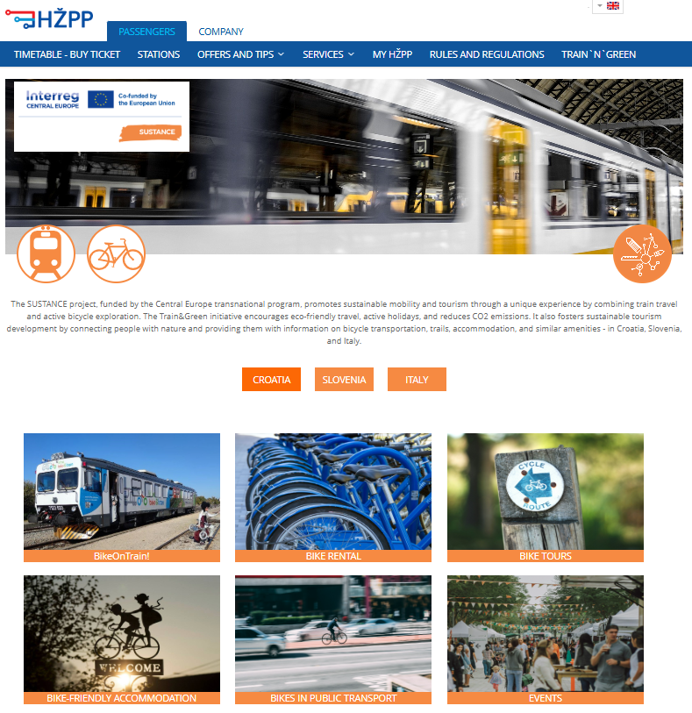

Picture 3: Bike routes in Croatia, Bike friendly accommodation in Slovenia and Bike on Train in Italy
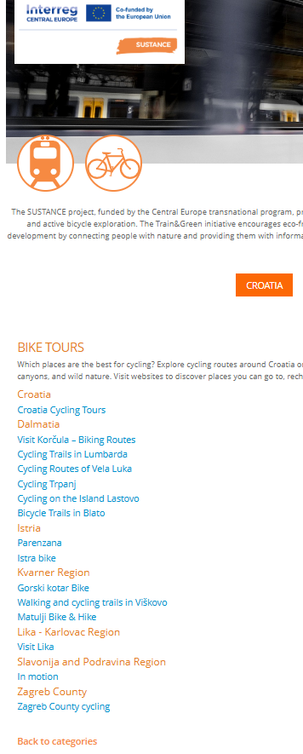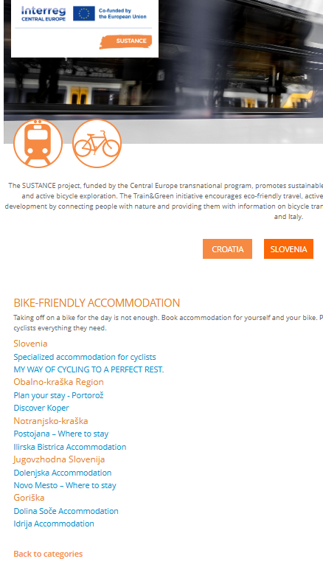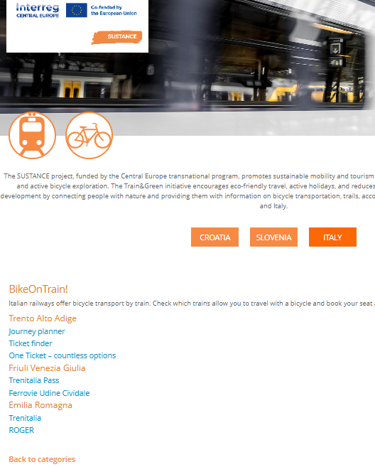

Pilot action was achieved by upgrading current HŽPP web portal (https://prodaja.hzpp.hr/en/Ticket/Sustance) and promoting it by targeting travellers and providing them with useful information. Those information’s are relevant to people who want to travel by train and bicycle (people who want to explore bike routes, campsites, cultural and sports events, festivals, gastronomy events, etc.). The TRAIN N' GREEN web domain setup included redesign, expansion and improvement of the data of the main HŽPP web page. To develop the pilot action, it was necessary to combine the necessity of population with an idea that can combine goals and expectations. Also, it was necessary to elaborate solutions and processes of how to achieve benefits for end users and disseminate results across borders. TRAIN N' GREEN offers organized routes throughout Istria and further (Pula – Buzet or Rijeka-Šapjane with the possibility to go cross border from Šapjane to Divača-Slovenia and Villa Opicina-Italy) and travel experience that will allow you to get to know the places often hidden from the eyes of common travellers. Generally speaking, the main role of transport is to connect spatially separated areas for the households and business sectors, for both person and commodity movements. Investments in the railway sector digitalization can also help attract more people towards rail especially if digital tool is user-friendly. The development of digital transport tools in the Republic of Croatia is extremely important for economic and social growth as well as for international connectivity. Investments in digitalization can be an instrument of development that drives the exchange of ideas and better accessibility to all economic, transport, tourist and other amenities.

HŽPP official web page was going through changes within last year. Changes are related to software that helps owners to create, manage, store, and modify digital content. The process used to manage digital content can be time-consuming and challenging, but result is new and improved web site with new functionalities and visual appearance. Consistent publishing ensures customers and clients to receive the most current information about products and services. Picture 4 is showing future design of TRAIN N' GREEN web domain.

Picture 4: Future design of TRAIN N' GREEN web domain
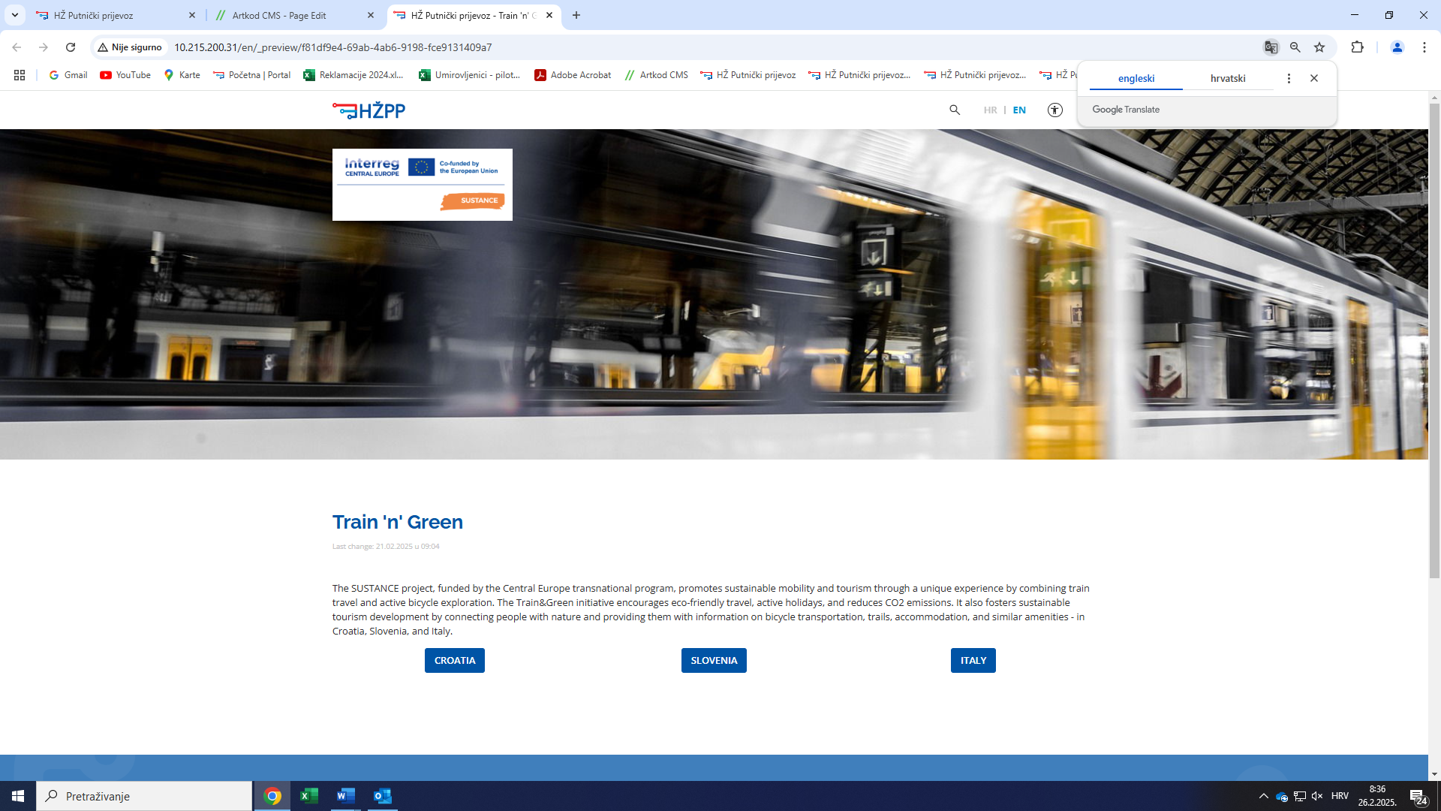

To have better insight of users' needs and preferences we created a survey with different questions. With this survey, we tried to better understand sustainable mobility needs of different users. The survey was anonymous and was not used for other purposes. The purpose of this survey was to complement Google analytics data. Since Google analytics are not available, our intention was to retrieve any possible data regarding pilot action. Therefore, an online survey was conducted.
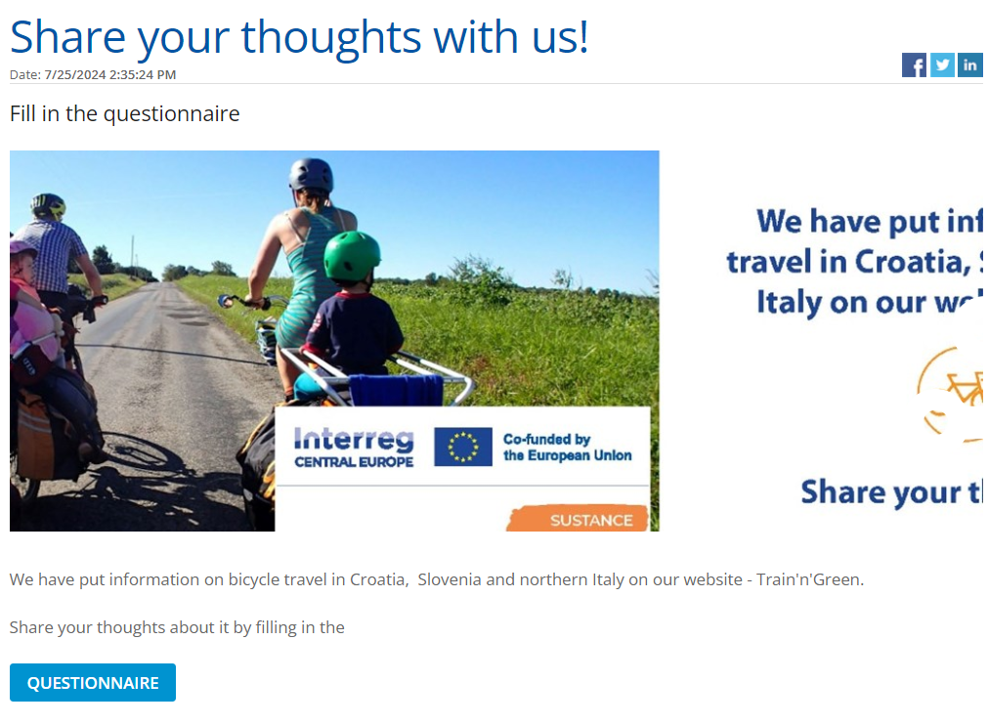
Following are questions and replays from survey:
 | QUESTION | REPLAY
1. | Are you travelling by train? | 92% YES
2. | What is the purpose of your travel? | 36% WORK  61 % LEISURE TIME  3% SCHOOL
3. | Are you visiting the website HŽ Putnički prijevoz (www.hzpp.hr)? | 15% NEVER  11 % EVERY DAY  74% OCCASINALLY
4. | Do you ride a bicycle? | 75,5% YES
5. | Have you noticed the section on the website https://prodaja.hzpp.hr/hr/Ticket/Sustance dedicated to travelling by bicycle (Train'N'Green)? | 56,4% YES
6. | Do you find the information useful? | 60% YES  22+% NO  18% PARTIALLY
7. | What would you change/improve in that part of website (Train'N'Green)? | Received answers were numerous. Listed are some of statements we consider relevant, which needs to be addressed in the future and the ones complementing activity:  “Transporting a bicycle at railway stations is a big problem (stairs).”  “The problem is always traveling by bicycle across the border. There are not enough trains for bicycles”  “Nothing, page is excellent!”  “Since setting up the web portal, progress has been visible in terms of more data and links in one place. This makes it really easy to access the required information.”  “The problems you encounter as a bicyclist traveling by train are many. A big problem is the uncertainty regarding if the train type will accommodate bicycles or not. What train will appear on the day of travel? Will there be dedicated bicycle storage on the train, or are you occupying the accessible space? Will the bicycle fit through the doors? If there are bicycle spaces on the train, how many?”  “The division by languages and Countries is a bit confusing. It could be improved. For example, when selecting BikeOnTrain! all solutions of Italy, Croatia and Slovenia could be seen in one single page!”  “A button to reserve a bike space, with only 10 spaces it is a bit risky to get to the train by bike without a reservation on weekends.”  “I would use Slo German and Italian in the web site given the number of tourists that visit Croatia from these two nations.”

POSSIBLE FOLLOW UPS to the SURVEY:
Based on received inputs from users, it will be necessary to address them and take certain actions to improve TRAIN’N’GREEN web domain. Replies will serve as a base point for classifying further steps. Some requests seem reasonable and can be addressed, such as make visible all three countries at one page, but on the other hand requests such as difficulties when transporting bicycle on station is matter of infrastructure company. It is also necessary to approach issues such as uncertainty regarding the train type. Will train accommodate bicycles and is it possible to make seat reservation? Different problems were identified and require addressing in the future.
    - Pilot action communication and promotional strategies
In this paragraph, the pilot action communication and promotional strategies and tools are presented.

The stakeholder event was held on Feb 28th, 2025. The event was organized in cooperation with stakeholder ODRAZ and different participants from NGOs, Ministry, Transport institutions etc.
Invitation for the event:
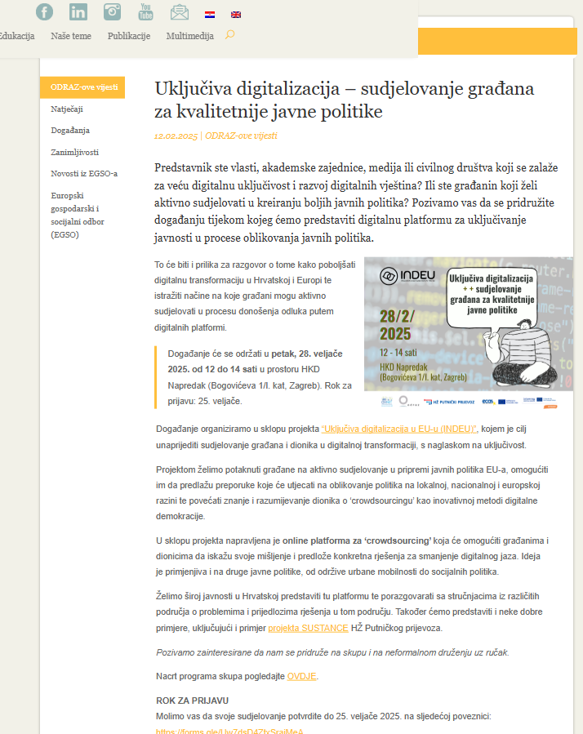

After the event:
https://www.odraz.hr/novosti/odraz-ove-vijesti/digitalna-transformacija-nije-samo-pitanje-tehnologije-vec-i-drustvenih-promjena-te-digitalne-ukljucivosti/
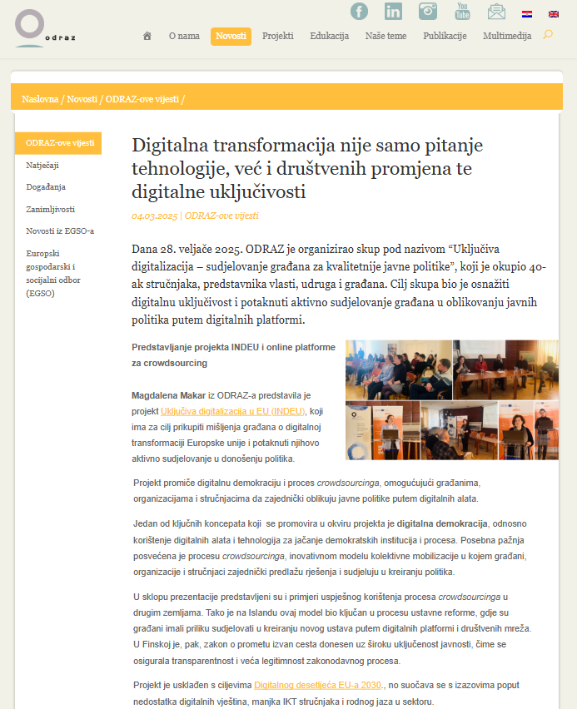

SUSTANCE project brochure published at web page but also sent to all business partners and stakeholders:
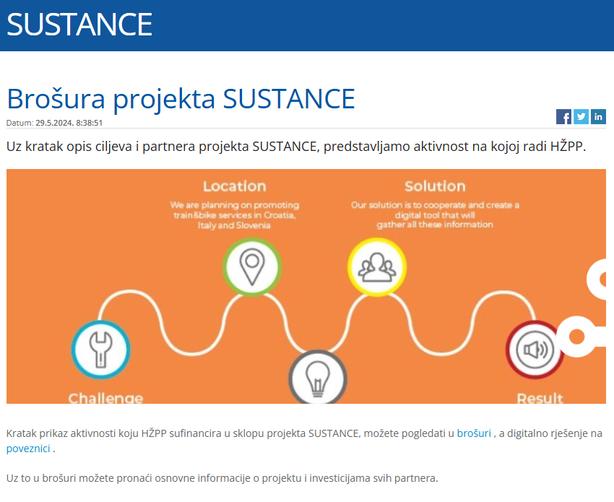

Social media announcements:
Facebook
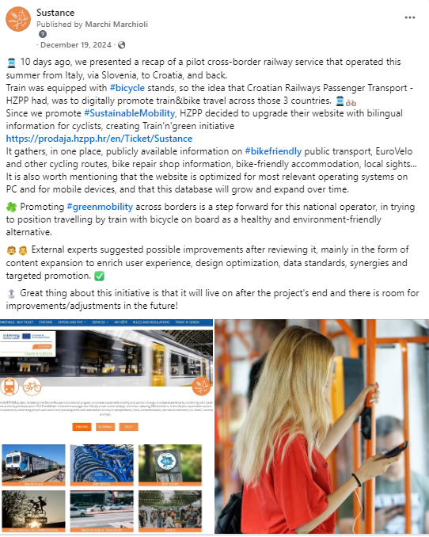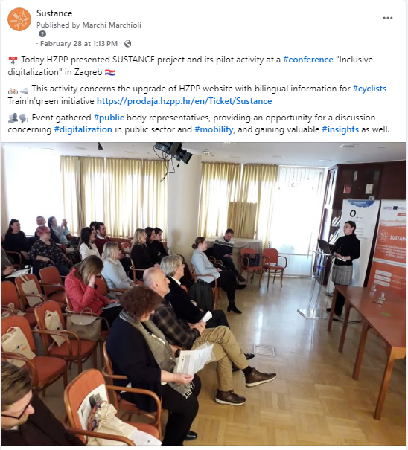
SUSTANCE X:
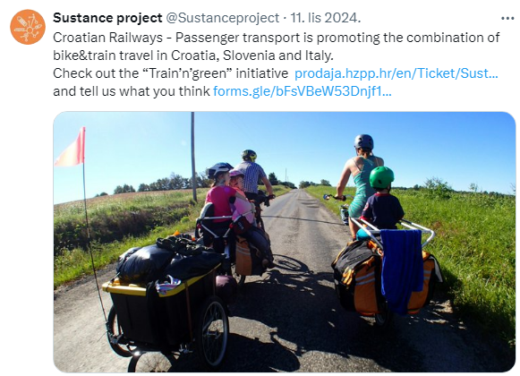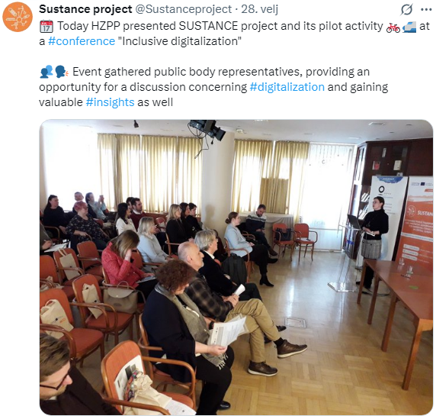

SUSTANCE LinkedIN:
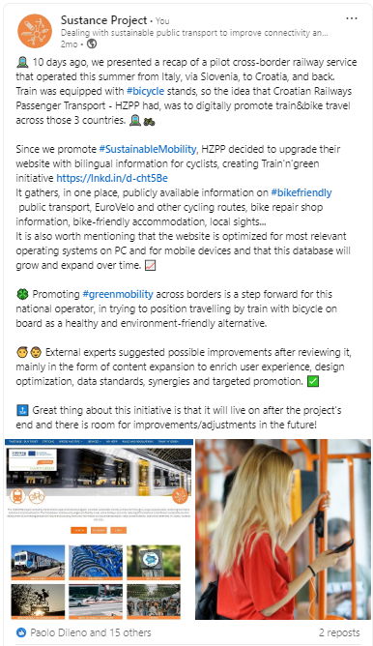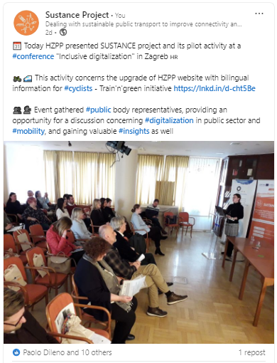
- Pilot action key outcomes
  - Lessons learned and replicability suggestions
In this paragraph, each responsible pilot action partner presents the main lessons learned during the pilot development, implementation and assessment. A specific focus is dedicated to the provision of relevant information and suggestions to external stakeholders interested in developing similar initiatives in other territorial contexts.

What is the key legacy of the pilot action?
Pilot action legacy is considered to be the web domain of HŽPP company which is usable and easy to access for everyday users and future travellers. Gathering and publishing information at one place can benefit to current passengers but also employees while updating content. Provided information’s are relevant not only at national base but also to neighbouring countries, Slovenia and northern Italy.
What are the suggestions for other stakeholders interested in replicating your pilot action?
- Create a unique form while seeking for relevant topics and content which someone wishes to place on web domain.
- Restrict research to relevant information which will satisfy business preferences.
- Narrow topics and classify them according to similar interests.
- Make visual interest. Create interesting diagrams, post colourful pictures, etc.
- Create marketing campaign to promote final product.

If you could re-do your pilot action differently, what would you do?
- Conduct research among frequent rail/bike users and provide valuable information on what to direct attention while making such web domain.
- Investigate which are most important items/web tools for cyclist to have on their rides.
- Investigate points of interest for future bike/rail users.
If you could give advices to another city/stakeholder implementing your pilot action, what would it be?
- Contact different NGOs, Institutions, Research organization to provide you with their research, ideas and overall needs.
- Verify information before placing it to the web.
- Disseminate as much as possible and conduct market activities in different media.

  - Strategies for the Sustance pilot action follow-up after the project conclusion
In this paragraph the adopted strategies and strategies for the pilot action continuation after the project conclusion are described.

How the pilot will live on?
Pilot will be financed further through operational business tools of HŽPP company. Considering that changes that pilot requires through the time are minimal, idea will be kept it to department specialized for IT will continue feeding pilot with relevant information. On the way, in case new ideas/needs pop up, it will be possible to replace existing with new and accommodated visuals/database.

There are synergies with other local/regional/national/EU projects/initiatives?
Almost every travelling web page contains useful information. The idea was to combine them all at one place. Therefore, synergies with other travelling resources are large. Interconnecting with different web portals and sites are crucial in order to provide users with relevant information and close circular virtual trip.

  - Pilot Action influence on local, regional and national policies
In this paragraph, starting from the stakeholder's engagement strategies analyzed in the ex-ante and interim reports, a brief description of the key pilot action influence on local, regional and national policies is presented.

How does your pilot impact on local/regional/national policies?
The intention of creating TRAIN’N’GREEN web domain was to inform general population with relevant information regarding their journey. In the frame of information, it is possible to bring closer European Commission declarations and Statements regarding transportation and urban mobility policies to everyday users. Also, European declarations are included in national policies and stipulated as obligatory. According to recommendations, transport service providers need to adjust their services to reach full potential. The EU, together with regional and local authorities, have a key role in supporting the further uptake of cycling.
This pilot action is not directly affecting local, regional and national polices, but on other hand is promoting all policies taken on national and EU level. The purpose is to improve quality, continuity and attractiveness of cycling use and cycling infrastructure, by supporting in different sections such as secure bike parking spaces, charging points for e-bikes and providing technical support such as useful information.

- Conclusions
This final paragraph provides a synthesis of the Sustance pilot key results, lessons learned, replicability factors and all the other relevant information related to the pilot development, implementation and assessment.

The pilot action will remain part of HŽPP web page in future. Idea and the concrete web site were developed and followed by stakeholder meeting where it was approved. Stakeholder meeting was followed by producing final pilot concept. Visual concept and design were approved and definition of visuals and website design in accordance with the visual identity and the objectives of the project was made. The intention was to create a modern design tailored to the target audience. Web page was developed in accordance with current web standards, enabled and optimized for:
- Windows (Edge, Firefox, Google Chrome, Safari)
- Linux (Google Chrome, Firefox)
- MacOS (Safari, Google Chrome, Firefox)
- Mobile devices with web browsers.

Pilot action and TRAIN’N’GREEN part of HŽPP web page will receive updates accordingly, to overcome obstacles such as:
- Not enough sources to link peripheral regions to TEN-T network
- Low attractiveness of public transport in some peripheral regions
- Not enough interest to use web domain as primary source for retrieving information.

Suggestions to overcome those issues:
- Better understanding gaps of public transport services in rural, peripheral and CB areas
- Implementing new PT possibilities by different operators and announce them, show their functionalities and exploit the potential of digital tools to improve the attractiveness of PT and support modal shift.
- Much frequent stakeholders ‘involvement to identify needs and potential measures.
Web page was created and set to a test server first and then to production server. The web page is now functional for general public however there are still additional changes that are still in progress and are referring to visual dimension and are related to administration roles. The CMS system should help with organizing the content of the pages into categories and add possibility to combine articles, while the structure of the application solution i.e. web page TRAIN’N’GREEN should allow unlimited number of subpages within the main navigation categories.
Pilot action was developed within and according to project guidelines which are:
- Better understanding gaps of PT services in rural, peripheral and CB areas​
- Implementing new PT services and digital tools to improve the attractiveness PT and support modal shift​
- Stakeholders‘ involvement to identify needs and potential measures​.
Benefits provided by pilot action:
- Positive influence
- Improved relations between different countries (political and operational)
- New possibilities for current service users
- Available Cycling routes (EuroVelo) and “EU Cycling Strategy. Recommendations for Delivering Green Growth and an Effective Mobility in 2030”.

Considering that pilot action is covering whole Croatia area as well as Slovenia and North Italy, its accessibility is nowadays available to all population with digital interest. The goal of the pilot action is to digitally promote green mobility in Croatia and surrounding countries and to contribute to collaboration and good relations between the countries involved. Pilot action will help current transport users and will try to help future tourists with information that is provided with digital tool created during this project lifetime. During the stakeholder consultation, on several occasions, pilot action is welcomed and well anticipated due to possibility of having proper information on one place. The idea is to promote and increase railway transportation and to position it to frequent travellers and tourists as a modern, attractive way of travelling between Croatia and bordering countries such as Slovenia and Italy.

Transferability of results of this particular pilot action is possible towards any interested party, whether that is transport agency or any other transport institution.

- Co-design and peer-review process
  - Co-design
In this paragraph, a brief description of the co-design activities updates are provided. In particular, are presented the updates about the information provided in the interim report.

Is there any additional topic of discussion with the other co-design partner(s)?
HZPP as pilot leader was sending requests to other project partners to contribute development of this pilot action in a manner to deliver and provide useful information which will be added to TRAIN’N'GREEN web domain and serve as part of data base with relevant information provided for end users. HŽPP has explored and consult partners and stakeholders on furthering idea towards more user-friendly web domain. This would include adding more direct links with useful information and also make TRAIN’N’GREEN domain visible on different stakeholders’ web pages and internet portals.
Please briefly describe how the co-design topics emerged during the ex-ante and interim phases were carried on.
Suggestion was presented during the partner meeting and partners were contacted via email in several occasions. According to content and technical specifications required for pilot action, we kindly asked for help and support in a range of possibilities and knowledge of each partner. Information that was asked for was related to digital promotion of green mobility in Croatia, Slovenia and four regions of northern Italy (Trentino Alto Adige, Friuli Venezia Giulia, Veneto and Emilia Romagna). Information provided must be relevant to people that want to travel by train and bicycle (people who want to explore bike routes, camp sites, cultural and sports events, festivals, gastronomy etc.). Contents were updated as new information arrived and additional access to information via external links. For this purpose, an Excell table was created, with cells dedicated to different links. Also, each country was dived by regions but also has a section at national level if necessary. Partners were asked to add rows with regions as they consider appropriate. Finally, not only useful links were retrieved but also different mobile apps which can help ticket purchase and provide official information.
During the project lifetime several stakeholders’ events were held, and strong suggestion was to work more on the field of digitalization. On the other hand, peer-review online events with experts showed that pilot was developing in right way but needed more encouragement and additional data. According to experts it is essential integration of various data sources for enhancing the tool's overall functionality and to focus on providing information about bike tours and related services as an entry point for users, rather than relying solely on traditional public transport operators or platforms.
All advices carried through ex-ante and interim phases were taken into consideration, and pilot was enhanced accordingly.

  - Stakeholder engagement
Please briefly list here the main recommendations/suggestions that emerged during the third round table discussion with Stakeholders (D.3.3.3) and summarize the key strategy you intend to adopt in order to integrate these suggestions in the pilot development/implementation phase.
During the final Stakeholder consultation process/event, which was held on Feb 28th, 2025 in cooperation with stakeholder ODRAZ and different participants from NGOs, Ministry, Transport institutions etc., strong suggestion was to work more on the field of digitalization. Digitalization is a process that future is bringing in all business departments. According to it, States and companies must develop its main core businesses and adjust to rapidly growing IT sector. It can bring many advantages in a manner of speeding up procedures, facilitate paper traces, schooling etc. With enhancement of IT sector, more and more young population will have to select education in this particular sector in order to maintain such digital tools and also work on their improvements for future generations. By developing new online tools, it is possible to gather different information and by that differentiate population needs as well as make government procedures closer to the public. Cooperation among different national institutions while creating one single web data base and combining different digital tools in one single platform is also an idea which is considered valuable and accessible.

  - Peer-review key results
Please briefly list here the main recommendations/suggestions that emerged during the third peer-review event and summarize the key strategy you intend to adopt in order to integrate these suggestions in the pilot assessment phase.
The portal represents a good opportunity to promote intermodality and zero emission travel, in particular for tourists.
- In order to attract users, it would be important to advertise the purpose and potential of the tool by creating narratives and stories, through describing exemplary journeys or real experiences by users. Suggestion which will be accepted by HŽPP after web page general visual design is finished.
- Considering a business model for the platform where bike friendly tourism initiatives (e.g. accommodation, rentals etc.) contribute to the web domain in general. Having in mind numerous stakeholders, promotion will be expanded via different stakeholder's web pages.

- Final advice was to consider the possible integration with other transport services, also at local level (DRT, Taxi, etc.), with the common objectives of replacing car-based tourism. Although replacement of cars is necessity by many capital cities, this particular initiative will have to be promoted by national or reginal institutions and government at the end.

