

D.2.3.3 – Pilot action n. 3 Feasibility analysis on train connections along the route Divaca-Buzet- Pula
Ex-post Pilot Action Report

Final
04/2025

Table of contents
Abbreviations 2
1 Overview 3
2 Pilot Action activities. Key results and SWOT analysis 3
2.1 Pilot key results and reached expectations 3
2.2 Pilot action SWOT analysis 5
3 Pilot Key results 6
3.1 Final KPIs assessment 6
3.2 Pilot action evidence and communication/promotional strategies 7
3.2.1 Pilot action evidence 7
3.2.2 Pilot action communication and promotional strategies 12
4 Pilot action key outcomes 12
4.1 Lessons learned and replicability suggestions 12
4.2 Strategies for the Sustance pilot action follow-up after the project conclusion 13
4.3 Pilot Action influence on local, regional and national policies 13
5 Conclusions 13
6 Co-design and peer-review process 14
6.1 Co-design 14
6.2 Stakeholder engagement 15
6.3 Peer-review key results 16

Abbreviations
AF Application Form
WP Work Package
PT Public Transport
SPAG SUSTANCE Pilot Advisory Grout
TCM Technical coordination meetings

- Overview
This report is related to the Sustance pilot action ex-post monitoring and assessment phase foreseen in Activity 2.2 “Solutions setting up: monitoring, peer review, assessment and dissemination”. In this report, each partner describes the key impacts and results of the Sustance pilot action implementation. The key goal is to assess from a qualitative and quantitative point of view the key effects of the pilot action in terms of environmental, social and economic impacts at local/regional/national levels.
In this report, it is possible to find relevant information on pilot implementation and testing key results, influence at local/regional and national levels and key impacts in terms of improvement of public transport offer in the testing areas. Moreover, it is possible to find information on the different strategies/solutions adopted for the continuation of the measure after the Sustance project conclusion.,
This ex-post report analyzes the results of the pilot action "Feasibility analysis on train connections along the route Divača-Buzet-Pula" together with the Investment 2.1. bike/scooter stations in Svetvinčenat & Vodnjan, conducted as part of the SUSTANCE project. The objective was to assess the environmental, social, and economic impacts of the pilot action at the local, regional, and national levels. The report evaluates the achieved results and outlines strategies for potential future implementation of the proposed improvements.
- Pilot Action activities. Key results and SWOT analysis
  - Pilot key results and reached expectations
In this paragraph, a brief description of the pilot's key results and main impacts at local, regional and national levels are presented. Moreover, each partner, starting from the objectives defined in the ex-ante and interim reports, is called to describe if the defined expectations are reached and if not why it is not possible.

What were the most important impacts of the pilot action?
Based on the conducted feasibility study, it can be concluded that improving passenger trains and infrastructure on the Pula-Buzet-Divača railway line has significant potential to enhance public transportation in the region, connect Croatia with Slovenia, Italy, and other countries as part of the TEN-T European network, and promote sustainable development. Various aspects involved in modernizing the railway line have been analyzed, leading to the following conclusions:
Market and demand - There is a growing need for higher quality and more efficient public transportation in Istria, and the Pula-Buzet-Divača line has the potential to become a key link not only within the region but also to international destinations via Divača. Modernizing the infrastructure and introducing new, energy-efficient trains will attract more passengers, especially tourists, creating conditions for an increased market share of rail transport in the overall public transportation sector.
Technical feasibility - Modernizing the railway line requires significant investments in infrastructure, including track renewal, the introduction of low-floor and battery-operated trains, and the construction or enhancement of stops and stations. These technical requirements can be met with proper planning, resource allocation, and technology implementation, with a crucial focus on integrating with other forms of transport such as buses and bikes.
Organizational structure - Collaboration with local communities, tourism organizations, and operators of other forms of transport is essential for increasing rail and public transport usage and successfully integrating new passenger services and promoting rail transport.
Financial feasibility - The project to improve rail transport on the Pula-Buzet-Divača route has the potential for financial sustainability due to reduced travel time, increased passenger numbers, and decreased operational costs through the introduction of energy-efficient trains. It also has the potential for funding from national budgets and EU funds.
Environmental sustainability - Modernizing the railway line and introducing energy-efficient trains will significantly reduce CO2 emissions, contributing to environmental preservation and achieving sustainable development goals. This ecological aspect provides a competitive advantage, especially in the context of increasing awareness of climate change and the demand for sustainable transport among tourists and local residents.
Modernization and enhancement of rail services on the Pula-Buzet-Divača route have strong foundations for financial sustainability and feasibility. By improving service quality with the introduction of battery trains to replace the existing fleet, the overall attractiveness and accessibility of transport will increase, leading to higher demand. Additionally, the transition to more energy-efficient trains, such as electric and battery-powered ones, will reduce operational costs and contribute to environmental sustainability. Potential funding from EU grants, EIB loans, or public service obligation contracts ensures further stability, even with lower demand, making the project a strategically sound investment with long-term benefits for the region’s economic and social development.
Based on the analysis of all these factors, the feasibility study shows that modernizing the Pula-Buzet-Divača railway line is both feasible and necessary for improving transport infrastructure. The project has the potential for successful implementation with proper management, collaboration with key stakeholders, and meeting the requirements of target groups, with undoubtedly positive impacts on the environment and quality of life.
The feasibility study provided key insights into the infrastructure, operational, and financial aspects of upgrading the railway service. The most significant impacts include:
- Identification of key infrastructural challenges affecting the efficiency of the railway service.
- Evaluation of potential demand growth for passenger transport in the region, particularly among commuters, students, and tourists.
- Assessment of integration possibilities between rail and alternative transport modes, with two bike-sharing stations installed near the railway.
- Potential environmental benefits, particularly in the reduction of CO2 emissions through increased rail usage.
- Policy recommendations to improve cross-border transport cooperation between Croatia and Slovenia.

What were your expectations at the beginning of the pilot action? Did the pilot meet your expectations?

ìThe key expectations of this analysis activity were to:
- Analyze the current state of railway services and identify areas for improvement.
- Assess infrastructure modernization needs and potential investment strategies.
- Evaluate the feasibility of a new direct cross-border train service between Pula and Divača.

The pilot successfully met expectations in terms of analyzing feasibility, identifying challenges, and proposing solutions.
  - Pilot action SWOT analysis
In this paragraph, using the SWOT methodology, each partner is called to summarize the pilot action's key strengths, weaknesses, opportunities and threats. In particular, each partner is called to focus on the pilot action development and implementation phases in order to analyze the key internal and external factors influencing the successful development of the pilot action. Moreover, the the key pilot action problems are analyzed and adopted solutions are described.

What problems did you face and how did you overcome them?
Main problems/issues:
- Aging infrastructure. The railway is single-track, non-electrified, and requires track upgrades.
- Low passenger numbers – current usage is limited, making financial sustainability a challenge.
- Lack of integration with other transport modes while no new transport integrations were introduced, two bike-sharing stations near the railway provide a basis for future bike & train connections.
- Cross-border cooperation challenges – differences in railway regulations between Croatia and Slovenia.
These issues were addressed by:
- Mapping and proposing infrastructure modernization projects (track and station upgrades).
- Recommending better coordination between Croatian and Slovenian railway operators.
- Identifying other solutions to improve rail services (e.g. hybrid and battery-powered rolling stock);
- Identifying funding opportunities through EU transport programs.

What are the key internal and external factors favoring the correct development of the pilot action?

Table 1. Pilot Action SWOT analysis
Internal factors | Strengths | Weaknesses
Infrastructure | The existing railway provides a direct cross-border link | Ageing infrastructure, non-electrified track
Intermodality | Potential to integrate rail with bike transport | Lack of seamless ticketing and timetables
Demand | Growing tourism sector in Istria | Low current passenger numbers
Policy support | EU and national focus on sustainable transport | Need for policy alignment between Croatia and Slovenia
External factors | Opportunities | Threats
Funding | Potential EU funding (Interreg) | Financial constraints, high investment costs
Environmental impact | CO2 reduction, supports green mobility goals | Dependence on government decisions for investment
Tourism & economy | Growth in eco-tourism and intermodal travel | Competition from cars and bus service

- Pilot Key results
  - Final KPIs assessment
In this paragraph, the key pilots' results are summarized (number of users, number of PT travels, etc.). Starting from the KPIs defined in the ex-ante and interim reports, each partner is called to describe both from the qualitative and quantitative point of view the key results reached by the pilot action.
Table 2. Pilot KPIs
KPI |  | Brief description | Value | Target reached | Measure methodology
KPI 1. Feasibility analysis |  | Development of a feasibility study for the Pula-Buzet-Divača railway connection | Number of documents developed | 1 | Finalized feasibility study
KPI 2. Installed bike-sharing points |  | Installation of bike-sharing stations to support bike & train integration in Istria | Number of installed bike sharing points (Svetvinčenat, Vodnjan) | 2 | Field verification through site visits and photo documentation.

As the monitoring of the bike sharing uses is still ongoing, in a dedicated annex to be presented by the end of 2025, further details of bike sharing usages will be provided.
  - Pilot action evidence and communication/promotional strategies
    - Pilot action evidence
In this paragraph, the pilot action key implementation and testing evidence are described and shown. In particular, photos showing the pilot implementation and testing phases are presented.
The key pilot action evidences are:
- Official feasibility study document summarizing required investments, technical constraints, and recommendations.
- Visual documentation of installed bike-sharing stations in Svetvinčenat and Vodnjan.

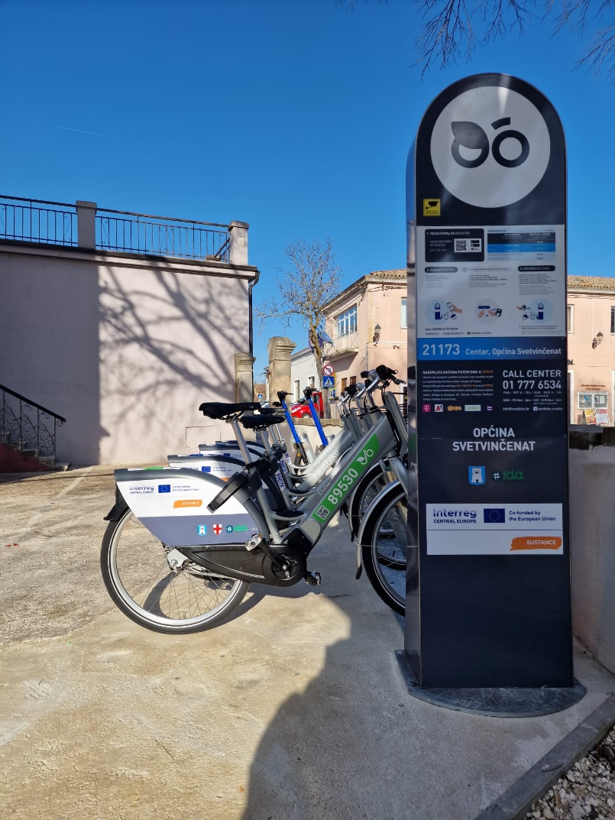
Figure 1: Bike/scooter station in Svetvinčenat

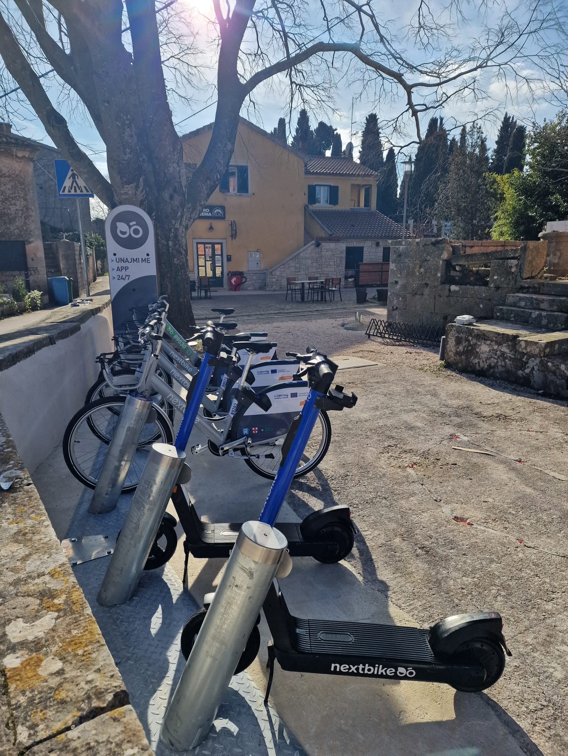
Figure 2: Bike/scooter station in Svetvinčenat

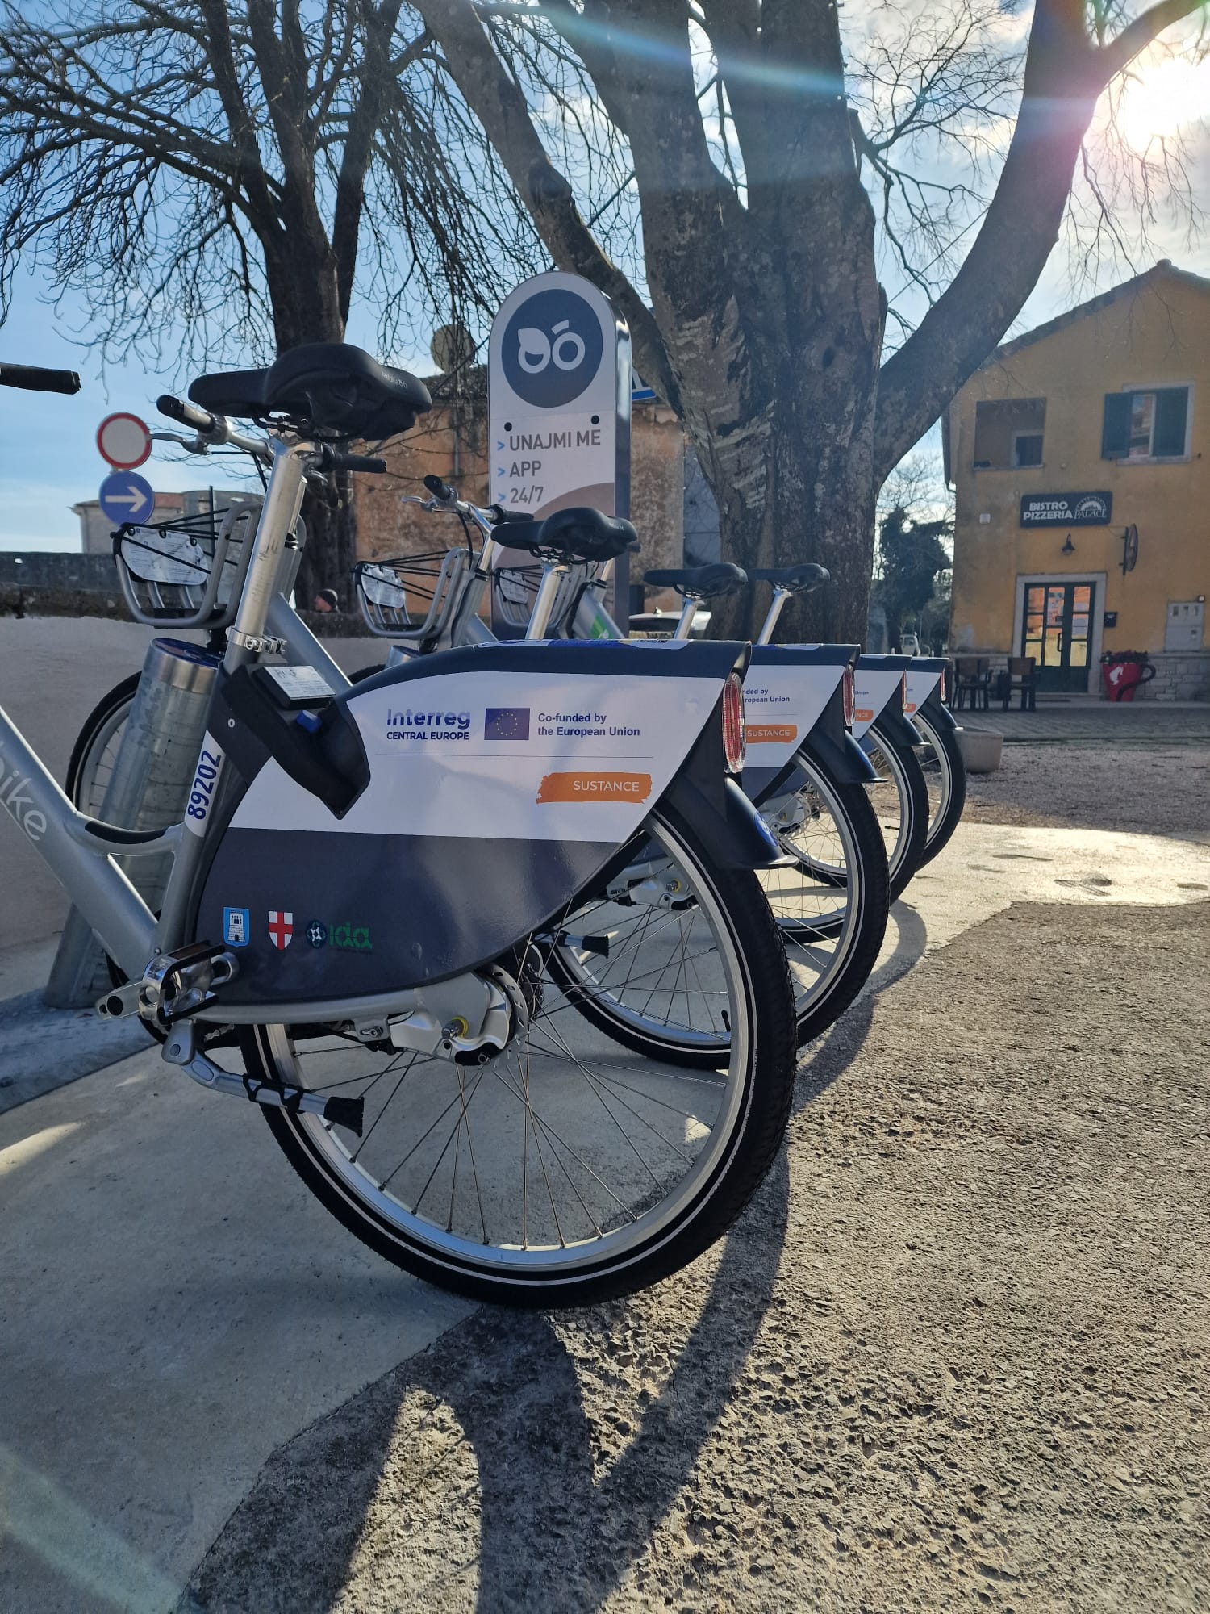
Figure 3: Bike/scooter station in Svetvinčenat

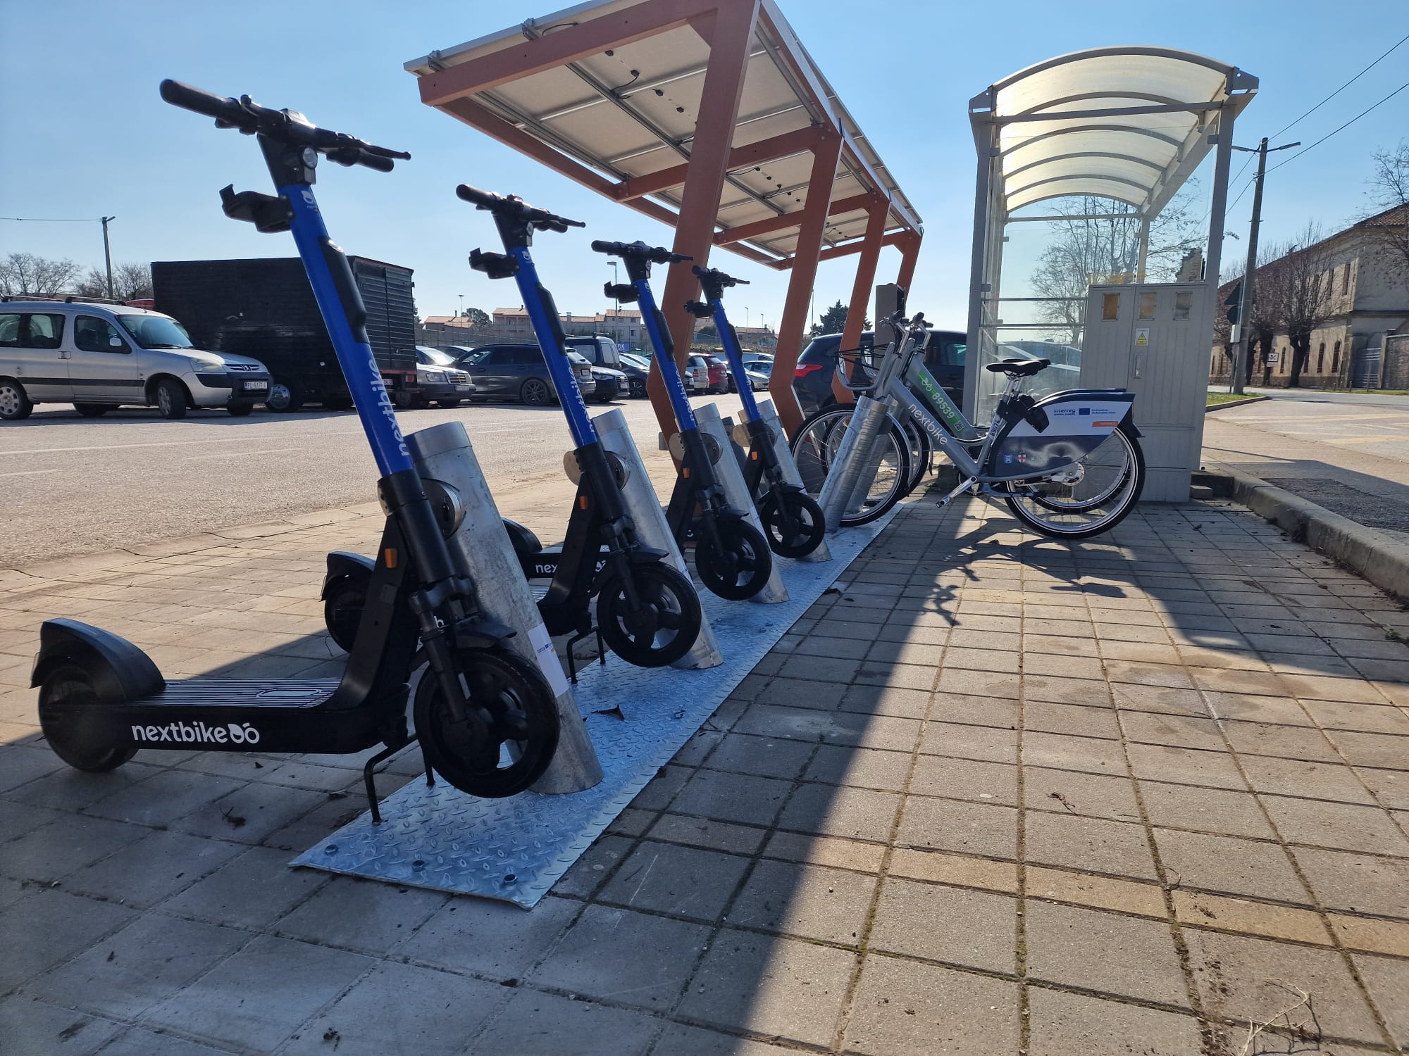
Figure 4: Bike/scooter station in Vodnjan
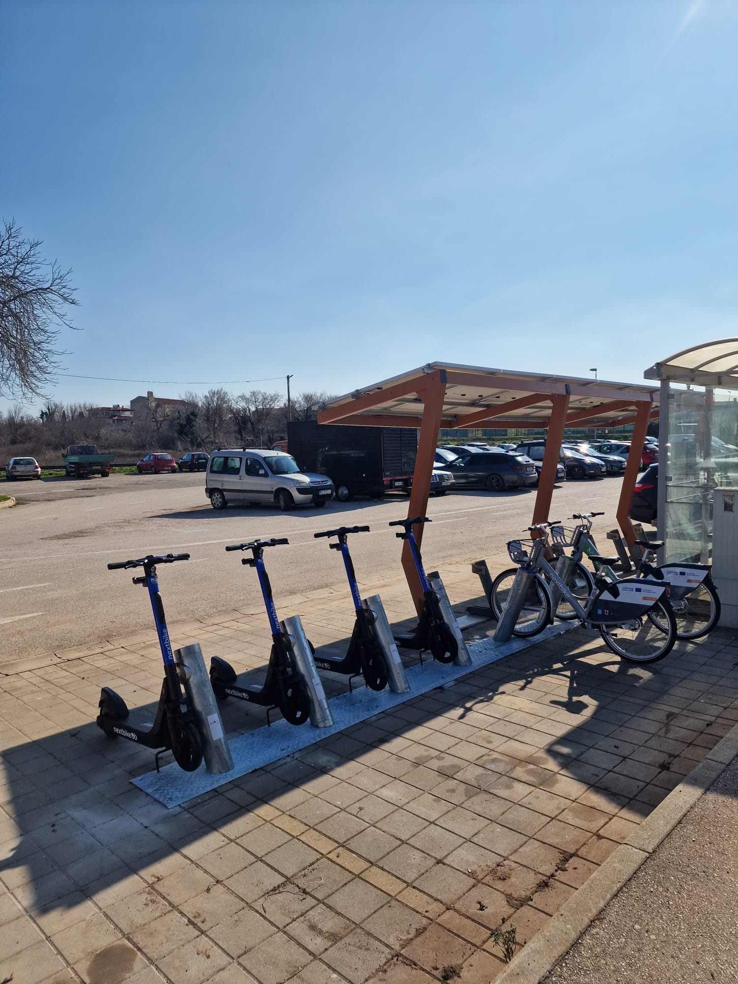
Figure 5: Bike/scooter station in Vodnjan

    - Pilot action communication and promotional strategies
In this paragraph, the pilot action communication and promotional strategies and tools are presented.

To effectively reach the pilot’s final users, we are implementing a comprehensive promotional strategy that leverages multiple channels and stakeholder collaborations.
Since most visitors in Svetvinčenat and Vodnjan arrive during the seasonal (tourist) months, we plan to start promoting the bike/scooter stations in April, in collaboration with local authorities and tourist boards, using all available marketing channels at our disposal. This includes social media campaigns, websites, local events, and printed materials placed in key locations such as tourist offices, hotels, and cultural sites.
Additionally, we will work with regional mobility initiatives to highlight the bike & scooter-sharing stations as part of a sustainable transport network, encouraging both tourists and residents to incorporate them into their daily travel. By engaging with local businesses, cycling communities, and travel agencies, we aim to create awareness and ensure higher usage of the stations.
Through these targeted strategies, we aim to maximize user engagement and ensure that the bike/scooter-sharing stations become a valuable asset for both residents and visitors in the region.

- Pilot action key outcomes
  - Lessons learned and replicability suggestions
In this paragraph, each responsible pilot action partner presents the main lessons learned during the pilot development, implementation and assessment. A specific focus is dedicated to the provision of relevant information and suggestions to external stakeholders interested in developing similar initiatives in other territorial contexts.

What is the key legacy of the pilot action?
- A comprehensive feasibility study providing a roadmap for improving train services in Istria.
- Policy recommendations for cross-border railway cooperation.
- Identification of funding sources for future infrastructure improvements.
What are the suggestions for other stakeholders interested in replicating your pilot action?
- Involve local governments early to ensure policy support.
- Conduct detailed demand analysis before proposing new train routes.
- Ensure multimodal integration where feasible, particularly with bike-sharing stations.
If you could re-do your pilot action differently, what would you do?
- Engage more stakeholders in early-stage planning.
If you could give advices to another city/stakeholder implementing your pilot action, what would it be?
- Prioritize infrastructure upgrades for rail speed and reliability.
- Use pilot projects to test new mobility solutions before full implementation.

  - Strategies for the Sustance pilot action follow-up after the project conclusion
In this paragraph the adopted strategies and strategies for the pilot action continuation after the project conclusion are described.

How the pilot will live on?
- Recommendations from the feasibility study will be used for future funding applications.
- Stakeholder engagement will continue to push for policy changes.
- The monitoring of the bike and scooter stations will be conducted through the rental application, providing real-time data on usage patterns. Key metrics such as the number of rentals, duration of use, and peak hours will be tracked, along with GPS data to analyze popular routes and station-to-station movement. The system will also monitor vehicle status, including battery levels and maintenance needs, ensuring optimal availability. Financial performance, including revenue and maintenance costs, will be assessed to evaluate sustainability. Additionally, user feedback and automated reports will support continuous improvements and data-driven decisions for future mobility initiatives.
There are synergies with other local/regional/national/EU projects/initiatives?
- TEN-T: Potential to integrate the route into the Trans-European Transport Network.
- EU Green Deal: Supports CO2 reduction goals.
- Regional tourism strategies: Improved rail services could benefit eco-tourism initiatives.
  - Pilot Action influence on local, regional and national policies
In this paragraph, starting from the stakeholder's engagement strategies analyzed in the ex-ante and interim reports, a brief description of the key pilot action influence on local, regional and national policies is presented.

How does your pilot impact on local/regional/national policies?
- Provides data-backed recommendations for regional transport authorities.
- Aligns with national and EU sustainable mobility goals.
- Encourages cross-border cooperation for seamless railway operations.

- Conclusions
This final paragraph provides a synthesis of the Sustance pilot key results, lessons learned, replicability factors and all the other relevant information related to the pilot development, implementation and assessment.

Pula-Buzet-Divača feasibility study successfully provided actionable insights for improving cross-border rail connectivity and sustainable mobility solutions in the region. Through detailed infrastructure analysis, demand assessment, and policy recommendations, the pilot action has laid the groundwork for potential service improvements and intermodal transport integration.
One of the key investments achieved within the pilot action is Investment 2.1, which resulted in the installation of two bike/scooter-sharing stations in Svetvinčenat and Vodnjan. While these stations are not yet directly integrated into a Bike & Train system, their strategic placement near the railway creates a foundation for future multimodal transport connections. This investment aligns with the broader objectives of the project by supporting sustainable and flexible last-mile transport solutions.

The feasibility study also identified critical infrastructural bottlenecks that need to be addressed to improve train service efficiency. The findings highlight the need for track modernization, better cross-border coordination between Croatian and Slovenian railway operators, and potential funding sources that could be leveraged for further investments.
Moreover, the study confirmed that the growth of eco-tourism and commuter demand in Istria presents an opportunity to enhance rail services. While no direct increase in passenger numbers has yet been recorded, the potential for ridership growth remains high if infrastructure and service improvements are implemented.
Going forward, the key steps involve:
- Monitoring the use of the new train/bicycles services
- Seeking funding opportunities (Interreg, TEN-T, Green Deal) for infrastructure modernization.
- Enhancing policy coordination between Croatia and Slovenia to facilitate a seamless cross-border railway service.
- Further developing intermodal solutions that could eventually integrate the installed bike/scooter-sharing stations with railway services.
Promoting sustainable rail transport by engaging local stakeholders, municipalities, and tourism operators. In conclusion, the pilot action has provided a solid foundation for future investments in railway infrastructure and sustainable transport solutions in the region. The results of this feasibility study will serve as a strategic document to guide decision-makers and funding bodies in prioritizing improvements to the Pula-Buzet-Divača railway corridor.

- Co-design and peer-review process
  - Co-design
In this paragraph, a brief description of the co-design activities updates are provided. In particular, are presented the updates about the information provided in the interim report.

During the ex-ante and interim phases, the co-design topics identified in the first Sustance co-design meeting were carefully considered and incorporated into the feasibility study and pilot action development.
The ticketing system was recognized as an important aspect of improving cross-border mobility. The feasibility study analyzed existing ticketing options. The study also acknowledged the need to enhance interoperability and accessibility for passengers traveling across different transport networks.
Regarding infrastructure limitations, the study examined the non-electrified railway line between Buzet and Pula and the challenges associated with diesel train restrictions in Istria. Several modernization scenarios were assessed, including the introduction of hybrid and battery-powered rolling stock, which would align with sustainability goals while improving service efficiency.
In addressing cross-border operational challenges, the study reviewed existing international agreements and railway cooperation frameworks, identifying areas for potential harmonization. Additionally, the importance of seamless tourist information systems was acknowledged, with references to Train&Green and Via Istra, which provide valuable insights for travellers in the cross-border area.
The feasibility study also incorporated a review of past and ongoing mobility projects, such as Interreg Italy-Croatia ICARUS and MIMOSA projects, ensuring that previous research and best practices informed the development of recommendations. Moreover, an analysis of technical and regulatory standards relevant to international rail operations across Croatia, Slovenia, and Italy was conducted, helping to outline the necessary steps for improved coordination and service integration.
The study reinforces the importance of digitalization and intermodal solutions in improving public transport services, ensuring that technological advancements and governance strategies remain central to future developments. These elements provide a foundation for further enhancing connectivity, particularly through innovative ticketing approaches and multimodal solutions.
In summary, the key themes discussed in the co-design phase were systematically integrated into the feasibility study, providing a strategic basis for decision-making and future enhancements in cross-border railway operations.

  - Stakeholder engagement
Please briefly list here the main recommendations/suggestions that emerged during the third round table discussion with Stakeholders (D.3.3.3) and summarize the key strategy you intend to adopt in order to integrate these suggestions in the pilot development/implementation phase.

Third stakeholder meeting was held with the aim of presenting the activities carried out so far by the Istrian Development Agency, specifically regarding the development of Pilot Action 3. All stakeholders involved in the development of these activities were invited to the meeting in order to discuss the progress in their development.
Main recommendations to ensure the functioning of PA3:
Stakeholders highlighted the importance of strategic planning and long-term policy alignment to ensure the relevance and implementation of the feasibility study results. Securing dedicated funding sources—such as EU transport programs, TEN-T, or national infrastructure funds—was seen as essential for future modernization of the railway line. In addition, the study should serve as a basis for coordinated efforts between Croatian and Slovenian institutions, enabling harmonization of cross-border operations. Stakeholders also emphasized the importance of maintaining momentum after the study’s completion through continued advocacy, technical project development, and collaboration with tourism and mobility stakeholders in the region.
In the short term, the pilot has provided a comprehensive overview of the existing railway infrastructure and actionable recommendations for improving service quality, especially in terms of connectivity and sustainability. It has also helped to identify opportunities for integration with micromobility services, through the installation of bike/scooter stations near railway access points. In the long term, successful implementation of the study’s recommendations could significantly reduce greenhouse gas emissions, boost cross-border mobility, improve transport accessibility for underserved areas, and support sustainable tourism growth. The pilot also sets the stage for future investment in battery-powered or hybrid trains, supporting green innovation in regional transport.
  - Peer-review key results
Please briefly list here the main recommendations/suggestions that emerged during the third peer-review event and summarize the key strategy you intend to adopt in order to integrate these suggestions in the pilot assessment phase.
During the third peer-review event, several valuable recommendations were provided by external experts to strengthen the long-term impact and feasibility of Pilot Action 3. It was highlighted that a robust market and demand analysis is essential for demonstrating the viability of the proposed railway service, with accurate ridership estimates serving as a foundation for future planning and investment. Financial feasibility was also emphasized, particularly the opportunity to explore EU funding sources such as the Green Deal. Technically, experts suggested adopting a discontinuous electrification strategy supported by battery-powered trains and installing charging infrastructure at selected stations to reduce costs while maintaining efficiency. To ensure uninterrupted operation, the inclusion of backup diesel engines (“donkey engines”) was recommended.
Additionally, improving marketing efforts through local outreach and social media was seen as crucial for raising public awareness and building trust. Stakeholder engagement at both regional and cross-border levels, especially between Croatian and Slovenian policymakers, was identified as a key success factor. Experts also encouraged the integration of digital tools such as online booking, real-time updates, and performance tracking to enhance user experience and transparency. It was underlined the importance of embedding this pilot within the broader framework of sustainable mobility strategies for the Istria region. He stressed that the railway improvement should not remain an isolated initiative, but rather be aligned with ongoing regional development plans to increase relevance, usage, and regional support. These insights will guide the final assessment of the pilot and shape recommendations for its further development and integration beyond the project’s duration.

