

D.2.4.2. PA5. New ICT service for MaaS in Istria
Ex-post Pilot Action Report

Final
04.2025

Table of contents
Abbreviations 2
1 Overview 3
2 Pilot Action activities. Key results and SWOT analysis 3
2.1 Pilot key results and reached expectations 3
2.2 Pilot action SWOT analysis 4
3 Pilot action Key results 5
3.1 Final KPIs assessment 5
3.2 Pilot action evidence and communication/promotional strategies 5
3.2.1 Pilot action evidence 5
3.2.2 Pilot action communication and promotional strategies 20
4 Pilot action key outcomes 21
4.1 Lessons learned and replicability suggestions 21
4.2 Strategies for the Sustance pilot action follow-up after the project conclusion 21
4.3 Pilot Action influence on local, regional and national policies 22
5 Conclusion 22
6 Co-design and peer-review process 23
6.1 Co-design 23
6.2 Stakeholder engagement 23
6.3 Peer-review key results 24

Abbreviations
AF Application Form
WP Work Package
PT Public Transport
SPAG SUSTANCE Pilot Advisory Grout
TCM Technical coordination meetings

- Overview
This report is related to the SUSTANCEpilot action ex-post monitoring and assessment phase foreseen in Activity 2.2 “Solutions setting up: monitoring, peer review, assessment and dissemination”. In this report, each partner describes the key impacts and results of the SUSTANCE pilot action implementation. The key goal is to assess from a qualitative and quantitative point of view the key effects of the pilot action in terms of environmental, social and economic impacts at local/regional/national levels.
In this report, it is possible to find relevant information on pilot implementation and testing key results, influence at local/regional and national levels and key impacts in terms of improvement of public transport offer in the testing areas. Moreover, it is possible to find information on the different strategies/solutions adopted for the continuation of the measure after the Sustance project conclusion.
The ex-post report for Pilot Action 5 – New ICT Service for MaaS in Istria analyses the development and implementation of a digital application aimed at improving access to public transport information in the region. The pilot action resulted in the creation of a mobility application that provides bus schedules and route details, as well as links to bike-sharing (Bolt) and train services (HŽPP).
The primary goal of this pilot was to enhance multimodal transport accessibility by offering a centralised source of public mobility information, enabling users to make informed and sustainable travel choices. This application represents a step toward a more integrated digital mobility ecosystem, ensuring that different transport services are easily accessible in one place.
- Pilot Action activities. Key results and SWOT analysis
  - Pilot key results and reached expectations
In this section, a brief description of the pilot's key results and main impacts at local, regional and national levels are presented. Moreover, each partner, starting from the objectives defined in the ex-ante and interim reports, is called to describe if the defined expectations are reached and if not why it is not possible.
What were the most important impacts of the pilot action?
- The mobility application developed within this pilot action aimed at improving public transport accessibility and usability by: Providing information on public bus schedules and routes in Istria.
- Offering direct links to bike-sharing and train services, ensuring users can easily find external mobility solutions.
- Increasing public awareness of sustainable transport options through a single, easy-to-use digital platform.
- Supporting regional mobility goals by promoting public and shared transport as an alternative to private car use.
What were your expectations at the beginning of the pilot action? Did the pilot meet your expectations?

The application was successfully developed and launched, delivering the planned functionalities outlined in the Ex-Ante Report. The app serves as a practical tool for public transport users, offering clear and structured access to different transport services in Istria.
  - Pilot action SWOT analysis
In this section, using the SWOT analysis, each partner is called to summarise the pilot action's key strengths, weaknesses, opportunities and threats. In particular, each partner is called to focus on the pilot action development and implementation phases in order to analyze the key internal and external factors influencing the successful development of the pilot action. Moreover, the key pilot action problems are analysed and adopted solutions are presented.

What problems did you face and how did you overcome them?
Challenge 1: Coordinating transport data – The app had to ensure provision of reliable and up-to-date information from various mobility providers.
Solution: A user-friendly interface with clearly structured transport options and external links was developed, ensuring smooth functionality.
Challenge 2: Securing long-term maintenance and updates – As public mobility services evolve, the app will need continuous updates to remain relevant.
Solution: The app was designed in a way that Pulapromet (bus service provider) or other relevant authorities can easily maintain and expand its functionalities in the future, especially with the planned Park & Ride project (2025-2026), which will introduce new mobility options.
What are the key internal and external factors favoring the correct development of the pilot action?
Table 1. Pilot Action SWOT analysis
Internal factors
Strengths | Weaknesses
- A user-friendly app providing clear and reliable information on various transport options.  - Information on bus schedules, train transport and micromobility options are easily available.  - The app helps users to plan their trips more efficiently.  - Cooperation with regional mobility stakeholders. | - Awareness ofthe app is still in its early stages.  - Requires continued updates to keep the information accurate and up to date.
External factors
Opportunities | Threats
- Encourages eco-friendly transport choices.  - Potential for future enhancements via EU-fundedprojects.  - Visitors can benefit from simplified access to various transport options. | - Users may still prefer private cars or taxis.  - Maintenance and long-term support require additional resources.  - Competing mobility apps may impact adoption.

- Pilot action Key results
  - Final KPIs assessment
In this section of the report, the key pilots' results are summarised (number of users, number of PT travels, etc.). Starting from the KPIs defined in the ex-ante and interim reports, each partner is called to describe both from the qualitative and quantitative point of view the key results achieved by the pilot action.
Table 2. Pilot KPIs
KPI | Brief description | Value | Target reached | Measure methodology
KPI 1: ICT application | Project documentation and development of the ICT transport application | Number of developed ICT applications | 1 | Confirmed through completion of project documentation and successful launch of the application

  - Pilot action evidence and communication/promotional strategies
    - Pilot action evidence
In this section, the pilot action key implementation and testing evidence are described and shown. In particular, photos showing the pilot implementation and testing phases are presented.

Key features:
Trip planning: users can enter their destination, and the application will provide step-by-step guidance, including:
- The nearest bus stop they need to go to.
- The correct bus line to take.
- Real-time updates on when the next bus will arrive at their stop.
- Real-Time bus tracking - users can see in real-time where the buses are on the map and how long they need to wait at any given stop.

Ticket purchasing:
- In-app bus ticket purchase: users can buy their bus tickets directly within the app, eliminating the need for physical tickets.
- HŽPP train tickets: the application provides a direct link to the HŽPP webshop, where users can purchase train tickets if they need to continue their journey by rail.

Micromobility services:
- The app includes a direct link to bike-sharing service, allowing users to easily rent a bike if they prefer cycling for shorter trips.
- This user-friendly and centralised digital solution improves public transport accessibility, making it easier for both locals and tourists to navigate the region using multiple modes of transport.

Application structure and main functionalities:
1.Onboarding screens



Before using the app for the first time, users can view a guided onboarding section that highlights core functionalities: stop search, timetable overview, real-time arrivals, and ticket purchase.
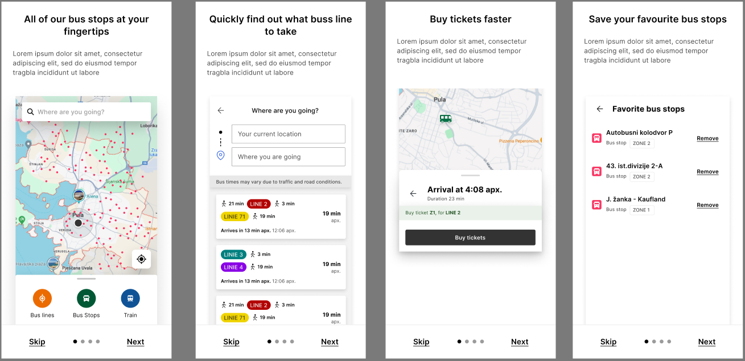
Figure 1: Onboarding screens

2.Map logic and location permission
The app features an interactive map interface. When location permissions are granted, users can see nearby bus stops, zoom in/out on the map, and track live arrival information. All zones and transport infrastructure become visible as the user navigates the map.

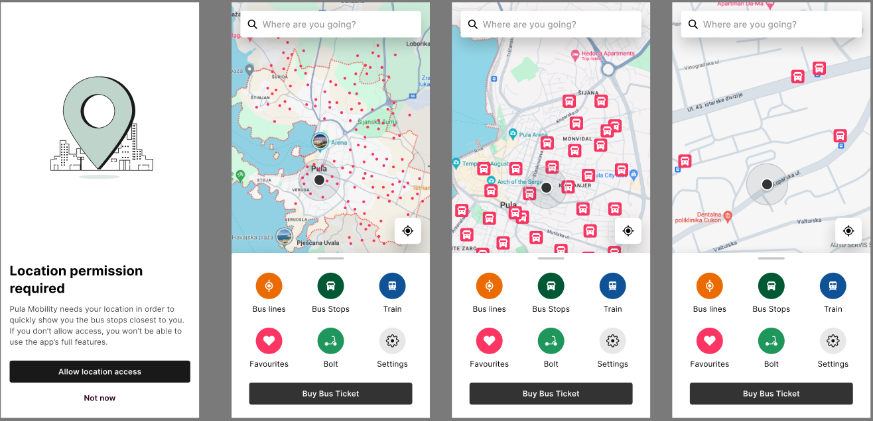
Figure 2: Map view

Within the application, it is also possible to explore the Pula–Buzet railway route, allowing users to combine multiple modes of transport. On the map, the railway line across the Istria County is clearly marked, enabling easy visual identification. When the user zooms in, the names of the railway stations along the route become visible.
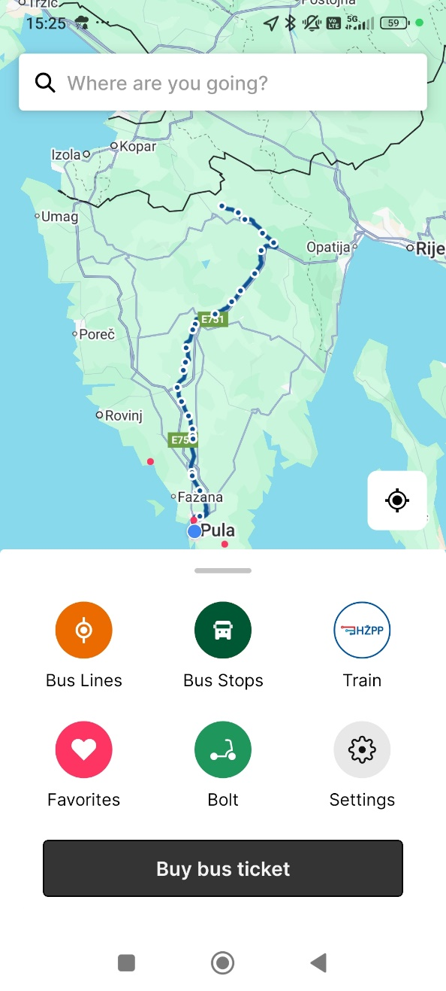
Figure 3: Regional train connection Pula-Buzet (map)

3. Search Engine and route results
Users can enter a starting point and destination to generate route suggestions. The search result includes estimated travel time, lines involved (with colors), walking segments, and next bus arrival times.
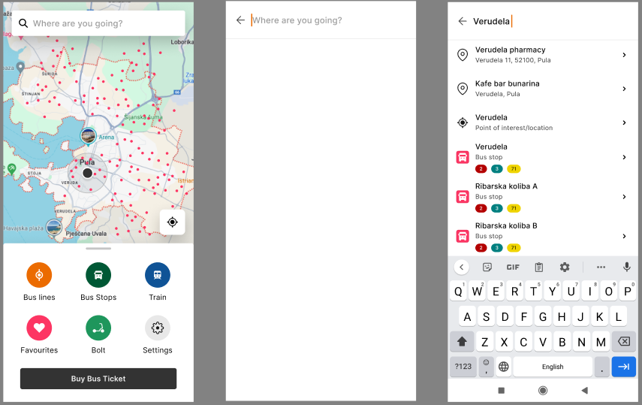
Figure 4: Search input

After entering the starting and destination points, the search results are visible on the map.
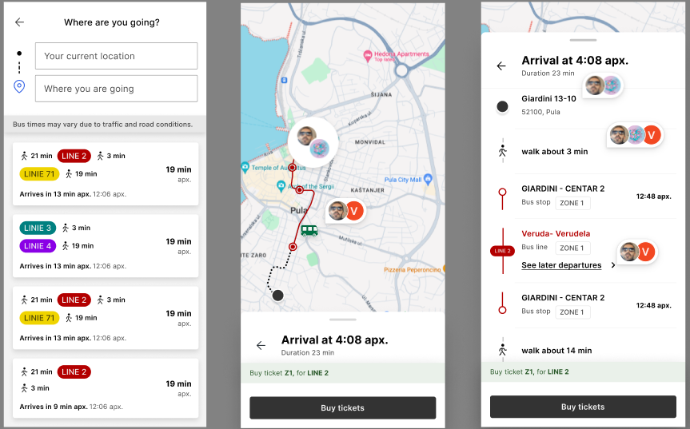
Figure 5: Search results
This list displays available public transport routes between the user's current location and the selected destination. Each entry in the list includes the following details:
1. Total Travel Time – Displayed in minutes (e.g., 21 min).
2. First Transit Line – Indicated by a number and color (e.g., LINE 2 in red).
3. Walking Time to the First Stop – Displayed in minutes (e.g., 3 min).
4. Second Transit Line (if a transfer is required) – Indicated by a number and color (e.g., LINIE 71 in yellow).
5. Bus Ride Duration – Displayed in minutes (e.g., 19 min).
6. Estimated Total Arrival Time – Approximate duration until arrival (e.g., 19 min apx).
7. Upcoming Bus Arrival Information – Shows the estimated time until the next bus arrives at the stop (e.g., Arrives in 13 min apx).
Note: Travel times may vary due to traffic and road conditions.

4. Timetable and Route Details
Selecting a bus stop shows all lines operating on that route, along with exact times of arrival. Users can tap a departure time to view the full list of stations on the line.
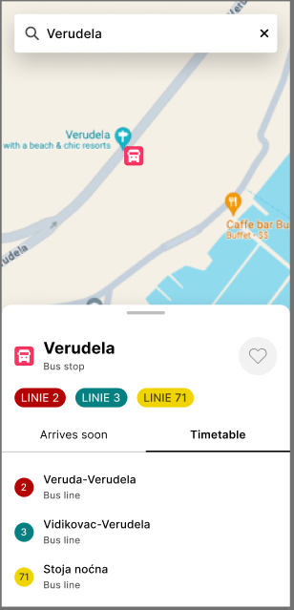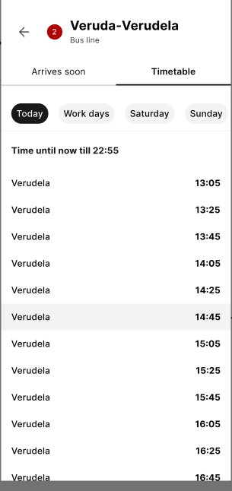
Figure 6: Timetable view

By pressing the desired time slot, a list of all stations on the selected route opens.
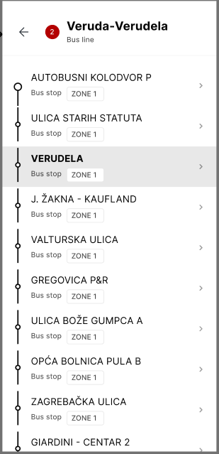
Figure 7: List of stations

6. Bus stops interface
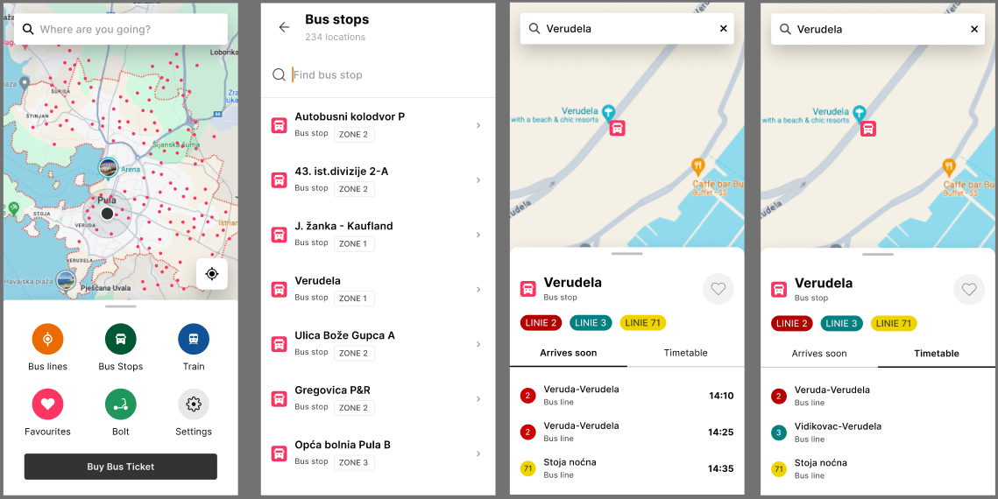
Figure 8: Bus stops overview

Similar to the timetable, by selecting a specific bus stop and one of the time slots, a detailed view of the bus stations is provided.
The application provides a visual representation of public transport through an interactive map. Users can access the following information:
1. Map with Bus Routes and Stops
- Red dots represent bus stops.
- Lines connecting the dots indicate bus routes.
2. Interactive Bus Stop View
- Users can search for stops and view their locations on the map.
- When a stop is selected, detailed information appears, including the stop name and available bus lines.
3. Bus Line Details
- Each stop displays the bus lines that serve it (e.g., LINE 2 and LINIE 71).
- Estimated arrival times for upcoming buses are shown.
- Users can access the full timetable for each line.
4. Navigation and Additional Options
- Buttons for searching bus lines, stops, and train connections.
- Option to add stops to favorites for quick access.
- Ticket purchasing directly within the app.
Conclusion: The map provides a fast and intuitive overview of bus routes and arrival times, helping users efficiently plan their journeys.

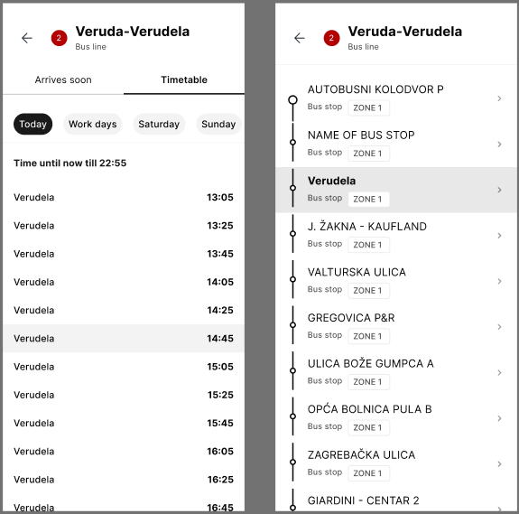
Figure 9: Travel time and station details

7. Bus Lines
By selecting “Bus Lines”, users can access a list of all available lines, their route maps, and stop locations. A detailed line view appears when tapping on any point.
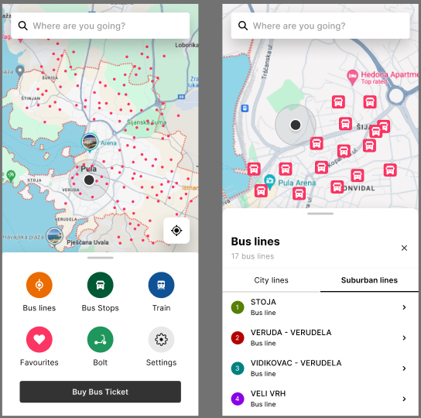
Figure 10: Bus lines

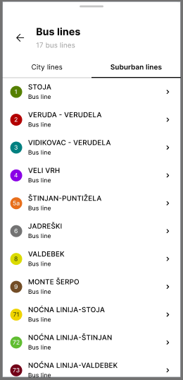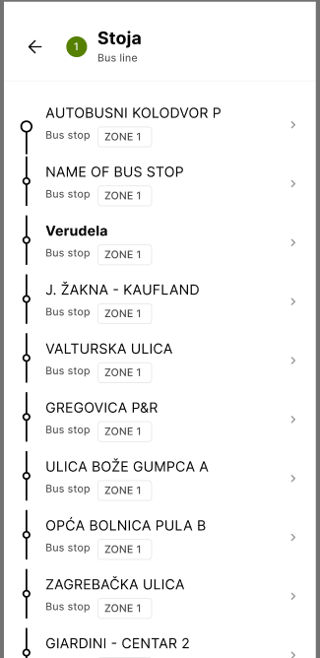
Figure 11: Line details

8. Favourites
Users can mark frequently used stops as favorites, allowing quick access in future use.
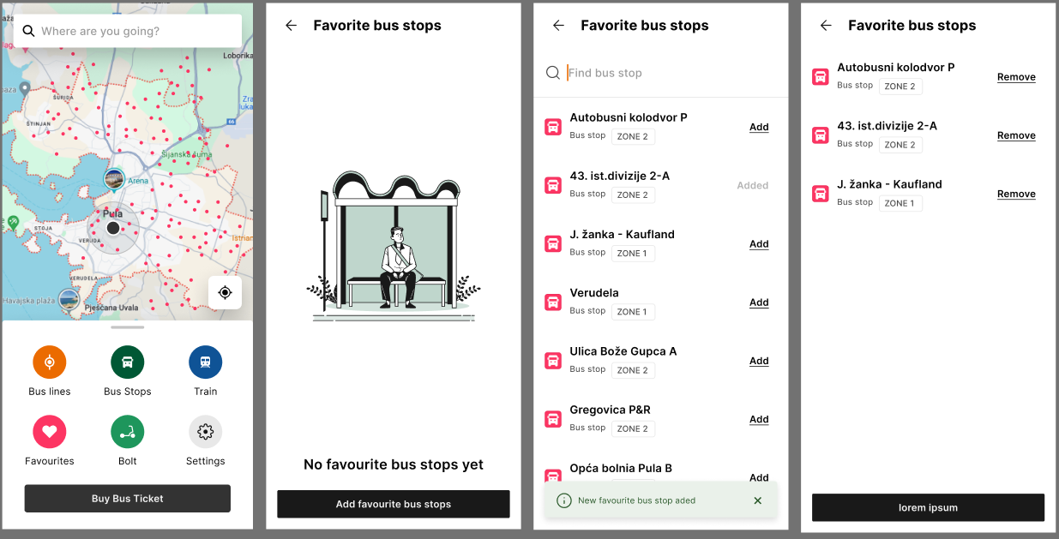
Figure 12: Favorites function

9. Ticket Purchase
Users can buy tickets within the app by choosing between a single ticket or a bus card refill. For train travel, users are redirected to the HŽ webshop for purchasing rail tickets across Istria.
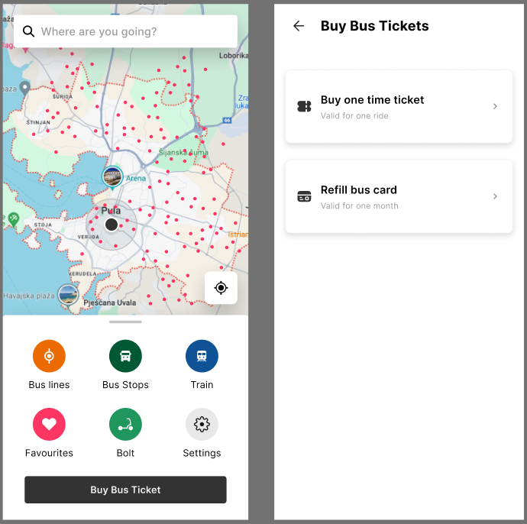
Figure 13: Ticket purchase view

HŽPP & Bolt (micromobility) service within the app:
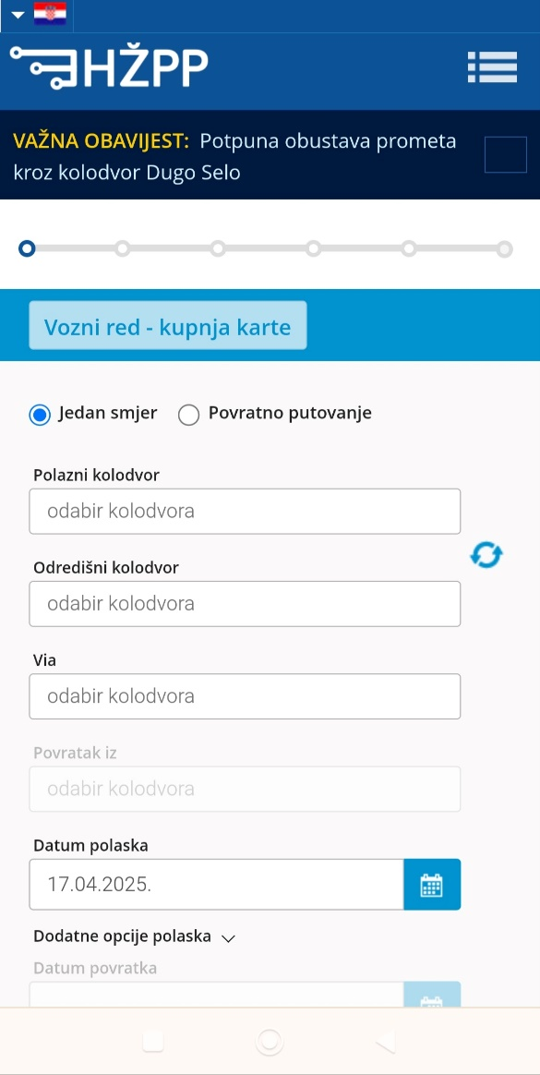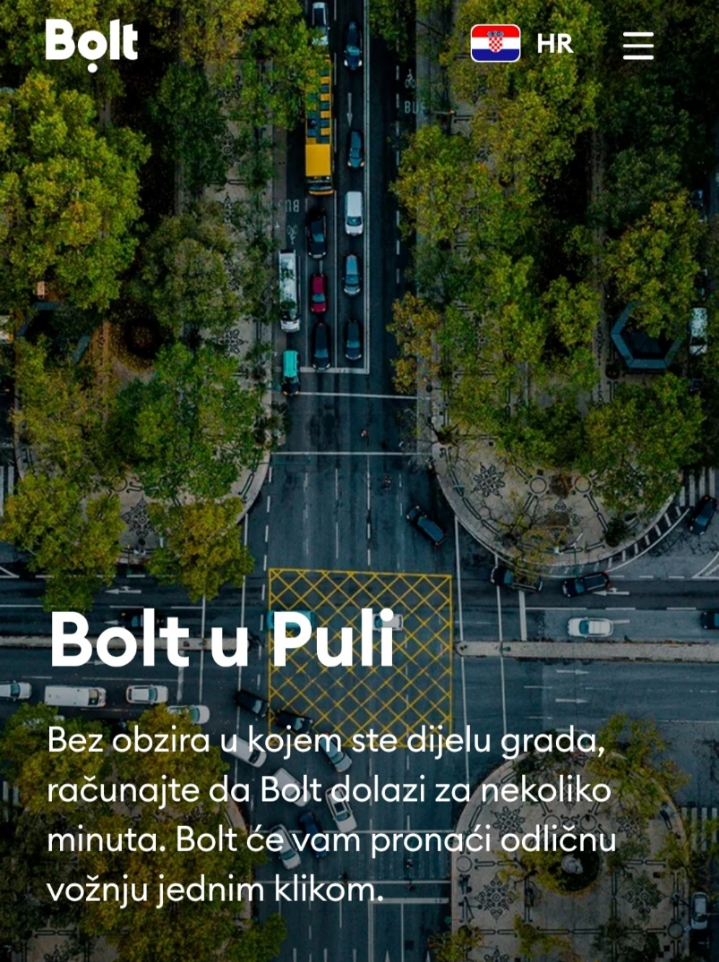
Figure 14: HŽPP & Bolt service

As part of the mobile application developed through Pilot Action 5, a basic micromobility feature has been introduced via integration with external service providers. Specifically, the app enables users to quickly access micromobility options in the Istria region through integration with the Bolt platform. By clicking on the Bolt icon within the app, users are automatically redirected to the Bolt mobile application, where they can view and rent available micromobility vehicles (such as e-scooters or bikes) in their immediate vicinity. This feature enhances the level of intermodality by allowing seamless combinations of public transport with sustainable “last-mile” travel options. Furthermore, this approach leaves room for future expansion of micromobility services, depending on market developments and potential changes in service providers.

10. Settings
Under “Settings,” users can change the language, view onboarding screens again, access legal info, learn more about the SUSTANCE project, or contact support.

11. Content Management System (CMS)
The app includes a web-based CMS for managing transport content.
11.1. Login - CMS access requires a username and password for security.
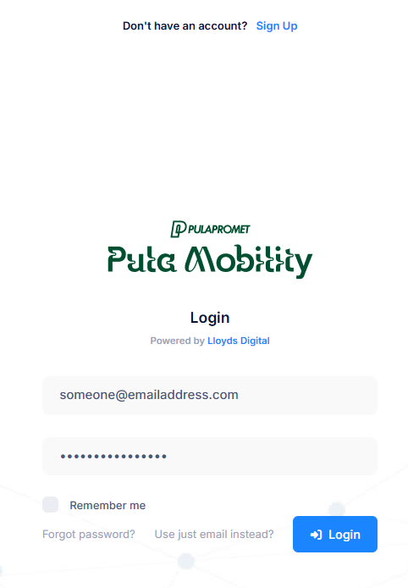
Figure 16: CMS Login

11.2. Dashboard
The dashboard offers an overview of key mobility data, including zones, lines, and stops.
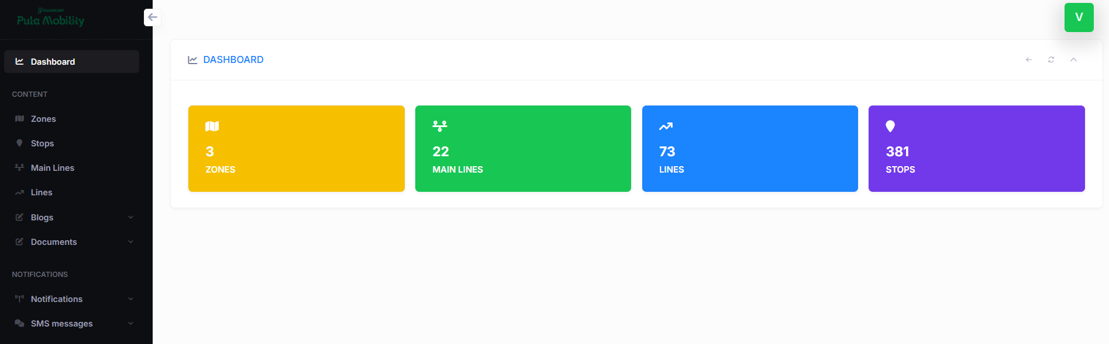
Figure 17: CMS dashboard

11.3. Sidebar Structure
The CMS sidebar includes sections for content management, user roles, and notifications.
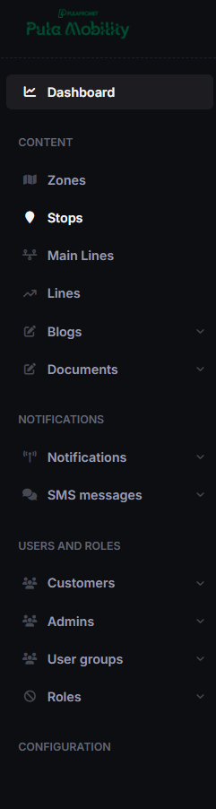
Figure 18: Sidebar menu

11.4 Zone and Route Management
Each section (Zones, Stops, Main Lines, Lines) allows authorized users to add, edit, or update:
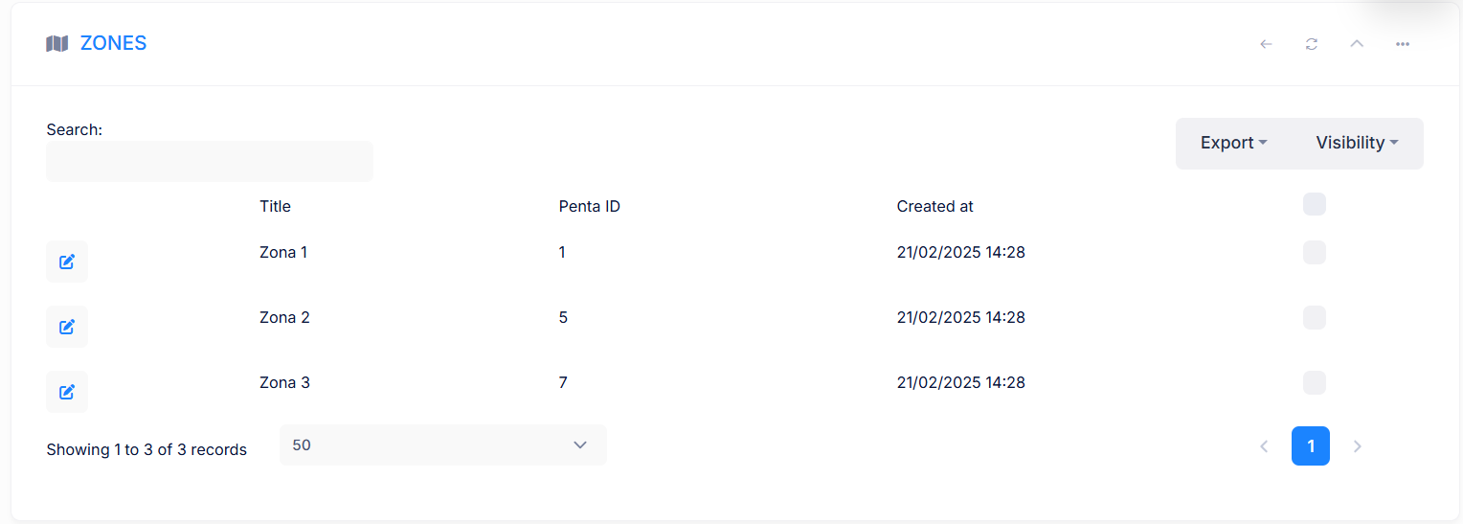
Figure 19: Zones management

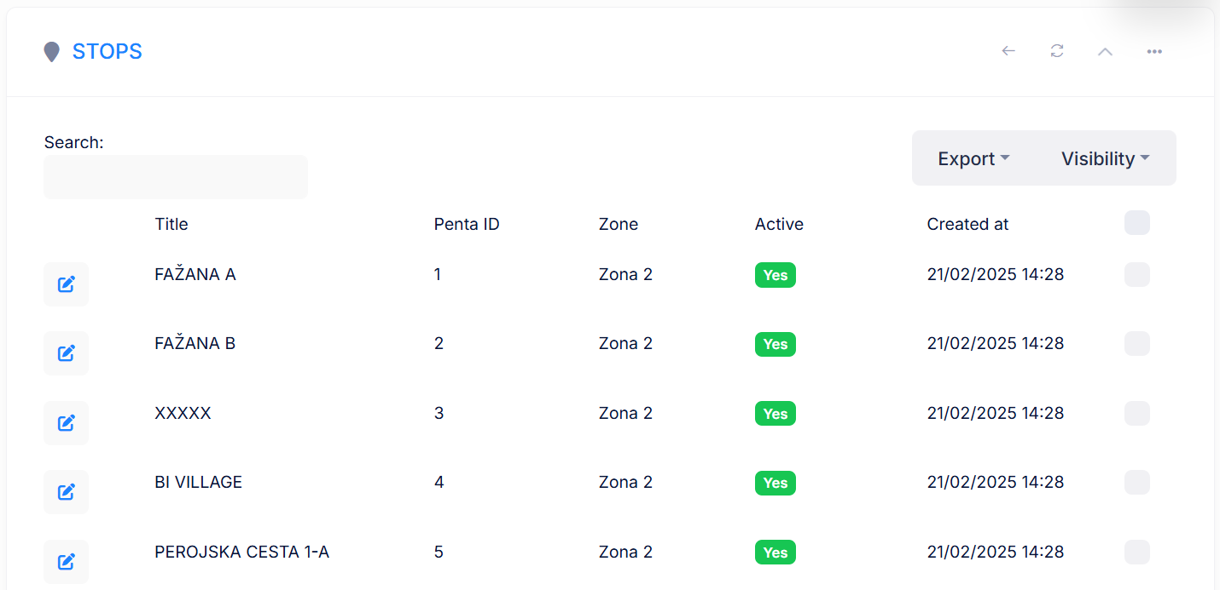
Figure 20: Stops management

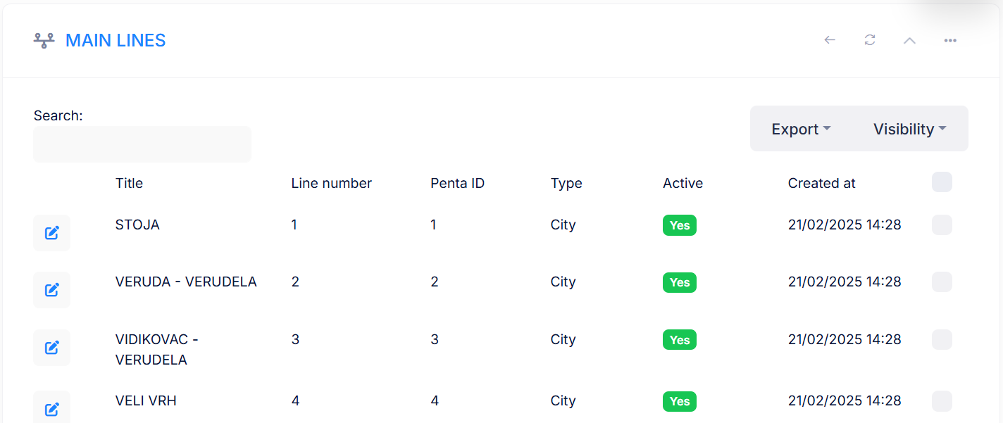
Figure 21: Main lines

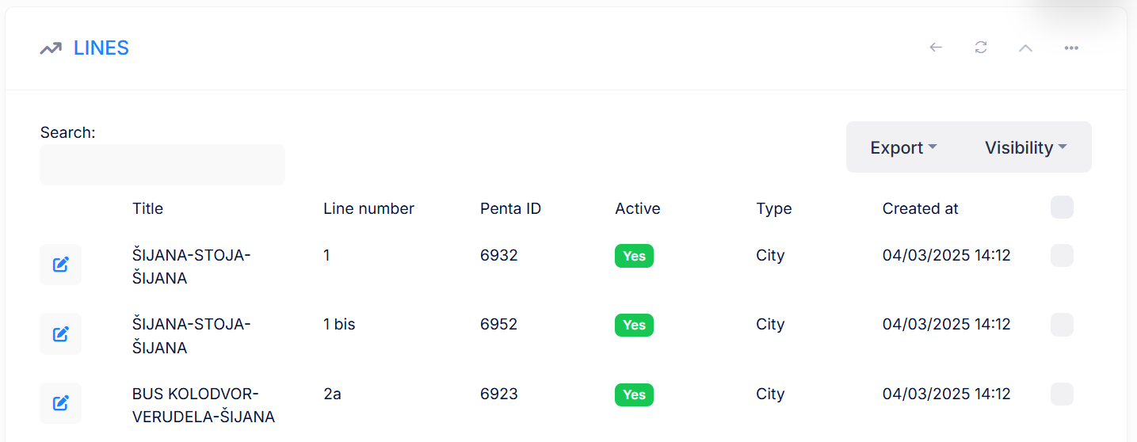
Figure 22: Other lines

Summary
This architecture ensures that the application is:
- User-friendly for passengers via the mobile app
- Easily maintainable through CMS for public transport authorities
- Flexible and scalable, with modular features ready for integration with other mobility services (e.g. Bolt, HŽPP, Park&Ride in the future)
    - Pilot action communication and promotional strategies
In this section, the communication and promotional strategies and tools for the pilot action are presented.
Which strategies do you adopt in order to reach the pilot’s final users?
- Online promotion via public transport and tourism websites, and social media channels.
- Physical marketing materials in bus stations, hotels, and tourist offices.
- Cooperation with local authorities to raise awareness.

- Pilot action key outcomes
  - Lessons learned and replicability suggestions
In this section, each responsible pilot action partner presents the main lessons learned during the pilot development, implementation and assessment. A specific focus is dedicated to the provision of relevant information and suggestions to external stakeholders interested in developing similar initiatives in other territorial contexts.

What is the key legacy of the pilot action?
- The creation of a functional digital platform that enhances access to public transport information.
- A system designed to be continuously updated, allowing for new transport services to be added in the future.
- Ensuring that future mobility projects can integrate additional functionalities
What are the suggestions for other stakeholders interested in replicating your pilot action?
- Ensure modularity in app development to allow for future expansions.
- Collaborate with transport authorities and service providers to align digital services with the future planned infrastructure projects.
- Regularly update mobility providers in the app to reflect changing service agreements.
If you could re-do your pilot action differently, what would you do?
Plan for earlier engagement with end-users – conducting more extensive early-stage user feedback sessions could have helped shape certain functionalities based on user preferences.
If you could give advices to another city/stakeholder implementing your pilot action, what would it be?
- Ensure flexibility for future expansion – public mobility services often change, so the digital solution should be adaptable to accommodate new transport providers and evolving technologies.
- Establish strong cooperation with mobility providers – early collaboration with public and private transport operators ensures smoother data exchange and more reliable service information.
  - Strategies for the Sustance pilot action follow-up after the project conclusion
This section describes the adopted strategies and plans for the continuation of the pilot action after the project's conclusion.
How the pilot will live on?
The application remains operational after the project's conclusion and can be expanded in the future. Continuous collaboration with transport operators will help maintain accurate and useful information. The mobility application developed through Pilot Action 5 is designed with long-term sustainability and scalability in mind. Although the app is currently in the process of being published on official platforms (Google Play and App Store), its backend infrastructure is fully operational and maintained by local stakeholders. After the project ends, the responsibility for content updates, maintenance, and potential feature expansion will be handed over to local authorities or the public transport operator(s). The app’s modular architecture allows for the integration of future mobility services ensuring its continued relevance in the region’s digital mobility ecosystem. As such, the app will remain a valuable tool for promoting sustainable travel choices in Istria, supporting both residents and tourists beyond the SUSTANCE project timeframe.
There are synergies with other local/regional/national/EU projects/initiatives?
- TEN-T initiatives for digitalized public transport services.
- Smart City strategies supporting digital mobility solutions in Istria.
- Sustainable and Smart Mobility Strategy.
- EU Green Deal
- Sustainable Urban Mobility Plans
- EU Tourism policy
- EU Data Strategy & Digital Europe Programme
  - Pilot Action influence on local, regional and national policies
In this section, starting from the stakeholder's engagement strategies analysed in the ex-ante and interim reports, a brief description of the key pilot action influence on local, regional and national policies is presented.
Pilot Action 5 contributes to the digital transformation of public transport services in Istria by setting a precedent for how real-time, multimodal information can be integrated into a single user-friendly platform. On a local level, it encourages municipalities and transport operators to collaborate on data sharing and service coordination. On a regional level, the app supports Istria’s smart mobility and sustainable development strategies by promoting digital tools that reduce reliance on private vehicles. Furthermore, the pilot aligns with national and EU-level transport policies that emphasize the importance of digitalization, accessibility, and environmental sustainability.

The key policy impacts are:
- Supports the transition to digital public transport services.
- Helps reduce car dependency by providing easier access to alternative transport modes.
- Serves as a model for other regions looking to improve public transport information systems.
- Conclusion
This final part of the report provides a synthesis of the SUSTANCE pilot key results, lessons learned, replicability factors and all the other relevant information related to the pilot development, implementation and assessment.

The implementation of the Sustance Pilot Action 5, ICT Service for MaaS in Istria, successfully delivered a public transport application that improves access to bus schedules and other transport options through direct links to different public transport services including bike-sharing and train services.
Importantly, the application was built with future scalability in mind. Since micromobility providers may change once current service concessions expire, the app will require ongoing updates. Additionally, as new transport initiatives develop, the platform can be expanded to include additional multimodal services, such as bike and scooter-sharing solutions.
This pilot action lays the foundation for further digital mobility improvements, ensuring that the region continues to advance towards a more connected and sustainable transport ecosystem.
- Co-design and peer-review process
  - Co-design
In this section, a brief description of the co-design activities updates are provided. In particular, are presented the updates about the information provided in the interim report.

The topics identified in the ex-ante and interim phases were actively incorporated into the final pilot implementation:
- User-friendly design – based on early discussions, the application was built to provide clear and easy access to public transport information, avoiding complex integrations that could limit its adaptability.
- Future adaptability – the application was structured to support additional transport modes in the future.

The co-design process ensured that the pilot action remained aligned with regional mobility goals and provided a solid foundation for future expansions and improvements.
  - Stakeholder engagement
Please briefly list here the main recommendations/suggestions that emerged during the third round table discussion with Stakeholders (D.3.3.3) and summarize the key strategy you intend to adopt in order to integrate these suggestions in the pilot development/implementation phase.

Third stakeholder meeting was held with the aim of presenting the activities carried out so far by the Istrian Development Agency, specifically regarding the development of Pilot Action 5. All stakeholders involved in the development of these activities were invited to the meeting in order to discuss the progress in their development.
Main recommendations to ensure the functioning of the PAs: Stakeholders recommend ensuring long-term institutional and financial support, particularly through local partnerships and potential new funding sources. They highlight the importance of assigning clear responsibilities for system maintenance and management, as well as promoting the services once fully operational. Continued user engagement and alignment with regional transport strategies are also seen as key to maintaining the pilot’s impact beyond the project duration.
Main short- and long-term impacts of the PA: According to stakeholders’ feedback, in the short term, the pilot action is expected to bring economic benefits through increased use of local mobility services and reduced transportation costs for users. Environmentally, it encourages a shift toward low-emission travel modes, contributing to improved air quality. Socially, it enhances accessibility and connectivity, especially for underserved areas. In the long term, the pilot may support the development of a more sustainable transport ecosystem, stimulate green jobs, reduce car dependency, and foster greater social inclusion through improved mobility options.
Core recommendations from 3rd Stakeholder consultations:
- Ensure ongoing maintenance and development of the mobile application after project end.
- Identify and secure long-term funding sources for continued operation of services.
- Define clear responsibilities among involved institutions for service management.
  - Peer-review key results
Please briefly list here the main recommendations/suggestions that emerged during the third peer-review event and summarize the key strategy you intend to adopt in order to integrate these suggestions in the pilot assessment phase.

During the third peer-review event, external experts provided several key recommendations for the further development and evaluation of the pilot actions.
First, under the topic of data availability, experts stressed the importance of open access to public transport data as a foundation for any Mobility as a Service (MaaS) solution. They advised aligning the service with EU standards such as NeTEx and GTFS, and ensuring compatibility with National Access Points (NAPs) under the EU ITS Directive. Initiatives like NAPCORE were highlighted as important harmonization frameworks that can enhance interoperability. Additionally, it was suggested to explore synergies with other relevant projects, such as the Interreg project Transborder+, which focuses on innovative mobility solutions in cross-border areas.
Second, regarding the creation of a mobility ecosystem, reviewers emphasized the need to actively involve transport operators, municipalities, and other mobility providers in the process of data exchange and service coordination. Building such an ecosystem is seen as essential for creating a user-centric and efficient transport network that goes beyond fragmented systems.
Lastly, within the topic of an integrated and inclusive approach, it was recommended to explore the integration of local and community-based services, including seasonal or municipally operated transport options. This would help ensure the platform reflects the real needs of users, especially in rural or tourist regions, and supports a more adaptive and comprehensive mobility offer.
To address these recommendations in the pilot assessment phase, the project team will: (1) assess technical requirements for aligning with EU open data standards and integrating with NAPs; (2) continue stakeholder engagement with the aim of expanding participation in the data-sharing process; and (3) identify local mobility services that could be gradually integrated into the app in future updates, leveraging its modular and scalable design. This strategy ensures that the assessment not only captures what has been implemented, but also the app’s long-term potential as a regional MaaS tool.

The concrete use of the ICT application (number of users) within pilot action 5 will be monitored during 2025 and the information collected will support the setting up of the Long term sustainability guidelines (D.2.5.1) and the roadmap (D.1.3.3).

