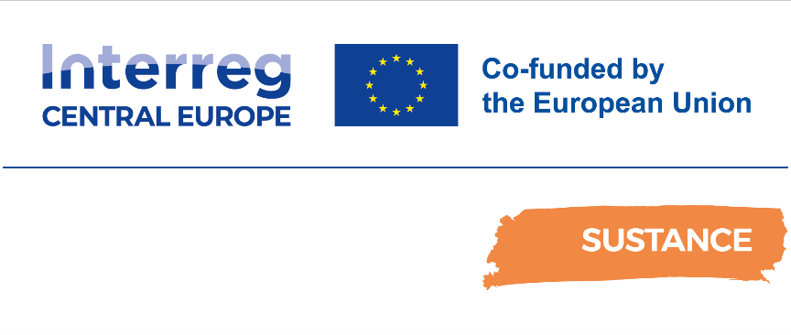

D.2.4.1. Pilot Action 3. New ICT booking service of DRT in Emilia-Romagna Region
Ex-post Pilot Action Report

Final
04/2025

Table of contents
Abbreviations 2
1 Overview 3
2 Pilot Action activities. Key results and SWOT analysis 3
2.1 Pilot key results and reached expectations 3
2.2 Pilot action SWOT analysis 3
3 Pilot Key results 4
3.1 Final KPIs assessment 4
3.2 Pilot action evidence and communication/promotional strategies 5
3.2.1 Pilot action evidence 5
3.2.2 Pilot action communication and promotional strategies 10
4 Pilot action key outcomes 13
4.1 Lessons learned and replicability suggestions 13
4.2 Strategies for the Sustance pilot action follow-up after the project conclusion 14
4.3 Pilot Action influence on local, regional and national policies 14
5 Conclusions 14
6 Co-design and peer-review process 15
6.1 Co-design 15
6.2 Stakeholder engagement 16
6.3 Peer-review key results 16

Abbreviations
AF Application Form
WP Work Package
PT Public Transport
SPAG SUSTANCE Pilot Advisory Grout
TCM Technical coordination meetings

- Overview
This report is related to the Sustance pilot action ex-post monitoring and assessment phase foreseen in Activity 2.2 “Solutions setting up: monitoring, peer review, assessment and dissemination”. In this report, each partner describes the key impacts and results of the Sustance pilot action implementation. The key goal is to assess from a qualitative and quantitative point of view the key effects of the pilot action in terms of environmental, social and economic impacts at local/regional/national levels.
In this report, it is possible to find relevant information on pilot implementation and testing key results, influence at local/regional and national levels and key impacts in terms of improvement of public transport offer in the testing areas. Moreover, it is possible to find information on the different strategies/solutions adopted for the continuation of the measure after the Sustance project conclusion.

- Pilot Action activities. Key results and SWOT analysis
  - Pilot key results and reached expectations

The key ambition of the Sustance pilot in the Emilia-Romagna Region is the creation of an open-source web app that allows digitalizing demand-responsive transport (DRT) solutions effectively and efficiently. The goal is to reduce the DRT management costs for small rural municipalities interested in developing such solutions but with low budgets for developing and managing them.
The key expected impacts of this Sustance solution are related from the users' point of view in an improvement in the access to these DRT services (nowadays managed only by phone calls and not allowing any kind of real-time notifications to final users if something is delayed and/or cancelled). In this sense, the Sustance App can contribute to increasing the trust of users in this demand-responsive transport and consequently increase the quota of people using these flexible public transport solutions. From the public transport authority's point of view, the most important impact associated with the development of such a WebApp is related to the possibility of creating a more effective exchange of data about the daily use of these services. This is fundamental as the public transport authority has an obligation in terms of reporting of kilometres provided and the number of users using these services to cover the costs of these services. Thanks to the Sustance WebApp, this process can be simplified allowing more reliable day-by-day data reporting activity.
Even if the pilot action test is still ongoing, the preliminary feedback received from the involved stakeholders (and in particular from the two companies managing the two demand-responsive transport services and from the mobility agency, AMR, managing the public transport services in the Romagna area) is positive in terms of reached expectations. All the involved operators provided positive feedback in terms of effective digitalization of the booking process, organization of the daily routing of each bus, reporting of the effective uses and the possibility of increasing the real-time communication with drivers and in some cases with final users.
The Sustance WebApp will be used until the end of the Sustance project so additional feedback will be collected, in particular from the old and new users of the two demand-responsive transport in Valmarecchia and Valconca.

  - Pilot action SWOT analysis

The key problem in the development of the Sustance WebApp was related to the need to “translate” in a digital solution many legislative and technical requirements at the base of the functioning of a complex service as an on-demand public transport service. This is a long process concerning the foreseen time plan and it requires several meetings with the WebApp developers, transport engineers and transport operators ‘technical staff. This brings to an extension of needed times and in some delays in the testing phase.
The key internal approach to overcome this problem was the adoption of a learning-by-doing approach. Several versions of the WebApp were developed and tested. Every time a problem and/or a misfunctioning was detected, it was adjusted and/or replicated by a most effective solution.

Table 1. Pilot Action SWOT analysis
Internal factors
Strengths | Weaknesses
- Full involvement, since the beginning of the project, of all the relevant local public and private stakeholders  - Strong political commitment at regional and local levels  - Easy-to-use Sustance WebApp  - Experiences of other EU/local projects on the same topic (DRT services)  - Experience of the selected WebApp developer in the development of such informatic solutions (and related databases) | - Complexity of the DRT services in terms of management and routing algorithms to be adopted in the WebApp  - Delays in the testing phase due to long WebApp development required times.
External factors
Opportunities | Threats
- Momentum. There are at regional and local levels relevant stakeholders interested in supporting and adopting the Sustance WebApp.  - Potential synergies with the ongoing definition of the regional Mobility-as-a-service platform (Roger)  - Potential interests of other municipalities in the regional territory | - Difficulties in promoting among old people such a digital solution  - Difficulties for people in general to change their mobility behaviours.

- Pilot Key results
  - Final KPIs assessment
In this paragraph, the key pilots' results are summarized (number of users, number of PT travels, etc.). Starting from the KPIs defined in the ex-ante and interim reports, each partner is called to describe both from the qualitative and quantitative point of view the key results reached by the pilot action.
Table 2. Pilot KPIs
KPI | Brief description | Value | Target value | Target reached | Measure methodology
KPI 1. Number of users using the service | Number of users booking a travel using the Sustance WebApp + number of users boarded as certified by the drivers. | Number of users | 100 users/per month | March 2025: 110 | Booking in the App + certified data provided by drivers with the onboard tablet.
KPI 2. CO2 saving | Number of users using public transport instead of private cars. | Saved CO2 | 100 users' mobility habits change and related CO2 savings | N.A | Km saved, type of vehicle used
KPI 3. Number of digital solutions developed | Publication online of the Sustance WebApp and in GitHub of the open-source code. | 1 | 1 | 1 |  | Published WebApp

As the test phase is still ongoing, by the end of the Sustance project a dedicated Annex to this report will be published with updated data about these key KPIs. At the moment, the available data refers only to two weeks of WebApp testing in March 2025.

  - Pilot action evidence and communication/promotional strategies
    - Pilot action evidence
The key element of the Sustance pilot action in the Emilia-Romagna Region is the WebApp. The WebApp represents the user interface of an information system designed for the specific purpose of managing the DRT services. This system stores relevant information (to be regularly updated) related to the general set-up of the DRT services as well as the other “traditional” public transport services available in the area. The latter are meant to re-direct to those services users whose requests can be satisfied by already existing connections from fixed timetable services.

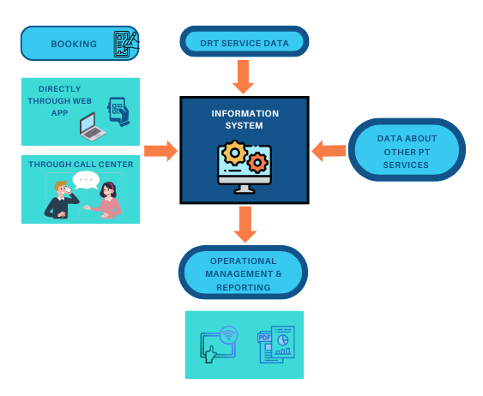
Figure 1. Different input/output flows and functionalities of the overall system supporting the Sustance WebApp

Then, a key usage of the system is the booking, which can be made by the customers either directly through the dedicated WebApp or via the call centre, where the operators can access a more comprehensive interface.
More in general, the operators in the condition to make use of other functionalities for the management of the operations (also through tablets used by the drivers) as well as for reporting on the planned and carried out activities.
In order to provide differentiated and tailored support to different typologies of users and tasks, the Sustance WebApp encompasses different sections.
For direct access of the customers, the key elements of the interface are:
- Landing page, providing general information to all interested users and providing a unified entry point to all the DRT services;
- Users’ Sustance WebApp, allowing the users to book the specific DRT services.
For a broader set of operations to be carried out by the staff of the operators (ranging from supporting the booking via the call centre and exchanging information with the drivers during the actual operation to the update and maintenance of the system), the interface includes specific elements as:
- WebApp Back-end allowing the managing of all the information by the single public transport operators involved in the project;
- Drivers Webapp, allowing the exchange of real-time information between the public transport control rooms and each single bus.
As anticipated, the first section meant to provide a general entry point to the external users is the landing page. It provides general information on the Sustance project and an explanation on how to use the Sustance WebApp.
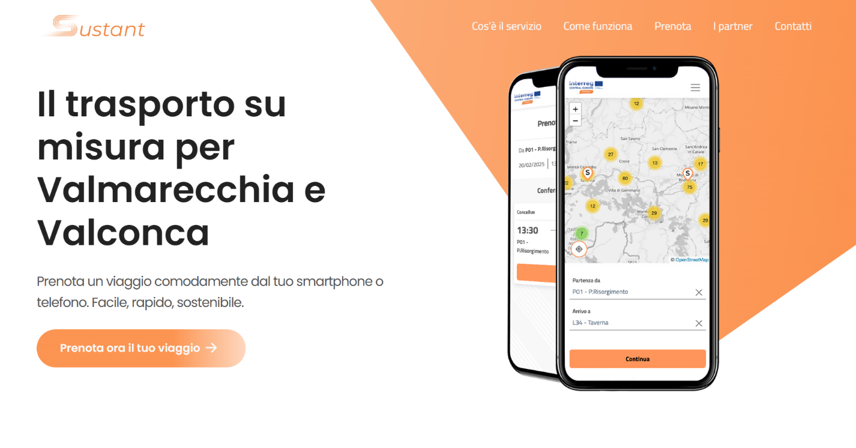
Figure 2. Sustance WebApp landing page

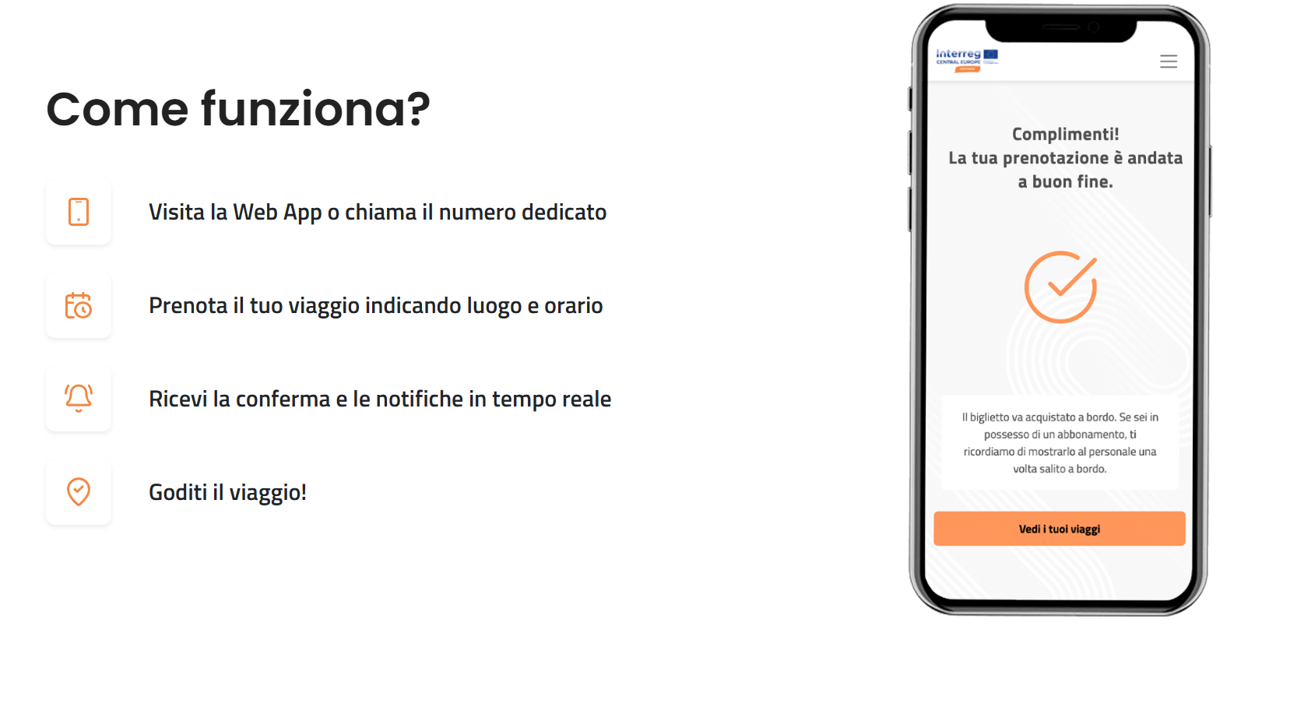

Figure 3. Sustance WebApp landing page. Detail of the guide section.

After the landing page, it is possible to have access to the WebApp for booking the different DRT services. The WebApp was designed to be responsive and easy to use also for people with difficulties in accessing these technologies.
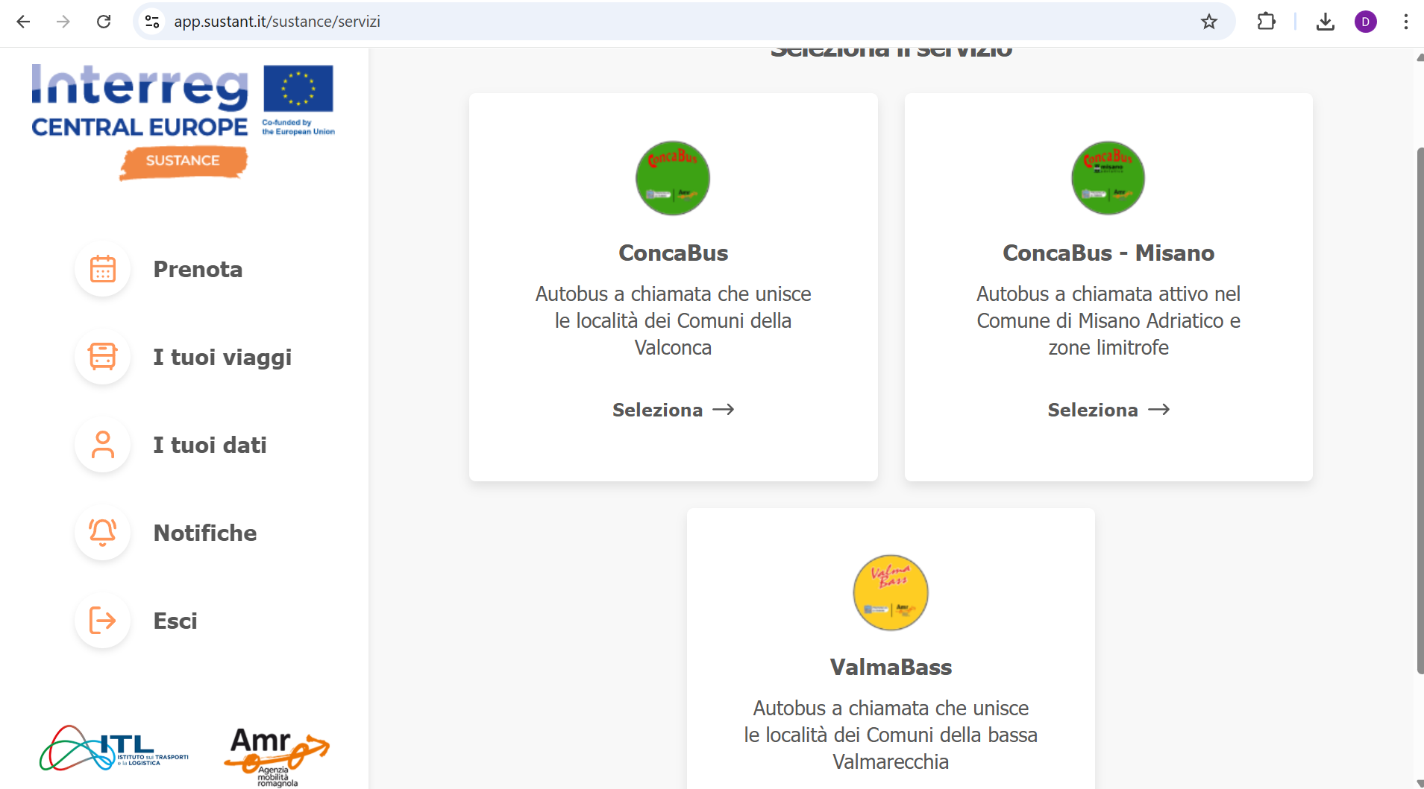
Figure 4. Sustance WebApp main page. It is possible to note the different available DRT services

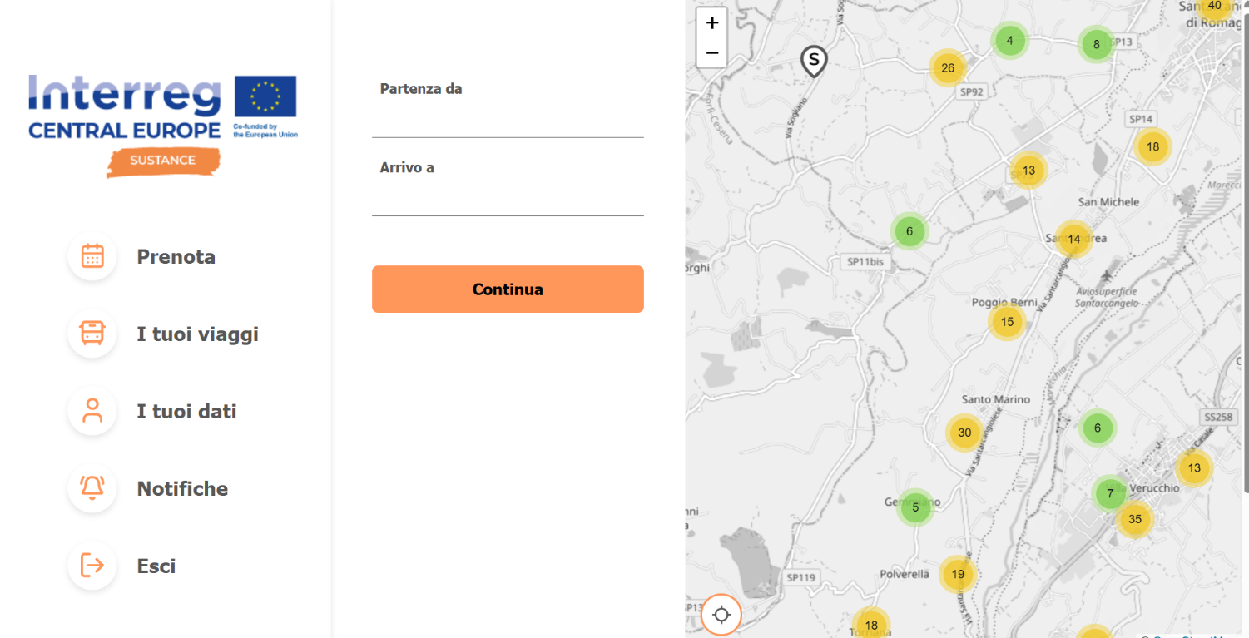

Figure 5. Details of the stop’s selection section in the Sustance WebApp

The WebApp Back-end is a private section that only allows persons having specific access credentials. This is the core of the Sustance WebApp as it contains all the functions for the digital management of the DRT services. It is organized into the following managing sections:
- DRT service information;
- Options for the collections of bookings and for the bus routing;
- Vehicles available and their characteristics;
- Bus lines;
- Exceptions to be managed (for example days without services, changes in the time plan in one specific day, etc.);
- Management of the daily booking requests (virtual bookings control room, fully integrated with the phone calls booking);
- Registered users' information (dataset of all the registered users);
- Statistics.

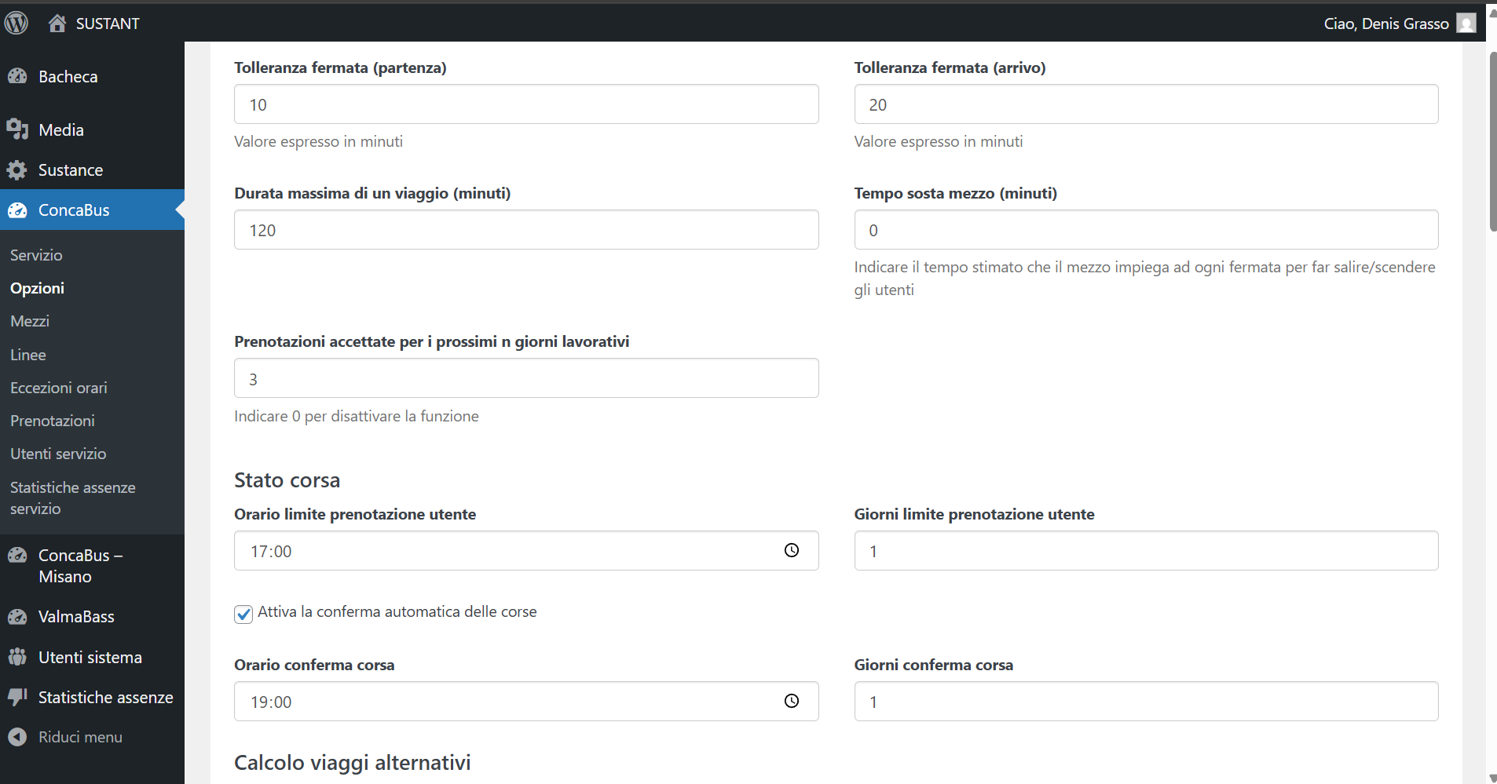
Figure 6. Sustance WebApp Back-end. Example of one management section

The Sustance drivers’ WebApp is installed in the dedicated tablets provided in all the seven different buses involved in the Sustance project.

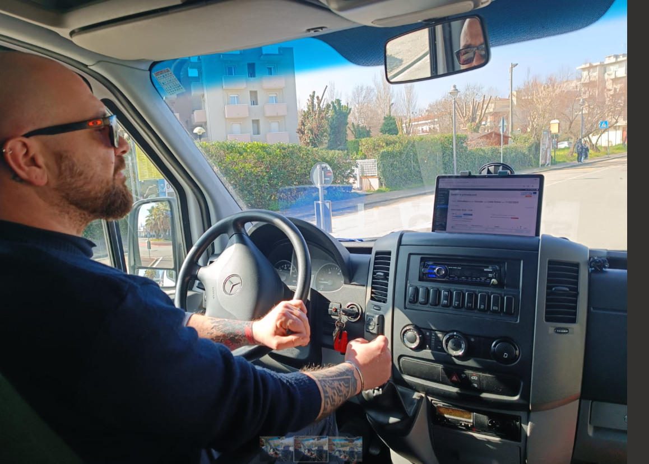
Figure 7. Tablet with the drivers Sustance WebApp during the testing phase

    - Pilot action communication and promotional strategies

In order to reach the highest number of interested users, dedicated promotional materials were elaborated. The adopted promotional strategy is a “traditional” one based on paper-printed posters and postcards to be shown in the places interested by the Sustance testing phase. The people using these services are mainly old people with limited access to social media and other digital promotional materials. Nevertheless, the ITL, AMR and if available regional and provincial websites and social networks will be used for additional promotional campaigns in the next months.
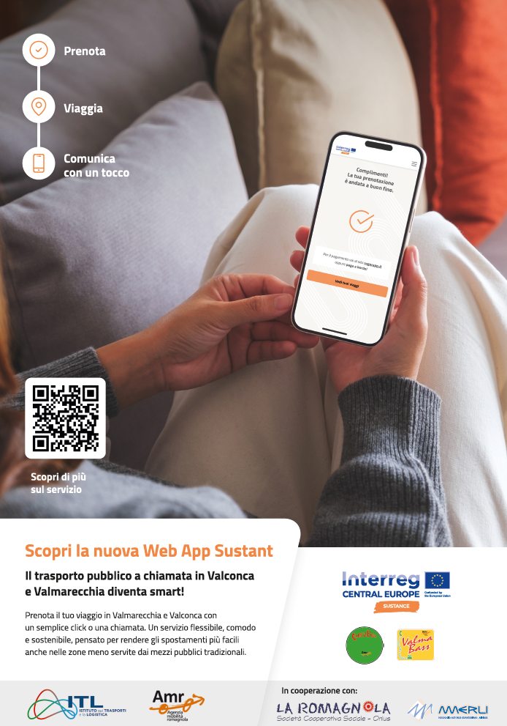
Figure 8. Sustance promotional poster 1.

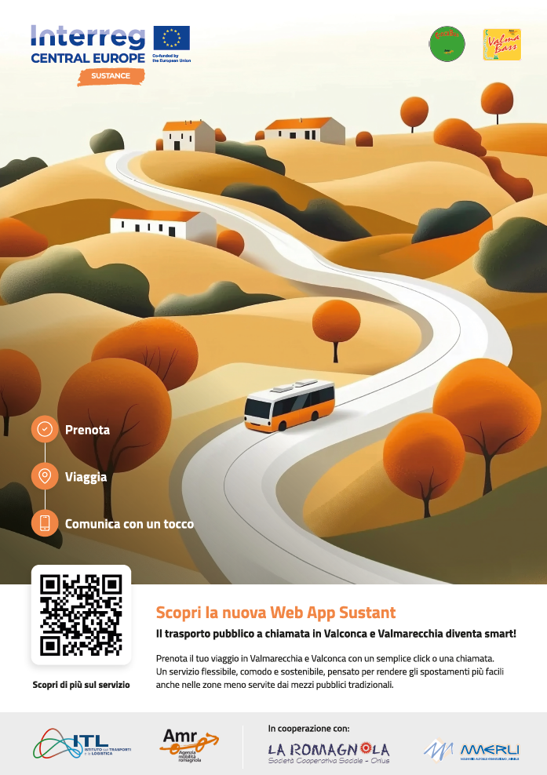
Figure 9. Sustance promotional poster 2.

Finally, we planned in the next months to organize at least one physical event directly at the interested main bus stops and/or near the little villages covered by these DRT services to directly explain to interested users how to use the WebApp and the kind of services provided by these DRT services.

- Pilot action key outcomes
  - Lessons learned and replicability suggestions

The key legacy of this Sustance pilot action in the Emilia-Romagna Region is the importance of having reliable digital solutions for improving the attractiveness of public transport services, both in urban and rural/peripheral areas. Digital services allow an improvement of the public transport service provision both from the public transport operator's point of view and for the final users. This increase in effectiveness and efficiency of the public transport services allows a better use of the financial resources and of the available buses and drivers.
Another important legacy of the Sustance pilot in the Emilia-Romagna Region is related to the development of an open-source application easily replicable in other contexts. The test of this solution is still ongoing but some other municipalities demonstrate their interest to know more about this solution. In fact, in many little rural municipalities in the Apennine area, the economic resources for developing such services are limited. Moreover, some municipalities are unable to develop such services because the costs of the existing platforms are too high for these limited budgets. The legacy of the Sustance project will be the possibility to have a reliable and no/low-cost solution, easily adaptable in other contexts and with reduced/no need of budget to be licensed.
So the key recommendation for all the interested stakeholders is to start from this open-source solution and to use/improve/integrate it with their specific needs adopting the same reusable and open-source approach. Nevertheless, the Sustance experience shows this open-source approach is not always the easiest road. In the market, there are different commercial platforms doing the same job as the Sustance WebApp. The adoption of these solutions could be easier for the public transport authority adoption but in many cases, the costs associated with these platforms are accessible only to the biggest municipalities and/or for services with high numbers.
Another important lesson learned is the key role of involving since the beginning of the planning phase all the relevant public and private stakeholders. In the Sustance pilot action, it was fundamental to involve the public transport authority and the Emilia-Romagna Region and involve the key staff persons knowing very well the complex processes and technologies allowing the provision of demand-responsive transport.
Finally, the last lesson learned is related to the importance of designing easy-to-use digital applications and adopting specific informatics solutions for people with physical and/or intellectual disabilities. Considering the old age of the average users of our DRT services and also the presence of people with disabilities, it was adopted an “inclusive design approach”. It is based on a simple and intuitive interface with large buttons, clear icons, and minimal text making navigation easy for elderly/people with disabilities users. High contrast and large, legible fonts improve readability, ensuring better visibility for those with impaired vision. For future development, voice assistance could help users with hearing or dexterity challenges interact more easily with the app. Personalized features, such as adjustable font size, contrast modes, and route preferences, enhance usability based on individual needs. Accessible customer support via call or chat ensures that users can get assistance whenever needed.

  - Strategies for the Sustance pilot action follow-up after the project conclusion
As already mentioned, the testing phase of the Sustance WebApp will continue also after the end of the project as all the code will be published online on the most important code-sharing platforms available (GitHub, etc.). The code will be accompanied by manuals and a use guide to allow the largest replication also outside the Emilia-Romagna Region and in future initiatives and projects.
Focussing on the Emilia-Romagna context, there are ongoing discussions with the Emilia-Romagna Region to identify potential political and technical possibilities in integrating the Sustance WebApp in the regional Mobility as a Service platform called “Roger”. The discussion is ongoing and at the moment it is still not possible to know if and how this integration will happen. Anyway, there is interest in the Region on the topic and for sure, after the testing phase, all the efforts will be dedicated to assessing the conditions for guaranteeing this potential integration.
Regarding the synergies with other projects, for sure the biggest one is with Interreg Central Europe project DREAM_PACE project (Demand Responsive Transport integrating regional Mobility networks for Passengers in Central Europe) aims to enhance mobility in peripheral and rural areas by integrating Demand Responsive Transport (DRT) services with existing public transport networks. The synergy is mainly related to DRT governance aspects to be adopted for full integration of the Sustance solutions in the regional context.

  - Pilot Action influence on local, regional and national policies

The key influence of the Sustance solution in the Emilia-Romagna Region at the local level is a sensibilization of the different public transport operators to digitalize the existing DRT services in order to allow an increase in users. Another important influence at the regional level is the provision of evidence of the importance of sustaining such flexible and demand-responsive transport solutions in peripheral areas not adequately covered by regular public transport services.

- Conclusions

The Sustance pilot intends to demonstrate how digital innovation can enhance demand-responsive transport (DRT) services, particularly in rural and peripheral areas where traditional public transport solutions are often inadequate. By introducing the Sustance WebApp, the project intends to improve both the efficiency of transport operators and the accessibility of services for users. The WebApp has simplified booking procedures, enhanced real-time communication both with users and drivers, and provided valuable data for better service planning and reporting to public transport authorities. As a result, trust in DRT services has increased, encouraging greater adoption among users who previously relied on less efficient means of transportation.
One of the key lessons learned from the Sustance pilot is the importance of an inclusive design approach, ensuring that elderly users and those with disabilities can access and navigate the platform easily. Features such as a user-friendly interface, high-contrast visuals, and large text sizes have proven crucial in making the service more accessible. Additionally, early and continuous stakeholder involvement, including public transport authorities and mobility agencies, has been a determining factor in the pilot's success, fostering strong collaboration and alignment with local mobility needs.
The replicability of the Sustance solution is a significant outcome of the pilot. The decision to develop an open-source WebApp enables other municipalities and transport agencies, particularly those with limited financial resources, to adopt and adapt the solution to their specific contexts. This approach not only ensures cost-effectiveness but also encourages innovation and continuous improvement through community-driven enhancements.
Despite its successes, challenges remain, particularly regarding the integration of the Sustance platform into broader public transport ecosystems. However, ongoing discussions with regional authorities, as well as synergies with initiatives like the DREAM_PACE project, provide promising opportunities for scaling up the solution. The Sustance pilot stands as a model for how digital tools can modernize DRT services, contributing to more sustainable, inclusive, and flexible mobility systems across Europe.

- Co-design and peer-review process
  - Co-design
On the basis of the co-design event held in 2023 and 2024, some steps ahead were made:
- Update the App to adhere to disabled people thanks to a webpage with easy-to-use functions; à This specific function is added to the Sustance App and it will be described in the WebApp replicability guidelines;
- Combine different targets (young and elderly): digital and smart App for the young and phone communication for the elderly. The phone operator can act as an intermediator and use the app to collect the information à This combination was considered and as defined one year ago the Sustance App will be used also by operators for inserting the phone booking into the Sustance App. This function is under testing and further details will be provided;
- Use the data collected in the past regarding the users of the DRT public transport services to develop the graphic design of the WebApp in a proper and useful way à The WebApp graphic interface was built considering all these aspects;
- Maintain two different ways for booking the service: app and phone call à Done.
- Elaborate and find synergies with other projects and use PA4 as best practice à Specific calls were conducted with SRM in relation to the DREAM_PACE project and potential synergies at the regional level.
- Put more emphasis on the added value of using open-source platforms à This is the core of our pilot action and it will be promoted within the WebApp guidelines and open-source code publication.
Moreover, ITL intends to continue the dialogue and collaboration with PP5-IDA which is working on the same topic (MaaS application) to identify common solutions and technical arrangements for the development of reliable and effective Apps for better public transport accessibility in rural areas.
Finally, PP6-ITL intends to continue the contacts with the other Emilia-Romagna EU and regional active projects working on the same Sustance topics. In this way, potential synergies and common policy recommendations at the regional level can be developed.

  - Stakeholder engagement
The third Sustance round table was held in Rimini on 24/02/2025. All the key local and regional stakeholder participated in the third round table and provided their feedback and comments on the Sustance WebApp called “Sustant”. Two different sessions were conducted: one with the local stakeholders in order to discuss the technical questions related to the Sustance WbApp finalization and testing, a second one at regional level in order to understand the potential technical solution to be adopted to create a positive dialogue and/or integration with the Regional MaaS.
In relation to the local session, the main recommendations and suggestions that emerged during the round table are related to the design of the Sustan WebApp and to its main functionalities. So the discussion started from the comments of the two DRT service operators and AMR in relation to the first week of real test. In general, the feedbacks were positive as the Sustant WebApp demonstrated to be able to collect all the bookings, make a reliable “trip plan” and transfer effectively the booking data to the authorities in charge to monitor these services. Moreover, the discussion regarded the coordination of the different activities related to the testing phase and the lunch event. The key recommendation collected from the key stakeholders was to make everything “simple”: simple for the final users, simple for the transport companies operating the services and simple for the drivers called to provide and receive information in real time. As the WebApp developers participated in the round table, all these recommendations were adopted in the WebApp development as a “Agile methodology” was adopted. It is an approach to software development that emphasizes flexibility, collaboration, continuous improvement, and customer feedback. It is designed to help teams deliver high-quality products quickly and efficiently by working in short, iterative cycles.
In relation to the Regional session with the Emilia-Romagna Region, it was possible to have some updates on the Maas application that the Region is working on. The possibilities of collaboration were confirmed and in the second semester of 2025, more discussions have to be organised. The Emilia-Romagna Region communicate the intention of organising a big event in July 2025 on MaaS and DRT services and they have asked for the interest and contribution of the Sustance project to this topic.

  - Peer-review key results
The third peer-review online meeting for the pilot action assessment was held online on 2nd April 2025. The main suggestions collected from the external technical experts Mr. Grea and Mr. Maratini can be summarised as follows:
- Create Local Synergies: Identify other local projects where Sustance solution could be scaled. Building synergies—particularly with municipalities—can support replication efforts, especially when based on open-source models. Consider forming partnerships that encourage adoption and customisation at the local level.
- Marketing the Pilot Initiative: Strengthen visibility through targeted marketing. Invite experts to speak about the benefits and potential of MaaS to increase interest and public engagement.
- Integration with Provincial-Level Planning: Engage with provinces like Bologna and Modena, which are advancing the integration of Demand-Responsive Transport (DRT) within MaaS systems at both planning and governance levels. A dialogue with these regions can provide valuable insights and guidance.
- Use of Open-Source Platforms: Ensure all digital tools and resources related to the service are available online. Open-source solutions can be scaled locally, especially when supported with user-friendly materials such as tutorials, guides, and technical assistance provided by early adopters.
- Alignment with Regional Strategies: Collaborate with other regions specially the neighbouring provinces who are working to incorporate DRT into Sustainable Urban Mobility Plans (SUMPs).
- Inclusive Digital Solutions: Ensure that digital tools accommodate the needs of vulnerable groups. Seek synergies with similar initiatives, such as the trip planner for physically impaired users being tested in Belluno province or the route planner for vulnerable populations developed by other projects.
- Digital data: Use of the digital data gathered to improve the service in the future.

Strategy to integrate suggestions in the pilot assessment phase
Considering the experts' suggestions, the pilot action will adopt targeted strategic measures to effectively integrate the peer review recommendations and enhance the implementation of the pilot in the Rimini Province and more in general at Regionl level.
Building on the interest gathered through local events and roundtables, the pilot action will actively explore synergies with ongoing local and regional mobility initiatives. This includes identifying other projects where the DRT solution could be adapted and scaled, particularly in smaller municipalities across the Romagna area. The pilot will be supported by a targeted marketing campaign aimed at raising awareness among residents and stakeholders. Expert speakers on MaaS and DRT will be invited to the upcoming event on DRT in Bologna (July this year), to communicate the broader benefits of the system. The event will be organised together with the SRM of Bologna, the lead partner of the DREAM-PACE Central Europe project working on Sustance similar topics and challenges.
To align with best practices, there will be a dialogue and knowledge exchange with provinces such as Bologna and Modena, which are advancing MaaS integration within their transport governance. All digital tools developed in the Sustance project will be made publicly accessible through open-source platforms. To ensure easy adoption, support materials such as user tutorials, technical guides, and training sessions will be provided.
The pilot will align with the broader objectives of Sustainable Urban Mobility Plans (SUMPs) across the Emilia-Romagna region. A key priority is to ensure that the App/WebApp and associated digital services are inclusive, especially for elderly users. In addition to traditional phone booking that is already been introduced, user-friendly training sessions will be organised to support digital onboarding. There are plans for DRT service to be extended to other target groups, for example, children who wish to participate in various sports activities but are unable to travel independently because their parents are at work.
The digital data gathered throughout the pilot will be systematically analysed to inform service optimization. Insights into user behaviour, demand trends, and operational performance will support iterative improvements and help tailor the service to emerging community needs.

To be reached by December 2025.
https://www.sustant.it

