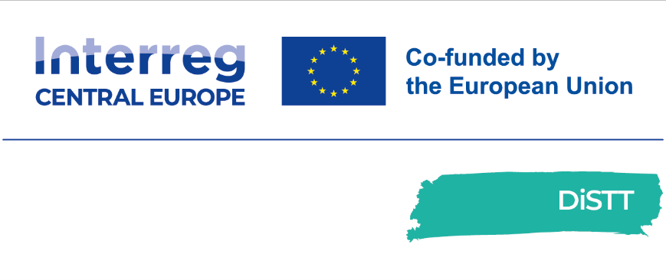


Digital Skills Transformation Toolkit

D.3.3.1

INTERREG CENTRAL EUROPE
Digital Skills Transformation Toolkit for a Resilient Labour Market
D3.3.1
Digital Skills Transformation Toolkit
A ready-made solution for FabLabs and training-oriented organisations
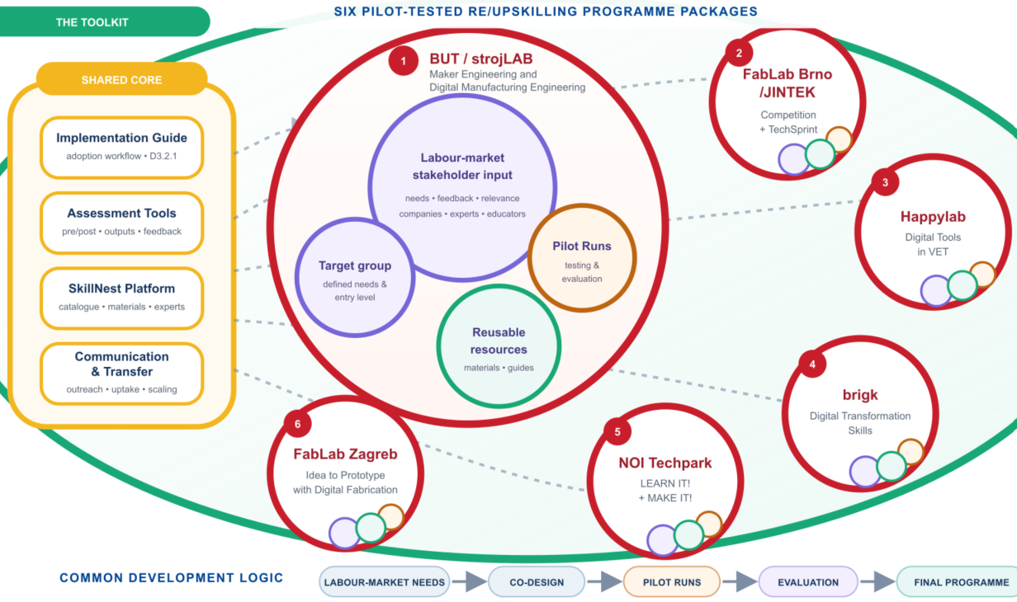
the Toolkit structure implemented to the SkillNest platform

Project ID: CE0200661 | Version: Final | August 2026
skillnest.app
Jointly developed by the DiSTT partnership

Document control
Field | Value
Project | Digital Skills Transformation Toolkit for a Resilient Labour Market (DiSTT)
Programme | Interreg CENTRAL EUROPE 2021–2027
Project ID | CE0200661
Deliverable | D3.3.1 Digital Skills Transformation Toolkit
Work package / activity | WP3 / A3.3
Lead organisation | Brno University of Technology (BUT)
Delivery month | July 2026
Website | skillnest.app

Table of Contents
Right-click and select Update Field.

The table of contents is an updateable Word field. Static chapter index:
- 1. Executive Summary
- 2. Purpose, Scope and Project Context
- 3. Development and Finalisation of the Toolkit
- 4. Toolkit Architecture
- 5. The Six Re/Upskilling Programme Packages
- 6. SkillNest Digital Implementation
- 7. Assessment Toolkit
- 8. How to Use and Adopt the Toolkit
- 9. Transferability, Inclusion and Scaling
- 10. Uptake, Sustainability and Governance
- 11. Conclusions
- Annexes A–F

List of Figures
- Figure 1. SkillNest landing page and entry point
- Figure 2. Workshop catalogue and discovery interface
- Figure 3. Workshop detail and metadata
- Figure 4. Embedded pre-assessment environment
- Figure 5. Pre/post assessment and learning objectives
- Figure 6. Role-gated workshop materials
- Figure 7. DiSTT laboratory network
- Figure 8. Skills Experts directory
- Figure 9. User registration
- Figure 10. RE/UP programme information page

List of Tables
- Table 1. Toolkit components and intended users
- Table 2. The six final programme packages
- Table 3. Public and restricted SkillNest access levels
- Table 4. Minimum assessment package by format
- Table 5. Comparative matrix of programme packages
- Table 6. Toolkit resource and download register
- Table 7. Project traceability matrix

Abbreviations
Abbreviation | Meaning
BUT | Brno University of Technology
CE | Central Europe
DME | Digital Manufacturing Engineering
EU | European Union
FabLab | Fabrication Laboratory
FGF | Fused Granulate Fabrication
LP / PP | Lead Partner / Project Partner
ME | Maker Engineering
RE/UP | Re/upskilling
SME | Small and medium-sized enterprise
VET | Vocational education and training

1. Executive Summary
The Digital Skills Transformation Toolkit is the final practical solution of the DiSTT project. It converts jointly developed programme concepts, more than thirty Pilot Runs, partner evaluations and stakeholder feedback into a reusable system that FabLabs, makerspaces, schools, universities, vocational-training providers and business-support organisations can adopt in their own context.

TOOLKIT DEFINITION
A ready-made yet adaptable solution consisting of six final re/upskilling programme packages, assessment and feedback tools, an implementation pathway.

The toolkit is implemented through SkillNest at skillnest.app. The platform makes the project’s workshop offer discoverable, links learning formats to identified skill gaps, presents labs and experts, embeds pre- and post-assessment, and provides role-based access to learning and facilitation materials.

Who the toolkit is for
- FabLabs and makerspaces seeking tested training formats rather than starting curriculum design from zero.
- Schools, universities and VET providers that want to connect digital skills with real fabrication tasks.
- Educators and technical experts looking for structured materials, assessment tools and implementation guidance.
- Learners who need transparent information about prerequisites, learning objectives, duration, equipment and outcomes.
- Companies and business-support organisations that need short, applied responses to workforce skill gaps.

What the toolkit contains
Component | Content | Primary users
Six programme packages | Finalised formats developed and piloted by the six DiSTT partners | Educators, FabLabs, training organisations
Assessment toolkit | Pre/post self-assessment, practical-output criteria, observation and stakeholder feedback | Educators, evaluators, learners
Adoption workflow | Readiness, selection, adaptation, delivery, evaluation and scaling steps | Adopting organisations
SkillNest | Catalogue, programme information, labs, experts, embedded surveys on the web and role-gated resources | All stakeholder groups

Source: DiSTT Application Form (approved version, 27 March 2024); D2.2.1 partner Pilot Run Reports; SkillNest, accessed 23 July 2026.

2. Purpose, Scope and Project Context

2.1 The challenge addressed
DiSTT responds to a shared Central European challenge: employers and learners need digital-fabrication skills, while conventional education and training systems often adapt more slowly than technologies and work practices. The gap affects SMEs, crafts and micro-enterprises, young people entering the labour market, university students, jobseekers and employees whose roles are changing.
FabLabs and makerspaces are well positioned to respond because they combine equipment, educators, prototyping culture and links to local communities. Their flexibility makes it possible to test short workshops, multi-day programmes, weekly studios, competitions and mentored sprints without requiring a single institutional teaching model.

2.2 Role in the DiSTT intervention logic
- A1.3 established a joint blueprint for comparable re/upskilling programme design.
- A2.1 translated the blueprint into partner-owned programmes for different regions and target groups.
- A2.3 and the related Pilot Runs tested programme content, teaching methods and assessment arrangements.
- A3.2 consolidated implementation guidance and lessons for transfer.
- A3.3 packages the validated programmes, assessment tools, implementation guidance and digital access into the final toolkit.

2.3 Difference between the Implementation Guide and the Toolkit
Deliverable | Primary question | Main contribution
D3.2.1 Implementation Guide | How should an organisation plan and implement a programme? | Detailed process guidance, preparation and transfer logic
D3.3.1 Digital Skills Transformation Toolkit | What final solution can an organisation take up and use? | Programme packages, assessment resources, SkillNest access and adoption workflow

SCOPE BOUNDARY
This deliverable does not repeat all raw Pilot Run evidence. It converts the evidence into adopter-oriented programme fiches and points users to the final digital and downloadable resources.

2.4 Intended uptake
The approved project framework expects all six project partners to take up the final toolkit and aims for uptake by at least 24 additional FabLabs or training-oriented organisations. Uptake should therefore be understood as practical reuse: selecting a programme, accessing its materials, adapting it to local conditions, delivering it and using the assessment cycle.

3. Development and Finalisation of the Toolkit

3.1 Development pathway
1. Skills-gap identification. Partners and stakeholders identified needs in regional labour markets and education ecosystems.
2. Joint blueprint. A shared programme structure made partner outputs comparable without suppressing local variation.
3. Programme design. Each partner converted needs into at least one complete re/upskilling programme.
4. Piloting phase. Programmes were tested through different lengths, target groups and delivery formats of the workshops.
5. Joint evaluation. Pre/post assessment, participant feedback, facilitator observation and stakeholder input were synthesised.
6. Finalisation and publication. Lessons were translated into final programme packages and made accessible through SkillNest.

3.2 Evidence used
- Approved DiSTT Application Form and output definitions.
- D2.1.1 partner RE/UPskilling programme descriptions.
- D2.2.1 Pilot Run Reports from LP1 and PP2–PP6.
- Joint evaluation findings and partner residency/tandem observations.
- Stakeholder, industry, student and facilitator feedback.
- Current public implementation of SkillNest, inspected on 23 July 2026.

3.3 Common design principles validated by the pilots
Principle | Operational meaning
Hands-on learning | Technical explanations are followed quickly by fabrication, programming, testing or design activity.
Visible output | A prototype, fabricated part, demonstration, presentation or documented solution gives the programme a concrete endpoint.
Project or challenge logic | Learning is organised around a meaningful task rather than disconnected software exercises.
Modularity | Duration, equipment, complexity and support can be adapted while preserving core learning outcomes.
Formative feedback | Facilitators intervene during practical work, not only after it.
Assessment before and after | Entry self-assessment supports differentiation; post-assessment documents perceived development.
Technical plus transversal skills | Collaboration, communication, planning and problem-solving are mostly developed through the technical task.
Stakeholder connection | If possible, companies, experts, juries and local institutions always help keep content relevant.

3.4 How pilot lessons changed the final toolkit
- Assessment questions are mirrored between pre and post stages to support direct comparison.
- Registration or anonymous matching codes are recommended when individual learning gains are needed.
- Short formats use a reduced assessment package to protect practical learning time.
- Materials are separated by participant and educator role where facilitation notes or possible answer keys should not be public.
- Programme fiches identify essential elements and adaptable elements to support responsible transfer.
- Alternative tasks and differentiated support are recommended for heterogeneous groups.
- Practical outputs and facilitator observation are used to triangulate self-assessment.

4. Toolkit Architecture

4.1 Three-layer architecture
Layer | What it contains | How it is used
1. Programme packages | Six partner packages with objectives, formats, resources, assessment and transfer notes | Select and adapt a validated learning offer
2. Assessment toolkit | Needs diagnosis, mirrored pre/post questions, output criteria and observation templates | Establish baseline, support delivery and document outcomes
3. Implementation and access | Adoption workflow, SkillNest catalogue, labs, experts and role-gated materials | Prepare, deliver, connect and scale

4.2 Core information flow
- A regional or organisational skill gap is identified.
- An adopter selects the closest programme package or workshop format.
- Learning outcomes, prerequisites, duration and equipment are adapted.
- Participants complete pre-assessment and, where useful, are grouped or differentiated.
- Educators deliver the programme using practical tasks and formative feedback.
- Participants complete post-assessment and produce practical output.
- The adopter interprets results, improves the programme and records the next run.

4.3 User roles
In terms of functionality on the skillnest.app platform, we distinguish between the roles of Learner and Educator. The other roles listed below are classified under one of them depending on the situation and the expected approach.

Role | Typical need | Toolkit pathway
Learner | Find a relevant workshop and understand what will be learned | Catalogue → workshop detail → registration → assessment → materials
Educator | Reuse or adapt a workshop and deliver it consistently | Programme fiche → educator resources → assessment → reflection
FabLab / training organisation | Adopt a complete format and connect it to facilities and experts | Readiness → package selection → adaptation → delivery → monitoring
Company / stakeholder | Signal a skill gap, co-design a challenge or support evaluation | Needs input → programme match → expert or jury role → feedback
Administrator / content manager | Create, maintain and publish structured content | CMS workflow → roles → resource management → monitoring

4.4 Public and restricted content
Access level | Examples | Reason
Public | Programme descriptions, workshops, skill gaps, labs, experts, prerequisites and learning objectives | Discovery and informed participation
Registered user | Participant resources, selected downloads and saved access | Controlled distribution and uptake tracking
Educator | Facilitation guides, editable templates, assessment setup and restricted teaching resources | Protect delivery quality and role-specific content
Administrator | Content creation, publication status, role management, results and platform configuration | Governance and data protection

5. The Six Re/Upskilling Programme Packages
The toolkit treats each partner’s final programme family as one transferable package. A package may contain several branches, modules or formats when these form a coherent local response. The common fiche structure below supports comparison while preserving the programme logic validated by each partner.
Package | Owner / region | Primary target | Signature format
Maker Engineering + DME | BUT / Brno | University students and professionals | Portfolio from short workshops to professional intensives
Competition + TechSprint | FabLab Brno | Secondary schools | Challenge-based team prototyping
Digital Tools in VET | Happylab / Vienna | Apprentices | Repeatable three-day robot programme
Digital Transformation Skills | brigk / Ingolstadt | SMEs, students, apprentices | Mini workshops + mentoring + series
LEARN IT! + MAKE IT! | NOI / Bolzano | Adults, SMEs, artisans | Courses and finished-object workshops
Idea to Prototype | FabLab Zagreb | Secondary schools / outreach | Five independent modules

5.1 BUT / strojLAB – Maker Engineering and Digital Manufacturing Engineering

Programme owner | Target groups | Core formats
Lead Partner 1 – Brno University of Technology / strojLAB, Czechia | University and secondary-school learners; company employees; independent professionals; lifelong learners | Short workshops, weekly thematic studios, challenge-based competitions, mentored project sprints and professional intensive courses

Purpose and value proposition
The BUT package combines two complementary branches. Maker Engineering (ME) develops broad maker, design and prototyping competences through accessible, project-based formats. Digital Manufacturing Engineering (DME) provides more specialized technical learning for professionals and advanced learners, with stronger emphasis on industrial application and structured recognition.

Core topics
- Additive manufacturing, 3D printing and fabrication-aware design
- Algorithmic and parametric modelling
- Robotic and large-format additive manufacturing
- 3D scanning, inspection and digital metrology
- CNC machining, laser/vinyl cutting, electronics and design thinking

Learning outcomes
- Translate a design intent into a feasible digital-fabrication workflow.
- Prepare data, select parameters and operate relevant equipment safely.
- Evaluate production constraints and troubleshoot common process problems.
- Develop, test and communicate a tangible prototype or technical result.
- Connect technical decisions with teamwork, planning and user or industry needs.

Implementation requirements
Learning and teaching resources. Workshop presentation, teacher’s guide, and optionally: step-by-step instructions, digital files, templates, practical assignments, safety guidance and assessment links.
Equipment and facilities. Depends on the selected module: computers and CAD tools, desktop or robotic 3D printing, 3D scanners, CNC/laser equipment, electronics and standard FabLab PPE.
Educator competence. Technical competence in the selected process, ability to supervise equipment and safety, and experience with project-based facilitation.
Assessment approach. SkillNest pre/post self-assessment; formative feedback; practical outputs; presentations; and, where relevant, expert or jury review.

Pilot evidence and lessons incorporated
PILOT EVIDENCE
LP1 reported 23 completed Pilot Runs, 339 workshop hours, 353 participant places and 5,510 cumulative participant-hours across ME and DME formats.

- A wide format portfolio increases reach but requires consistent metadata and assessment design.
- Pre-assessment can support team formation and differentiation.
- Hands-on activity should remain directly connected to the programme’s final project.
- Registration or a stable participant code improves matching of pre/post responses.

Transfer logic
Essential elements | Adaptable elements | Recommended transfer scenarios
A real fabrication task, clear learning outcomes, direct equipment use, facilitator feedback and a documented practical result. | Technology, duration, difficulty, target group, challenge brief, delivery schedule and recognition method. | University FabLabs, design and engineering programmes, professional short courses, company upskilling and outreach for secondary schools.

Location in SkillNest
Workshop catalogue under strojLAB; related labs and experts; assessment links; registered-user materials.
Source: Relevant partner D2.2.1 Pilot Run Report and current SkillNest implementation.
5.2 FabLab Brno/JINTEK – High School Competition and TechSprint

Programme owner | Target groups | Core formats
Project Partner 2 – FabLab Brno, Czechia | Secondary-school classes and student teams, teachers, company challenge owners | Multi-week competition and intensive three-to-five-day challenge sprint

Purpose and value proposition
This package turns labour-market and community challenges into motivating team projects for secondary-school learners. The longer competition supports deeper project development and public presentation; TechSprint offers a compact format suitable for a whole class and can be connected to a real company brief.

Core topics
- 3D modelling, slicing and desktop 3D printing
- Vector graphics and laser cutting
- Arduino, electronics and prototyping
- Project planning, teamwork and time management
- Presentation and communication of technical solutions

Learning outcomes
- Move from a challenge brief to a working prototype.
- Use at least one digital-fabrication process safely and purposefully.
- Combine design, electronics or programming where appropriate.
- Distribute team roles and work under a fixed time frame.
- Present the project to educators, stakeholders or a jury.

Implementation requirements
Learning and teaching resources. Workshop presentation, teacher’s guide, and optionally: Challenge briefs, machine introductions, starter files, team planning prompts, presentation guidance and assessment questions.
Equipment and facilities. FabLab access with 3D printers, laser cutter, computers, electronics and suitable materials.
Educator competence. Multi-technology facilitation, ability to support heterogeneous classes, and experience structuring team roles and milestones.
Assessment approach. Pre/post self-assessment; facilitator observation; final prototype and presentation; teacher, company and jury feedback.

Pilot evidence and lessons incorporated
PILOT EVIDENCE
PP2 piloted two complementary activity families through repeated school groups. Reported technical gains were strongest in 3D modelling, 3D printing and laser cutting; soft-skill change was more modest in short runs.

- Form teams using pre-assessment when technical experience is uneven.
- Whole-class delivery needs deliberate participation structures so work is not concentrated in a few students.
- A short onboarding phase reduces the gap between beginners and hobbyists.
- Company involvement works best when the challenge is clearly scoped and participation expectations are light.

Transfer logic
Essential elements | Adaptable elements | Recommended transfer scenarios
Authentic challenge, team-based prototyping, access to fabrication tools, milestone support and final presentation. | Challenge source, programme length, number of technologies, class size, jury composition and competition element. | Secondary schools, science centres, mobile FabLabs, vocational schools and company-supported STEM initiatives.

Location in SkillNest
FabLab Competition and TechSprint workshop pages; FabLab Brno lab profile; educator profile and assessment links.
Source: Relevant partner D2.2.1 Pilot Run Report and current SkillNest implementation.
5.3 Happylab – Digital Tools in Vocational Training

Programme owner | Target groups | Core formats
Project Partner 3 – Happylab Vienna, Austria | Apprentices from technical, commercial and mixed vocational backgrounds | Repeatable three-day makerspace programme

Purpose and value proposition
A deliberately consistent introductory format that connects CAD, 3D printing, laser cutting, robotics and programming through a shared robotic prototype. Repetition across vocational organisations tests whether the same core learning design can be transferred while adjusting pacing and support.

Core topics
- CAD modelling and file preparation
- 3D printing and laser cutting
- Calliope mini programming and electronics
- Robot assembly, testing and challenges
- Creative problem-solving and teamwork

Learning outcomes
- Create and prepare a simple CAD model.
- Start and monitor a 3D-printing process.
- Operate a laser cutter under workshop procedures.
- Apply basic programming concepts to a moving prototype.
- Test, debug and demonstrate a functioning team result.

Implementation requirements
Learning and teaching resources. Workshop presentation, teacher’s guide, and optionally: printed worksheets, CAD templates, example code, fabrication files, challenge cards and a harmonised survey.
Equipment and facilities. Computers, 3D printers, laser cutter, Calliope mini and movement kits, hand tools and workshop facilities.
Educator competence. Competence across digital fabrication and introductory programming; close facilitation for beginners; ability to stage challenges.
Assessment approach. Seven mirrored pre/post items, open feedback, trainer observation and final prototype demonstration.

Pilot evidence and lessons incorporated
PILOT EVIDENCE
Nine runs reached 67 apprentices and 189 scheduled hours. The overall mean across seven items increased from 2.61 to 3.85 (+1.23/5), with the strongest gains in laser cutting, 3D printing, robot programming and 3D modelling.

- One repeated format produces strong implementation knowledge and improves transferability.
- Programming needs differentiated scaffolding and optional extensions.
- Pre-checking wiring and mechanical components protects productive learning time.
- Additional experimentation time is valuable once core functions are mastered.

Transfer logic
Essential elements | Adaptable elements | Recommended transfer scenarios
Connected multi-technology prototype, beginner-accessible progression, iterative challenges and final demonstration. | Robot challenge, optional sensors, programming depth, pace and organisational recruitment route. | Apprenticeship training, VET centres, company academies and makerspaces working with mixed vocational cohorts.

Location in SkillNest
Programme workshop page; Happylab profile; educator/expert links; assessment and final teaching package.
Source: Relevant partner D2.2.1 Pilot Run Report and current SkillNest implementation.
5.4 brigk – Digital Transformation Skills Programme

Programme owner | Target groups | Core formats
Project Partner 4 – brigk Makerspace / Startup Incubator, Ingolstadt, Germany | SME employees, university students, hackathon teams and apprentices | Mini workshops, hackathon follow-up mentoring and an apprentice workshop series

Purpose and value proposition
The brigk package combines fast technology entry points with longer transformation-oriented project support. Mini workshops provide low-threshold exposure; hackathon follow-up turns ideas into viable prototypes; and the apprentice series integrates CAD, embedded systems, programming and fabrication.

Core topics
- CNC Shaper, laser cutting and 3D printing
- Generative AI, vibe coding and software prototyping
- CAD, embedded systems, Arduino and digital circuits
- Hackathon concept development and rapid prototyping
- Project management, communication and presentation

Learning outcomes
- Gain a practical entry point into an emerging tool or method.
- Translate an initial idea into a demonstrable prototype.
- Combine digital design, fabrication and programming.
- Coordinate interdisciplinary work with company or team stakeholders.
- Present a technical solution and development pathway.

Implementation requirements
Learning and teaching resources. Workshop presentation, teacher’s guide, and optionally: Introductory workshop guides, competency matching prompts, hackathon follow-up canvases, prototype milestones and feedback formats.
Equipment and facilities. Selected workshop equipment, computers and software, electronics kits, 3D printers, laser/CNC tools and prototyping materials.
Educator competence. Technology-specific competence plus innovation facilitation, mentoring and the ability to work with company-defined problems.
Assessment approach. Short feedback for mini workshops; DAKI reflection and skills matching for follow-up; pre/post and practical evidence for longer apprentice formats.

Pilot evidence and lessons incorporated
PILOT EVIDENCE
PP4 reported three complementary activity branches. Demand shifted from some short equipment introductions toward longer, practice-oriented programmes in coding, programming and generative AI.

- Short formats are useful for discovery but do not replace deeper practice.
- Scheduling across students, SMEs and mentors is a central implementation risk.
- Shared commitment, milestones and obligations help hackathon teams maintain momentum.
- Assessment intensity should match the duration and maturity of the format.

Transfer logic
Essential elements | Adaptable elements | Recommended transfer scenarios
A clear skill or challenge focus, immediate practical application, facilitator support and an explicit reflection or demonstration. | Technology topic, duration, challenge ownership, mentoring cadence, number of prototype iterations and participant profile. | Startup incubators, chambers, SME support programmes, apprentice academies and university innovation challenges.

Location in SkillNest
brigk workshop entries, brigk Makerspace lab profile, experts and linked assessment/resources.
Source: Relevant partner D2.2.1 Pilot Run Report and current SkillNest implementation.

5.5 NOI Techpark – LEARN IT! and MAKE IT!

Programme owner | Target groups | Core formats
Project Partner 5 – NOI Techpark Maker Space, Bolzano, Italy | Employees, jobseekers, trainees, artisans, micro-enterprises and SMEs | Structured technical courses and short project-based maker workshops, delivered in Italian and German

Purpose and value proposition
NOI’s two programme families create a flexible regional catalogue. LEARN IT! offers structured technical courses in CAD, electronics, CAM/CNC and simulation. MAKE IT! lowers the entry barrier by guiding participants through a finished object that combines multiple fabrication processes.

Core topics
- Fusion 360 CAD basics
- Arduino and electronics
- CAM and CNC milling
- CAE / finite-element simulation
- Multi-process maker projects such as tool trays and charging stations

Learning outcomes
- Develop a defined technical competence through structured practice.
- Use Maker Space tools with increasing autonomy.
- Troubleshoot a digital or physical workflow.
- Apply learning to a finished object or participant project.
- Recognise the Maker Space as a resource for future work.

Implementation requirements
Learning and teaching resources. Workshop presentation, teacher’s guide, and optionally: exercises, starter files, project bills of materials, mirrored surveys and satisfaction questions.
Equipment and facilities. Depends on the course: computers and CAD/CAE software, CNC equipment, 3D printers, laser cutter, electronics and woodworking tools.
Educator competence. Subject competence, bilingual or language-adaptable delivery, and ability to move between structured instruction and project coaching.
Assessment approach. Course-specific technical items plus common transversal items, mirrored pre/post assessment, satisfaction and open feedback.

Pilot evidence and lessons incorporated
PILOT EVIDENCE
PP5 reported 18 delivered runs and approximately 249 training hours across four LEARN IT! subjects and two MAKE IT! formats. Later runs recorded mean satisfaction of about 4.6/5.

- A broad catalogue supports regional responsiveness but requires disciplined version and metadata management.
- Project-based objects reduce intimidation and demonstrate that users can operate machines themselves.
- Bilingual delivery expands access but resources must be maintained consistently.
- Assessment instruments should be stabilised early to improve aggregation across runs.

Transfer logic
Essential elements | Adaptable elements | Recommended transfer scenarios
Clearly defined competence or object, supervised hands-on use, participant autonomy and a reusable assessment core. | Course subject, language, entry level, object design, session structure and participant recruitment channel. | Regional innovation centres, adult-learning providers, chambers, crafts organisations and bilingual training ecosystems.

Location in SkillNest
NOI workshop pages, NOI Techpark lab profile, experts, assessment and programme resources.
Source: Relevant partner D2.2.1 Pilot Run Report and current SkillNest implementation.
5.6 FabLab Zagreb – Idea to Prototype with Cutting-Edge Fabrication Technology

Programme owner | Target groups | Core formats
Project Partner 6 – FabLab Zagreb, Croatia | Secondary-school learners, including participants in smaller or geographically remote communities | Five independent educational modules delivered in school and community settings

Purpose and value proposition
This inclusive modular pathway supports learners from problem framing to physical and interactive prototypes. Each module can stand alone, while the full set offers a broad progression across design thinking, 2D and 3D fabrication, electronics and material awareness.

Core topics
- Think Fast, Build Smart – Design Thinking
- Patterns with Purpose – 2D Patterns
- Digital Bodies – 3D Bodies
- Smart Interactions – electronics and interaction
- Innovative Materials – recycled and alternative materials

Learning outcomes
- Structure a problem, goal, idea and possible solution.
- Create and fabricate simple 2D or 3D digital forms.
- Develop a basic interactive circuit or smart object.
- Document and communicate a project concept.
- Make informed choices about material and fabrication methods.

Implementation requirements
Learning and teaching resources. Workshop presentation, teacher’s guide, and optionally: Module worksheets, seminar tasks, design prompts, digital files, fabrication instructions and translated pre/post instruments.
Equipment and facilities. Portable or local access to computers, 2D/3D fabrication tools, basic electronics, recycled plastic tools/materials and low-cost prototyping supplies.
Educator competence. Inclusive facilitation, school coordination, basic competence across the selected module and ability to operate with constrained local infrastructure.
Assessment approach. Module-specific pre/post self-assessment, open responses, facilitator observation, worksheets and practical outputs.

Pilot evidence and lessons incorporated
PILOT EVIDENCE
PP6 reported 13 module-group implementations, 27 live meetings and 109 modular participations. Modules were independent, so participation figures are not presented as unique individuals.

- Independent modules improve scheduling and reduce prerequisite barriers.
- Simple examples and guided practice work well for learners with little prior experience.
- Aggregate pre/post results should not be interpreted as matched individual gains without participant identifiers.
- Portable and low-cost variants support outreach beyond metropolitan FabLab sites.

Transfer logic
Essential elements | Adaptable elements | Recommended transfer scenarios
Accessible problem or task, guided practical work, learner output, inclusive support and local safety arrangements. | Module combination, equipment intensity, school schedule, language, delivery location and project theme. | Secondary schools, rural outreach, mobile makerspaces, youth centres and community digital-fabrication programmes.

Location in SkillNest
FabLab Zagreb programme/workshop pages, lab profile, experts and module-level resources.
Source: Relevant partner D2.2.1 Pilot Run Report and current SkillNest implementation.

6. SkillNest Digital Implementation
SkillNest is the user-facing digital environment of the toolkit. The following documentation reflects the public interface observed on 23 July 2026. Screenshots are included as evidence of current functionality; content and interface details may evolve after project completion.

6.1 Platform entry point and stakeholder pathways
The landing page introduces the platform mission and provides direct navigation to workshops, experts, labs, registration and stakeholder-specific information. It positions SkillNest as a bridge between companies, educators, individuals and policymakers.

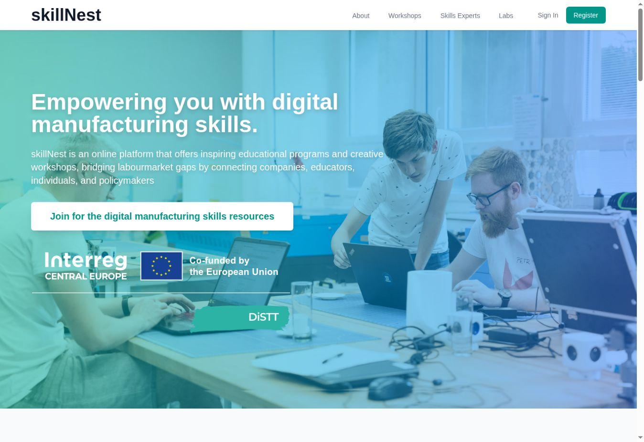
Figure 1. SkillNest landing page and entry point.

6.2 Workshop catalogue and discovery tools
The public catalogue supports full-text search, filters and an option to show workshops with open sessions. Cards expose key selection metadata such as title, organisation, educator, level, status, target group, format, duration, capacity and skill-gap tags.
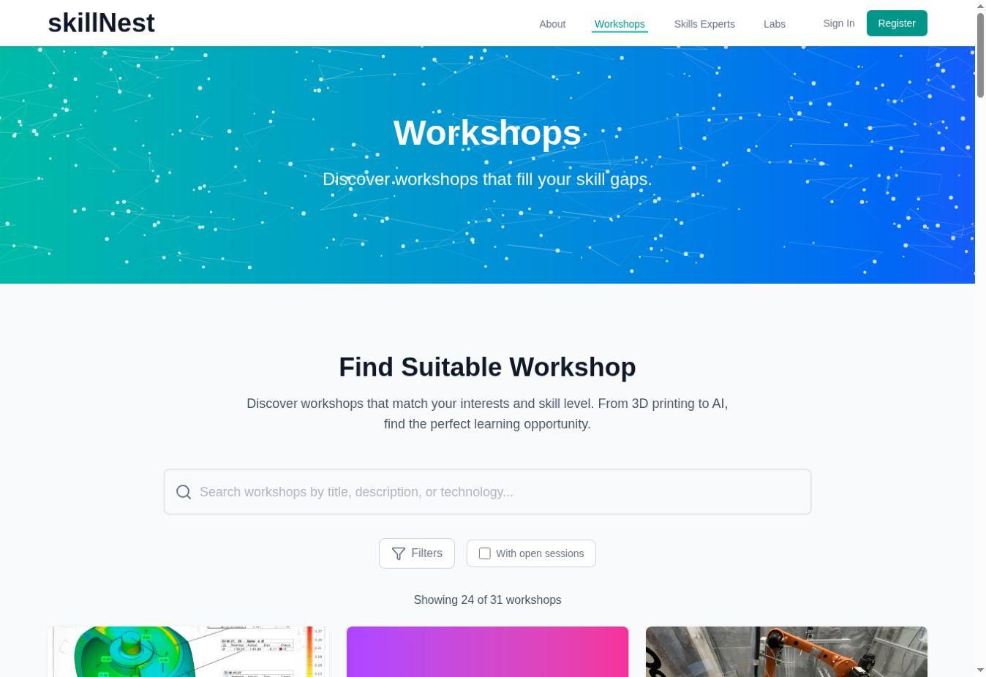
Figure 2. Workshop catalogue, search and filter interface.

6.3 Workshop detail
Each workshop detail page turns a catalogue entry into an implementation and participation record. It combines description, organisation, lecturers, audience, duration, capacity and skill gaps with learning objectives, prerequisites, assessment links and access to materials.
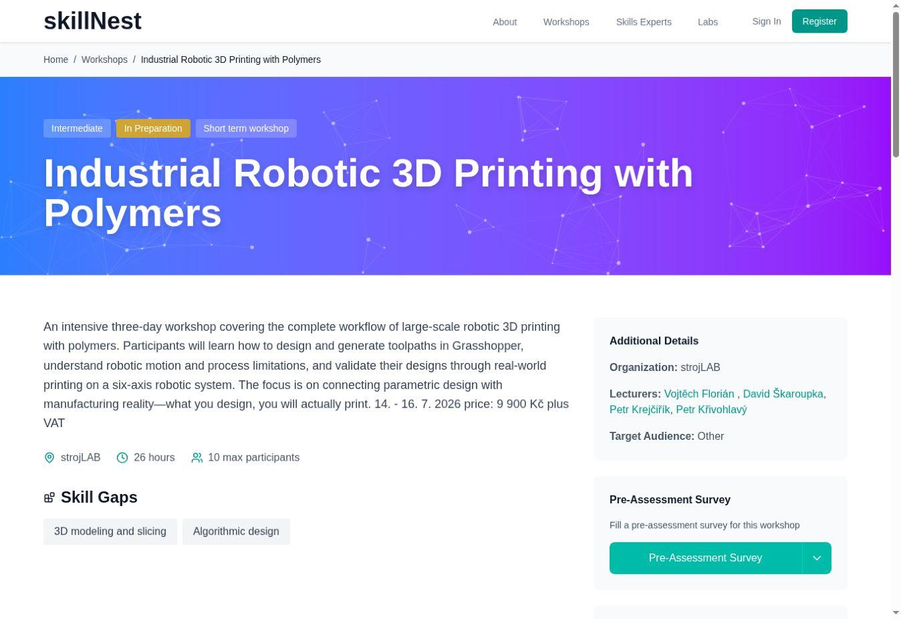
Figure 3. Workshop detail with metadata and assessment entry point.

6.4 Pre- and post-assessment tools
Workshop pages can link to separate pre- and post-assessment surveys. Surveys are embedded in SkillNest and can also be opened through a shareable link. The same core competence statements should be used at both stages.

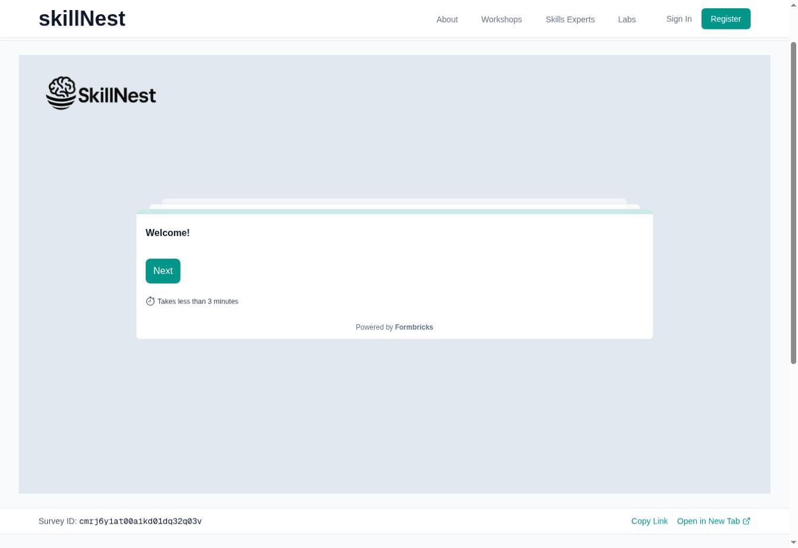
Figure 4. Embedded pre-assessment environment.
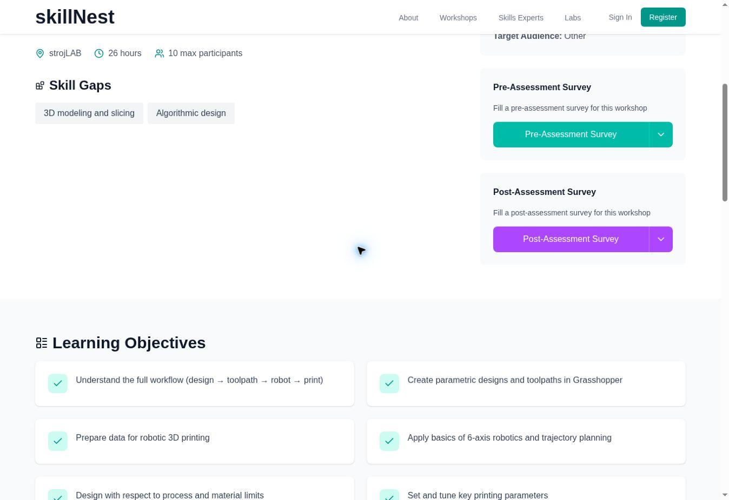
Figure 5. Pre/post assessment access and learning objectives within a workshop.

6.5 Workshop materials and downloadable resources
Workshop materials can be role-gated. Public users can understand that resources exist, while sign-in or an additional role may be required to download participant or educator content. This supports both dissemination and responsible control of facilitator-only materials.
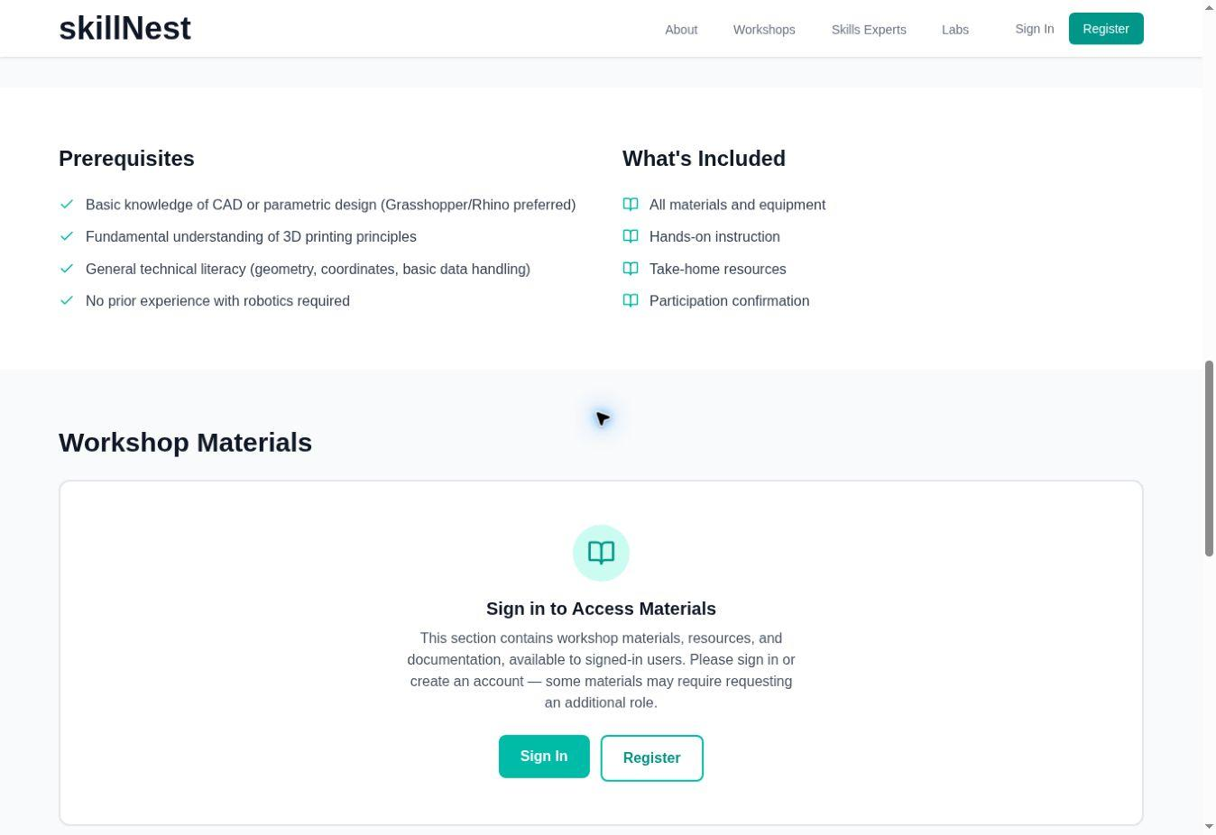
Figure 6. Role-gated workshop materials and account access.

6.6 Lab network
The Labs section presents the six DiSTT environments across five countries. Profiles connect location, specialisation, facilities and contact information and can link a user from a programme to a delivery environment.
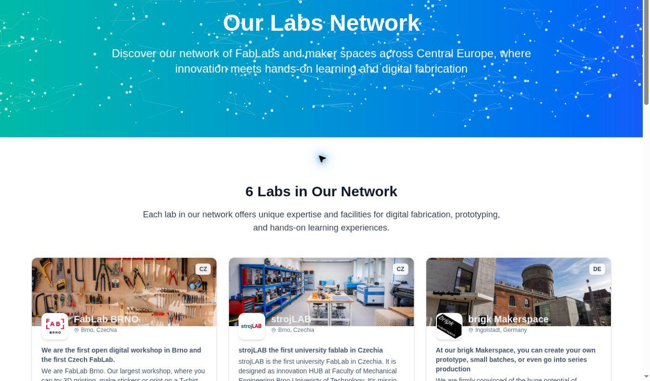
Figure 7. DiSTT laboratory network.

6.7 Skills Experts directory
The experts directory makes delivery capacity visible. Users can filter educators and industrial experts and inspect expertise, affiliation and contact routes. This supports programme transfer, peer support and stakeholder engagement.
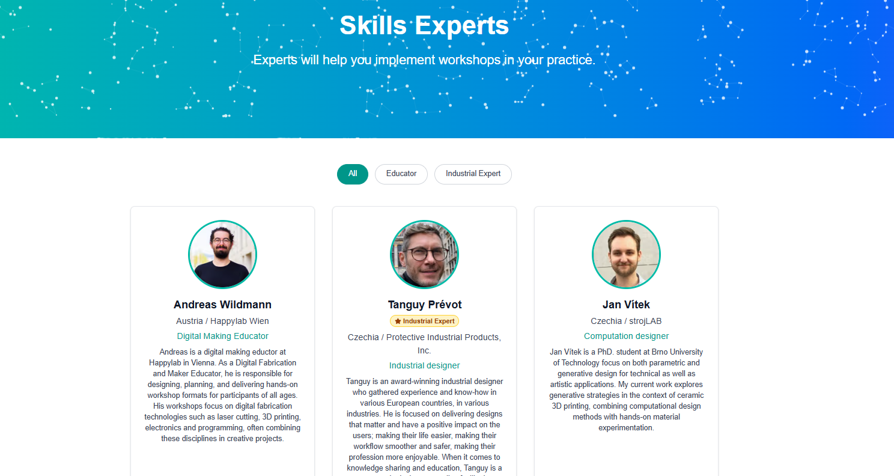
Figure 8. Skills Experts directory and role filters.

6.8 Registration and programme information
Registration creates the basis for access to restricted resources and can support stronger uptake monitoring. The RE/UP page explains the overall programme concept, industry-driven curriculum and practical structure.
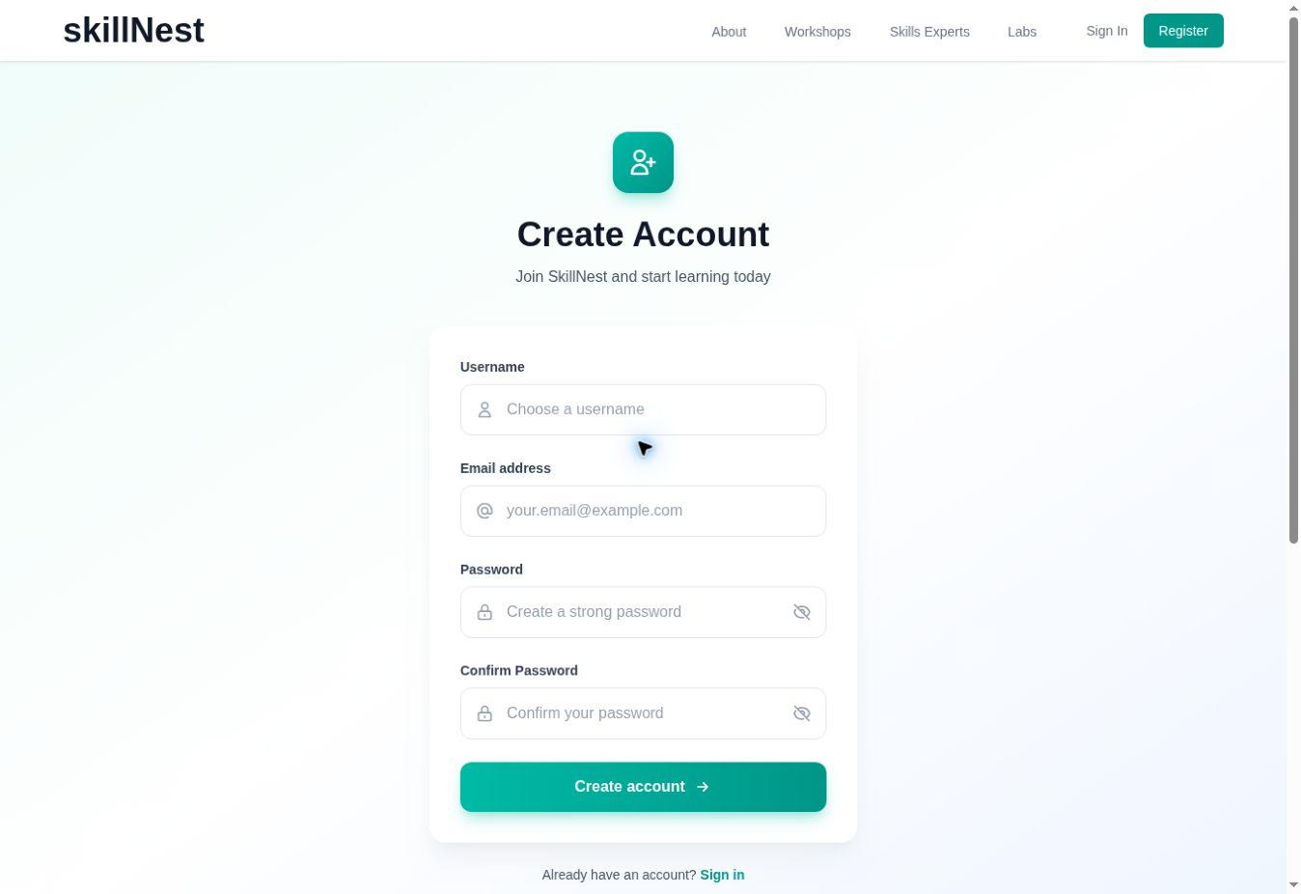
Figure 9. User registration interface.
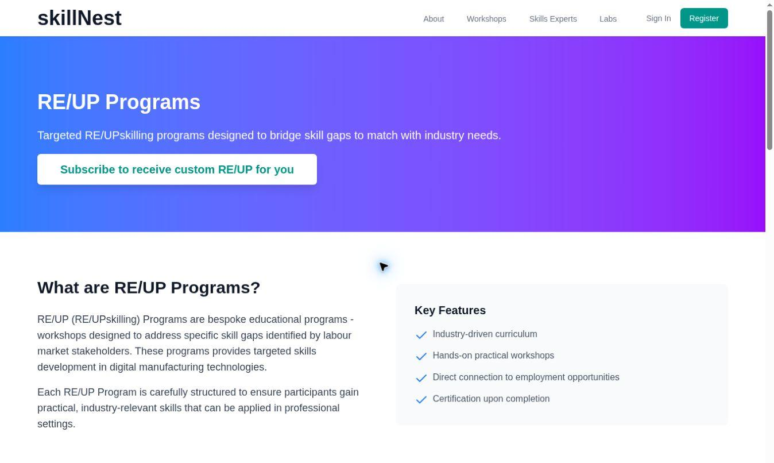
Figure 10. RE/UP programme information page.

6.9 Communication and feedback
- Newsletter subscription and workshop notifications.
- Contact routes from workshop and lab profiles.
- Feedback form and expressions of interest.
- Links between workshops, organisations and experts.

7. Assessment Toolkit

7.1 Assessment purposes
Assessment in DiSTT is designed primarily for learning and programme improvement. It is not a replacement for formal qualification testing unless a partner adds validated competence criteria and appropriate examination arrangements.
Purpose | Use
Needs diagnosis | Identify entry experience, confidence and support needs.
Differentiation | Form balanced teams or provide alternative task levels.
Learning reflection | Help participants recognise what changed.
Programme evaluation | Compare patterns across runs and identify weak modules.
Stakeholder evidence | Demonstrate relevance and outcomes without exposing personal data.

7.2 Recommended measurement model
- Use identical competence statements before and after delivery.
- Use a five-point anchored scale, for example 1 = no understanding / cannot perform; 5 = can perform independently and explain to others.
- Keep questions specific to the actual learning outcomes and practical task.
- Add no more than three common transversal items unless soft skills are a central objective.
- Use a registration identity or anonymous matching code when individual gain is required.
- Report response counts and unmatched-response limitations transparently.

7.3 Core assessment components
Component | When | Evidence produced
Pre-assessment | Before or at the start | Baseline, expectations and support needs
Formative observation | During practical work | Safety, process use, collaboration and troubleshooting
Practical output | During and at completion | Applied competence demonstrated in a prototype, file or presentation
Post-assessment | At the end | Perceived development, satisfaction and next-step intention
Stakeholder/expert feedback | At review or demonstration | External relevance and transfer recommendations

7.4 Minimum package by programme format
Format | Minimum assessment package | Recommended extension
1–4 hour workshop | 3–5 mirrored competence items + one usefulness question | Facilitator observation note
1–3 day intensive | 5–8 mirrored items + output check + satisfaction/open feedback | Matching code and transfer-intention question
Multi-week studio | Baseline + milestone reviews + output rubric + post-assessment | Portfolio and peer/expert review
Competition / sprint | Baseline + team observation + final prototype/pitch criteria | Jury feedback and team reflection
Professional programme | Technical baseline + practical criteria + post-assessment | Recognition, employer feedback and follow-up application

7.5 Practical-output rubric
Criterion | 1 – emerging | 3 – competent | 5 – independent / transferable
Technical execution | Output incomplete or requires continuous support | Functional output with occasional support | Reliable output; participant can explain and adapt process
Process understanding | Steps followed without understanding dependencies | Explains main workflow and constraints | Diagnoses trade-offs and proposes improvements
Safety and equipment use | Needs repeated correction | Follows required procedures | Works consistently and supports safe team practice
Problem-solving | Stops when an error occurs | Tests plausible corrections | Uses evidence, compares options and documents learning
Communication | Result is difficult to interpret | Explains goal, process and result | Tailors explanation to users, peers or stakeholders

7.6 Interpretation and limitations
Self-assessment measures perceived competence and confidence. It can be influenced by response shift: beginners may initially overestimate a skill and rate themselves more critically after understanding its complexity. For this reason, DiSTT combines survey results with practical evidence and facilitator observation.
REPORTING RULE
Always state the number of pre and post responses, whether responses were individually matched, the scale anchors and whether the practical output was independently assessed.

7.7 Data protection
- Collect only data needed for delivery, evaluation and agreed uptake monitoring.
- Use aggregated reporting for minors and sensitive groups.
- Keep attendance records and identifiable survey responses separate where possible.
- Inform participants about purpose, retention, access and contact points.
- Do not publish personal assessment results in SkillNest workshop pages.

8. How to Use and Adopt the Toolkit

8.1 Nine-step adoption workflow
Assess readiness. Confirm strategic fit, educator capacity, equipment, safety, target group access and time.
Identify the skill gap. Use employer, learner, educator or regional evidence to define the need.
Select a programme package. Choose the closest validated package and inspect essential versus adaptable elements.
Adapt responsibly. Change language, examples, duration or equipment while protecting core outcomes and practical logic.
Prepare delivery. Assign roles, test equipment, obtain materials, configure assessment and plan contingencies.
Recruit and register. Use target-group channels and explain prerequisites, accessibility and expected outputs.
Deliver and assess. Combine concise input, practical work, formative feedback and the selected assessment package.
Review and improve. Compare assessment evidence, facilitator notes and stakeholder feedback.
Repeat and scale. Version resources, document the next run, share learning and connect with the SkillNest network.

8.2 Readiness check
Area | Minimum readiness question
Strategic fit | Is the target skill gap evidenced and relevant to our mission?
Learners | Can we recruit the intended group and remove participation barriers?
Educators | Who owns technical content, facilitation and safety?
Equipment | Are machines, software, consumables and maintenance available?
Assessment | Can we administer mirrored pre/post questions and observe practical outputs?
Partnership | Do we need a company, school, expert, jury or referral partner?
Sustainability | Can the format be repeated after the first adoption run?

8.3 Adaptation decision rule
PRESERVE THE LEARNING MECHANISM
An adopter may change the local topic, software, material or timetable. It should not remove the element that creates the intended learning: direct fabrication, iterative challenge, final demonstration, mentoring or another package-specific mechanism.

8.4 First-run implementation record
- Adopter organisation, location and responsible person.
- Selected package and version of resources.
- Target group, recruitment channel and participant numbers.
- Adaptations made and reasons.
- Delivery dates, hours and format.
- Pre/post response counts and matching method.
- Practical outputs and facilitator observations.
- Participant and stakeholder feedback.
- Changes required before the next run.

9. Transferability, Inclusion and Scaling
9.1 Transfer across territories
Transferability is supported by joint development across six partners operating in five Central European countries. The packages were tested in university, open FabLab, VET, startup-support, regional innovation and school-outreach contexts. This diversity provides evidence that common quality principles can coexist with regional adaptation.

9.2 Transfer across sectors and target groups
Original context | Potential transfer | Adaptation emphasis
University FabLab | Professional training or company academy | Industrial examples, scheduling and recognition
Secondary-school challenge | VET or youth employment programme | Task difficulty, safeguarding and employer role
Apprentice makerspace programme | Adult career-transition course | Pacing, prior experience and application planning
Startup hackathon follow-up | SME innovation programme | Problem ownership, IP and mentoring cadence
Regional technical catalogue | Chamber or adult-learning offer | Language, pricing and referral pathways
Remote school modules | Mobile FabLab or community centre | Portable equipment and low-cost variants

9.3 Inclusion principles
- Describe prerequisites accurately and avoid treating prior access to technology as ability.
- Offer beginner pathways, visual instructions and staged tasks.
- Use team formation and differentiated roles to prevent exclusion by confidence or experience.
- Provide reasonable accessibility adaptations and alternative ways to demonstrate learning.
- Use inclusive language and imagery and monitor participation patterns.
- Protect minors and vulnerable participants through appropriate consent and safeguarding.
- Use local languages where they materially improve participation and learning.

9.4 Scaling without quality loss
- Scale through repeated cohorts before increasing group size.
- Train additional facilitators using observed delivery and co-facilitation.
- Maintain a versioned core resource set with local add-ons.
- Track fidelity to essential elements and reasons for adaptation.
- Use a small common assessment core so results remain comparable.
- Share problems and improvements through the FabLab and SkillNest network.

10. Uptake, Sustainability and Governance

10.1 Ownership and durability
Brno University of Technology will maintain SkillNest as the digital access point for the toolkit. Programme ownership remains distributed: each partner is responsible for the accuracy and practical relevance of its package and associated resources. This combined model supports platform continuity while preserving subject ownership.

10.2 Partner responsibilities
Responsibility | Platform owner | Programme owner | Adopter
Technical availability | Maintain application and core services | Report problems | Use supported access routes
Programme content | Provide structure and publishing support | Review and update package | Adapt transparently
Assessment templates | Maintain access and common structure | Validate programme-specific items | Administer responsibly
User roles and access | Manage role model and platform rules | Nominate authorised educators | Request appropriate access
Uptake monitoring | Aggregate platform indicators | Record partner reuse | Provide first-run feedback

10.3 Content governance cycle
- Programme owner reviews content at least annually or after a material process change.
- Changes receive a version number, date and short revision note.
- Broken links, obsolete software instructions and safety information receive priority.
- New resources are labelled by audience and access level.
- Assessment changes preserve comparability or document a deliberate break in series.
- Adopter feedback is reviewed for general improvements and local-only variants.

10.4 Uptake monitoring indicators
- Number of registered organisations and educators accessing toolkit resources.
- Number of distinct programme packages downloaded or requested.
- Number of adopter organisations completing a first run.
- Countries, territories and target groups represented.
- Repeated delivery after the first adoption.
- Participant reach and assessment-response rates.
- Qualitative improvements contributed back to the toolkit.

11. Conclusions
The Digital Skills Transformation Toolkit is the jointly developed solution through which DiSTT moves from experimentation to repeatable practice. It brings together six regionally grounded programme packages, a common assessment approach, transfer guidance and a digital environment that connects workshops, labs, experts, learners and resources.
Its value lies neither in rigid standardisation nor in a loose collection of workshop ideas. The toolkit identifies what should remain essential—hands-on application, visible outcomes, formative support, assessment and stakeholder relevance—and what can be adapted to local target groups, equipment, language and delivery conditions.
FINAL RESULT
A practical route from an identified digital-fabrication skill gap to a selected programme, prepared delivery, documented learning outcome and repeatable local offer, accessible through skillnest.app.

Annex A – Comparative Matrix of the Six Prgm. Packages
Package | Target group | Typical duration | Primary mechanism | Equipment intensity
BUT strojLAB | Students, professionals | 2 h to multi-week | Project, studio and professional practice | Low to very high
FabLab Brno/Jintek | Secondary schools | 3 days to multi-month | Challenge and competition | Medium to high
Happylab | Apprentices | 3 days | Shared robotic prototype | High
brigk | SMEs, students, apprentices | 1 h to multi-month | Technology entry + mentored innovation | Low to high
NOI | Adults, SMEs, artisans | Short to multi-session | Technical course or finished object | Medium to high
FabLab Zagreb | Secondary schools / outreach | Independent modules | Guided modular prototyping | Low to medium

Annex B – Assessment Questions and Templates

B.1 Common pre/post statements
- I understand the complete workflow covered by this programme.
- I can prepare the required digital data for the selected fabrication or programming process.
- I can use the relevant tool or machine according to the required safety procedure.
- I can select or adjust the main parameters that influence the result.
- I can identify a common error and test a suitable correction.
- I can apply the process to create a functional or communicable output.
- I can explain my technical decisions to another person.
- I can contribute effectively to a team-based digital project.
- I feel confident trying an unfamiliar digital tool.
- I know where to find further support, facilities or learning resources.
Recommended scale: 1 = not at all / cannot perform; 2 = limited; 3 = with some support; 4 = mostly independently; 5 = independently and able to explain.

B.2 Post-only questions
- How satisfied are you with the programme overall?
- How relevant was the programme to your work, study or project goals?
- How likely are you to apply the skills within the next three months?
- Which activity contributed most to your learning, and why?
- Where did you need more time, explanation or practice?
- What should be changed before the programme is repeated?

B.3 Facilitator observation checklist
☐ Participant follows equipment and safety instructions.
☐ Participant can move from explanation to practical action.
☐ Participant seeks or offers support appropriately.
☐ Participant tests and revises after an unsuccessful result.
☐ Participant can explain the output, the demonstrated learning outcomes and the next improvement.
☐ Team roles and contribution are sufficiently balanced.

Annex C – Toolkit Resource and Download Register
No. | Package | Expected resource set | Access | Final URL / version
1 | Maker Engineering and Digital Manufacturing Engineering | Programme fiche; educator guide; workshops,workshop presentation, expert list, assessment | Public + registered + educator | https://skillnest.app/en/labs/stroj-lab
2 | High School Competition and TechSprint | Programme fiche; educator guide; workshops,workshop presentation, expert list, assessment | Public + registered + educator | https://skillnest.app/en/labs/FLbrno
3 | Digital Tools in Vocational Training | Programme fiche; educator guide; workshops,workshop presentation, expert list, assessment | Public + registered + educator | https://skillnest.app/en/labs/happylab
4 | Digital Transformation Skills Programme | Programme fiche; educator guide; workshops,workshop presentation, expert list, assessment | Public + registered + educator | https://skillnest.app/en/labs/brigk-makerspace
5 | LEARN IT! and MAKE IT! | Programme fiche; educator guide; workshops,workshop presentation, expert list, assessment | Public + registered + educator | https://skillnest.app/en/labs/noi-techpark
6 | Idea to Prototype with Cutting-Edge Fabrication Technology | Programme fiche; educator guide; workshops,workshop presentation, expert list, assessment | Public + registered + educator | https://skillnest.app/en/labs/fab-lab-zagreb

Annex D – SkillNest Functionality and Screenshot Register
Figure | Functionality | Access level | Status on 23 July 2026
1 | Landing page and stakeholder entry | Public | Verified
2 | Workshop catalogue, search and filters | Public | Verified
3 | Workshop details and metadata | Public | Verified
4–5 | Embedded pre/post assessment | Public link | Verified
6 | Materials access gate | Public / registered / role-based | Verified publicly
7 | Labs network | Public | Verified
8 | Experts directory and filters | Public | Verified
9 | Account registration | Public | Verified
10 | RE/UP information page | Public | Verified
— | Workshop/content administration | Educator / administrator | Admin evidence required
— | Assessment results and monitoring | Administrator | Admin evidence required

Annex E – Source Deliverables and Project Traceability
Toolkit element | Primary source | How reflected in D3.3.1
Project need and solution definition | Approved DiSTT Application Form | Chapters 1–2 and toolkit architecture
Joint design requirements | D1.3.1 Joint Blueprint | Common fiche structure and design principles
Partner programmes | D2.1.1 RE/UPskilling programmes | Six programme packages
Pilot evidence and lessons | D2.2.1 LP1 and PP2–PP6 reports | Evidence, lessons, essential/adaptable elements
Joint evaluation | D2.3.1 Joint Evaluation Report | Common principles and assessment recommendations
Implementation guidance | D3.2.1 Implementation Guide | Adoption workflow and readiness
Digital implementation | SkillNest | Chapter 6 and screenshot register

Annex F – Toolkit Adoption Checklist

Selection
☐ The target skill gap and participant group are evidenced.
☐ A programme package and workshop format have been selected.
☐ Essential and adaptable elements have been reviewed.

Preparation
☐ Educator, technical support and safety responsibilities are assigned.
☐ Equipment, software, materials and contingency options are ready.
☐ Participant and educator resources use the correct version.
☐ Pre/post assessment and matching method are configured.

Delivery
☐ Participants understand objectives, prerequisites and expected output.
☐ Practical activity follows concise explanation and demonstration.
☐ Facilitators record observations and support differentiation.

Review and scale
☐ Response counts, practical outputs and limitations are documented.
☐ Participant, facilitator and stakeholder feedback is reviewed.
☐ Changes are versioned before the next delivery.
☐ Adoption feedback is shared with the programme owner or SkillNest contact.

