

Implementation Guide
D 3.2.1

INTERREG CENTRAL EUROPE
Digital Skills Transformation Toolkit for a Resilient Labour Market
D3.2.1
Implementation Guide
Step-by-step adoption of the DiSTT re/upskilling programmes, assessment tools and SkillNest toolkit
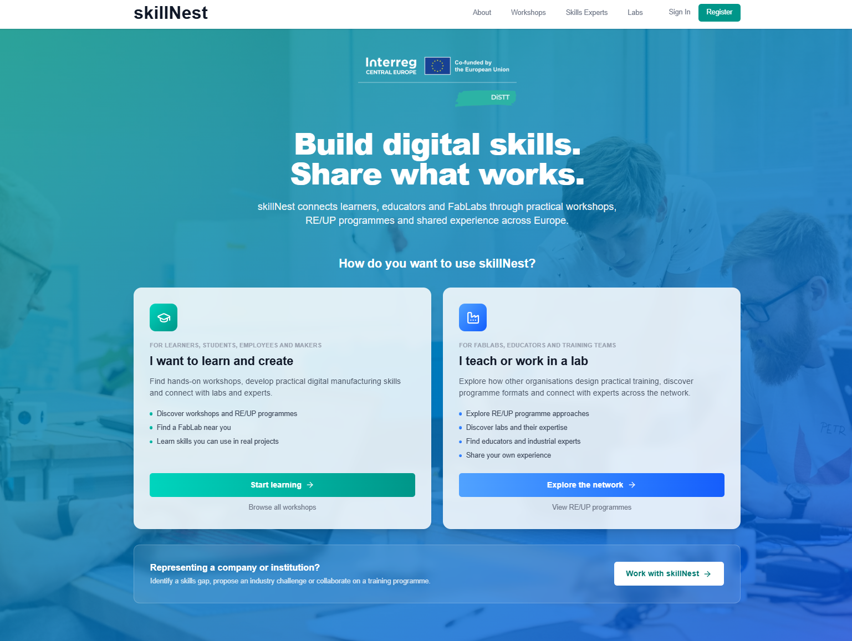


Document control
Field | Value
Project | Digital Skills Transformation Toolkit for a Resilient Labour Market (DiSTT)
Programme | Interreg CENTRAL EUROPE 2021–2027
Project ID | CE0200661
Deliverable | D3.2.1 Implementation Guide
Work package / activity | WP3 / A3.2
Document purpose | Adoption manual for the programmes and assessment tools packaged in D3.3.1
Activity contribution | Jointly developed by the DiSTT partnership; one dedicated project meeting organised by PP5
Delivery month | July 2026
Digital access point | skillnest.app
Status | Draft for consortium validation and completion

Table of Contents
Right-click and select Update Field.

The table of contents is an updateable Word field. Static chapter index:
- 1. Executive Summary
- 2. Purpose, Scope and Relationship to D3.3.1
- 3. Implementation Principles from WP2
- 4. Two Delivery Formats of the Guide
- 5. Step-by-Step Implementation Pathway
- 6. Selecting the Right Programme Package
- 7. Detailed Operational Planning
- 8. Assessment, Evaluation and Quality Assurance
- 9. Implementing through SkillNest
- 10. Inclusion, Ethics and Data Protection
- 11. Sustainability, Transfer and Scaling
- 12. Conclusions
- Annexes A–H

List of Figures
- Figure 1. SkillNest landing page and stakeholder pathways
- Figure 2. Workshop catalogue used for programme discovery
- Figure 3. Workshop detail and implementation metadata
- Figure 4. Embedded pre-assessment environment
- Figure 5. Role-gated access to learning and facilitation materials
- Figure 6. Skillnest Educator's Dashboard
- Figure 7. Skillnest Educator's Dashboard - create new workshop
- Figure 8. SkillNest learner statistics - self-evaluation report

List of Tables
- Table 1. Relationship between D3.2.1 and D3.3.1
- Table 2. Implementation principles derived from WP2
- Table 3. Web step-by-step guide structure
- Table 4. Implementation stages, outputs and decision gates
- Table 5. Comparative programme selection matrix
- Table 6. Minimum implementation team
- Table 7. Assessment package by format
- Table 8. Sustainability and scaling indicators

Abbreviations
Abbreviation | Meaning
AF | Application Form
BUT | Brno University of Technology
CE | Central Europe
DME | Digital Manufacturing Engineering
EU | European Union
FabLab | Fabrication Laboratory
KPI | Key performance indicator
LP / PP | Lead Partner / Project Partner
ME | Maker Engineering
PPE | Personal protective equipment
RE/UP | Re/upskilling
SME | Small and medium-sized enterprise
VET | Vocational education and training

1. Executive Summary
The D3.2.1 Implementation Guide is the jointly developed manual for organisations adopting the re/upskilling programmes and assessment tools contained in the D3.3.1 Digital Skills Transformation Toolkit. It converts the practical experience of WP2 into a repeatable implementation pathway for FabLabs, makerspaces, schools, universities, VET providers, innovation organisations and company-training environments.
PURPOSE
Help an adopting organisation move from an identified digital-fabrication skill gap to a selected and adapted programme, prepared delivery, documented learning outcomes and a sustainable repeat offer.

The guide is designed for two publication formats. The first is a concise, easy-to-use step-by-step guide for rapid orientation and action. The second is this comprehensive, web-embedded document, which explains decisions, roles, checklists, assessment, risk management, quality assurance, transfer and sustainability in sufficient detail for an implementation team.

Who should use the guide
- A FabLab or makerspace manager deciding whether and how to add a DiSTT programme to the local offer.
- An educator adapting a validated workshop to a new target group, language, machine or timetable.
- A school, university or VET coordinator arranging access to facilities, educators and assessment.
- A company or business-support organisation commissioning an applied upskilling activity.
- A programme owner or SkillNest administrator supporting transfer and monitoring uptake.

How to use the guide
Situation | Recommended entry point | Expected result
First exploration | Chapter 4 web step-by-step structure | Understand the full adoption route in minutes
Programme choice | Chapter 6 selection matrix | Shortlist the closest validated package
Planning a first run | Chapters 5 and 7 | Complete an implementation plan and risk register
Configuring assessment | Chapter 8 | Select a proportionate evidence package
Using SkillNest | Chapter 9 | Find content, register users and connect resources
Repeating or scaling | Chapter 11 | Protect quality while increasing reach

Source: D3.3.1 Digital Skills Transformation Toolkit; D2.2.1 partner Pilot Run Reports; D2.3.1 Joint Evaluation Report; approved DiSTT output definition.

2. Purpose, Scope and Relationship to D3.3.1

2.1 Scope of the Implementation Guide
D3.2.1 covers organisational adoption and implementation. It explains what an adopter must decide, prepare, deliver, record and improve. It does not reproduce all programme materials and does not replace technology-specific operating instructions, machine safety documentation or local legal requirements.

2.2 Relationship between the guide and the toolkit
Deliverable | Primary question | Content | Use by adopter
D3.2.1 Implementation Guide | How do we implement it successfully and sustainably? | Steps, decisions, roles, readiness, adaptation, delivery, assessment, risks and scaling | Plan and govern adoption
D3.3.1 Digital Skills Transformation Toolkit | What validated solution and resources can we adopt? | Six programme packages, assessment toolkit, programme fiches, SkillNest functions and resources | Select and use the final solution
SkillNest | Where do we discover, access and connect the elements? | Catalogue, workshop details, assessments, materials, labs and experts | Access and support delivery

2.3 What adoption means
Adoption is more than downloading a presentation. An organisation has adopted the toolkit when it has selected a package, and optimally also documented local adaptations, assigned coordination and lecturer roles, prepared the required resources, delivered at least one run, collected proportionate assessment evidence.
MINIMUM ADOPTION EVIDENCE
A completed implementation record (eg. Letter of Intent), organisation itself or experts are visible on the skillnest.app

2.4 Scope boundaries and local responsibility
- The programme owner supplies the validated learning logic and core resources.
- The adopter remains responsible for local safety, equipment compliance, accessibility, safeguarding and data protection.
- Technology substitutions are permitted when learning outcomes remain achievable and the substitution is documented.
- Formal certification requires separate validation, examination and recognition arrangements unless explicitly included in the selected package.
- Commercial terms, licensing and cost recovery must follow the rights attached to the final toolkit resources or global skillnest licensing rules.

3. Implementation Principles from WP2
The guide is grounded in practical implementation across different Central European regions, target groups and institutional settings. WP2 showed that transfer is most reliable when a common quality core is preserved while format, language, examples, duration and equipment are adapted transparently.
Principle | Operational interpretation | Minimum evidence
Start from a real skill gap | Use evidence from learners, employers, educators or regional stakeholders; avoid selecting technology only because equipment is available. | Needs statement and target-group profile
Keep learning hands-on | Move quickly from explanation to making, programming, testing or troubleshooting. | Practical activity occupies the majority of delivery time
End with visible evidence | Use a prototype, file, demonstration, pitch, portfolio or documented process as an observable outcome. | Defined final output and review criteria
Preserve the learning mechanism | Retain the programme element that produces the intended learning, such as a challenge, iterative project, mentoring or final demonstration. | Essential-versus-adaptable decision record
Use formative facilitation | Support participants during the process and adapt scaffolding to entry competence. | Facilitator plan and observation notes
Assess proportionately | Match the depth of pre/post assessment and practical evidence to programme duration and purpose. | Assessment package selected before recruitment
Combine technical and transversal skills | Embed teamwork, communication, planning and problem-solving in the technical task. | Explicit roles, milestones or presentation
Version and improve | Treat the first run as an evidence-generating implementation cycle. | After-action review and revised resource version

3.1 Lessons with direct implementation consequences
- Heterogeneous groups benefit from pre-assessment, differentiated tasks and balanced team formation.
- Mirrored pre/post questions are more useful than unrelated satisfaction-only surveys.
- Registration or stable matching codes are needed when individual learning gains are to be calculated.
- Short workshops need a reduced assessment package so evaluation does not displace practical work.
- Equipment, software, wiring, consumables and starter files should be tested before participants arrive.
- Final projects should remain connected to taught content; activities with no visible role in the final task are often perceived as less useful.
- Company and expert participation works best with a clear, bounded role and realistic time commitment.
- Scaling should begin with repeated cohorts and facilitator development before increasing group size.

3.2 Implementation quality standard
FOUR NON-NEGOTIABLES
Every adopted workshop (pilot run) should have: (1) evidenced need, (2) explicit learning outcomes, (3) supervised practical activity, (4) proportionate assessment.

4. Two Delivery Formats of the Guide

4.1 Guide format 1 – Step-by-step guide
The Step-by-step guide serves users who need more clarity. It is a sequence of short action cards, each with one decision, a short checklist, the expected output.
Card | Core action | Output
1. Define your case | Name the target group, need and programme owner. | One-sentence implementation case
2. Check readiness | Score facilities, people, safety, recruitment, assessment and sustainability. | Readiness decision
3. Select a package | Compare the six validated programme families. | Selected package and fallback
4. Protect the core | Identify essential and adaptable elements. | Adaptation record
5. Build the team | Assign programme, educator, technical, safety and evaluation roles. | Named implementation team
6. Prepare resources | Test equipment, software, files, materials and contingencies. | Delivery-ready checklist
7. Configure assessment | Choose mirrored questions, output evidence and matching method. | Assessment package
8. Recruit and onboard | Communicate prerequisites, access, schedule, safety and expected output. | Confirmed cohort
9. Deliver and support | Use concise input, demonstration, hands-on work and feedback. | Completed programme run
10. Review and improve | Combine data, observations and participant/stakeholder feedback. | After-action review
11. Repeat and scale | Version resources, plan the next run and report adoption. | Sustainability decision

4.2 Guide format 2 – Comprehensive web-embedded document
This document is the detailed implementation reference. It is embedded or linked from the web guide. It contains the rationale and instruments that would guide Educators to create their own workshops. We have prepared a procedure on the website for the natural adoption of the toolkit https://skillnest.app/how-to

4.3 Linking the two formats
Web-guide element | Deep link in comprehensive guide | SkillNest action
Define your case | Chapters 2 and 5 | Review programme information
Check readiness | Chapter 5 and Annex A | Review lab and expert requirements
Select a package | Chapter 6 | Search catalogue and programme pages
Prepare resources | Chapter 7 and Annexes B–D | Access registered/educator materials
Configure assessment | Chapter 8 and Annex E | Open or configure pre/post assessment
Review and scale | Chapter 11 and Annex F | Record uptake and contact programme owner

4.4 Accessibility and language
- Use action-led headings and short sentences in the web format.
- Provide text alternatives for screenshots and diagrams.
- Avoid relying on colour alone for status or meaning.
- Publish key implementation content in the relevant partner and adopter languages.
- Keep a stable English reference version for cross-border comparability.
- Show document version and last review date in both formats.

5. Step-by-Step Implementation Pathway
The pathway below is the core operating model of the guide. An organisation may move quickly through familiar stages, but it should not skip the associated decision gate. Each stage produces a small piece of evidence that makes the first run auditable, improvable and transferable.
Stage | Action | Main task | Required output | Decision gate
0 | Appoint an implementation owner | Confirm authority, time, internal sponsor and reporting route. | Named owner and sponsor | Owner can commit resources or escalate decisions
1 | Define the implementation case | Describe target group, skill gap, context and intended value. | Implementation case | Need is evidenced and aligned with mission
2 | Assess readiness | Review people, facilities, safety, recruitment, assessment and sustainability. | Readiness score and gap plan | Critical readiness gaps have owners
3 | Select the programme package | Compare target group, mechanism, duration, resources and transfer fit. | Selected package and fallback | Selection rationale is documented
4 | Adapt while protecting the core | Localise language, examples, schedule, software or equipment. | Adaptation record | Essential learning mechanism remains intact
5 | Plan delivery and risks | Assign roles, sequence sessions, test resources and prepare contingencies. | Delivery plan and risk register | Safety and critical dependencies are controlled
6 | Configure SkillNest and assessment | Prepare pages, access, surveys, matching and data handling. | Published information and assessment package | Participant journey has been tested
7 | Recruit and onboard participants | Use suitable channels and communicate prerequisites and expectations. | Confirmed cohort and onboarding record | Participants can make an informed commitment
8 | Deliver the programme | Combine short inputs, demonstrations, practical work and feedback. | Completed run and practical outputs | Learning outcomes were addressed
9 | Evaluate and improve | Triangulate survey, practical, observation and feedback evidence. | After-action review and change list | Limitations and changes are explicit
10 | Repeat, transfer and scale | Version resources, develop facilitators and plan sustainable continuation. | Next-run and scaling decision | Quality can be maintained with available capacity

5.0 Appoint an implementation owner
Confirm authority, time, internal sponsor and reporting route.
- Nominate one accountable implementation owner.
- Confirm an internal sponsor who can resolve budget, staffing or partnership barriers.
- Set a decision date for first-run approval.
- Create one shared implementation record rather than dispersed email decisions.
Required output: Named owner and sponsor. Decision gate: Owner can commit resources or escalate decisions.

5.1 Define the implementation case
Describe target group, skill gap, context and intended value.
Question | Implementation note
Who should learn? | Define group, size, age, prior experience, language and access barriers.
What should change? | State 3–8 observable learning outcomes, not only technologies covered.
Why now? | Link the need to learner demand, employer evidence, curriculum or regional priorities.
What should participants produce? | Specify a prototype, file, demonstration, pitch, portfolio or validated process.
What happens after? | Identify a next course, project, workplace application or independent access route.

Required output: Implementation case. Decision gate: Need is evidenced and aligned with mission.

5.2 Assess readiness
Review people, facilities, safety, recruitment, assessment and sustainability.
Domain | Scoring anchor
Strategic fit | 0 = unclear; 1 = plausible; 2 = evidenced and sponsored
Educator capacity | 0 = unavailable; 1 = external/partial; 2 = named and competent
Facilities and equipment | 0 = missing; 1 = gaps manageable; 2 = tested and available
Safety and safeguarding | 0 = unresolved; 1 = plan exists; 2 = approved and assigned
Recruitment access | 0 = no channel; 1 = partner-dependent; 2 = confirmed route
Assessment capacity | 0 = no plan; 1 = basic survey; 2 = survey plus practical evidence
Sustainability | 0 = one-off only; 1 = conditional repeat; 2 = repeat pathway identified

READINESS RULE
Do not proceed while any safety or safeguarding domain scores 0. For other domains, a score of 0 requires a named mitigation, owner and deadline before recruitment begins.

Required output: Readiness score and gap plan. Decision gate: Critical readiness gaps have owners.

5.3 Select the programme package
Compare target group, mechanism, duration, resources and transfer fit.
Use Chapter 6 to compare packages. Select by learning mechanism and target-group fit before selecting by equipment. Record one fallback format in case the preferred duration, educator or machine cannot be secured.
Required output: Selected package and fallback. Decision gate: Selection rationale is documented.

5.4 Adapt while protecting the core
Localise language, examples, schedule, software or equipment.
Preserve | Adapt with documentation
Learning outcomes | Examples, terminology and local industry context
Hands-on or project mechanism | Timetable and session length
Final practical evidence | Software, machine or material where outcomes remain achievable
Safety and supervised access | Group size within safe staffing limits
Assessment purpose | Number of questions and collection method

Required output: Adaptation record. Decision gate: Essential learning mechanism remains intact.

5.5 Plan delivery and risks
Assign roles, sequence sessions, test resources and prepare contingencies.
- Freeze the first-run scope early enough to test all files, accounts and machines.
- Prepare a low-technology or alternative-machine contingency for non-critical equipment failure.
- Schedule setup, cleanup, data collection and participant movement—not only teaching time.
- Confirm software licences, user accounts, material quantities, PPE and accessibility adjustments.

Required output: Delivery plan and risk register. Decision gate: Safety and critical dependencies are controlled.

5.6 Configure SkillNest and assessment
Prepare pages, access, surveys, matching and data handling.
Publish accurate public information, check registered and educator access, configure pre/post assessment and test the complete participant journey. Exact administrative procedures are described in Chapter 9 and require final verification by the platform owner.
Required output: Published information and assessment package. Decision gate: Participant journey has been tested.

5.7 Recruit and onboard participants
Use suitable channels and communicate prerequisites and expectations.
- State prerequisites honestly and offer a beginner route where possible.
- Explain duration, attendance expectations, physical access, language, safety and expected output.
- Use schools, employers, community organisations and existing FabLab networks as trusted recruitment channels.
- Collect only registration data needed for delivery and evaluation.
- Send a short pre-arrival task or assessment only when it will be used in facilitation.
Required output: Confirmed cohort and onboarding record. Decision gate: Participants can make an informed commitment.

5.8 Deliver the programme
Combine short inputs, demonstrations, practical work and feedback.
Delivery phase | Facilitator action
Open | Connect objectives to the participant context; confirm safety and final output.
Demonstrate | Show the complete workflow briefly before dividing it into supported steps.
Practice | Keep participants active; use staged tasks and optional extensions.
Troubleshoot | Ask learners to identify evidence and test corrections before giving the answer.
Review | Make outputs visible and connect them explicitly to learning outcomes.
Close | Complete post-assessment and explain next access or application opportunities.
Required output: Completed run and practical outputs. Decision gate: Learning outcomes were addressed.

5.9 Evaluate and improve
Triangulate survey, practical, observation and feedback evidence.

- Compare mirrored pre/post results only for items actually taught.
- Report response counts and whether responses were individually matched.
- Triangulate self-assessment with practical outputs and facilitator observation.
- Identify which adaptations helped, which created friction and which affected comparability.
- Translate findings into a short, owned change list before the next run.
Required output: After-action review and change list. Decision gate: Limitations and changes are explicit.

5.10 Repeat, transfer and scale
Version resources, develop facilitators and plan sustainable continuation.

- Repeat with a comparable cohort before making major scale claims.
- Develop additional facilitators through observation and co-delivery.
- Version the core resource set and preserve local variants separately.
- Share transferable improvements with the programme owner and SkillNest contact.
- Confirm financing, facility access, staff time and content maintenance for the next 12 months.
Required output: Next-run and scaling decision. Decision gate: Quality can be maintained with available capacity.

6. Selecting the Right Programme Package
D3.3.1 organises the toolkit into six programme packages. The adopter should choose the closest learning mechanism and context, then adapt it. A package is a validated starting point rather than a fixed franchise.
Package | Target group | Typical duration | Primary mechanism | Equipment | Best-fit context
BUT / strojLAB – ME and DME | Students, professionals, secondary schools | 2 hours to multi-week | Project, studio, challenge and professional practice | Low to very high | FabLab, university or professional technical training
FabLab Brno/Jintek – Competition and TechSprint | Secondary-school classes and teams | 3 days to multi-month | Authentic challenge and team prototype | Medium to high | School–FabLab or company-supported STEM programme
Happylab – Digital Tools in VET | Apprentices | 3 days | Shared multi-technology robotic prototype | High | VET and apprenticeship introduction
brigk – Digital Transformation Skills | SMEs, students, apprentices | 1 hour to multi-month | Technology entry plus mentored innovation | Low to high | Innovation hub, incubator or SME support
NOI – LEARN IT! / MAKE IT! | Adults, employees, artisans, SMEs | Short to multi-session | Structured technical course or finished object | Medium to high | Regional bilingual course catalogue
FabLab Zagreb – Idea to Prototype | Secondary schools and outreach groups | Independent modules | Guided modular prototyping | Low to medium | School outreach, mobile or resource-limited settings

6.1 Selection questions
- Which package uses the learning mechanism most appropriate to the intended outcomes?
- Is the target group comparable in age, motivation, prior experience and institutional setting?
- Can the adopter provide the minimum educator, facility and safety conditions?
- Can the programme duration accommodate meaningful hands-on work and a visible output?
- Which elements must change for language, culture, equipment, accessibility or labour-market relevance?
- Is there a lower-equipment or shorter fallback that still protects the intended learning?

6.2 Package-specific implementation notes

Maker Engineering and Digital Manufacturing Engineering
Essential: Framing by an engineering perspective, a real fabrication task, clear learning outcomes, direct equipment use, facilitator feedback and a documented practical result. Adaptable: Technology, duration, difficulty, target group (partially), challenge brief, delivery schedule and recognition method.
Minimum implementation condition: Technical competence in the selected process, ability to supervise equipment and safety, and experience with project-based facilitation. Depends on the selected module: computers and CAD tools, desktop or robotic 3D printing, 3D scanners, CNC/laser equipment, electronics and standard FabLab PPE.

High School Competition and TechSprint
Essential: Authentic challenge, team-based prototyping, access to fabrication tools, milestone support and final presentation. Adaptable: Challenge source, programme length, number of technologies, class size, jury composition and competition element.
Minimum implementation condition: Multi-technology facilitation, ability to support heterogeneous classes, and experience structuring team roles and milestones. FabLab access with 3D printers, laser cutter, computers, electronics and suitable materials.

Digital Tools in Vocational Training
Essential: Connected multi-technology prototype, beginner-accessible progression, iterative challenges and final demonstration. Adaptable: Robot challenge, optional sensors, programming depth, pace and organisational recruitment route.
Minimum implementation condition: Competence across digital fabrication and introductory programming; close facilitation for beginners; ability to stage challenges. Computers, 3D printers, laser cutter, Calliope mini and movement kits, hand tools and workshop facilities.

Digital Transformation Skills Programme
Essential: A clear skill or challenge focus, immediate practical application, facilitator support and an explicit reflection or demonstration. Adaptable: Technology topic, duration, challenge ownership, mentoring cadence, number of prototype iterations and participant profile.
Minimum implementation condition: Technology-specific competence plus innovation facilitation, mentoring and the ability to work with company-defined problems. Selected workshop equipment, computers and software, electronics kits, 3D printers, laser/CNC tools and prototyping materials.

LEARN IT! and MAKE IT!
Essential: Clearly defined competence or object, supervised hands-on use, participant autonomy and a reusable assessment core. Adaptable: Course subject, language, entry level, object design, session structure and participant recruitment channel.
Minimum implementation condition: Subject competence, bilingual or language-adaptable delivery, and ability to move between structured instruction and project coaching. Depends on the course: computers and CAD/CAE software, CNC equipment, 3D printers, laser cutter, electronics and woodworking tools.

Idea to Prototype with Cutting-Edge Fabrication Technology
Essential: Accessible problem or task, guided practical work, learner output, inclusive support and local safety arrangements. Adaptable: Module combination, equipment intensity, school schedule, language, delivery location and project theme.
Minimum implementation condition: Inclusive facilitation, school coordination, basic competence across the selected module and ability to operate with constrained local infrastructure. Portable or local access to computers, 2D/3D fabrication tools, basic electronics, recycled plastic tools/materials and low-cost prototyping supplies.

6.3 When no package fits exactly
Combine modules only when one organisation remains accountable for the complete learner journey. Start with one package as the backbone, borrow clearly identified modules from another, align learning outcomes and avoid duplicate assessment. Record the hybrid design as a local variant rather than presenting it as an unchanged DiSTT package.

7. Detailed Operational Planning

7.1 Minimum implementation team
Role | Accountability | May be combined with
Implementation owner | Scope, resources, decisions, partner coordination and final record | Programme coordinator
Lead educator | Learning outcomes, facilitation, differentiation and final review | Assessment lead
Technical / lab lead | Equipment readiness, files, materials, setup and troubleshooting | Safety lead where locally permitted
Safety / safeguarding lead | Risk assessment, induction, PPE, minors and incident procedure | Institutional safety officer
Assessment lead | Questions, consent, matching, response monitoring and analysis | Lead educator
SkillNest/content contact | Pages, access, resources, links and support requests | Implementation owner
External stakeholder | Challenge relevance, expert input, jury or application feedback | Optional but recommended

7.2 Planning backwards from the final output
- Define the practical output and acceptance criteria.
- Identify the knowledge and skills needed to produce it.
- Select the demonstrations, exercises and milestones that build those skills.
- Estimate machine time, educator attention and failure/rework time.
- Add assessment, setup, breaks, cleanup and reflection.
- Remove activities that do not support the outcomes or the final output.

7.3 Equipment and materials readiness
- Verify machine condition, calibration, maintenance status and local operating permission.
- Test the exact software version, licence, account and starter file on participant devices.
- Prepare consumables for the planned run plus a reasonable failure allowance.
- Create labelled kits where participants would otherwise queue for small components.
- Prepare sample outputs showing acceptable quality and common failure modes.
- Separate participant-facing instructions from educator notes, answers and recovery procedures.
- Define a productive alternative task if a non-critical machine becomes unavailable.

7.4 Group size and facilitator ratio
Capacity should be determined by the narrowest operational constraint: safe machine access, educator attention, available workstations, material preparation or the number of participants who can remain meaningfully active. Increasing registration capacity without changing the workflow can reduce learning to observation.
CAPACITY RULE
If participants wait for equipment, redesign the workflow with parallel stations, team roles, simulation, sample data or staggered machine access before increasing cohort size.

7.5 Communication and recruitment
Audience | Message emphasis | Useful channel
Learners / individuals | Practical outcome, prerequisites, time, access and next step | SkillNest, social media, newsletters, community partners
Schools / VET | Curriculum fit, class logistics, safeguarding and teacher role | Direct outreach, teacher networks, regional education bodies
Companies / SMEs | Skill gap, application, employee time and expected business relevance | Business networks, chambers, expert contacts, direct invitation
Educators | Reusable resources, facility needs, assessment and support | FabLab networks, professional communities, partner referrals

7.6 Risk management
Risk | Prevention | Contingency
Low enrolment | Recruit through trusted partners; confirm value and prerequisites | Merge cohorts, reschedule or use outreach format
Wide entry-skill variation | Use pre-assessment and transparent prerequisites | Balanced teams, staged tasks and extensions
Equipment failure | Pre-test, maintain and prepare spares | Alternative machine, sample data or offline task
Software/account failure | Test licences and logins on actual devices | Guest accounts, offline files or demonstration path
Safety incident | Risk assessment, induction, supervision and PPE | Stop activity and follow local incident procedure
Incomplete post-assessment | Reserve time before participants leave | Send one follow-up; report response limitation
External expert cancellation | Confirm bounded role and backup date/person | Educator-led review using shared criteria
Programme too dense | Prioritise outcomes and rehearsal | Remove optional module; protect practical output

7.7 First-run approval gate (checklist)
- ☐ Implementation owner and educator approve the final scope.
- ☐ Safety and safeguarding requirements are complete.
- ☐ Equipment, accounts, files and consumables have passed a dry run.
- ☐ Public programme information and participant instructions are accurate.
- ☐ Assessment and data-handling arrangements are configured.
- ☐ Critical risks have owners and workable contingencies.

8. Assessment, Evaluation and Quality Assurance

8.1 Assessment purpose
DiSTT assessment is primarily formative and evaluative. It helps educators understand entry conditions, support learning and improve the programme. Unless a package includes validated examination arrangements, self-assessment and workshop outputs should not be presented as a formal qualification.

8.2 Minimum package by format
Format | Minimum evidence | Recommended extension
1–4 hour workshop | 3–5 mirrored competence items and one usefulness question | Short facilitator note
1–3 day intensive | 5–8 mirrored items, practical-output check and satisfaction/open feedback | Matching code and application-intention question
Multi-week studio | Baseline, milestone reviews, output rubric and post-assessment | Portfolio plus peer/expert review
Competition / sprint | Baseline, team observation and final prototype/pitch criteria | Jury feedback and team reflection
Professional programme | Technical baseline, practical criteria and post-assessment | Recognition, employer feedback and follow-up application

8.3 Building mirrored pre/post questions
- Select predesigned skillGaps from the list (system add 3 questions per skillGap for comparability across workshops)
- Write one statement for each central learning outcome.
- Use the same wording and scale before and after delivery.
- Anchor the five-point scale in observable independence.
- Avoid asking about tools or concepts not addressed in the programme.
- Use no more than three common transversal items unless they are central outcomes.
- Decide before recruitment whether responses must be matched individually

Recommended anchor: 1 = no understanding / cannot perform; 2 = limited understanding; 3 = can perform with support; 4 = mostly independently; 5 = independently and able to explain or adapt.

8.4 Triangulating evidence
Evidence | What it shows | Main limitation
Pre/post self-assessment | Perceived confidence and development | Response shift and self-rating bias
Practical output | Application in a defined task | May reflect team rather than individual contribution
Facilitator observation | Process, safety, troubleshooting and collaboration | Requires clear criteria and consistent observation
Participant feedback | Usefulness, pacing and experience | Satisfaction is not competence
Stakeholder/expert feedback | External relevance and transfer potential | Perspective may be context-specific

8.5 Interpretation and reporting
- Report pre and post response counts and the number of matched pairs.
- Describe the scale, timing and administration method.
- Separate perceived learning gain from objective or practical evidence.
- Do not over-interpret small or unmatched samples.
- Document logistical causes of missing data.
- Use findings to change a specific part of the next run.

8.6 Quality assurance cycle
- Before delivery: verify outcomes, resources, assessment and participant information.
- During delivery: record deviations, incidents, bottlenecks and adaptations.
- Immediately after: preserve response counts, outputs and facilitator observations.
- Within two weeks: conduct an after-action review and agree changes.
- Before the next run: publish or distribute the revised version and archive the superseded version.

8.7 Recommended implementation indicators
Area | Indicator
Reach | Registered, attended and completed participants; target-group profile
Delivery | Planned versus delivered hours; completion of practical output
Assessment | Pre/post response rate; matched pairs; practical evidence coverage
Learning | Change in mirrored items plus rubric or observation result
Experience | Usefulness, satisfaction and open improvement themes
Transfer | Intention and evidence of application after the programme
Sustainability | Repeat run scheduled; educator capacity; resource and financing status

9. Implementing through SkillNest
SkillNest is the digital access point for the toolkit. It supports discovery, structured workshop information, assessment, role-based materials and connections between programmes, labs and experts. The implementation team should test the full participant and educator journey before recruitment opens.

9.1 Find the relevant pathway
Start at skillnest.app and use the stakeholder pathways and RE/UP programme information to clarify whether the user is acting as an Learner (trainee) or educator (e.g. adopting organisation).
Figure 1. SkillNest landing page and stakeholder pathways.

9.2 Discover and compare workshops
Use the catalogue, search and available filters to identify relevant workshops, skill-gap tags, labs and delivery formats. Compare workshop metadata with the readiness and package-selection criteria in Chapters 5 and 6.
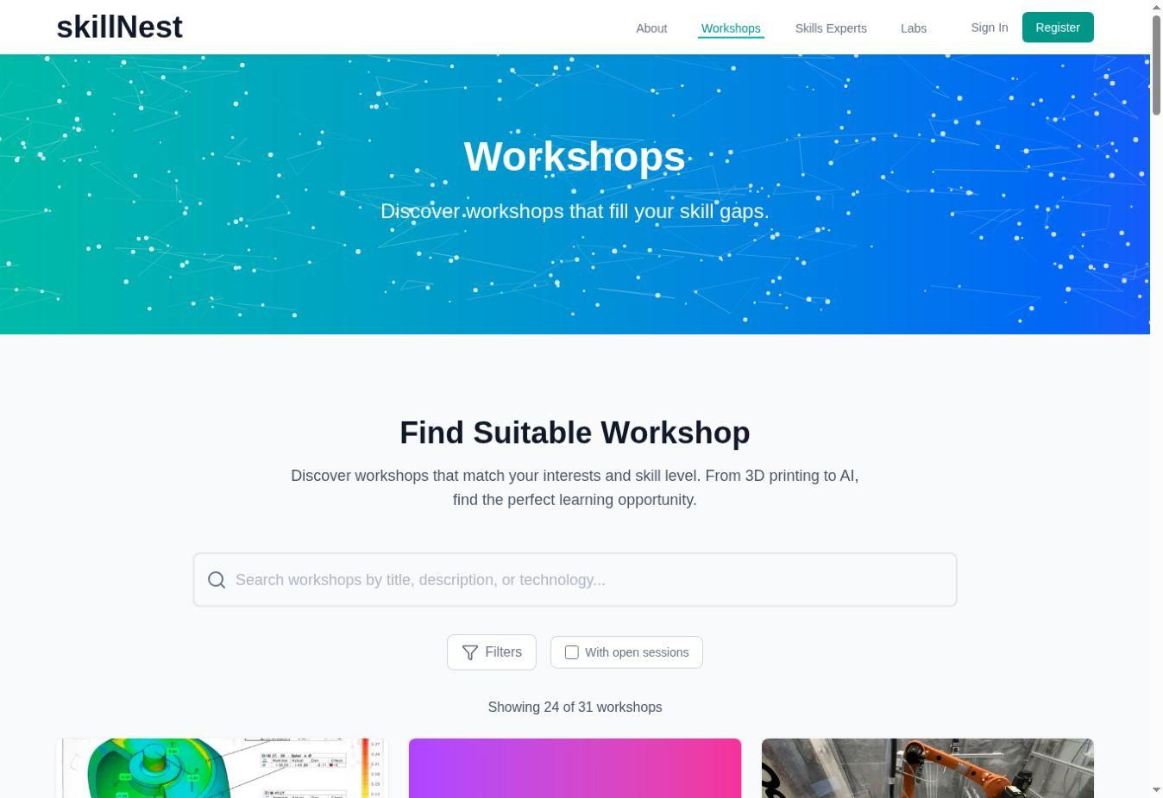
Figure 2. Workshop catalogue used for programme discovery.

9.3 Verify the workshop detail
Before adopting or promoting a workshop, verify learning objectives, prerequisites, target group, duration, capacity, organisation, educators, experts, assessment links and material access. Incomplete metadata should be corrected before public recruitment.
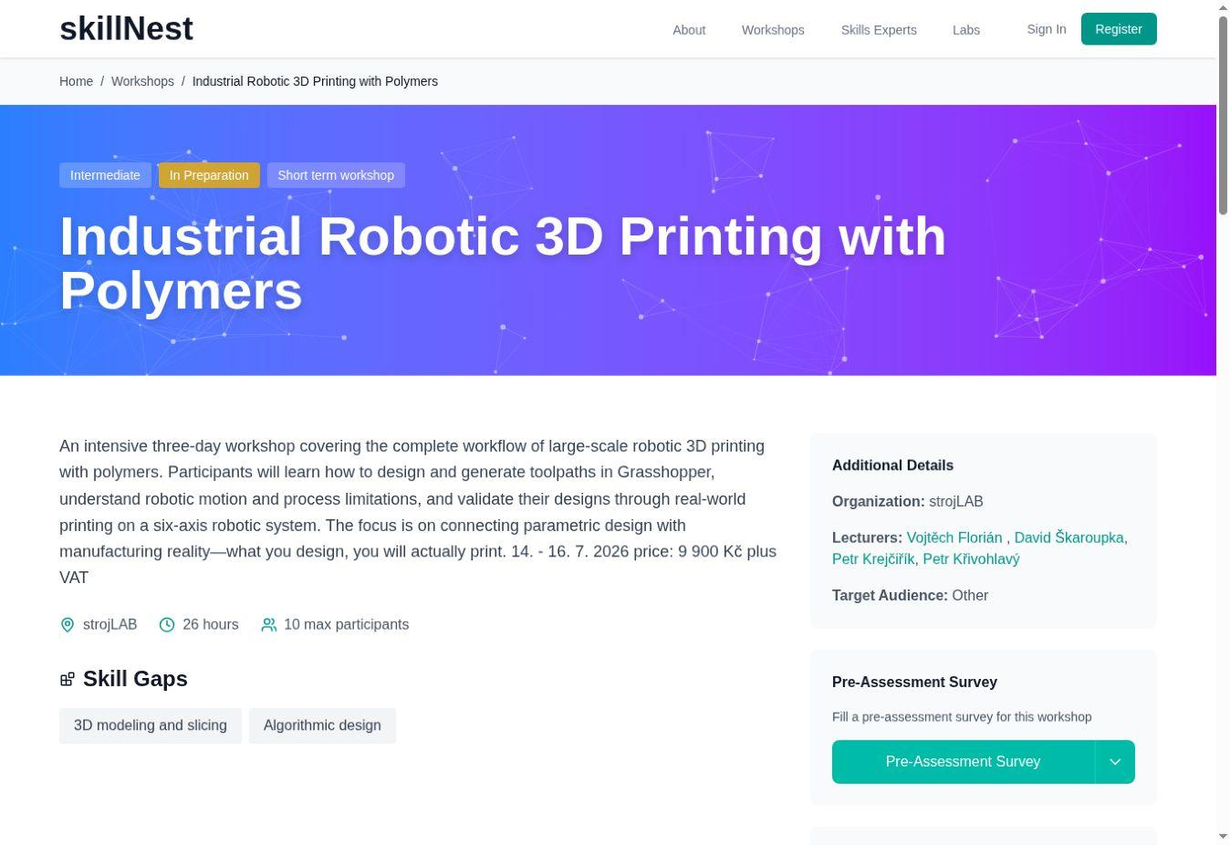
Figure 3. Workshop detail and implementation metadata.

9.4 Configure the assessment journey
Participants should receive the pre-assessment early enough for the educator to use the results. Reserve time for post-assessment before the formal end of the programme. Test survey links, scale labels, language and the chosen matching method.
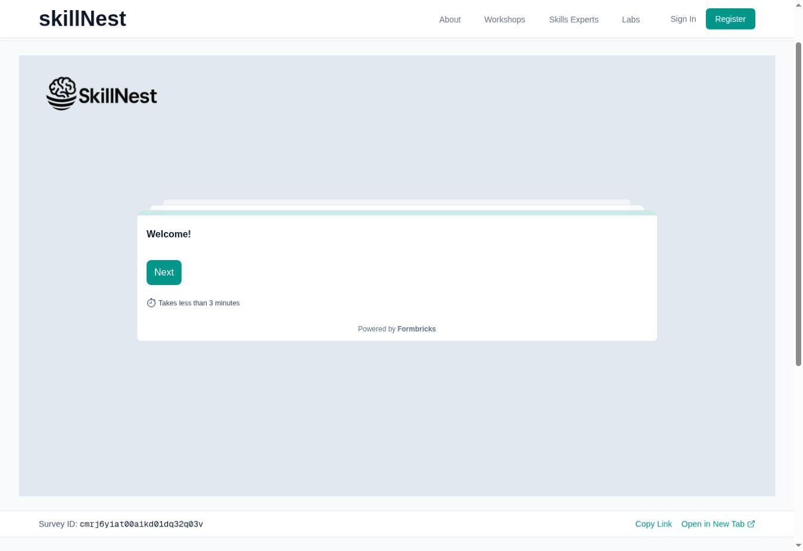
Figure 4. Embedded pre-assessment environment.

9.5 Access and distribute materials
Confirm which resources are public, registered-user or educator-only. Use a versioned participant package and a separate educator package when facilitation notes, answer keys or recovery procedures should not be distributed publicly.
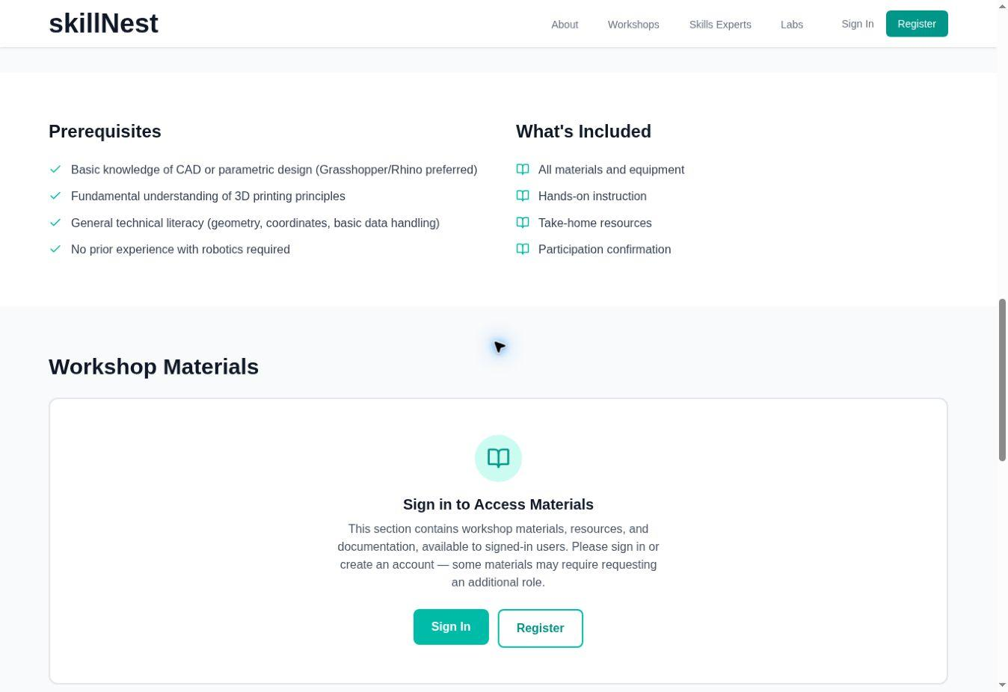
Figure 5. Role-gated access to learning and facilitation materials.

9.6 Educator and administrator procedures
After registering on skillNest, submitting an application for the role of educator and its approval, the Dashboard is accessible on the skillNest platform with the role of "educator", where workshops can be managed.
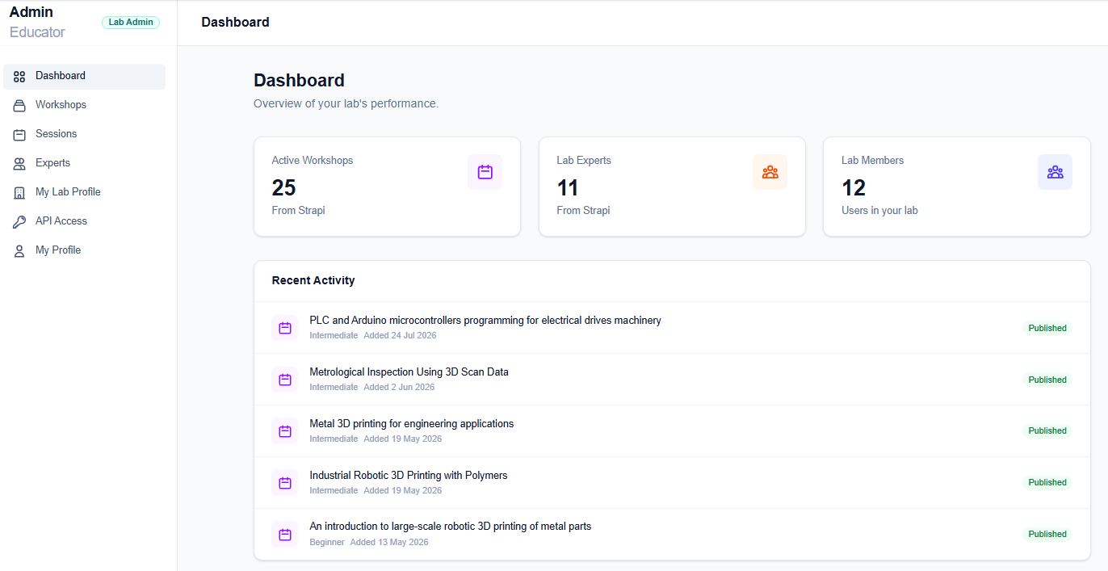
Figure 6. . SkillNest educator dashboard.

In the dashboard menu "workshops", after click the “Create new workshop” following form for the setting up a new workshop appears.
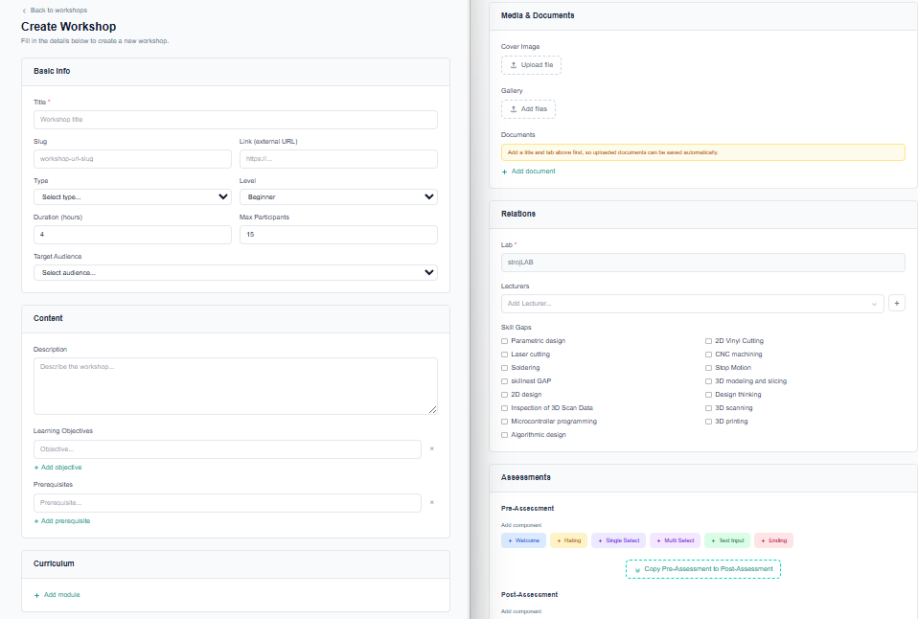
Figure 7. SkillNest educator dashboard - creating workshop.
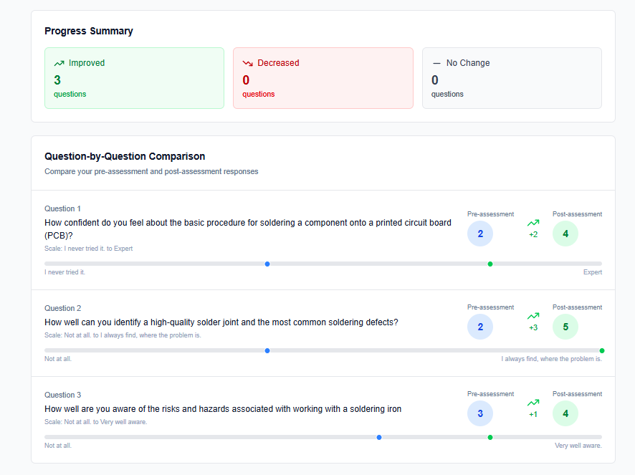
Figure 8. SkillNest learner statistics - self-evaluation report

9.7 Pre-publication content check
- ☐ Title, summary and target group are accurate.
- ☐ Prerequisites, duration, capacity and delivery format are explicit.
- ☐ Learning outcomes match the assessment questions.
- ☐ Organisation, educator, expert and lab links are current.
- ☐ Participant and educator materials have the correct access level and version.
- ☐ Pre/post assessment links work in the intended language.
- ☐ Contact and registration routes have been tested from a non-admin account.

10. Inclusion, Ethics and Data Protection

10.1 Inclusive implementation
- Describe prerequisites without equating previous access to technology with ability.
- Offer staged beginner tasks and optional extensions for experienced participants.
- Use visual demonstrations, readable instructions and more than one way to ask for help.
- Balance team roles so confident machine users do not monopolise the practical task.
- Provide reasonable adjustments and alternative ways to demonstrate learning.
- Use inclusive language and imagery and monitor participation patterns.
- Use local languages where they materially improve participation and safety.

10.2 Minors and vulnerable participants
School and youth formats require local safeguarding, consent, supervision and communication arrangements. Assessment reporting should use aggregated data unless individual identification is necessary, lawful and clearly communicated.

10.3 Responsible assessment data
Principle | Implementation requirement
Purpose limitation | Collect data only for delivery, learning support, evaluation and agreed uptake monitoring.
Data minimisation | Avoid names where an anonymous matching code is sufficient.
Transparency | Explain purpose, access, retention and contact point before collection.
Access control | Limit identifiable results to authorised roles.
Aggregation | Use grouped reporting for public or consortium communication.
Retention | Delete or anonymise identifiable data according to the approved schedule.
Accuracy | Allow correction of registration data and document analytical limitations.

10.4 Intellectual property and third-party content
- Use only software, images, files and teaching materials that may lawfully be shared with the intended audience.
- Mark third-party licences and attribution requirements in educator resources.
- Clarify ownership and permitted use of participant prototypes, photographs and portfolios.
- Do not publish confidential company challenge information without approval.
- Separate open toolkit materials from locally restricted or commercially licensed resources.

11. Sustainability, Transfer and Scaling

11.1 Plan sustainability before the first run
Sustainability is stronger when the first run is designed as the beginning of a local offer rather than a one-off event. The implementation owner should identify the post-project owner, likely participant pipeline, educator capacity, facility access, annual content-review need and a realistic financing route before delivery.

11.2 Sustainability dimensions
Dimension | Key question | Evidence of durability
Strategic | Does the programme support the organisation’s mission and regional need? | Named owner and inclusion in an annual plan
Operational | Can staff, machines, rooms and materials support repetition? | Reserved capacity and replenishment process
Pedagogical | Can another educator deliver the format consistently? | Versioned guide, co-delivery and facilitator handover
Financial | How will preparation, educator time and consumables be covered? | Budget line, fee, sponsor or programme funding
Digital | Will links, files, accounts and assessments remain maintained? | Content owner and review schedule
Network | Who provides recruitment, expertise, challenges or progression? | Active school, employer, FabLab or policy partner

11.3 Transfer to another territory or target group
- Document the original context and the reason for transfer.
- Compare target-group characteristics, institutional setting and labour-market relevance.
- Identify regulatory, language, safety, equipment and accessibility differences.
- Preserve the learning mechanism and revise examples, pacing and support.
- Pilot with one cohort and collect the common assessment core.
- Review with the original programme owner where adaptation is substantial.
- Publish or record the local variant and its evidence.

11.4 Scaling without quality loss
- Repeat before expanding.
- Increase facilitator capacity before cohort size.
- Use observed co-delivery and a facilitator checklist.
- Keep core resources versioned and local add-ons identifiable.
- Monitor waiting time, equipment access and practical participation as scale increases.
- Retain a small common assessment core across locations.
- Share transferable improvements through SkillNest and the FabLab network.

11.5 Recommended sustainability and scaling indicators
Indicator | Minimum record
Repeatability | Date or decision for the next run
Educator capacity | Number able to lead and co-facilitate
Resource continuity | Equipment, software, materials and budget status
Content currency | Last review date and responsible owner
Adoption | Organisation, territory, selected package and delivery status
Reach | Participants, target group and delivery hours
Quality | Assessment response, output completion and improvement actions
Transfer | Local adaptations and evidence from the first transferred run

11.6 Post-project governance
The D3.3.1 governance model identifies BUT as the long-term maintainer of SkillNest and distributes programme-content responsibility among the partners.

12. Conclusions
D3.2.1 provides the operational bridge between the validated content of D3.3.1 and its successful use by organisations beyond the original pilots. Its central contribution is a complete but proportionate adoption pathway: define the need, check readiness, select and adapt a package, prepare people and resources, configure SkillNest and assessment, deliver, evaluate, repeat and scale.
The guide protects a common quality core without forcing identical delivery. Adopters may change language, examples, duration, equipment and local partnerships when they preserve the learning mechanism, safety, practical evidence, assessment purpose and documented improvement cycle.
IMPLEMENTATION RESULT
A locally relevant, safely delivered and evidence-informed re/upskilling programme that can be repeated, improved and connected back to the wider DiSTT and SkillNest ecosystem.

Annex A – Organisational Readiness Checklist
Domain | Readiness statement | Score | Evidence / gap action
Strategic fit | Target skill gap is evidenced and aligned with organisational mission. | 0 / 1 / 2
Ownership | Implementation owner and sponsor are named. | 0 / 1 / 2
Educators | Technical and facilitation competence is available. | 0 / 1 / 2
Facilities | Rooms, machines, software and materials are available and tested. | 0 / 1 / 2
Safety | Risk, safeguarding, PPE and incident arrangements are approved. | 0 / 1 / 2
Recruitment | A realistic route to the intended participants is confirmed. | 0 / 1 / 2
Assessment | Pre/post and practical evidence can be administered. | 0 / 1 / 2
Accessibility | Likely participation barriers and adjustments have been reviewed. | 0 / 1 / 2
Finance | Preparation, delivery and consumable costs can be covered. | 0 / 1 / 2
Sustainability | A credible repeat or continuation route is identified. | 0 / 1 / 2

Scoring: 0 = not ready / unresolved; 1 = partially ready with a feasible gap action; 2 = ready and evidenced. Safety or safeguarding at 0 blocks delivery.

Annex B – Implementation Canvas
Canvas field | Content to complete
Implementation case | Target group, skill gap, intended value and evidence of need
Selected package | Package, version, fallback and selection rationale
Learning outcomes | Three to eight observable outcomes
Practical output | Prototype, file, demonstration, pitch, portfolio or process evidence
Essential elements | Elements that create the intended learning
Local adaptations | Language, examples, timing, equipment, accessibility and partnerships
Implementation team | Owner, educator, technical, safety, assessment and SkillNest roles
Resources | Facility, machines, software, files, materials, PPE and contingencies
Assessment | Pre/post items, matching, practical criteria, observation and feedback
Recruitment | Channels, prerequisites, participant information and onboarding
Risks | High risks, controls, contingencies and owners
Sustainability | Next run, financing, educator development and content review

Annex C – Session Planning Template
Time | Learning outcome | Activity | Participant action | Educator / technical action | Resources / evidence

Annex D – Risk Register Template
Risk | Likelihood | Impact | Prevention | Contingency | Owner / status

Annex E – Assessment and After-Action Review

E.1 Common pre/post statements
- I understand the complete workflow covered by this programme.
- I can prepare the required digital data for the selected process.
- I can use the relevant tool or machine according to the required safety procedure.
- I can select or adjust the main parameters that influence the result.
- I can identify a common error and test a suitable correction.
- I can apply the process to create a functional or communicable output.
- I can explain my technical decisions to another person.
- I know where to find further support, facilities or learning resources.

E.2 After-action review questions
- What was planned and what was actually delivered?
- Which evidence shows that the learning outcomes were addressed?
- Where did participants wait, disengage or require unexpected support?
- Which adaptation improved local relevance?
- Which adaptation weakened the learning mechanism or comparability?
- What safety, equipment, software or logistics issue must be corrected?
- What should be kept, stopped, changed or tested next time?
- Who owns each change and by when?

Annex F – First-Run Implementation Record
Record item | Value
Adopter organisation and territory
Responsible person and contact
Selected package and resource version
Target group and recruitment route
Delivery dates, format and hours
Registered / attended / completed participants
Adaptations and reasons
Pre / post / matched response counts
Practical outputs and observation evidence
Participant and stakeholder feedback
Incidents, deviations and limitations
Changes before next run
Next-run or scaling decision

Annex G – Web Step-by-Step Publication Register
Follow https://skillnest.app/how-to

Annex H – Source and Traceability Matrix
Guide element | Primary source | Implementation use
Output definition and two-format requirement | Approved DiSTT Application Form / D3.2.1 definition | Chapters 1, 2 and 4
Programme packages and toolkit architecture | D3.3.1 Digital Skills Transformation Toolkit | Chapters 2, 6, 9 and 11
Implementation lessons | D2.2.1 partner Pilot Run Reports | Chapters 3, 5, 7 and 8
Common evaluation findings | D2.3.1 Joint Evaluation Report | Chapters 3 and 8
Programme design | D2.1.1 partner RE/UPskilling programmes | Chapter 6 and adaptation logic
Digital implementation | SkillNest public interface | Chapter 9

