

D 1.2.3 MESTRI-CE Smart Data Hub with database of buildings
Version 1
09 2025

Contents

A. Introduction 2
B. MESTRI-CE Smart Data Hub 2
1. Screenshots of the tool 3

- Introduction
The need for a Smart Data Hub arises from the complexities and challenges involved in building renovations and energy efficiency improvements. Currently, renovation projects are often delayed or even abandoned due to a lack of information. Building owners, planners and policymakers often lack access to reliable data on building conditions, energy performance and detailed cost estimates. Without this information, it is extremely challenging to plan renovations effectively or evaluate the potential impact of different measures.
Moreover, existing data is often fragmented, inconsistent or difficult to use for technical and economic assessments. This creates uncertainty and risk, which discourages investment in renovations, even though these measures could provide significant energy savings and cost benefits in the long term.
A Smart Data Hub should address these challenges by centralising building data, enabling the creation of digital building models and generating energy indicators by running energy simulations, as well as generating detailed renovation roadmaps. In short, a Smart Data Hub is necessary to overcome the current barriers to building renovation and accelerate the transition towards energy-efficient, sustainable buildings.
- MESTRI-CE Smart Data Hub
The MESTRI-CE Smart Data Hub was developed in collaboration with the start-up Scandens and is available at the following URL: http://www.mestri-smartdatahub.eu
In preparation for this, requirements for the Smart Data Hub were defined and formulated together with the project team. These were continuously developed until the decision to collaborate with Scandens was made and served as the basis for the development of the Smart Data Hub. Together with Scandens, the requirements were then specified and transferred to the new tool. The requirements can be found in Deliverable 1.2.1.
In addition, a manual was developed during the development of the smart data hub to assist with the implementation and editing of buildings in the tool. This can be found in Deliverable 1.5.2.

- Screenshots of the tool
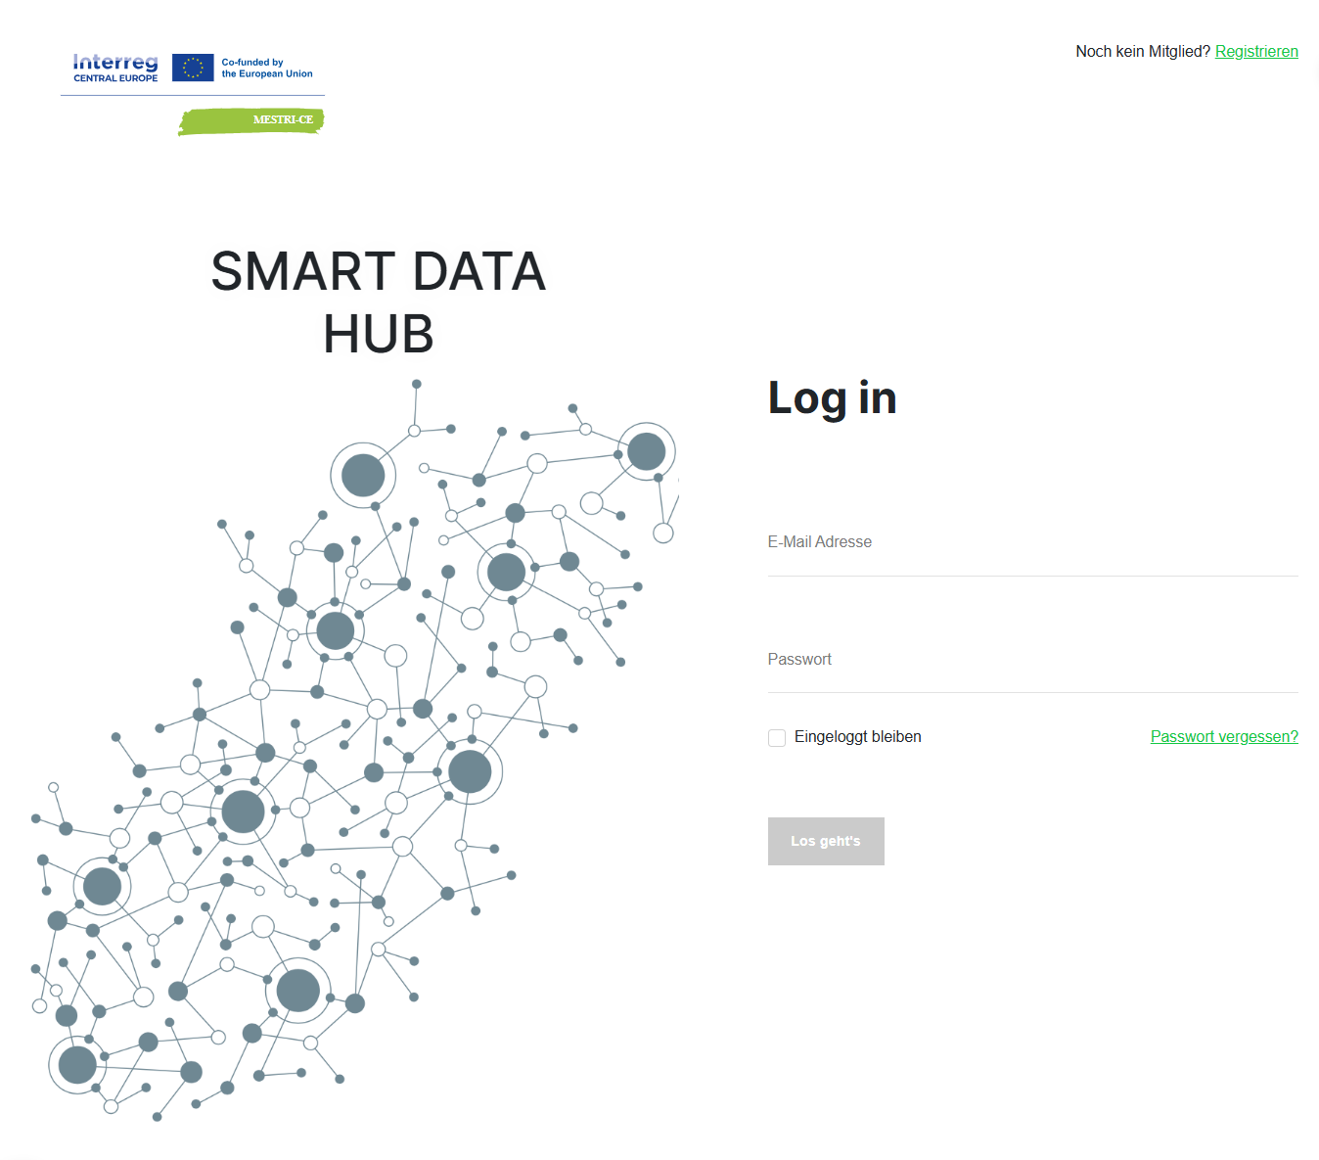
Figure 1 Homepage of the Smart Data Hub
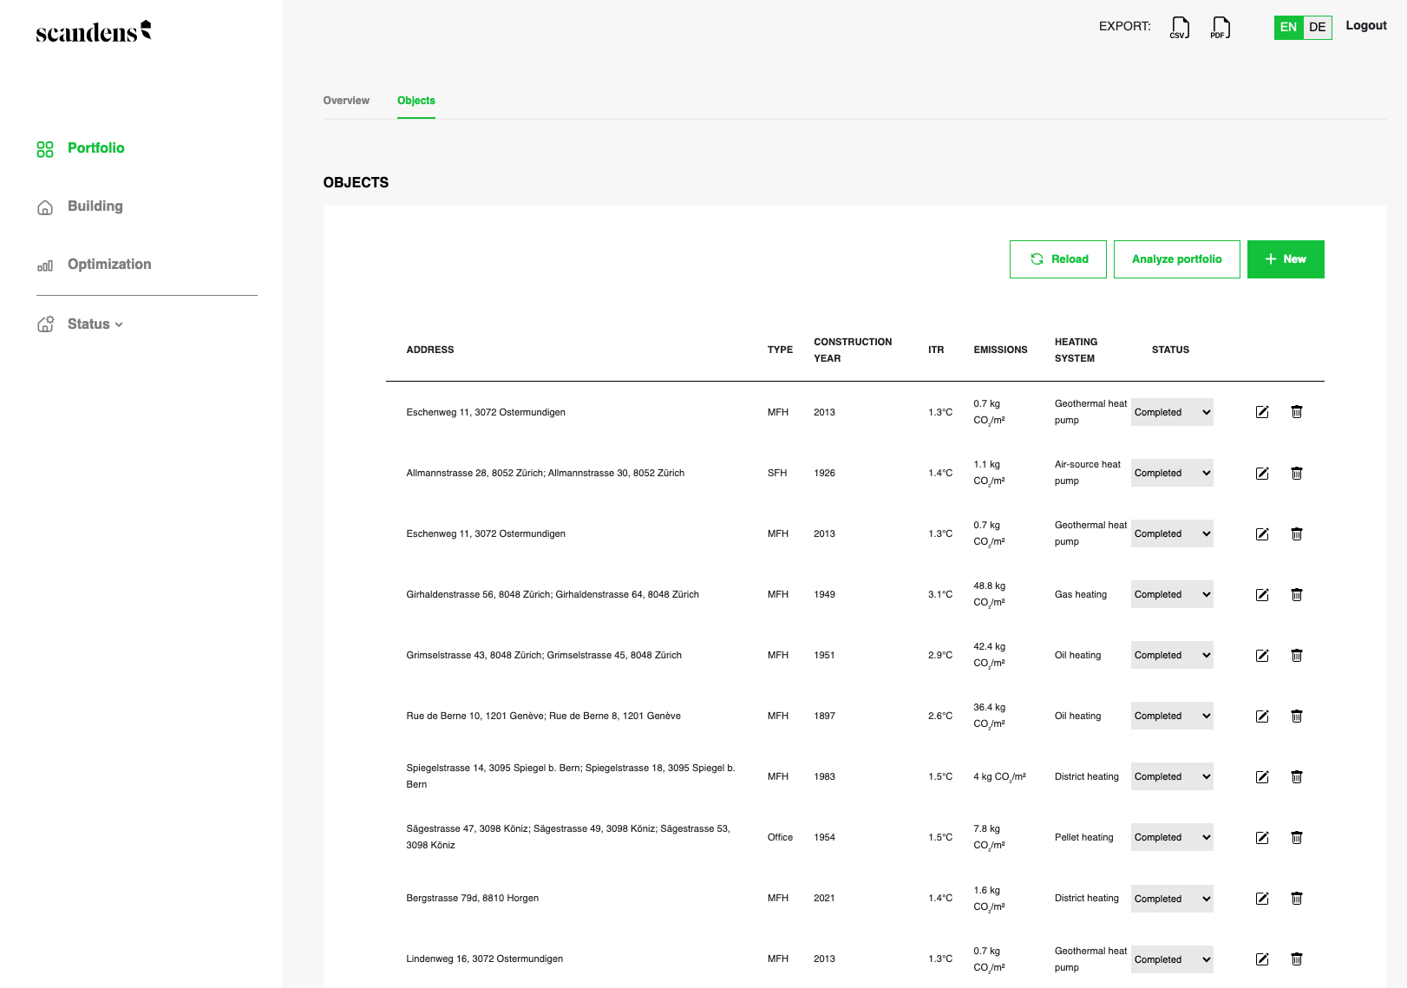
Figure 2 Overview of the building portfolio
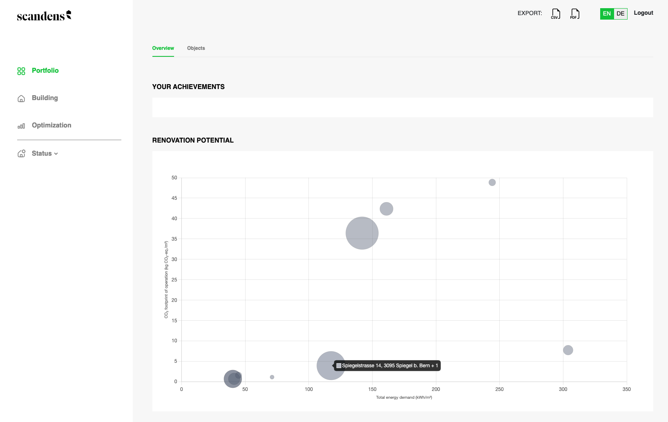
Figure 3 Renocation potential of the buildings
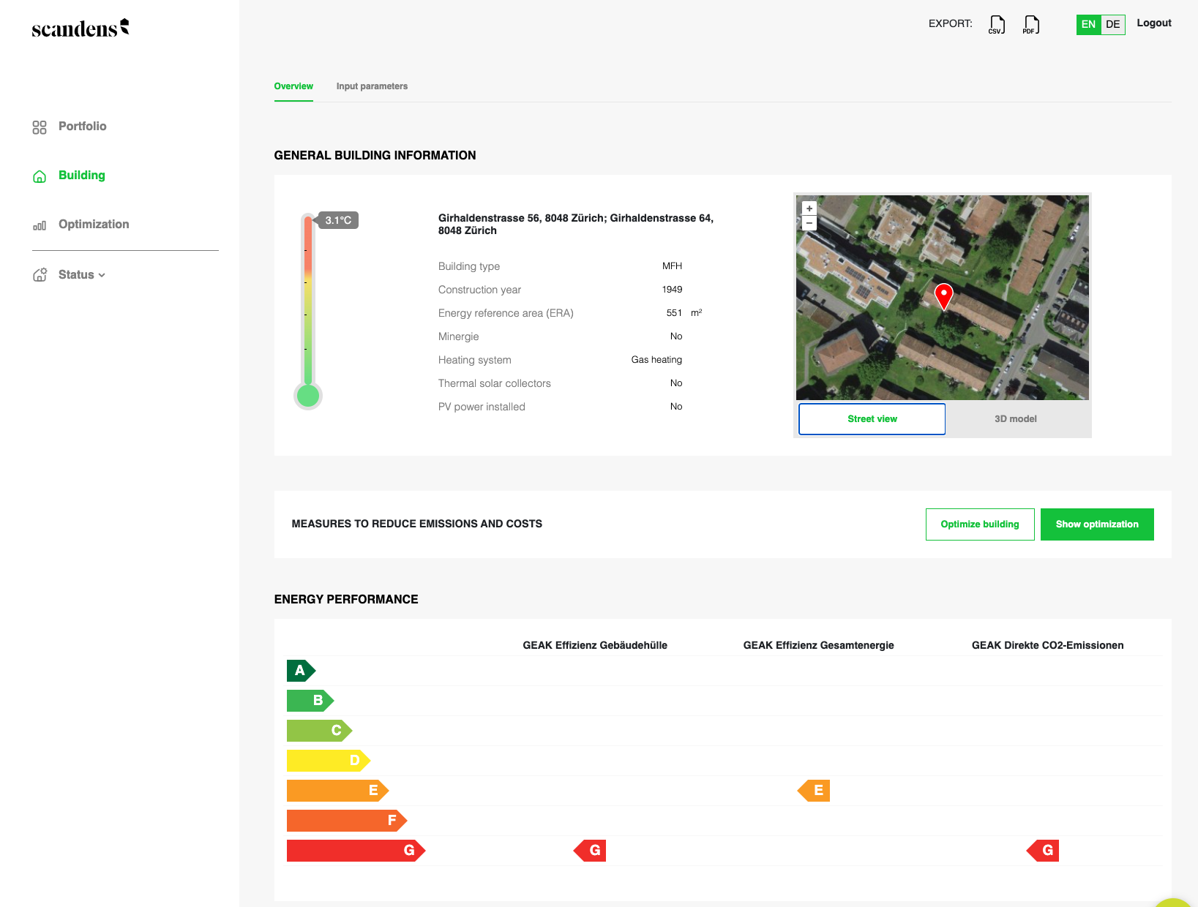
Figure 4 General building information of one building
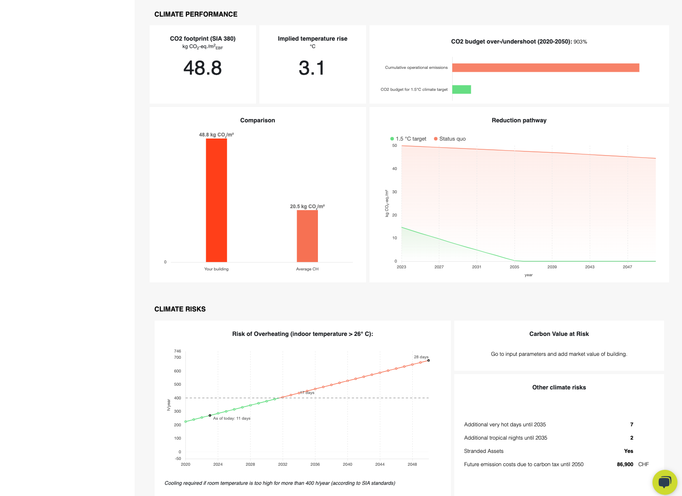
Figure 5 Evaluation of one building

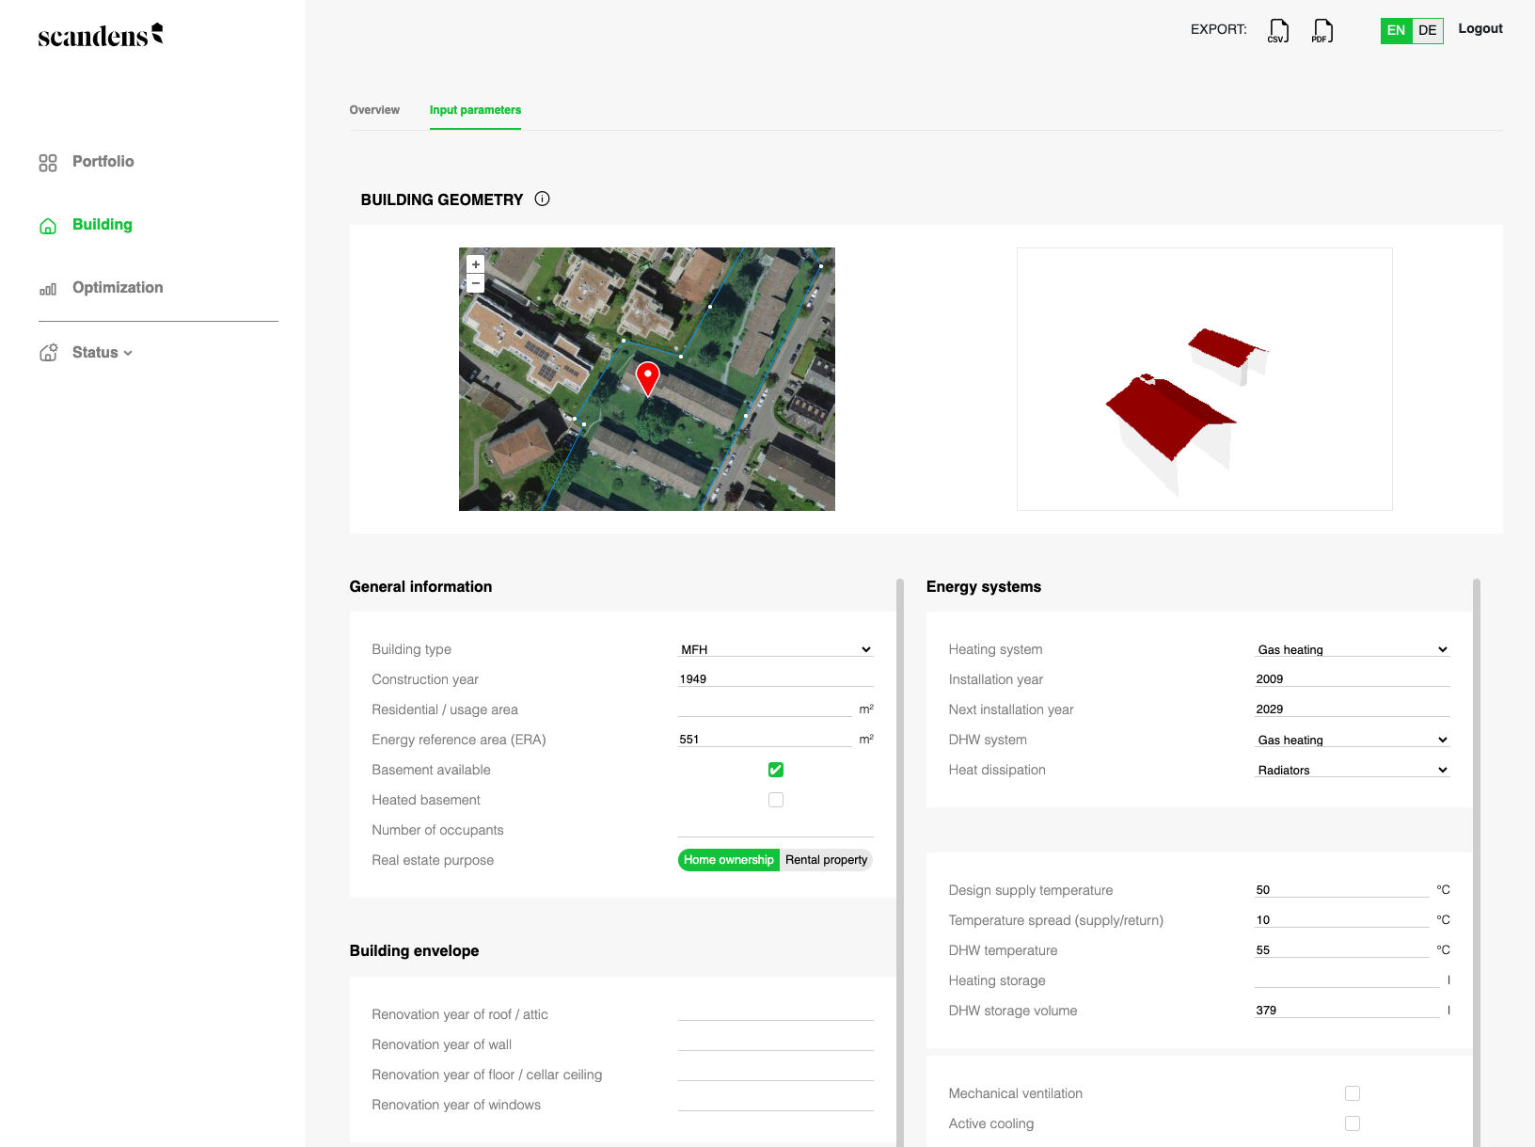
Figure 6 Overview and model
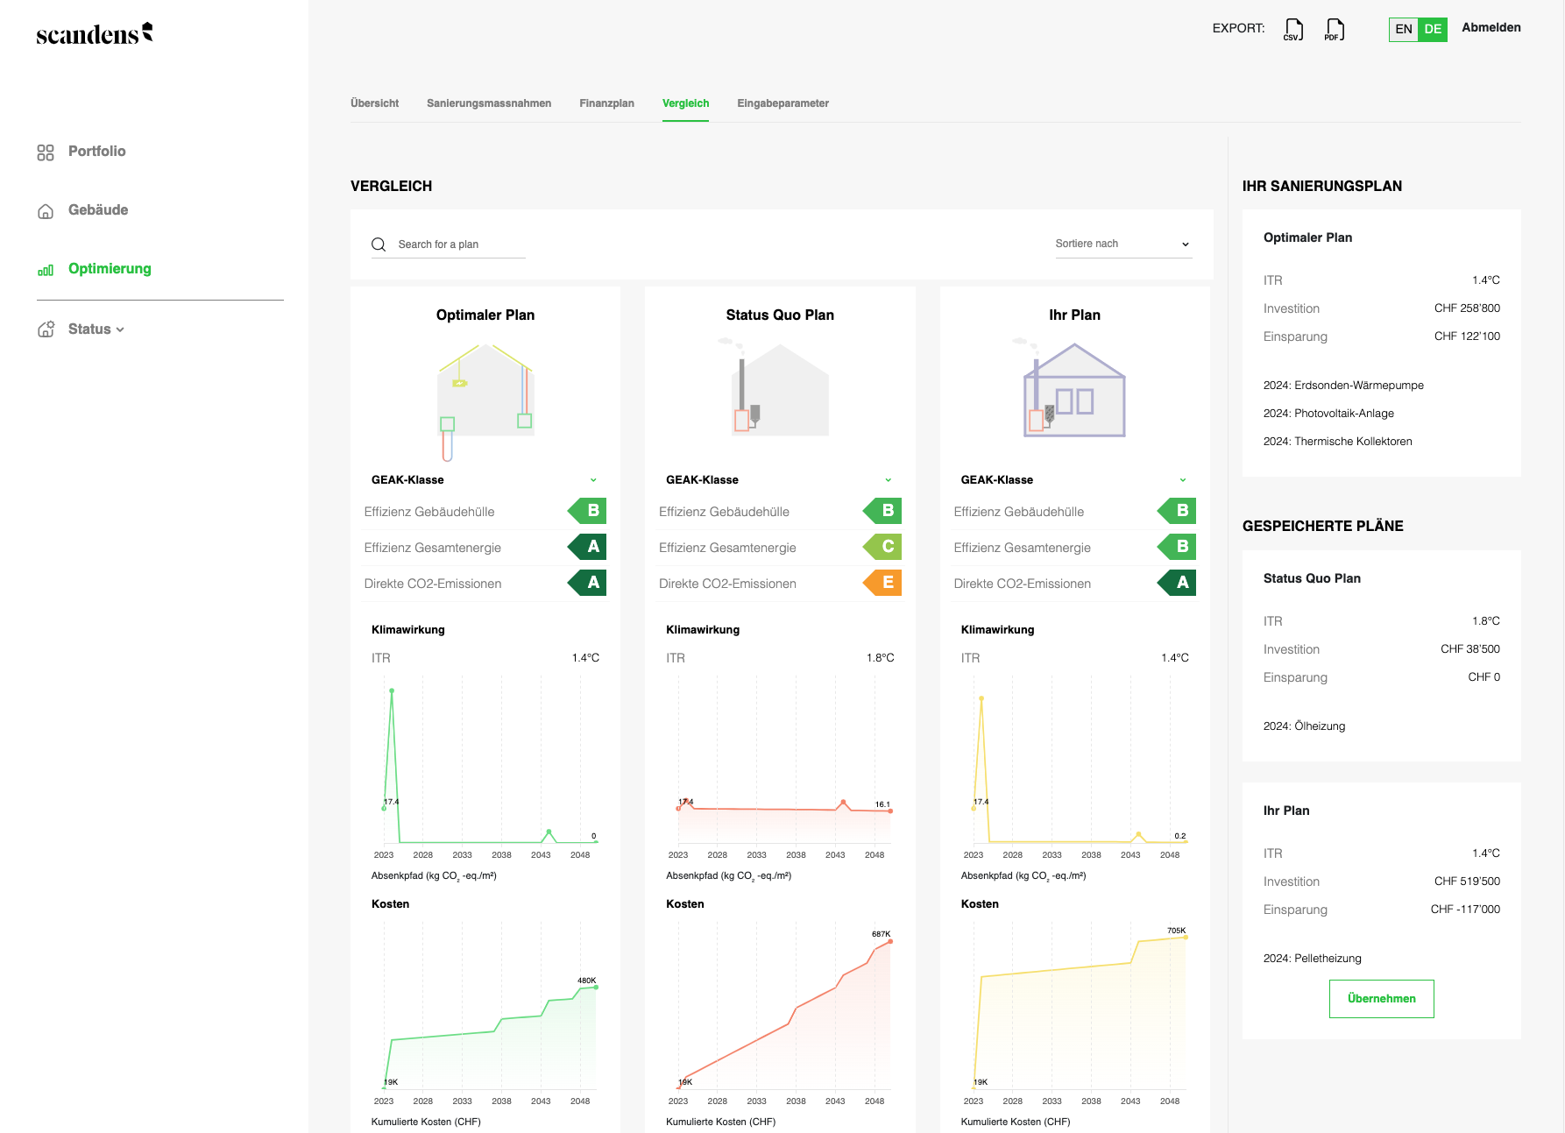
Figure 7 Comparison of the renovation plans

