Report on jointly implemented pilot
action in AT-CZ pilot area
Final Version
October 2025
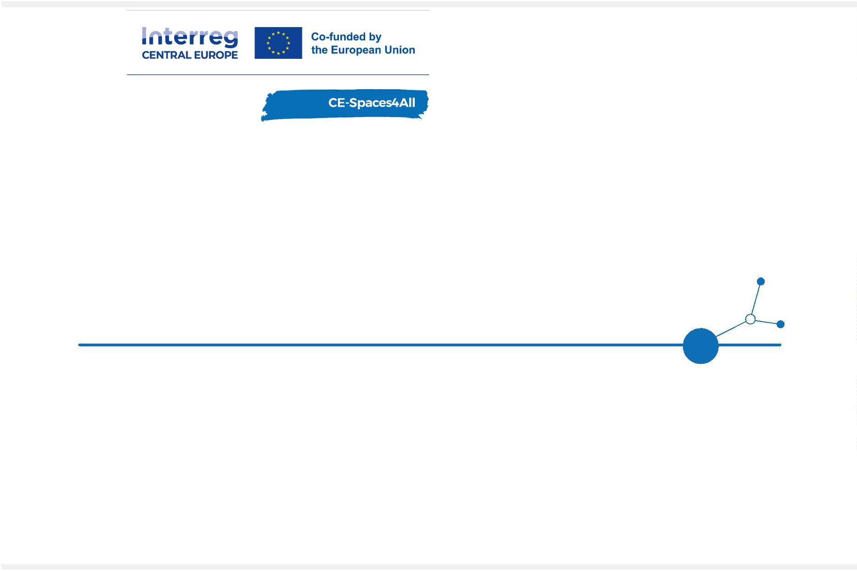

Table of contents
1
1
1
2
2
2
2
3
3
3
4
4
4
. Introduction .........................................................................................2
.1. About this document ............................................................................2
.2. Accessibility definitions ........................................................................2
. Implementing the pilot action in the AT-CZ area.............................................3
.1. Summary of pilot implementation plan......................................................3
.2. Final status of pilot activities in Weinviertel ...............................................4
.3. Final status of pilot activities in Znojmo region ......................................... 18
. Implemented awareness raising activities ................................................... 33
.1. Event summaries -Weinviertel region...................................................... 38
.2. Event summaries - Znojmo region .......................................................... 42
. Key findings........................................................................................ 43
.1. Weinviertel region............................................................................. 43
.2. Znojmo region .................................................................................. 44
Page 1
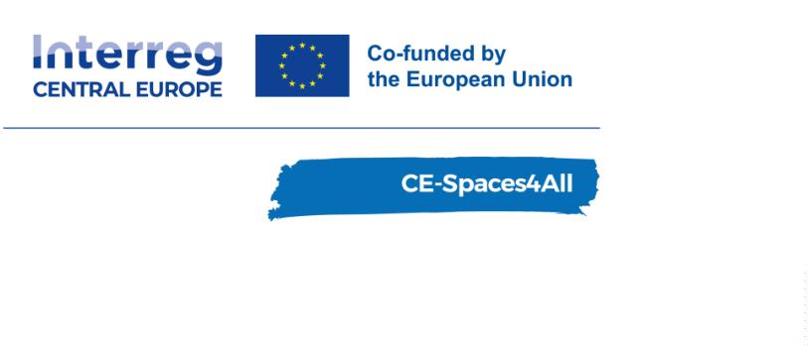

1. Introduction
1.1. About this document
This document describes the final jointly implemented pilot action in the cross-border
tourism area Austria-Czech Republic (AT-CZ). The joint report on implemented pilot action is
going to concentrate on finding solutions for improving accessibility in tourism for people
with impaired mobility and vision in the cross-border pilot region AT-CZ (Weinviertel-
Znojmo), based on joint concept testing. It will include summaries of stakeholder workshops.
The contents of this document will be used for finalisation of O2.5 and for planning uptake
(WP3).
1.2. Accessibility definitions
All necessary accessibility definitions like “accessible tourism”, “accessible services and
tools”, “accessible independent travel”, “rural tourism” can be found in the Compendium on
Capacity Building on Territorial Planning for Accessible Tourism, which was prepared in
August 2023 by the project partners BOKU and European Disability Forum (EDF). All detailed
technical requirements for accessibility are collected in the Methodology for Data Collecting,
which also has been prepared during the first reporting period of the CE-Spaces4All project
and was finished in August 2023
Page 2

2. Implementing the pilot action in the AT-CZ area
2.1. Summary of pilot implementation plan
BOKU and Austrian pilot area – Retz region - implemented the following pilot action plan
activities in RP4:
•
•
Presentation of the project at international conferences
Organisation of a special session on the topic of “Invisible Cities” at the ISOCARP
World Planning congress
•
•
Preparation of and literature research for presentations and publications at upcoming
international conferences
Preparations for an awareness raising video which will show the experiences of blind
and visually impaired people on a touristic trip
•
•
•
•
•
•
•
•
Fieldwork - mapping the accessibility of excursion destinations and service providers
Meeting of project parteners in Laa an der Thaya
Summary of hard and soft barriers of the tourism facilities from WAV
Design of a unified format for publishing accessibility information - 3 Manuals
Pilot testing of the Manuals (in progress)
Educating tourism providers about how to create the Accessibility Guide (webinars)
Creating Accessibility Guides of tourism facilities from WAV (in progress)
Leaflet with 6 accessible routes from the pilot area (in progress)
BOKU and Austrian pilot area – Retz region - implemented the following Pilot Action Plan
activities in P5:
•
•
Fieldwork - mapping the accessibility of excursion destinations and service providers
Pilot testing of the Manuals on how to create the Accessibility Guide for customers
with disabilities, including feedback from the tourism providers
•
•
Educating tourism providers about how to create the Accessibility Guide of their
venue
Educating tourism authorities about how to promote publishing of accessibility
information amongst tourism business and support tourism providers to use
Accessibility Guides
•
•
•
•
Consultations and site-visits to assist with creation of the Accessibility Guides at
tourism facilities listed in WAV
Promotion of businesses and service providers who have an accessibility guide on their
websites – listing in a special section on the Weinviertel Tourismus website
Leaflet with 6 accessible routes from the pilot area.Implementation, distribution and
promotion of the leaflet for PWD listing 6 accessible POIs from the pilot area
Marketing – ordering an electric wheelchair for the bike rental shop in Retz to make
the tourist offer more attractive for people with disabilities visiting the region.
Preparing and implementation of the charity run Wings for Life in Retz
Creation of an awareness raising video documenting a day trip to the historic city of
Eggenburg with two visually impaired test persons.
•
•
Page 3

•
Expert meeting with stakeholders from Austrian tourism providers, related
institutions, public transport associations and providers, PWD associations and
Austrian Federal Ministries with project presentation, video premiere, and an
extensive discussion about contents and results.
Czech pilot area - Znojmo region - implemented the following Pilot Action Plan activities in
RP4:
•
•
•
•
•
•
•
Adding new values in WAV to assess soft barriers in accessibility
Summary of hard and soft barriers of the tourism facilities from WAV
Design of a unified format for publishing accessibility information - 3 Manuals
Pilot testing of the Manuals (in progress)
Educating tourism providers about how to create the Accessibility Guide
Creating Accessibility Guides of tourism facilities from WAV (in progress)
Leaflet with 6 accessible routes and 3 POI from the pilot area (in progress)
Czech pilot area - Znojmo region - implemented the following Pilot Action Plan activities in
P5:
•
•
•
Pilot testing of the Manuals on how to create the Accessibility Guide for customers
with disabilities, including feedback from the tourism providers
Educating tourism providers about how to create the Accessibility Guide of their
venue
Educating tourism authorities about how to promote publishing of accessibility
information amongst tourism business and support tourism providers to use
Accessibility Guides
•
•
Consultations and site-visits to assist with creation of the Accessibility Guides at
tourism facilities listed in WAV
Distribution and promotion of the leaflet for PWD listing 6 accessible routes and 3 POI
from the pilot area
•
•
Leaflet for tourism providers/authorities on how to create the Accessibility Guide
Motivational/inspirational video of one hotel from the pilot region, which successfully
applied Accessibility Guide
•
•
Coordinating and facilitating a dialog between students of Mendel University and
Thayatal National Park to develop proposals to remove hard barriers in accessibility of
some parts of the national park (as noted in WAV)
Summary report on the publication of accessibility information of barrier-free tourism
attractions in the pilot area (published on the website of the main tourism authority
in the pilot region)
•
•
Creation of an online resource platform with free instructional materials for tourism
providers on how to create the Accessibility Guide
Adding data from WAV into Znojmo Council mapping portal
2.2. Final status of pilot activities in Weinviertel
Soft barriers in WAV this activity was completed in Period 4:
Page 4

After mapping the accessibility of the tourism facilities in the pilot area, data were saved
and visualized in Web Accessibility Viewer (WAV). These were data on hard/physical barriers
in accessibility. Such attributes were gathered in the previous project periods. Yet there are
also soft barriers in accessing tourism services for PWD - the major one is the lack of
information about available barrier-free services on provider websites. In period 4, the
project team reviewed the websites of all the tourism service providers listed in the WAV, as
well as the newly mapped facilities, destinations and service providers. The website was
checked for information on the accessibility of each facility.in cooperation with project
partners Cenia and the Czech Paraplegic Association, the tool "Accessibility Guide" was
developed and was in P5 put into practice.
Accessibility guide AT
In cooperation with Czech projectpartner was created an accessibility guide for tourism
facility providers. Accessibility Guide (AG) is a summary of basic information about
accessibility of a tourism venue. The AG helps customers with disabilities to evaluate barrier-
free services of the tourism provider, thus significantly improving trip planning. This guide
will help providers easily determine which information is important for people with
disabilities. It was created in CZ and translated into DE. The Manuals were prepared in the
Czech language and translated to German and English for other project partners to use.
Accessible guide was created for accommodation, restaurants and other tourism facilities. It
is used for tourism facilities to put this information on the website to make it easier and
faster for people with disabilities to find a suitable facility. All Manuals are published under
project outputs for free download: https://www.interreg-central.eu/projects/ce-
spaces4all/?tab=outputs (scroll to output: Model for improving mobility of PWD for
independent tourism travel in the transborder tourism area).The materials are also available
on the Weinviertel Tourismus website: https://www.weinviertel.at/accessibility-guide-
leitfaden
Pilot testing of the Manual for creating AG of trip destination
As the Manuals were being created, was tested at excursion destination: themed trail in the
Hollabrunn cellar alley "in the footsteps of the cellar cat". We obtained valuable feedback
from the process, which was used for the Manual improvement. Our first test of AG of
accommodation facility was presented as a case study at online webinars to demonstrate this
Page 5
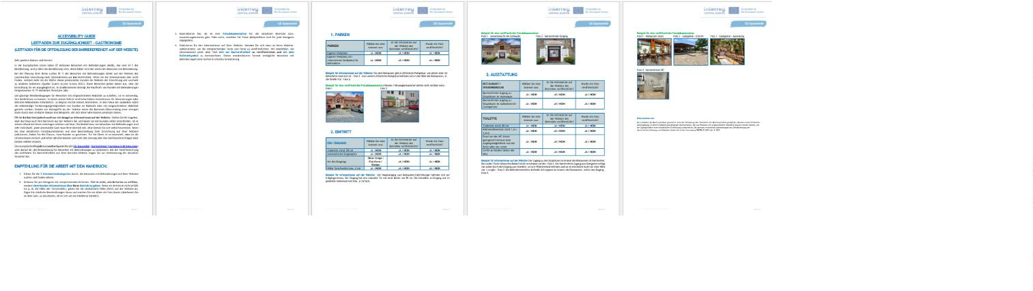

new approach to other tourism providers in the pilot area. AG is now published on:
Themenweg Sitzendorfer Kellergasse Hollabrunn, NP Thayatal https://www.np-
thayatal.at/de/pages/barrierefreiheit-534.aspx,
Stadt
Retz
https://www.retz.gv.at/de/Tourismus_und_Freizeit/Info_ueber_Barrierefreiheit
Benchmarking analyses of accessibility of tourism facilities in the pilot area
In Period 5, the results of the analysis carried out in the previous period were followed up.
The results served as demonstration material during practical consultation meetings with
tourism service providers, which took place in Period 5.
At period 4, benchmarking analyses of the tourism facilities from WAV were created with
focus on clear display of basic accessibility attributes (hard and soft barriers). All tourism
providers were presented with the results to allow for specific improvements of accessibility
features which transpired as inadequate during the mapping. Three benchmarking analyse
was prepared for accommodation. Simple graphics demonstrated the level of accessibility of
each tourism facility. Benchmarking analyses was also presented at online webinars (below)
as fact sheets to demonstrate the lack of publishing information on accessibility of the
tourism venues in the pilot region (soft barrier in accessibility).
Online webinars for tourism providers
Page 6
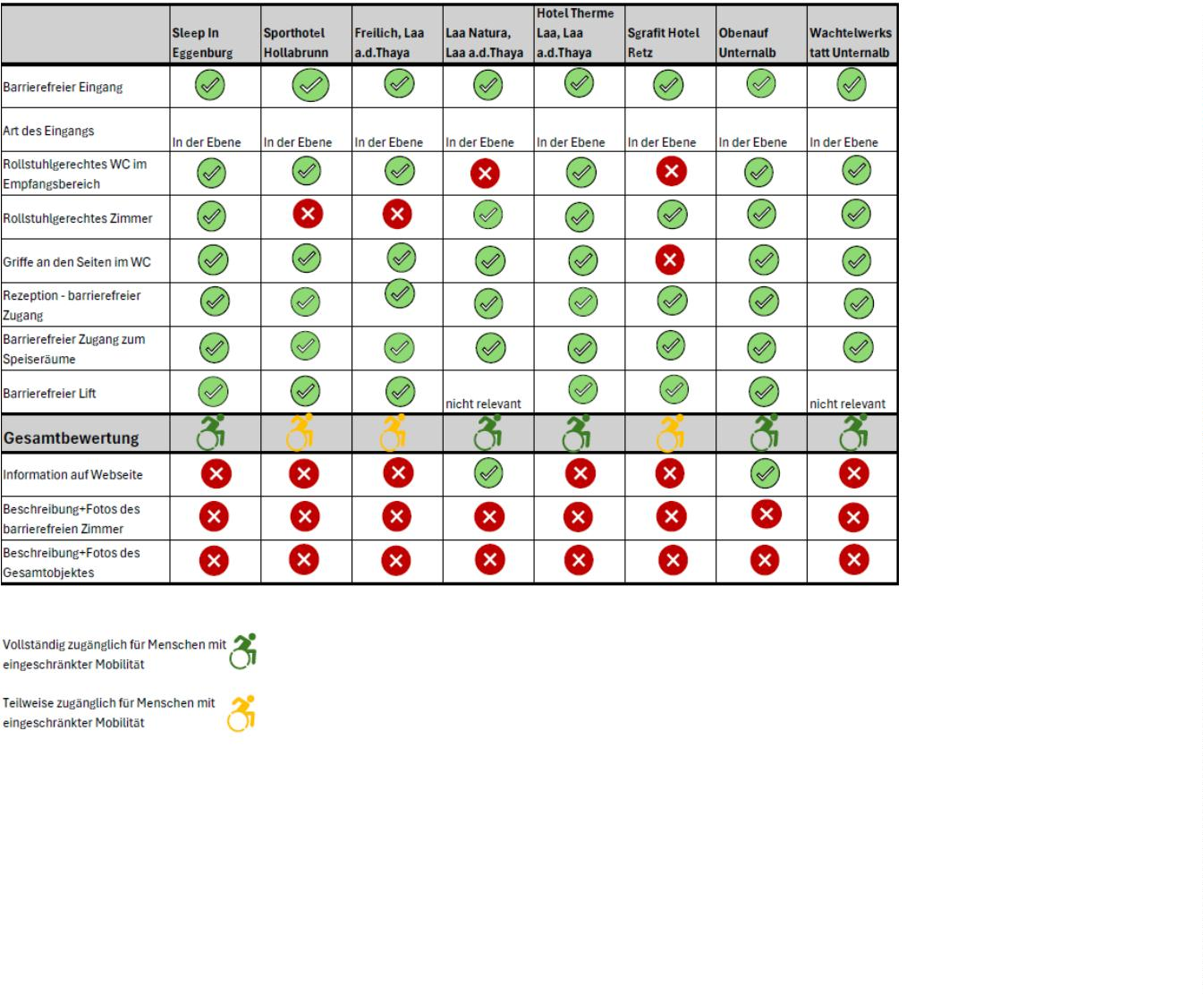

Webinars for tourism service providers were held in the previous period (below). In period 5,
face-to-face consultations were held with representatives of businesses and service
providers.
Local tourism service providers needed to be informed about the newly developed
Accessibility Guide tool. Following the example of the Czech project partners, two identical
online tutorial webinars for tourism service providers were held. Invitations to the webinars
were sent out by email and a video invitation was prepared in cooperation with the Czech
project partners: https://interreg-central.eu/wp-content/uploads/2025/02/VID-20250108-
WA0000.mp4
The webinars, entitled Accessible guide - Guide for the disclosure of accessibility on the
website (Accessible guide – Leitfaden für die Offenlegung der Barrierefreiheit auf der
Webseite), presented three guides and gave step-by-step instructions on how to create and
publish AGs on the website. At the same event, the benchmarking (see above) and the use of
WAVs were presented to tourism service providers. The webinars were recorded for future
reference:
2
9. 01. 2025 Accessible guide - Offenlegung der Barrierefreiheit auf der Webseite
6. 02. 2025 Accessible guide - Offenlegung der Barrierefreiheit auf der Webseite
2
Venue: Online, 29. 01. 2025, 26. 02. 2025
Time: 10:00 – 11:00
Organizers: Weinviertel Tourismus
Participants: 31 participants (10 participants PP)
•
•
•
•
Weinviertel Tourism PP: Eva Köllner, Julia Teis
BOKU PP : Tatjana Fischer, Manfred Schrenk
Czech paraplegic association (CZEPA) PP: Marie Scott, Jan Matoušek
Czech Environmental Information Agency (CENIA) PP: Jitka Faugnerová, Vendula
Dastychová, Kateřina Horáková, Martina Sálová
Page 7

Online webinar attendance list:
First
ID
1
Last Name
Facility Name
Date
Email
Name
Weinviertel Tourismus,
Incoming
Melisa
Bartos
29.1.2025 m.bartos@weinviertel.at
2
3
4
5
Romana
Christina
Ilse
Bruckner
Danzer
Hotel freilich
29.1.2025 romana@freilich.at
Weingut Kitla
29.1.2025 Christina.danzer@gmx.at
29.1.2025 i-gritsch@gmx.at
Gritsch
KellergasseführerinDürnleis
Stadtgemeinde Eggenburg
Josef
Gundiger
29.1.2025 Josef.gundinger60@gmail.com
MarktgemeindeNappersdorf-
Kammersdorf
6
Maria
Kappe
29.1.2025 maria.kappe@aon.at
Retzer Land -
7
Silvia
Köhrer
NationalparkThayatalRegiona 29.1.2025 silvia.koehrer@aon.at
lvermarktung
8
9
Robert
Adrien
Johannes
Daniel
Lisa
Köllner
Modre
Pleil
Gemeinde Pernersdorf
Caritas OBENauf Zimmer und
Frühstück
Weinviertel Tourismus
WeinviertlerHeuriger|DasTra
ubenwerk
Gasthaus Matthias Herbst
LEADER Region Weinviertel-
Manhartsberg
29.1.2025 koellner.robert@gmail.com
29.1.2025 adrien.modre@caritas-wien.at
29.1.2025 j.pleil@weinviertel.at
1
1
1
1
0
1
2
3
Seidl
29.1.2025 seidl@weinviertler-heuriger.at
29.1.2025 hanfthal48@gmail.com
Woltran
Zvarikova
Hana
29.1.2025 h.zvarikova@leader.co.at
1
1
1
4
5
6
Manfred
Flora
Breindl
KellergassenvereinHollabrunn 26.2.2025 breindl@mbc.co.at
Buchinger
Gruber
BhW Niederösterreich GmbH
26.2.2025 flora.buchinger@bhw-n.eu
26.2.2025 birgit.gruber@np-thayatal.at
Birgit
NationalparkThayatal
Gemeindedigital, i. V. Oskar
Bayer
1
1
7
8
Peter
Haferl
Schild
26.2.2025 office@haferl.at
robert.schild@hadres.at
Robert
MarktgemeindeHadres
26.2.2025
1
2
9
0
Carina
Scheuer
Schuster
StadthotelHollabrunn
Thermenresort Laa
26.2.2025 hotel@sth-hollabrunn.at
26.2.2025 b.schuster@therme-laa.at
Bettina
Weinviertel Tourismus,
Incoming
2
1
Maria
Susic
26.2.2025 m.susic@weinviertel.at
Agenda:
1
0:00 – 10:05
Welcome
Presentation of accessibility guide
Presentation of WAV and activities in rural areas
Discusion
1
1
1
0:05 – 10:35
0:35 – 10:50
0:50 – 11:00
Description:
The webinar served as a practical tutorial for tourism providers on how and why to create
the Accessibility Guide (AG). Within the framework of the cross-border cooperation in the
pilot area Znojmo - Retz, the format of the webinar for Austrian service providers was
Page 8
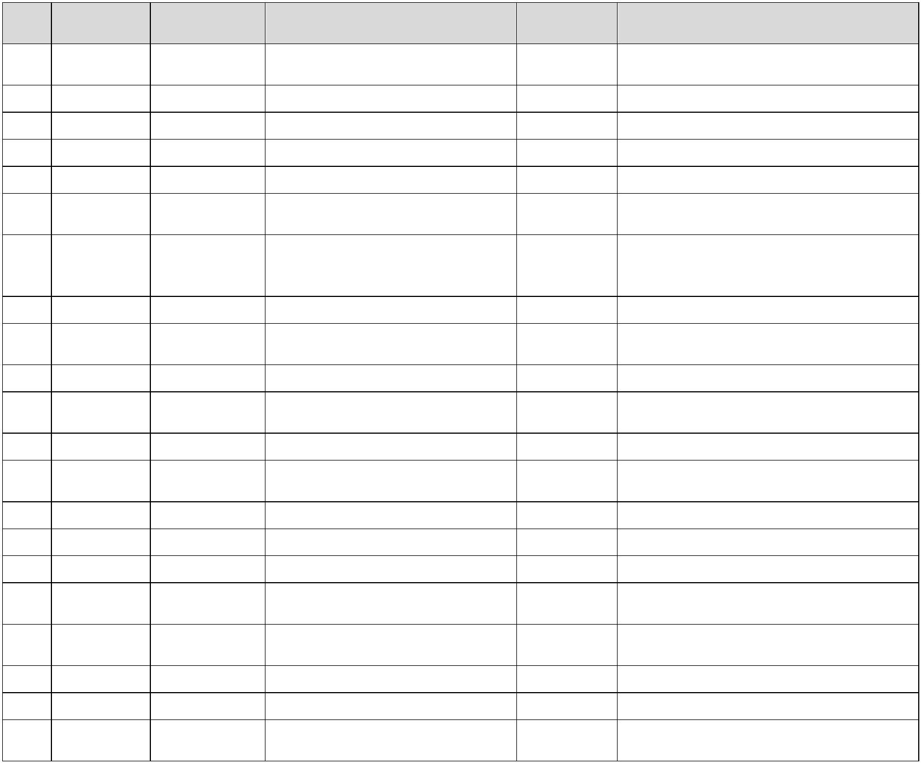

adopted from the Czech project partners Cenia and Czepa and adapted for Austrian
conditions.
Project team developed three Manuals, which were presented and reviewed to allow the
attendees to see all its parts: 1st Manual - accommodation, 2nd - restaurant and 3rd - other
tourism attractions. Examples of photographs which should be part of the AG were shown to
the audience and there was a room for practical questions. The webinar presented the case-
study of hotel Premium Znojmo and the excursion destination "Themed Trail in the Footsteps
of the Cellar Cat" in Hollabrunn and, additionally, demonstrated other tourism facilities
locally and abroad which utilize AG online to welcome customers with disabilities. Challenges
which can be faced while publishing the AG on the website were reviewed and a unified
format for publishing the AG was introduced with its logo. The webinars also included
information on how the project partners can assist local tourism providers with AG creation
and publishing. The last part of the webinar focused on presenting the project, including a
demonstration of data mapping, the WAV, and the project's goal of promoting independent
travel for PWDs.
Outcomes of the pilot testing
A total of 21 representatives from various tourist facilities attended the webinars. Several
participants expressed interest in receiving assistance in preparing their Accessibility Guides.
Several participants are already working on the guide and shared their experiences as
examples during the webinar.
The webinars successfully provided tourism operators with practical knowledge on how to
improve accessibility transparency of their venue. The discussions and shared experiences
contributed to an increased awareness of the importance of presentation of clear and unified
accessibility information online. As a result, the initiative is expected to encourage more
businesses to produce AG, ultimately benefiting both PWDs and tourism operators.
The manuals have been published and are freely available on the website:
https://www.interreg-central.eu/projects/ce-spaces4all/?tab=outputs
Information about the webinars was published on the project website:
https://www.interreg-central.eu/news/another-webinar-about-accessibility-guide-this-time-
for-austria/
Page 9

Screenprints from one of the online webinars:
9.1.2025:
2
Page 10
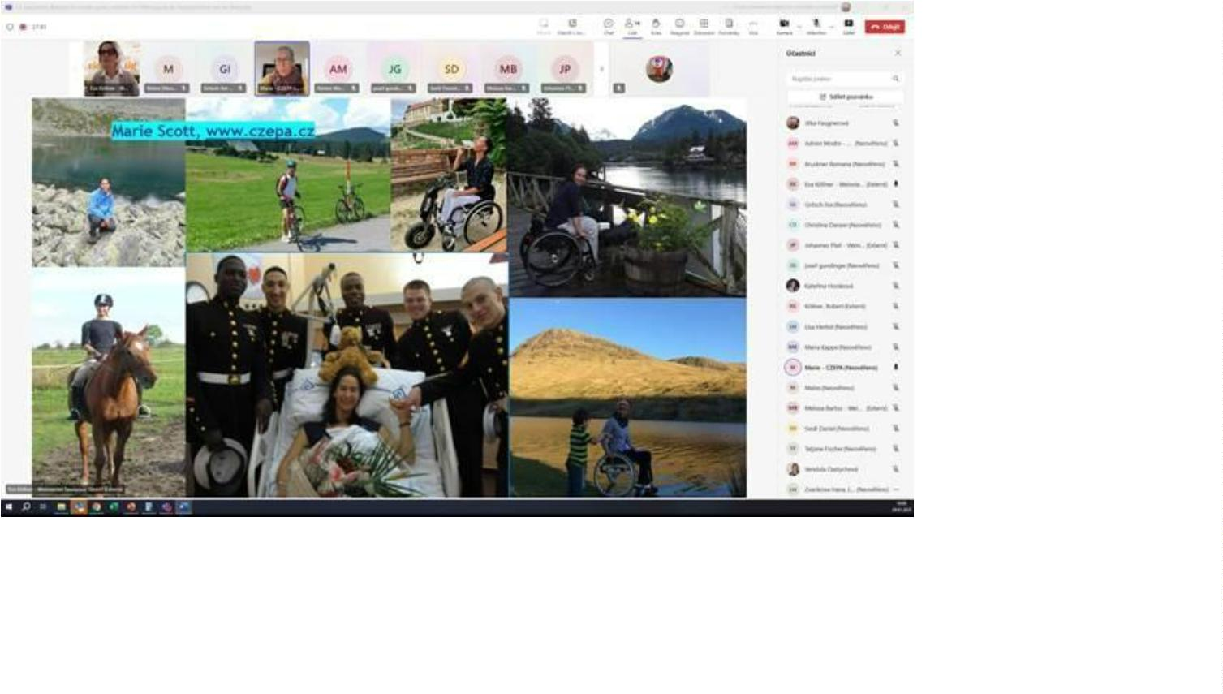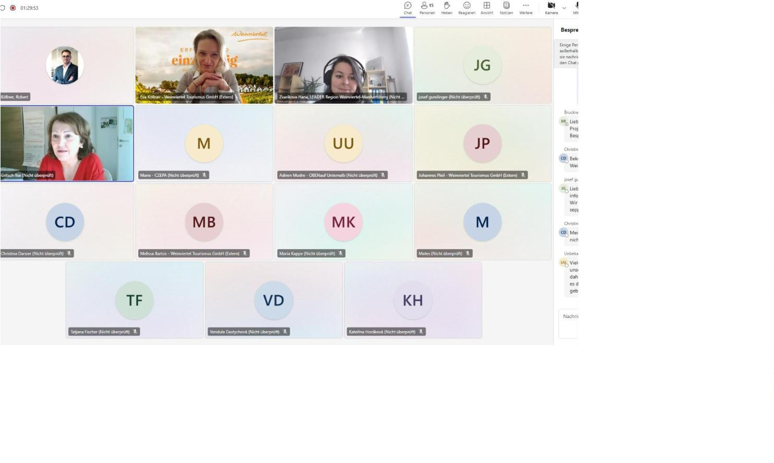

26.2.2025:
Leaflets
The leaflet offers 6 star excursion routes starting from Retz, which are suitable for
passengers with reduced mobility. It was created in cooperation with the tourist information
centres of Retz and Eggenburg. The electronic version is available on the websites of the
Page 11
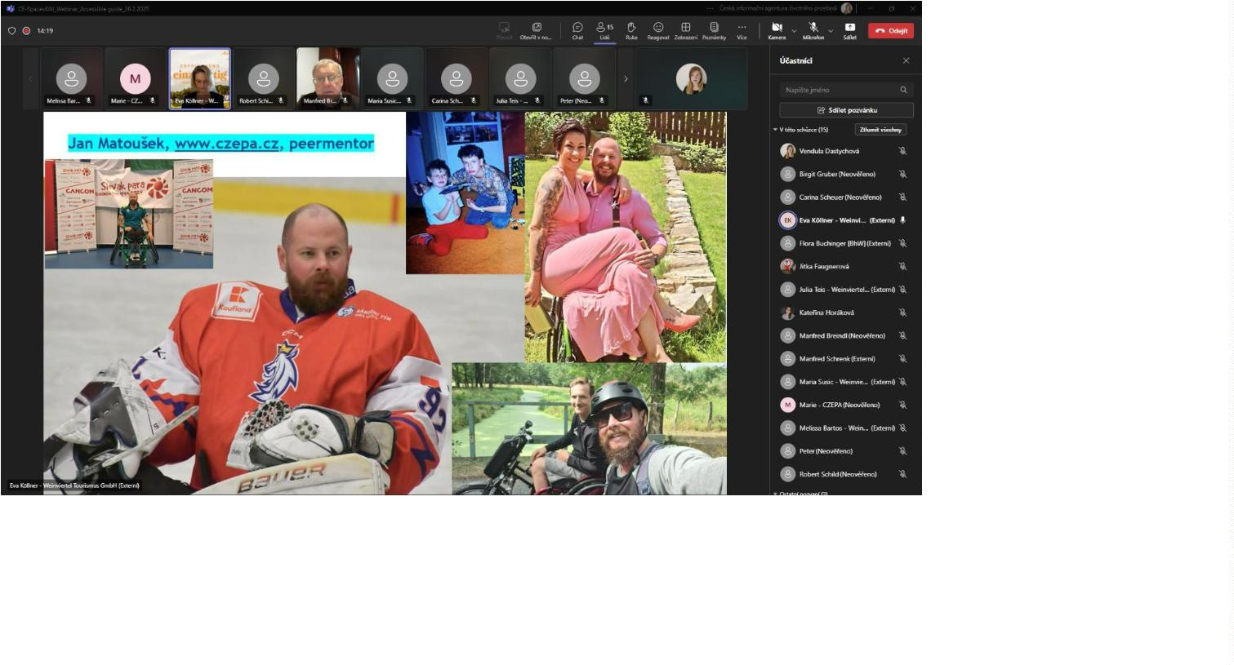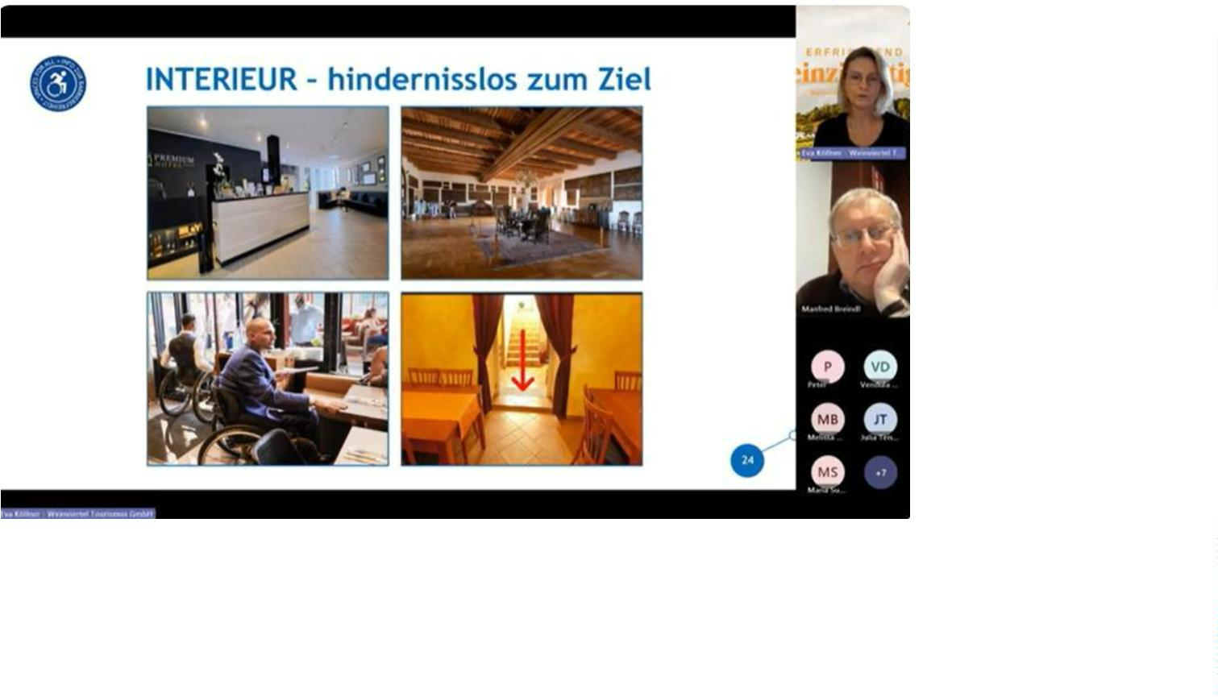

tourist information centres Retz, Eggenburg, Hollabrunn. On the Czech side, on the websites
of the ZnojmoRegion and the South Moravia Tourism Centre.
In Period 5, the content preparation for the leaflet “Star-trips in the Weinviertel without
barriers” was completed. The leaflet was printed and distributed to tourist information
centers (Retz, Eggenburg, Znojmo), to POIs, and service providers in the region. The leaflet
is also available through the ordering portal of the partner Weinviertel Tourismus. The leaflet
shows six tested trip tips, while other available destinations can be viewed using the QR code
at the bottom of the leaflet. The link leads to the Weinviertel Tourismus website
https://www.weinviertel.at/top-tipps-barrierefreiheit. The content can thus be constantly
updated and expanded with additional offers of available services in the region.
Page 12
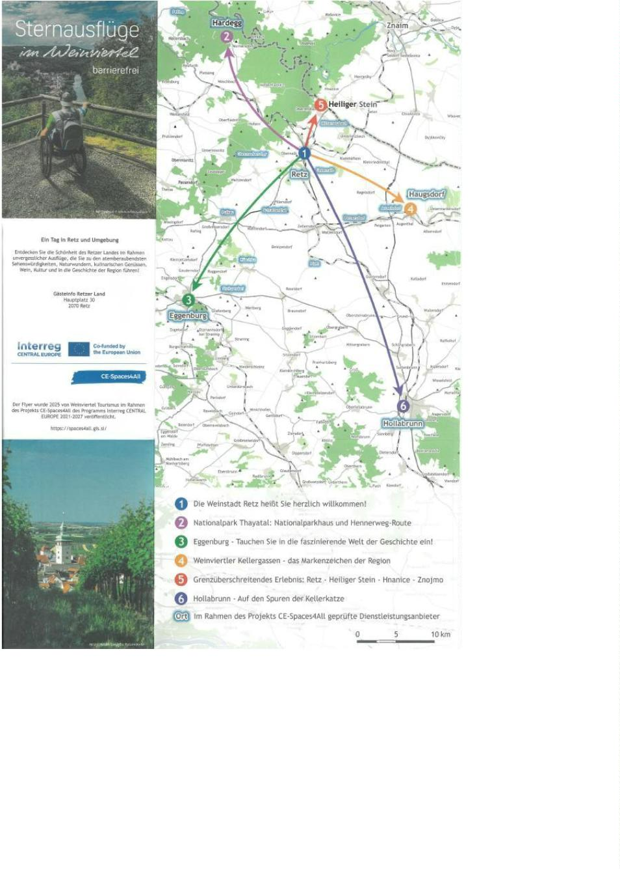

Project partner meeting in Rzeszów (PL)
The project partners Weinviertel Tourismus and BOKU participated in a project meeting in
Rzeszów on May 7-8, 2025.
Project partner meeting in Laa an der Thaya:
Project partner Weinviertel Tourismus organized two-day event, scheduled 16th to 17th
October 2024 in reporiting period 4.
The meeting was attended by representatives of all 12 project partners. The aim of the
meeting was to acquaint the project partners with the activities implemented so far and to
ensure the quality implementation of the upcoming activities in the next phases. In the
afternoon, a visit to barrier-free excursion destinations and businesses in the Retz pilot area
took place. During the study visit of the barrier-free facilities the companies were informed
aboutthe progress of the project implementation and project activities.
Page 13
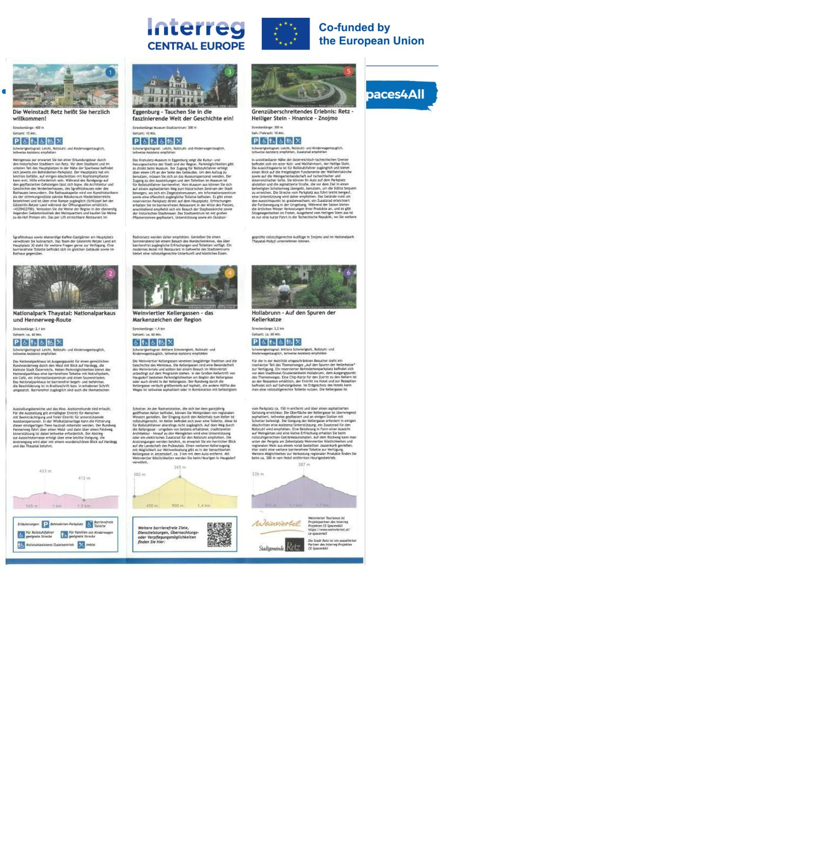

On the second day, the workshop continued with presentations on WP1, WP2 activities,
project management and communication.
Meetings with representatives
In reporting period 4, the project partner Weinviertel Tourismus participated in the
coordination meeting “Strategiegruppe Tourismus in der EU-Dounauraumstrategie”, which
took place on 19 February 2025 in Vienna. In addition to the current developments in the EU
Danube Strategy, the exchange of information on ongoing and completed EU Interreg
projects, initiatives and planned projects and important topics for the coming year was
presented.
Page 14
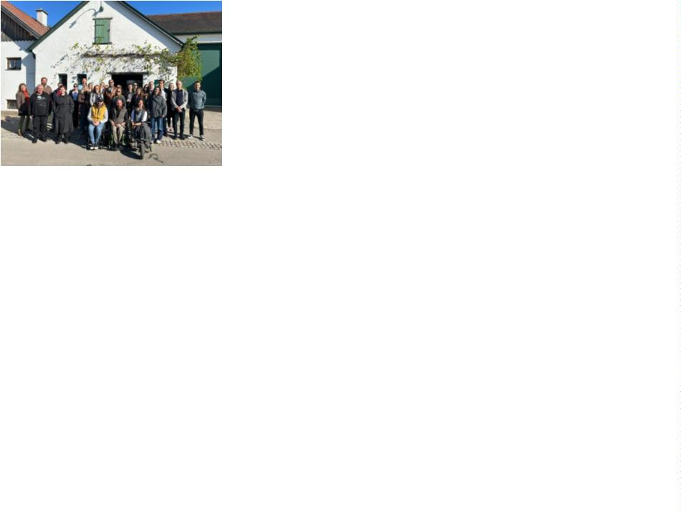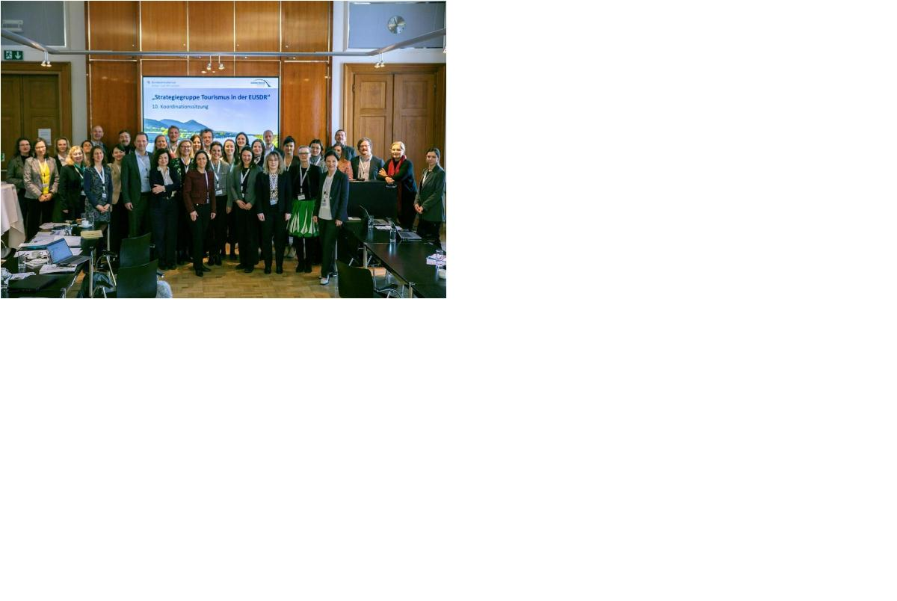

Charity run Wings for Life
Project partner Weinviertel Tourismus, in cooperation with the city of Retz and project
partners Cenia and CZEPA, organized the Wings for Life charity run and helped promote it in
the region. The event took place on May 4, 2025, in Retz. The CE-Spaces4All project was
presented and promoted during this event.
Page 15
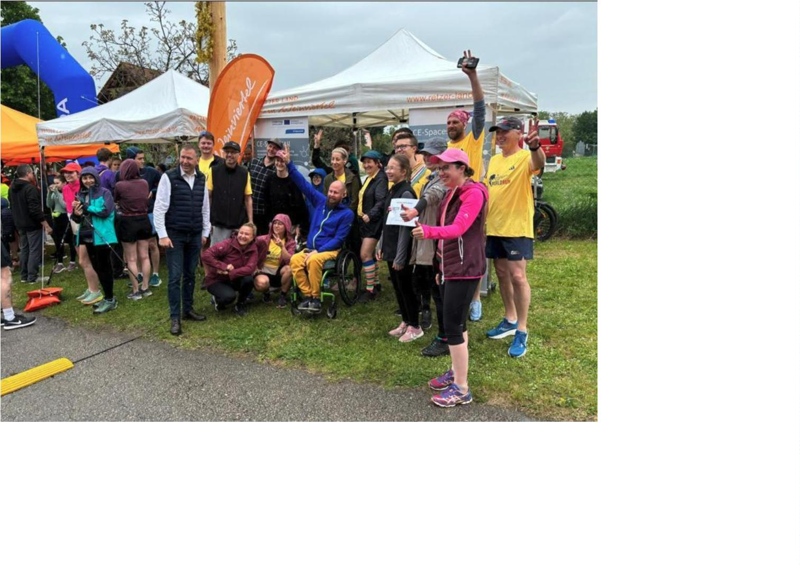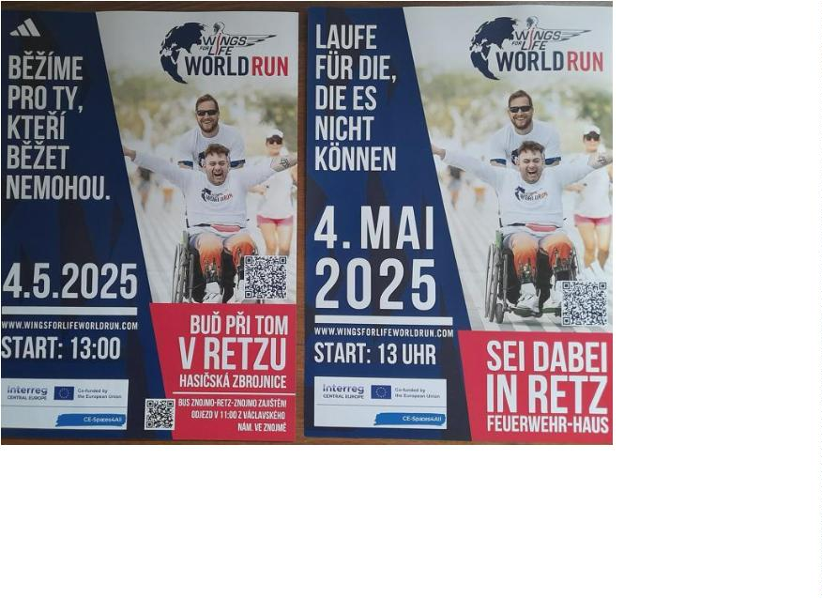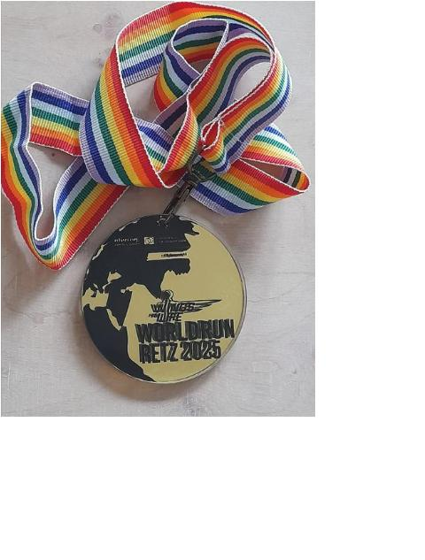

Promo-Wheelchair
Project partner Weinviertel Tourismus purchased a special wheelchair with an additional
electric drive in the 5. period. The choice of wheelchair was consulted with representatives
of project partner CZEPA. The intention to purchase this wheelchair was discussed with
representatives of the town of Retz and a service company (bike rental). The purchase was
consulted with the lead partner and approved. The wheelchair will be located in Retz on the
main square at the bike rental shop and will serve visitors to the city with reduced mobility
to facilitate visits to tourist attractions in Retz and its surroundings. Delivery of the
wheelchair with an additional electric drive is planned for early September 2025.
Video on a touristic trip of blind and visually impaired people
In summer, BOKU started with preparation works for a video showing the experiences of blind
and visually impaired people on a touristic trip to Eggenburg, a medieval city in the border of
Waldviertel and Weinviertel regions. The target group of this video are tourism stakeholders
and spatial planners with responsibility for public infrastructure which is used in tourism. The
video should show them where to pay attention to when acting with and for blind and
visually impaired. It is about demonstrating feasibility and raising awareness.
The elements of the video were orientated towards the travel cycle, which includes all
activities in the course of preparing, carrying out and following up a trip. Visual impairments
are partially shown with visual effects. The viewer should be able to put themselves in the
shoes of the blind or visually impaired holiday maker and understand the journey from their
first-person perspective.
The video was filmed with the support of BOKU’s media department in Eggenburg end of May
2025 after an initial site visit at the beginning of May. The contents of the video are:
•
•
•
•
•
•
•
•
•
•
test persons introducing themselves and explain their visual impairments
arrival of the travellers by train
walk from the railway station towards the city centre
visit of the Krahuletz Museum
visit of the city tourist information office
using a public toilet
visit of the historic city wall
lunch break in a café-restaurant
visit of St. Stephan’s church
walking trip along the historic city wall
While the action itself is filmed without additional comments (i.e. only what the test person
talk to each other was recorded), interrupting sequences feature interview statements from
both test persons about their experiences.
The video was produced in a length of 20-30 minutes and is planned to presented to
representatives of target groups, tourism actors and other relevant stakeholders only in a
moderated and accompanied manner. In the course of such events, the video is embedded in
Page 16

the sequence (1) introduction, (2) video presentation, (3) discussion. Although the production
of the video limits its further usability with regard to accompanied screenings, the scope for
communication with the relevant stakeholders and representatives of user groups is
intensified as a result, and the presentation can be customised. The video was produced in
German. There will be a shorter English version (voice overlay) to be published through the
project’s communication channels
To summary, these activities took place:
Date, place
Topic, title
Stakeholders involved
Page 17
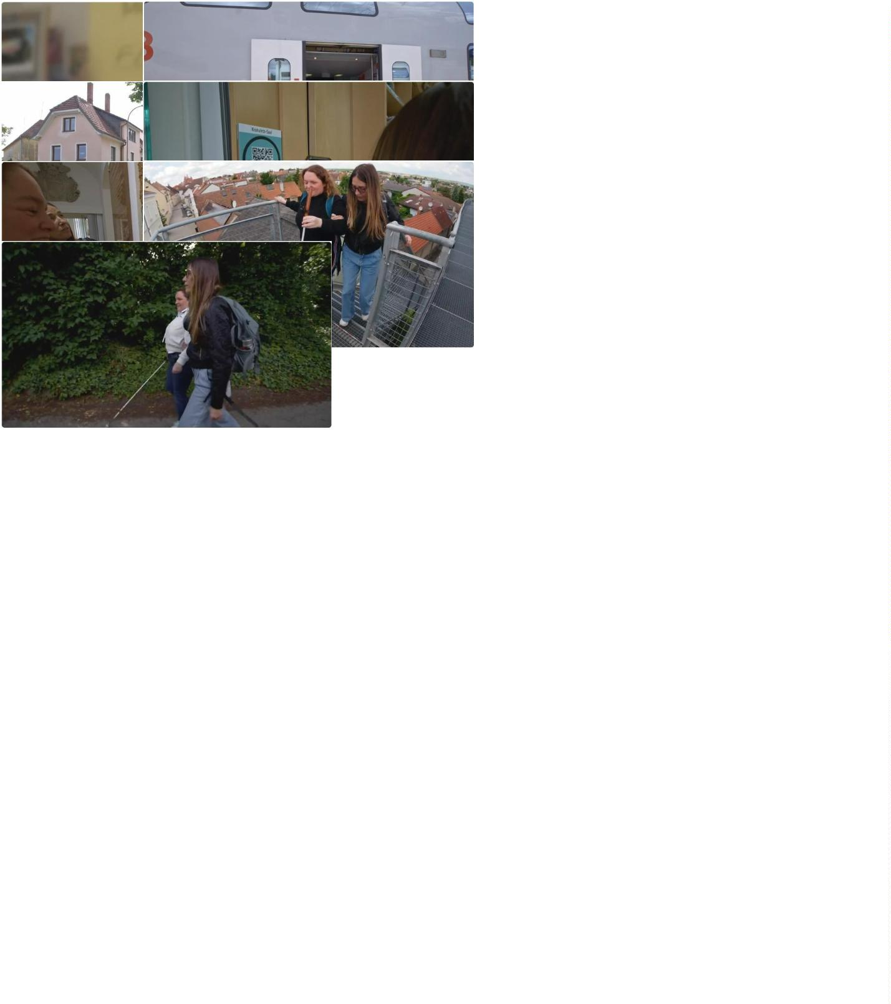

Spring 2025, Retz
and surroundings
Weinviertel Tourismu project
team, CZEPA project team
field work a WAV
Weinviertel Tourismu project
team, CENIA + CZEPA project
team
Spring 2025
Event Wings for Life Run
Video about a trip of
persons with vusual
April/May 2025
BOKU, WVT, City of Eggenburg
impairments to Weinviertel
Final editing, print and
distribution of leaflets with
routes suitable for people
with reduced mobility.
Spring 2025
CENIA project team, Retz
active communication with
tourism service providers to
implement AG on their
websites
Spring + summer
Weinviertel Tourismus project
team
2025
Info day and workshop at
BOKU
July 2025
BOKU
2.3. Final status of pilot activities in Znojmo region
Soft barriers in WAV (activity completed in RP4)
After mapping the accessibility of the tourism facilities in the pilot area, data were saved
and visualized in Web Accessibility Viewer (WAV). These were data on hard/physical barriers
in accessibility. Such attributes were gathered in the previous project periods. Yet there are
also soft barriers in accessing tourism services for PWD - the major one is the lack of
information about available barrier-free services on provider websites (e.g. a hotel offers a
wheelchair accessible bedroom with no information on the website, thus creating a false
impression that the venue offers no barrier-free accommodation). In period 4, the project
team reviewed websites of all the tourism providers listed in WAV to evaluate whether there
is any information about its accessibility available. Four new values were added into the WAV
to assess the current situation: 1.facility has barrier-free services available (often revealed
at site-visit), 2. reference about barrier-free services on the website (e.g. “we offer an
accessible bedroom”), 3. detailed description & photographs of the available adapted
service, 4. detailed description & photographs of all the facilities available at the tourism
venue - Accessibility Guide.
Accessibility guide
Accessibility Guide (AG) is a summary of basic information about accessibility of a tourism
venue. The AG helps customers with disabilities to evaluate barrier-free services of the
tourism provider, thus significantly improving trip planning.
Page 18
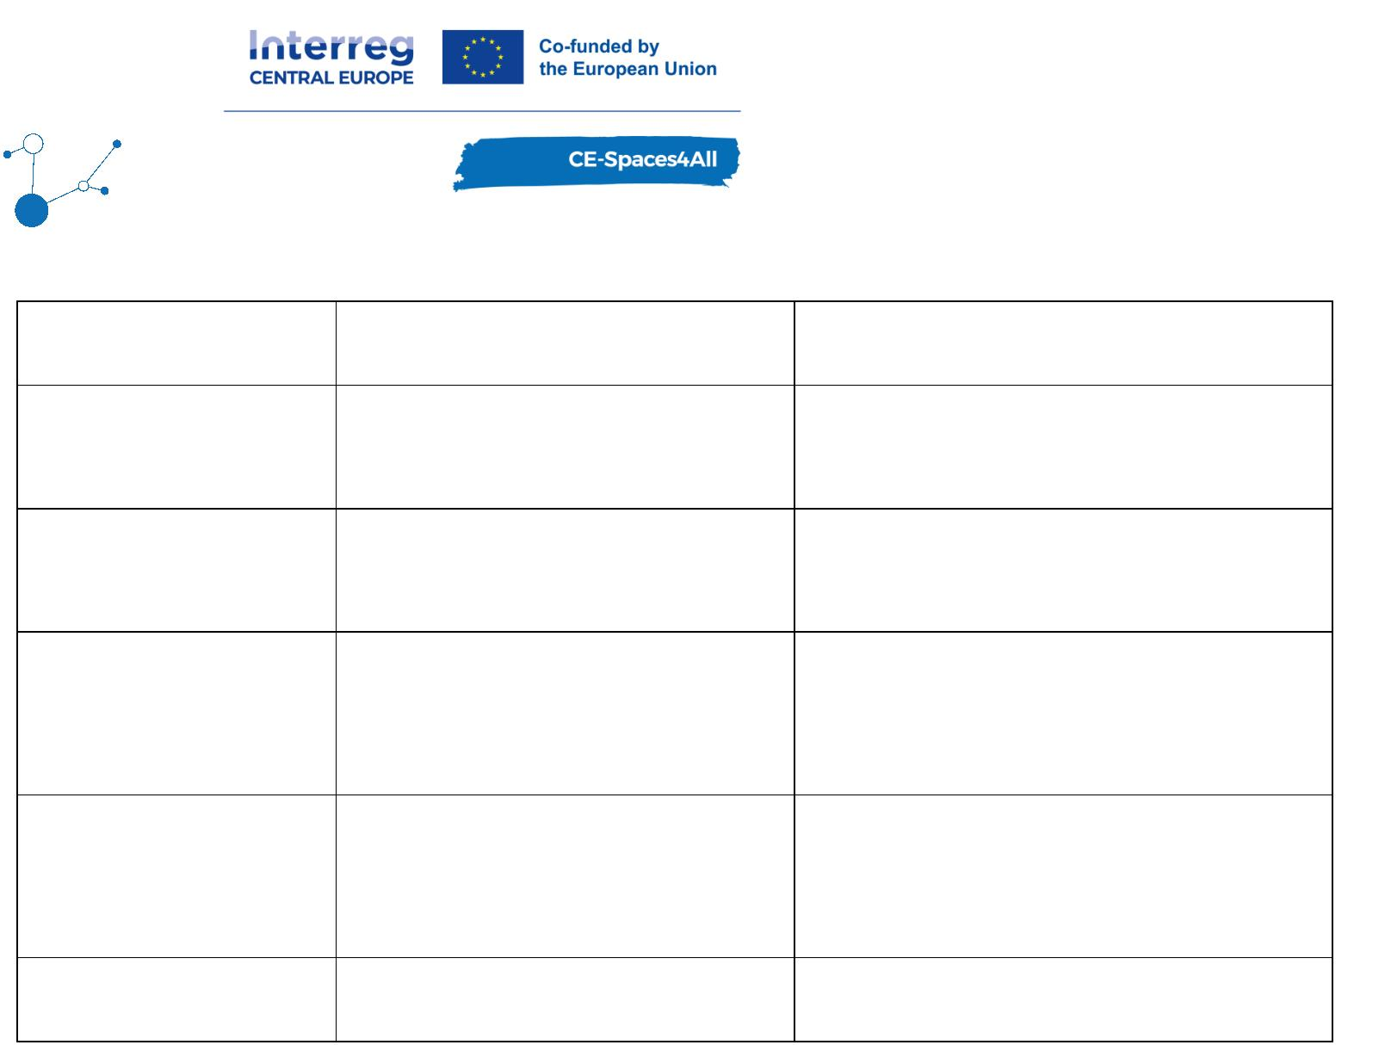

Tourism providers often do not know what information to publish online when offering
barrier-free services. Therefore, three Manuals for tourism providers on how to create the AG
were created - 1. accommodation, 2. restaurants and 3. other tourism attractions (e.g.
museums). The Manuals were prepared in the Czech language and translated to German and
English for other project partners to use. All Manuals are published under project outputs for
free
download:
https://www.interreg-central.eu/projects/ce-spaces4all/?tab=outputs
(scroll to output named Model for improving mobility of PWD for independent tourism travel
in the transborder tourism area)
In RP5, more instructional materials for tourism providers were added to an online resource
platform, so that any business can now download all necessary materials free of charge in
order to create its own Accessibility Guide (AG). We created the following instructional
materials:
•
The Manuals on how to create the Accessibility Guide (AG) - accommodation,
gastronomy and tourism attraction
•
•
•
•
•
Icon of AG in colour variations under which the AG is published on provider’s website
Tutorial video with step-by-step guidance on how to create AG
Examples of published AG
Motivational video with tourism provider who explains the process of AG creation
Leaflet for tourism business on how to create AG
Pilot testing of the Manual for creating AG of the accommodation facility
As the Manual for accommodation facility was created, we tested it at The Hotel Premium in
Znojmo. We obtained valuable feedback from the process, which was used for the Manual
improvement. Our first test of AG of accommodation facility was presented as a case study at
online webinars to demonstrate this new approach to other tourism providers in the pilot
Page 19
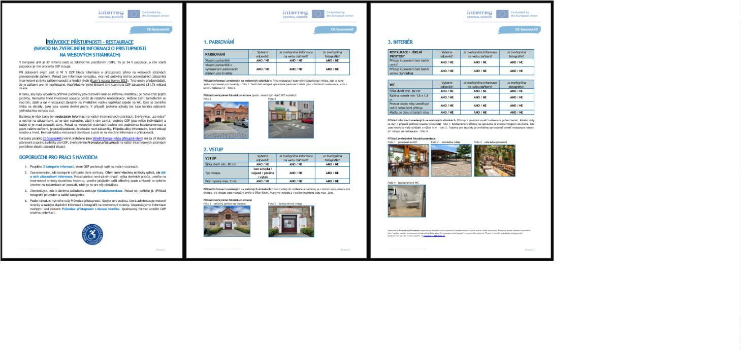

area. AG is now published on the Hotel Premium website in Czech and English (click on the
wheelchair icon at the main menu next to contacts): https://www.premiumhotel.cz/en/.
In P5, all three Manuals have been used as a template for collecting information about
venue’s accessibility. The project team has been assisting tourism facilities listed in WAV
from our pilot region to use them and are now in a process of collecting valuable feedback.
Here are some examples of AG (Průvodce přístupnosti) published online:
Hotel Happy Star
Hotel Savannah
Krčma a hotel U Císařské cesty
Family City Entertainment Center
Hotel Thaya
Feedback on the use of AG has been collected in the form of qualitative questioning. Tourism
providers listed in WAV with completed AG have been contacted by a telephone and asked
how the AG approach has been working for them. These are question topics being asked:
•
•
•
What did you find easy when creating the AG?
What challenges did you face?
Suggestions for improvements
Benchmarking analyses of accessibility of tourism facilities in the pilot area
At this period, benchmarking analyses of the tourism facilities from WAV were created with
focus on clear display of basic accessibility attributes (hard and soft barriers). All tourism
providers were presented with the results to allow for specific improvements of accessibility
features which transpired as inadequate during the mapping. Three benchmarking analyses
were prepared - 1. accommodation, 2. restaurants (gastronomy) and 3. other tourism
attractions. Simple graphics demonstrated the level of accessibility of each tourism facility.
Benchmarking analyses were also presented at online webinars (below) as fact sheets to
demonstrate the lack of publishing information on accessibility of the tourism venues in the
pilot region (soft barrier in accessibility).
Page 20

In RP5, benchmarking analyses have been used to demonstrate the lack of accessibility
information in tourism, e.g. at online webinar organised for local and regional tourism
authorities on the 10th June.
Online educational webinars
As the new Accessibility Guide (AG) approach needed to be communicated amongst the local
tourism providers, a series of three identical tutorial online webinars for tourism providers
took place. Invitations for the webinar were communicated via various social platforms and
with use of a short video-invitation: https://www.interreg-central.eu/news/czech-austrian-
pilot-region-has-been-testing-accessibility-guides-weibnar-n-2/
At the webinars called How to create an Accessibility Guide for customers with disabilities,
the three Manuals were presented and step-by-step guidance on how to create the AG and
publish it on the website was introduced. At the same event, the tourism providers were
presented with the benchmarking analyses (see above) and use of WAV. The webinars were
recorded for possible future use: https://www.youtube.com/watch?v=NExjE5wAvJo
Participants of the webinars: tourism providers from the Znojmo region identified in WAV +
other tourism providers organized under the Tourism Authority South Moravia (Centrála
Cestovního Ruchu Jižní Morava - CCRJM) and ZnojmoRegion. These stakeholders might be
interested in the results of the pilot actions, which can be expanded outside the Znojmo
region to the entire South Moravia region and beyond. The online setup was chosen due to
the workload of managers of the tourism facilities. Experience from past events has shown
that responsible personnel often cannot attend in person. Three dates in two consecutive
Page 21
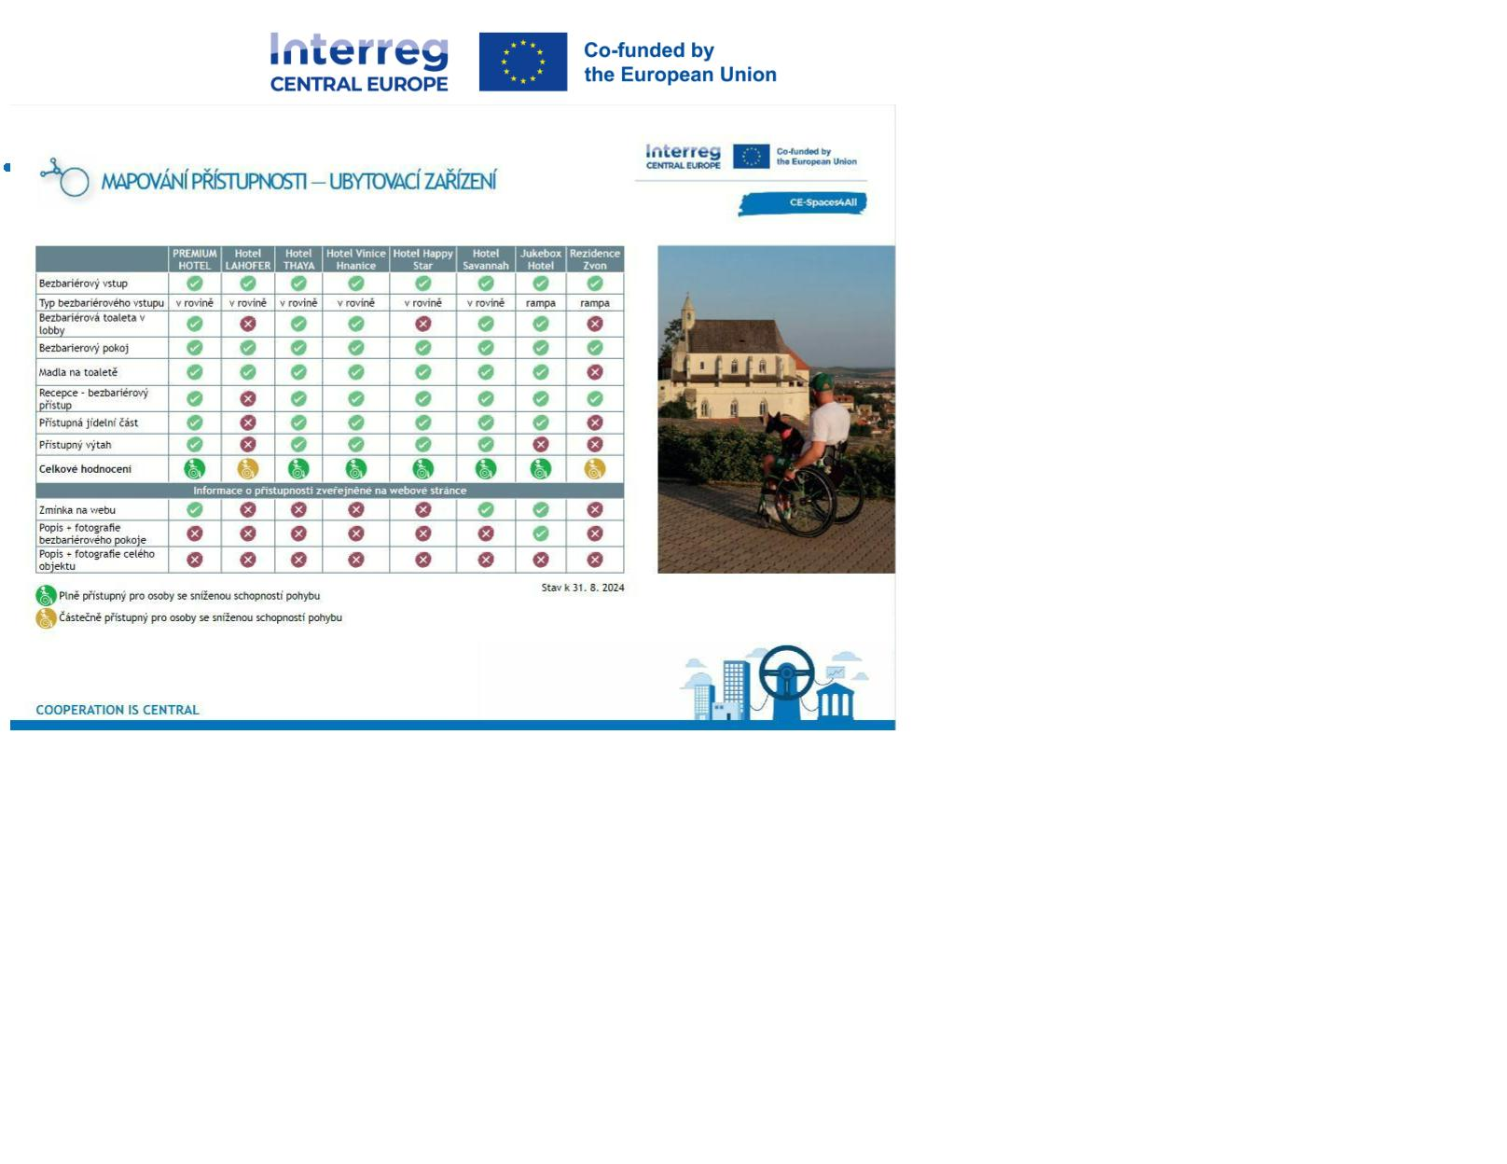

months were offered to allow for flexibility while choosing the date of the webinar.
Venue: Online - 10. 12. 2024, 14. 01. 2025, 23. 01. 2025, 10. 06. 2025, 19. 06. 2025
Duration: 60 minutes + time for discussion
Organizers: CENIA and CZEPA
Participants: participants in table below (+ 7 participants PP)
•
•
Czech paraplegic association (CZEPA) PP: Marie Scott, Jan Matoušek
Czech Environmental Information Agency (CENIA) PP: Jitka Faugnerová, Vendula
Dastychová, Kateřina Horáková, Martina Sálová
•
Weinviertel Tourismus PP: Eva Köllner
Online webinars attendance list:
ID First Name
Last Name
Bartíková
Buršík
Červinková
Flechtnerová
Habartová
Facility Name
Hotel Atlantis
Facility type
Accommodation 10.12.2024
Info centre
Info centre
Other
Date
1
2
3
4
5
Veronika
Miroslav
Pavla
Jana
Lenka
Správa Národního parku Podyjí
IC Moravský Krumlov
CZEPA
Galerie mlýn Žeraviny
Regionální muzeum v Mikulově, p.
o. - Archeopark Pavlov
Hotel Happy Star
Jihomoravské muzeum ve Znojmě
Muzeum města Brna, p.o.
Hájenka pod větrníky
10.12.2024
10.12.2024
10.12.2024
10.12.2024
Other
6
Zuzana
Havlická
Other
10.12.2024
7
8
9
Martin
Renata
Šárka
Herzig
Accommodation 10.12.2024
Other
Other
Accommodation 10.12.2024
Other
Hurníková
Klištincová
Kováříková
10.12.2024
10.12.2024
1
1
1
0
1
2
Lenka
Taťána
Patrik
Krajčírovičová Technické muzeum v Brně
Kubát
10.12.2024
10.12.2024
Národní vinařské centrum
Centrála cestovního ruchu – Jižní
Morava
Centrála cestovního ruchu Jižní
Morava
Other
Tourism
Authority
Tourism
Authority
1
1
3
4
Klára
Lepičová
10.12.2024
10.12.2024
Monika
Lidmerová
1
1
1
5
6
7
Kateřina
Irena
Eva
Mrnuštíková
Navrkalová
Oubělická
Maximus Resort
ZnojmoRegion
Brněnsko, z.s.
Accommodation 10.12.2024
Info centre
Info centre
10.12.2024
10.12.2024
Turistické informační centrum
Tišnov
1
8
Barbora
Peterková
Info centre
10.12.2024
1
2
2
2
2
9
0
1
2
3
Veronika
Dana
Tereza
Jan
Procházková
Součková
Tesařová
Zika
AVANTI Hotel
VozejkMap
Dům přírody Moravského krasu
Hotel Vinice Hnanice
Bazén Louka Znojmo
Accommodation 10.12.2024
Other
Info centre
10.12.2024
10.12.2024
Accommodation 10.12.2024
Radek
Sauer
Other
14.01.2025
Accommodation
2
2
4
5
Andrea
Petra
Weisová
Family City
14.01.2025
/
Restaurant
Královéhradecká krajská centrála
cestovniho ruchu, p. o.
SZ Lednice
Vrbasovo muzeum Ždánice
Národní ústav lidové kultury
Bednářová
Info centre
14.01.2025
2
2
2
2
3
6
7
8
9
0
Tomáš
Monika
Marie
Eva
Kollár
Jandorová
Sýkorová
Other
Other
Other
Other
Other
23.01.2025
23.01.2025
23.01.2025
23.01.2025
23.01.2025
Kellner Fialová Zámek Slavkov-Austerlitz
Šimánková Město Mikulov Kultura
Marcela
Page 22


3
3
1
2
Lukáš
David
Agentura průvodců REMO-Agency
Středočeská centrála cestovního
ruchu, p. o.
Other
Tourism
Authority
23.01.2025
10.06.2025
Hanka
Musílková
Tourism
3
3
Eva
Beranová
CzechTourism
10.06.2025
Authority
Info centre
Info centre
Tourism
Authority
Tourism
3
3
4
5
Dana
Martin
Černá
Karas
DMO Kraj blanických rytířů
Královéhradecký kraj
10.06.2025
10.06.2025
3
3
3
3
6
7
8
9
Zuzana
Vojtova
CCRVM
10.06.2025
10.06.2025
10.06.2025
10.06.2025
Centrála cestovního ruchu Východní
Moravy, o.p.s.
Evropská kulturní stezka sv. Cyrila a
Metroděje
Centrála cestovního ruchu Východní
Moravy, o.p.s.
Lenka
Kučerová
Janochová
Valášková
Authority
Martina
Radka
Info centre
Tourism
Authority
Tourism
4
4
4
0
1
2
Lenka
Jitka
Kováčoáv
Destinační společnost Valašsko
MIC Uherské Hradiště
Vysočina Tourism
10.06.2025
10.06.2025
10.06.2025
Authority
Info centre
Tourism
Zálešáková
Merunková
Klára
Authority
Tourism
Authority
Tourism
4
4
3
4
Alena
Lenka
Kudílková
Kováčová
Prague City Tourism
10.06.2025
10.06.2025
Destinační společnost Valašsko
Authority
Centrála cestovního ruchu Východní
Moravy
Spolek Trend vozíčkářů Olomouc
Centrála cestovního ruchu Východní
Moravy, o.p.s.
Tourism
Authority
Other
Tourism
Authority
4
4
4
5
6
7
Petr
Michalec
Macková
Skaunicová
10.06.2025
10.06.2025
10.06.2025
Ludmila
Veronika
Centrála cestovního ruchu Jižní
Morava
Tourism
Authority
4
8
Monika
Lidmerová
10.06.2025
Česká asociace paraplegiků - CZEPA,
z.s.
Česká asociace paraplegiků
Kostel Panny Marie Vítězné a
Pražského Jezulátka
4
5
5
9
0
1
Alena
Vaclav
Marie
Jančíková
Uher
Other
Other
Other
10.06.2025
10.06.2025
10.06.2025
Ambrozková
Tourism
Authority
Tourism
Authority
Tourism
Authority
Other
5
5
2
3
Lucie
Eva
Holásková
Sojáková
Region Slovácko
Region Slovácko
10.06.2025
10.06.2025
Centrála cestovního ruchu Východní
Moravy, o. p. s.
Galerie mlýn Žeraviny
Regionální muzeum v Mikulově,
příspěvková organizace
54
55
56
Veronika
Lenka
Skaunicová
Habartová
Kukla
19.06.2025
19.06.2025
19.06.2025
Tomáš
Other
Tourism
Authority
57
Eva
Sojáková
Region Slovácko
19.06.2025
5
5
6
8
9
0
Lenka
Lenka
Eva
Vlasatá
Kováříková
Kellner Fialová
Resort Ohrada s.r.o.
Hájenka pod větrníky
Zámek Slavkov-Austerlitz
Muzeum Brněnska - Památník
písemnictví
Royal Garden Apartments
Centrála cestovního ruchu Jižní
Morava
Accommodation 19.06.2025
Accommodation 19.06.2025
Other
19.06.2025
61
62
63
Šárka
Dudková
Zýková
Other
19.06.2025
Vladislava
Monika
Accommodation 19.06.2025
Tourism
Lidmerová
19.06.2025
Authority
Page 23
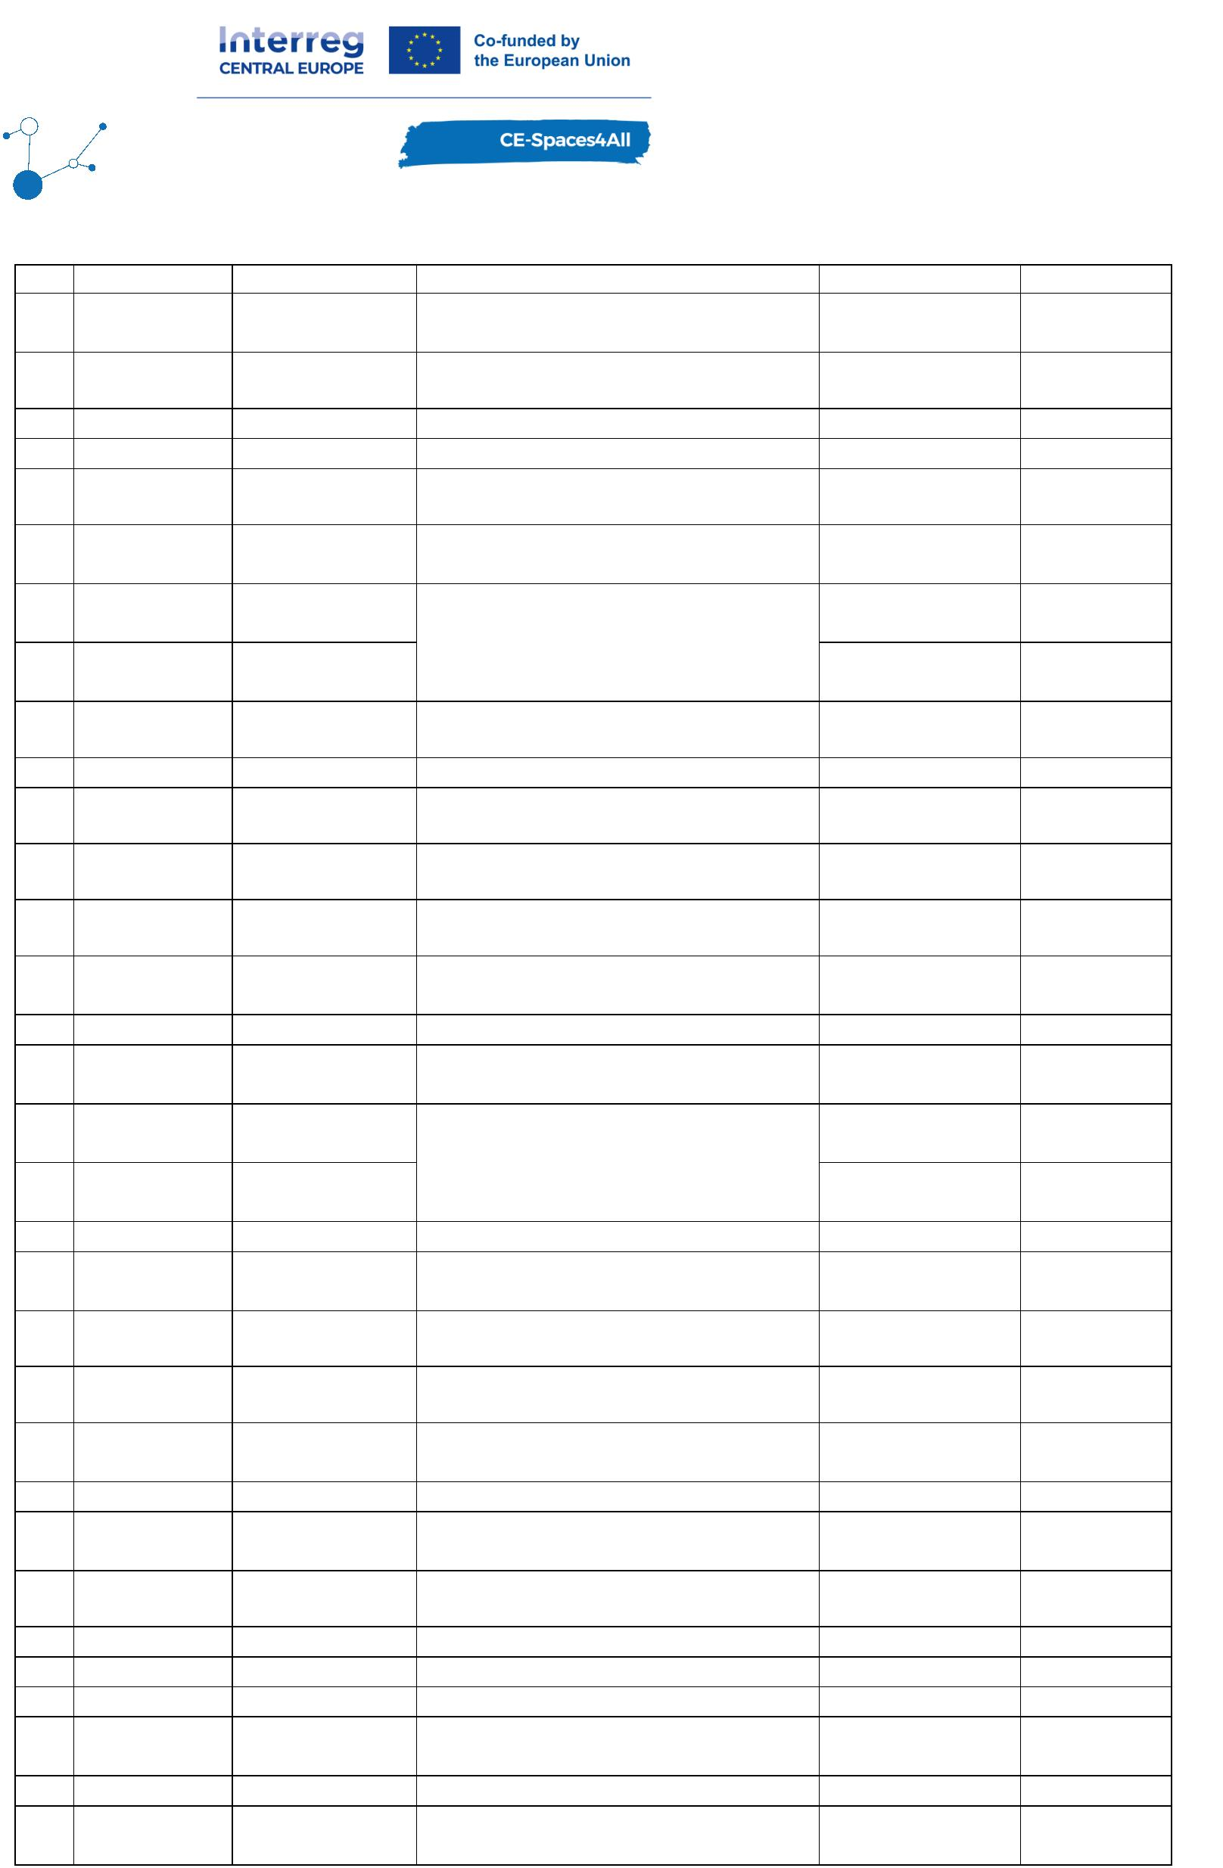

64
65
66
67
68
69
70
Michaela
Blanka
Kristýna
Jana
Andrea
Kamila
Magdalena
Bělinová
Veselá
Králová
Harestová
Musilová
Pokorná
Učňová
Destinační společnost Hradecko, z.s.
MKS Letovice, příspěvková organizace
Benátky 214
Hotel Sladovna
Tree house
Info centre
Other
Accommodation 19.06.2025
Accommodation 19.06.2025
Accommodation 19.06.2025
19.06.2025
19.06.2025
VIDA! science centrum
Muzeum Brněnska
Other
Other
19.06.2025
19.06.2025
Tourism
Authority
71
Hanka
Musílková
Středočeská centrála cestovního ruchu
19.06.2025
Agenda:
5
3
1
1
mins
Welcome
0 mins
5 mins
0 mins
Presentation of Accessibility Guide approach + Manuals
Presentation of WAV and activities in rural areas (not presented 10. 19.6.
Discussion
Description:
The webinar served as a practical tutorial for tourism providers on how and why to create
the AG. The three Manuals were presented and reviewed in its entirety to allow the
attendees to see all its parts. Examples of photographs which should be part of the AG were
shown to the audience and there was a room for specific questions. The webinar presented
the case-study of hotel Premium and, additionally, demonstrated other tourism facilities
locally and abroad which utilize AG online to welcome customers with disabilities. Challenges
which can be faced while publishing the AG on the website were reviewed and a unified
format for publishing the AG was introduced with its logo. The webinars also included
information on how the project partners can assist local tourism providers with AG creation
and publishing. The last part of the webinar focused on presenting the project, including a
demonstration of data mapping, the WAV, and the project's goal of promoting independent
travel for people with disabilities.
In P5, we have created a video-tutorial out of the online webinars. Step-by-step guidance on
how to create the AG in a form of video-tutorial is now available at the online resource
platform with instructional materials for free use for any tourism provider who wishes to
make its accessibility information public. Two educational webinars are being organised at
this monitoring period. One is aimed at all tourism authorities in the Czech Republic
(national, regional, local level). In this webinar, we demonstrated the process of pilot-testing
of the new Accessibility Guide approach. The idea is for the AG to be used by tourism
providers on the national level. Examples of success in our pilot region can motivate tourism
authorities to learn from our experience and utilise our instructional materials all across the
country and beyond. Second webinar is identical to those presented in P4 - in the form of a
tutorial for tourism providers on how to create the AG (more practical).
Summary report on the publication of information on accessibility of barrier-free venues
listed on the website of the main tourism authority in the pilot region
Page 24
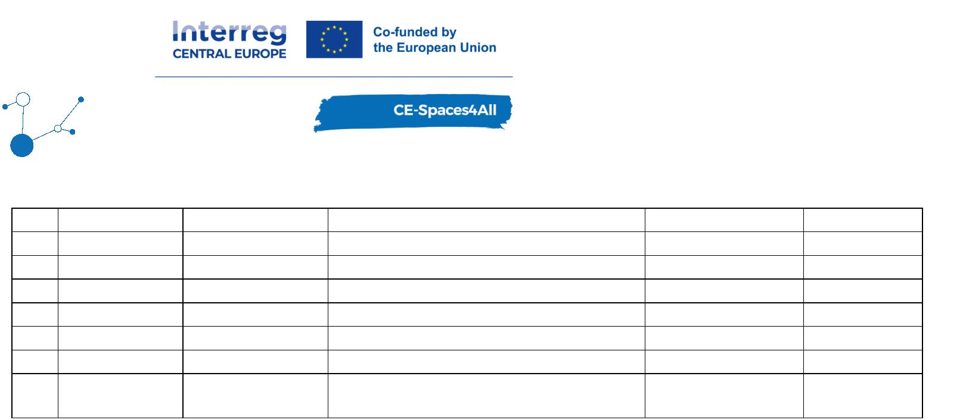

Tourism Authority South Moravia (CCRJM) has been active in promoting accessible tourism in
the pilot region for years. It operates an online portal called South Moravia Without Barriers,
where wheelchair accessible tourism attractions are being advertised. As some of the
published venues have not had detailed information on accessibility, the project team
reviewed the website and created a summary of findings. Recommendations for
improvements were discussed with the representative from CCRJM and are now being
transferred into the website.
Outcomes of the pilot testing
A total of 31 representatives from various tourist facilities attended the online webinars. The
webinars successfully provided tourism operators with practical knowledge on how to
improve accessibility transparency of their venue. The discussions and shared experiences
contributed to an increased awareness of the importance of presentation of clear and unified
accessibility information online. As a result, the initiative is expected to encourage more
businesses to produce AG, ultimately benefiting both PWDs and tourism operators.
In RP5, the online webinars’ attendance will be added.
Several participants expressed interest in receiving assistance in preparing the Accessibility
Guides (AG). CZEPA representatives are now in the process of preparing the AG for a number
of local tourism providers in the pilot region - meeting responsible personnel on site to help
with photo-documentation and decision making on what accessibility features to document in
AG. When the AG draft is created, it is followed by a review and clearance for publishing by
the project team.
The three Manuals on how to create the AG have been tested. The Manuals for
accommodation and gastronomy facilities have been tested the most so far. Initially at The
Hotel Premium in Znojmo, where the project team assisted with the whole process (from the
collection of accessibility information according to the Manual, photo-documentation,
transcription of the data into AG format, translation from Czech to English and its publication
on the hotel’s website). Number of other accommodation facilities are now working on their
AG with use of the Manual, tutorial from the online webinar and counselling with the project
team. Screenprints from one of the online webinars:
Page 25

In RP5, the project team conducted the following site-visits with the aim of developing the
AG:
•
•
•
Accommodation facilities - 6
Gastronomy facilities - 8
Tourism attraction - 3
AG published online to the date:
•
•
•
Accommodation facilities - 5
Gastronomy facilities - 1
Tourism attraction - 0
Hotel Happy Star
Hotel Savannah
Page 26
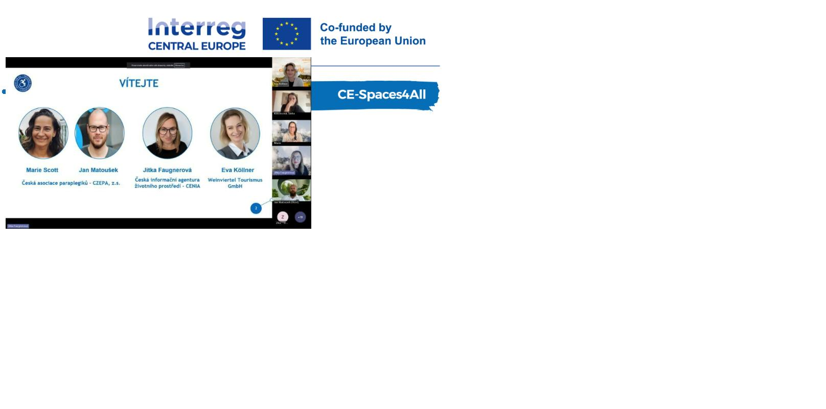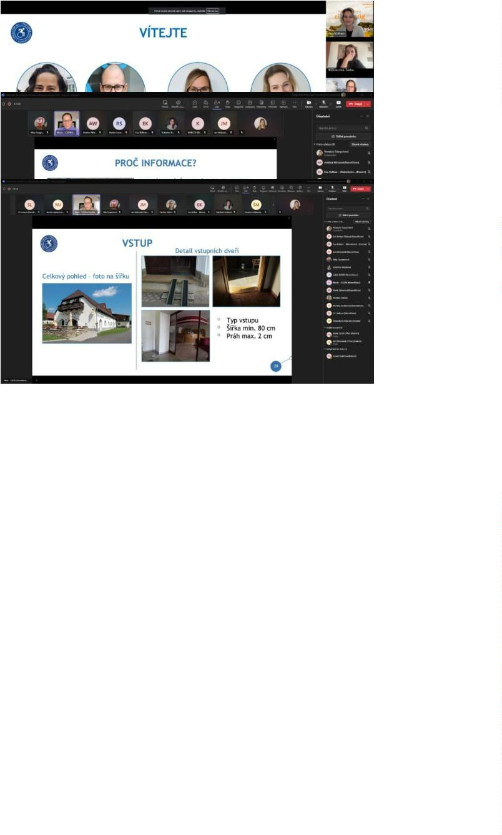

Krčma a hotel U Císařské cesty
Family City Entertainment Center
Hotel Thaya
Hotel Premium
Feedback and experience led the project team to establish an online resource platform for
tourism providers where they can find all materials needed to create the Accessibility Guide.
Here are some statements that businesses shared as feedback:
“It couldn’t have been any easier!” (manager of The Hotel Thaya)
“It’s a good thing, I believe it will help us to attract more customers.” (owner of The Hotel
Happy Star)
“I am not sure why we waited so long for this.” (manager of The Hotel Savannah)
“I would appreciate it if the Accessibility Guide was hosted on an external website and I
could just put a link to it on my website.” (manager of the restaurant Bistrograf)
The summary report with recommendations for improvements in publication of accessibility
information was shared with the representative of the main tourism authority in the pilot
region. It was gladly accepted and used as a guide for amendments.
Meeting with data and GIS experts of Znojmo
Meeting to raise awareness about WAV - focused on data, content, usability for the agendas
of the city of Znojmo. Experts for GIS, city geoportal and spatial planning were contacted
individually as they had not participated in any of the project events organised in Znojmo
since June 2023. There was no official meeting, CENIA team and GIS experts of Znojmo met
at an occasion of two geoinformatics conferences on 23rd September 2024 and 21st
November. Representatives of Znojmo were informed about the activities of the project
activities and possibility of use of the open data coming from the project. CENIA offered to
prepare a web map service (WMS) from WAV data that can be joined to Znojmo geoportal.
(https://mapy.muznojmo.cz/app/index.php?project=katastr_hsl) (under the CENIA – WMS)
Page 27

Meetings with stakeholders
During the reporting period, three key meetings with stakeholders of the Spaces4All project
were held, focusing on strengthening cooperation and coordinating activities in the pilot
area. On 27 March 2025, the project was reintroduced to representatives of Podyjí National
Park in connection with the appointment of the new park director (since February 2025). The
meeting focused on ongoing cooperation, the significant support provided by park rangers
and data specialists in designing accessible routes and conducting field checks, and the
potential organisation of a student workshop by Mendel University to assess the accessibility
of the area and propose possible improvements
On 28 March 2025, a meeting took place with the leadership of the City of Znojmo and the
organisation CZEPA. The project was presented to the newly elected mayor (autumn 2024)
and other city representatives, and current project updates were discussed. These included
the preparation and distribution of leaflets promoting accessible trips, the newly planned
construction of a footbridge in Podyjí National Park, participation of all project partners in
the Wings for Life charity run, and opportunities for cooperation with Mendel University
students
The final meeting was held on 2 May 2025 in Retz with partners from Weinviertel Tourism
and the City of Retz, focusing on the organisational details of the Wings4Life event, including
participant transport logistics and project publicity. The final leaflet with accessible routes
in Znojmo and a draft of similar routes for the Retz area were also presented, reinforcing the
cross-border nature of this activity
All meetings contributed to strengthening collaboration with local partners and ensuring
better dissemination and practical implementation of project outputs.
Leaflet - Znojmo region without barriers
Page 28
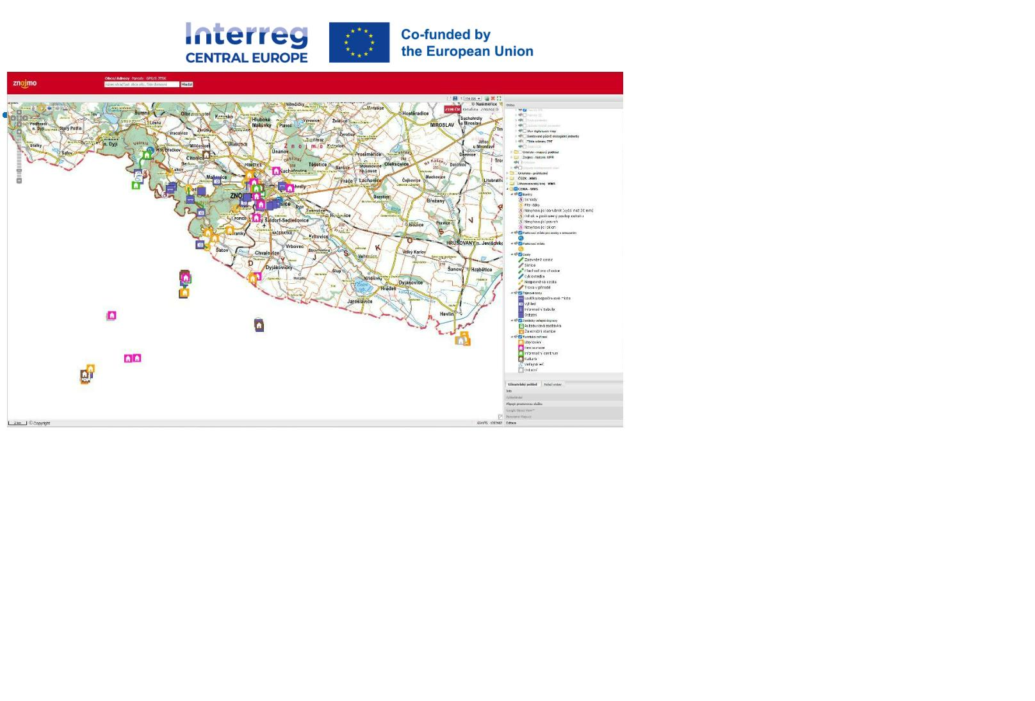

A thematic leaflet “Znojemsko bez bariér” (Znojmo Region without Barriers) was prepared
and published. It offers 6 recommended routes and 3 additional points of interest suitable for
travellers with limited mobility in the Znojmo region. The leaflet was developed in
cooperation with local tourist information centres and designed in alignment with the City of
Znojmo’s visual identity to ensure its long-term use and distribution in printed form through
the region’s tourist information centres. An electronic version is available on the websites of
the main regional tourism authorities – ZnojmoRegion (https://znojmoregion.cz/en) and
Tourism Authority South Moravia (https://www.jizni-morava.cz/cz/vylety-bez-barier/) – and
can also be downloaded free of charge from the project partner CZEPA’s website (leaflet
link). In project period 5, the leaflet was printed, distributed among local TICs, and actively
promoted via social media targeting persons with disabilities. The leaflet contributes to
better awareness of available accessible routes and strengthens the practical impact of the
project in the pilot area
Leaflet - Accessibility Guide for tourism providers
In P5, the project team created another leaflet, this time aiming at tourism providers. The
leaflet summarises advantages of the Accessibility Guide (AG) and states the process of
creating one - QR code takes the reader to the online resource platform.
Page 29
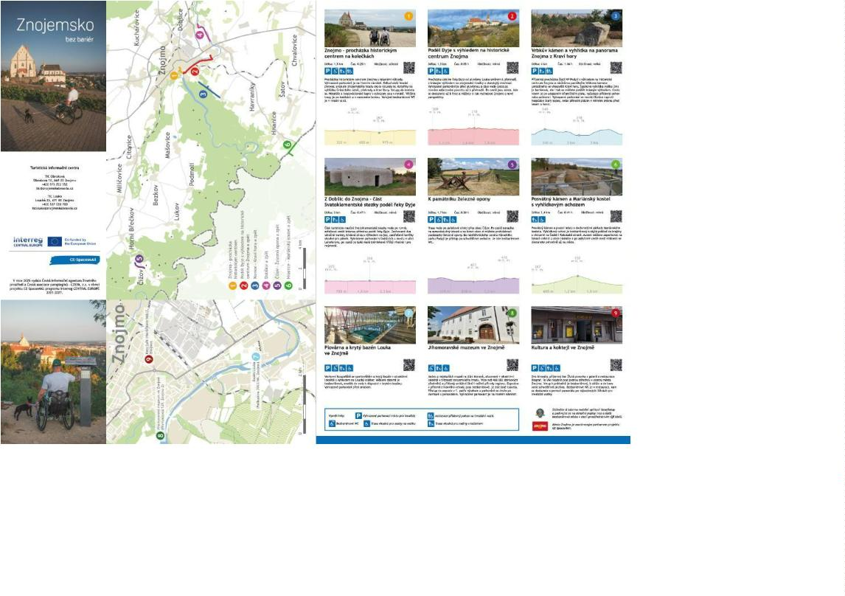

Cooperation with MENDELU
The Spaces4All project connects Mendel University, CENIA, Podyjí National Park, the
Weinviertel region, and the Czech Paraplegic Association (CZEPA) to improve accessibility of
public spaces for all, particularly people with limited mobility. In May 2025, a series of field
workshops began with an introductory meeting at MENDELU’s Faculty of Horticulture.
Students then joined experts in the field to experience nature alongside a wheelchair user,
identifying barriers and challenges.
They conducted detailed analyses of two locations – Havraníky and Čížov – focusing on trail
adjustments, viewpoints, shelters, furniture, and the information system. Proposals included
new barrier-free paths, a three-level trail classification (blue, red, black), sensitive
architectural solutions for viewpoints and footbridges, and accessible toilets and parking.
The information system would feature QR codes with audio recordings and tactile elements
for visually impaired visitors.
The aim is to remove physical barriers and create a safe, logical, and attractive trail
network, allowing all visitors – regardless of physical ability – to move through Podyjí National
Park comfortably and with dignity.
Page 30
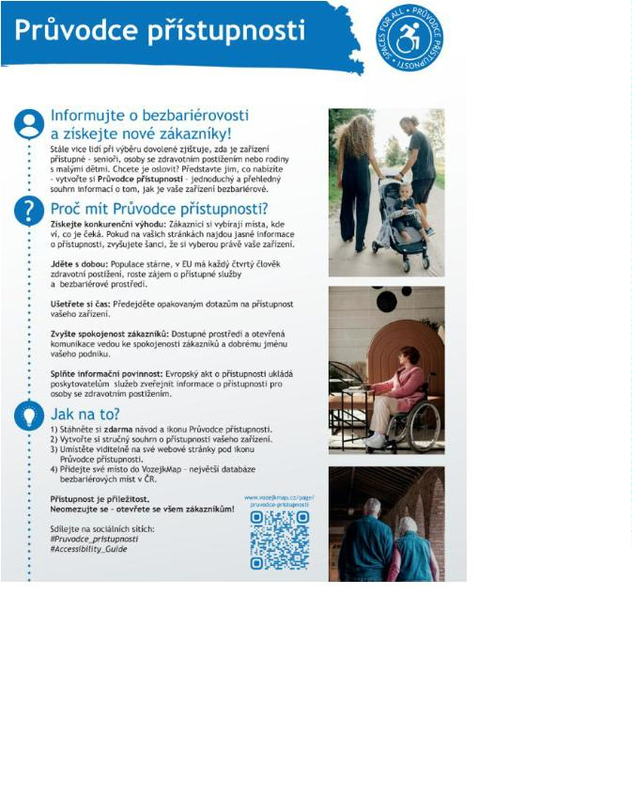

To summarize, these activities took place:
Date, place
Topic, title
Stakeholders involved
Spring 2025,
Znojmo and
surroundings
CENIA project team, CZEPA
project team
field work for WAV
CENIA project team, CZEPA
project team, Tourism Authority
South Moravia (CCRJM),
ZnojmoRegion, tourist information
centres in Znojmo
Final editing, print and
distribution of leaflets Znojmo
region without barriers
Spring 2025
Promo campaign in Znojmo for
the Wings4Life run in Retz.
Presentation of the project at
information stand (roll-up,
distributions of leaflets with
maps of accessible trips)
CENIA project team, CZEPA
project team, Weinviertel team,
BOKU team, Tourism Authority
South Moravia (CCRJM),
ZnojmoRegion, tourist information
centres in Znojmo, Retz
4.5.2025
Provide summary of the online
advertising of barrier-free
destination offers in the pilot
area - this will be based on the
review of the main tourism
authority websites - CCRJM.
Tourism Authority South Moravia
(CCRJM), tourist information
centres in Znojmo, CENIA project
team, CZEPA project team
Spring -
summer 2025
Page 31
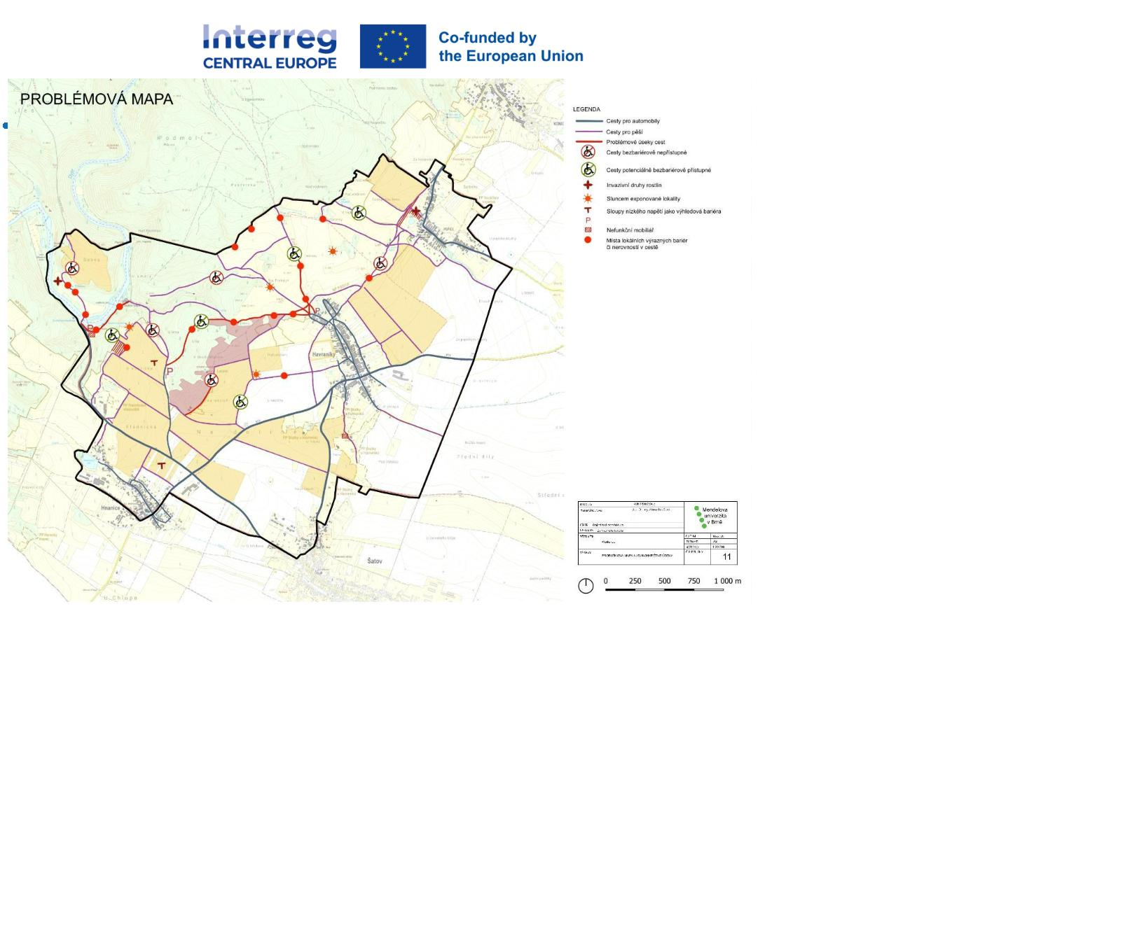

Date, place
Topic, title
Stakeholders involved
Evaluation of usability of WAV
data for the application
Spring –
summer 2025
https://www.vozejkmap.cz
(managed by CZEPA). Transfer
of suitable data, translation to
English) in progress
CENIA, CZEPA
Offer solution to hard barriers
in accessibility in National Park
Podyjí - inaccessible viewing
point Iron Trails, inaccessible
resting cabins - see more below
in progress
Administration of the National
Park Thayatal- Mr. Bursík and his
team, CENIA & CZEPA project
team, Mendel University Brno -
Institute of Landscape Planning
May 2025
Assistance with creation of
Accessibility Guides for tourism
providers in pilot region
Spring -
Autumn 2025
CENIA project team, CZEPA
project team
CCRJM, ZnojmoRegion, other
regional tourism authorities (e.g.
Tourism Authority the Hradec
Králové region), CzechTourism?,
CENIA project team, CZEPA
project team
Introducing Accessibility Guide
approach to a wider group of
service providers in tourism
June 2025
Office of the Government of the
Czech Republic - Committee of
the Government Council for
Persons with Disabilities for the
Accessibility of Public
Proposal for the introduction of
a general information
obligation regarding the
accessibility of services
July 2025
Administration and Public
Services, CZEPA
CENIA project team, CZEPA
project team, Znojmo town,
CCRJM, ZnojmoRegion,
CzechTourism
Leaflet to popularize AG
concept for tourism facilities
August 2025
Page 32
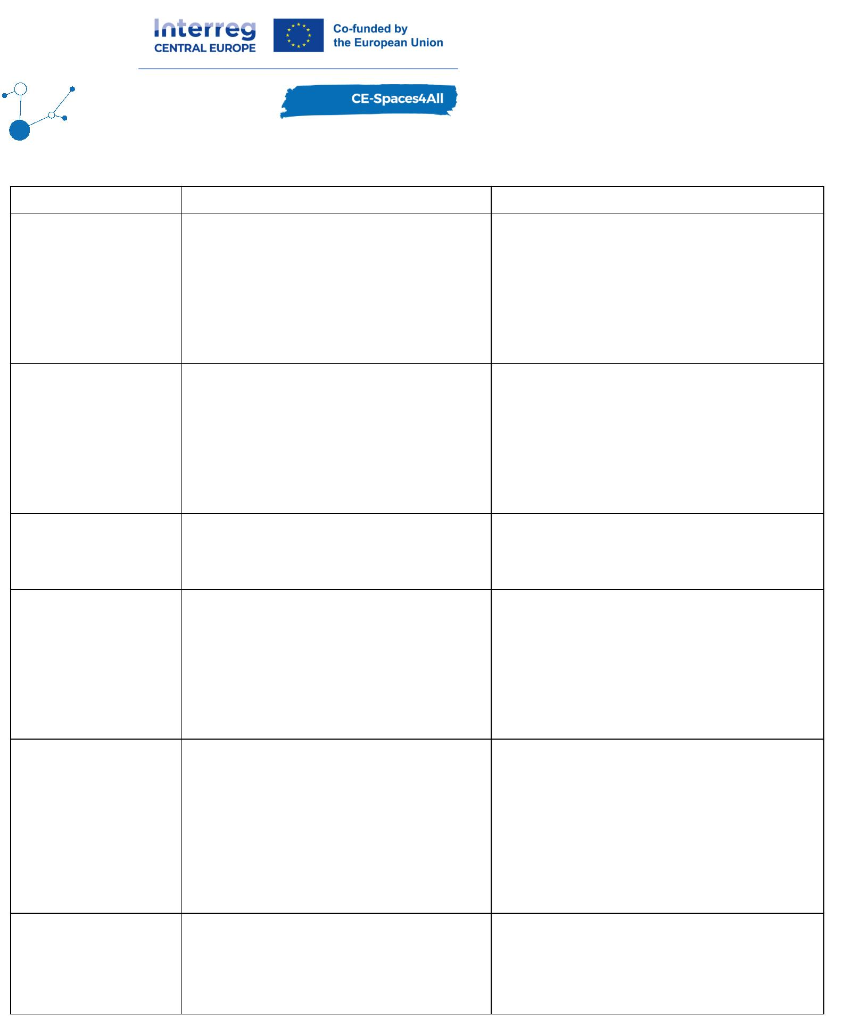

3. Implemented awareness raising activities
These awareness-raising activities have been held in the AT-CZ pilot area during reporting
periods 4 and 5. The most important events are listed below and there is a short summary of
these events in this chapter.
Weinviertel
Date, place
Topic, title
Stakeholders involved
Weinviertel Tourismus in
cooperation with CENIA project
team and CZEPA project team
Creating an accessibility guide for
tourism facility providers
09. 2024
2
Bali
(Indonesia),
virtual
attendance
-3 Sept 2024,
project presentation at World
Disability and Rehabilitation
Conference (WDRC), paper title:
Travel Behavior and Experiences
of Persons with Disabilities Living
in Austria – Findings from an
Online-Survey
BOKU project team
2
-6 Sept 2024,
project presentation at WMCCAU
conference, paper title: The Web
Accessibility Viewer: a Tool to
Assist Travelling Persons with
Disabilities
BOKU project team
BOKU project team
Ostrava (CZ)
8-12 Oct
Special session at ISOCARP World
Planning Congress, topic:
2024, Siena
(IT)
Inclusive INVISIBLE CITIES – How
to deal with blindness and visual
impairments in Urban and
Regional Planning?
Study visit – tourism providers
from the Retz region.
Project partner meeting in Laa an der
Thaya
10/2024
Benchmarking analyse- creation of
overview with visually clear and
simple evaluation of hotels.
Evaluation based on accessibility
catalogue - mapping in the pilot
area and its data transcription
into WAV.
1
1
1/2024 -
2/2024
Tourism providers from the Retz
region identified in WAV + new
Tourism providers from the
Austria site of the pilot region
where mapping of accessibility
took place and its results were
saved in the WAV database.
Telephone consultations with
tourism providers from the pilot
area where mapping took
place/WAV database
11/2024
Page 33


Weinviertel Tourismus, CENIA
project team, CZEPA project
team. Developed in cooperation
with Retz information centre
Creation of texts for a leaflet
with routes suitable for people
with reduced mobility.
12/2024
Weinviertel Tourismus, CENIA,
CZEPA, tourism providers from
Retz region identified in WAV +
any tourism provider in
Weinviertel (Retz + Eggenburg -
area)
Online webinar for tourism
providers - what and how to
publish info on accessibility -
Accessibility Guide
2
9 Jan 2025,
online
Weinviertel Tourismus, CENIA,
CZEPA, tourism providers from
Retz region identified in WAV +
any tourism provider in
Online webinar for tourism
providers - what and how to
publish info on accessibility -
Accessibility Guide
2
6 Feb 2025,
online
Weinviertel (Area Retz,
Hollabrunn, Laa, Poysdorf)
Conference "Strategiegruppe
Tourismus in der EU-
Dounauraumstrategie"-
Weinviertel Tourismus + BOKU
project team + implementers of
Interreg projects in area EU-
Danube.
information about the project,
raising awareness, finding
potential partners for pilot
events. Acquiring new contacts
for further cooperation, building
networks and capacities.
19 Feb 2025
communication with service
providers - implementation of
accessibilty guide on service
providers' websites
Weinviertel Tourismus + service
providers in pilot area Retz
Spring 2025
03-
0
5,08/2025,
Weinviertel Tourismus project
team, CZEPA project team
field work for WAV
Retz and
surroundings
Weinviertel Tourismus project
team, CENIA project team,
CZEPA project team, tourist
information centres in Retz,
Hollabrunn, Eggenburg and
Haugsdorf, NP Thayatal,
Preparing, editing, production
and distribution of leaflets “Star
trips in Weinviertel without the
barriers”
0
4-08/2025
4-05/2025
preparation for implementation
for the charity run Wings4Life in
Retz (4.5.2025). Presentation of
the project at information stand
Weinviertel Tourismus team,
CENIA project team, CZEPA
project team, BOKU team,
Tourism Authority South Moravia
0
Page 34
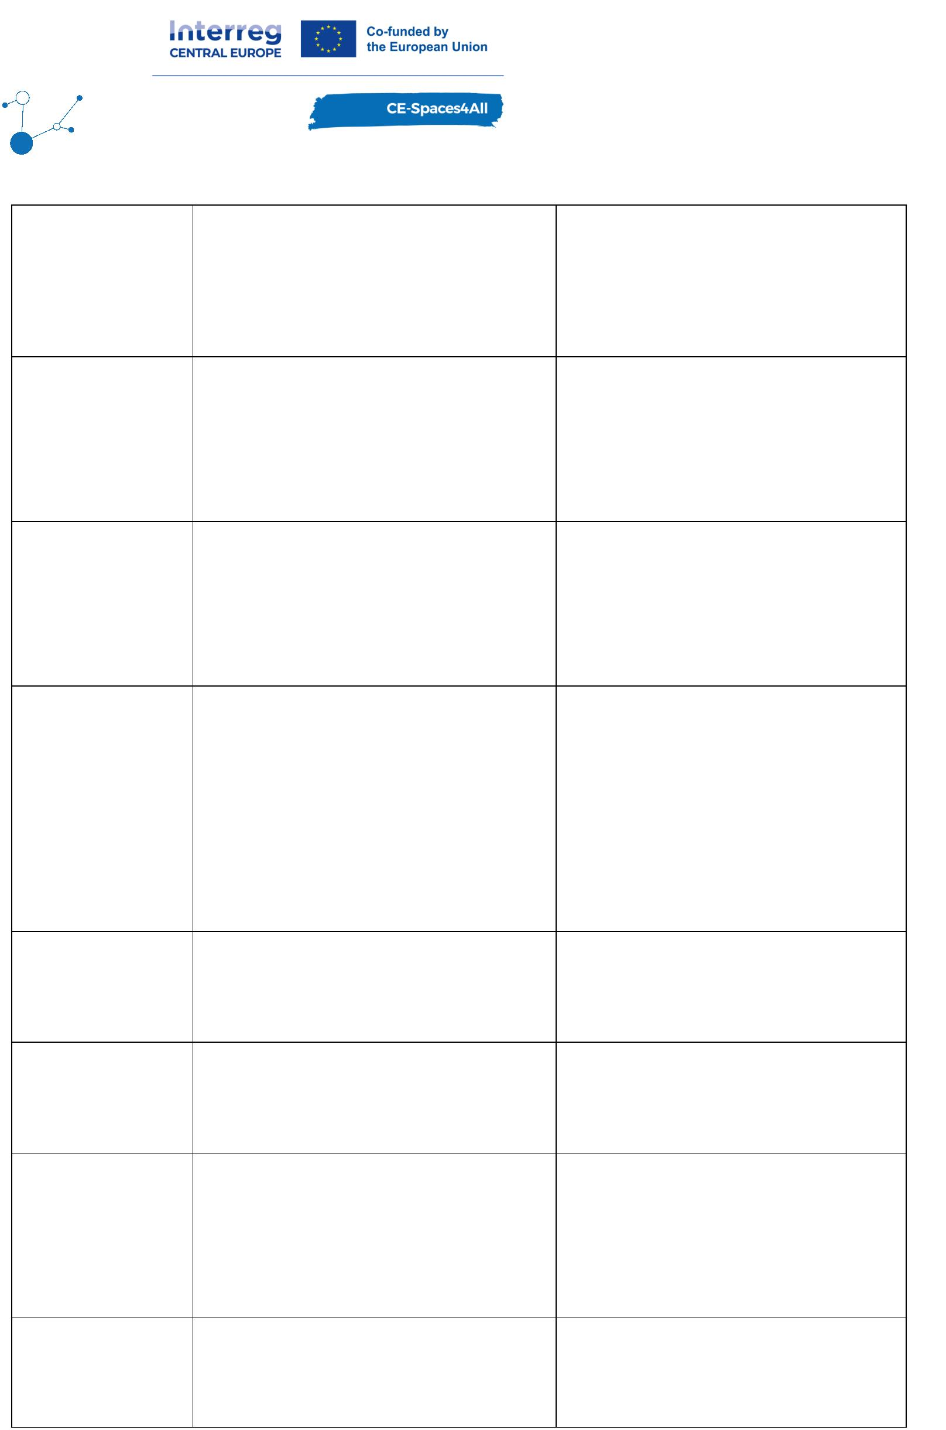

(roll-up, distributions of
information about project
(CCRJM), ZnojmoRegion, tourist
information centres in Retz,
Znojmo, town Retz, running
clubs from Retz and Znojmo
“Bildung hat Wert” - information
about the project, raising
awareness, finding potential
partners for pilot events.
Acquiring new contacts for further
cooperation, building networks
and capacities.
Weinviertel Tourismus team +
implementers of Interreg
projects
0
6/2025
/2025 -
Consultations and sites visits at
tourism facilities listed in WAV to
assist with creation of the AG
3
Weinviertel Tourismus team,
local service providers
ongoing
Weinviertel Tourismus team,
project partners CZEPA and LP
GI of Slovenia,participans of
Retz municipality, tourist
information centre Retz and
bike rental,
Wheelchair with additional
electric drive – preparation of
purchase and purchase
07-08/2025
Presentation of the project and
project results during the expert
conference
"
FachgesprächLändlicher
Weinviertel Tourismus team, PP
BOKU, stakeholders of project
area.
Tourismus für Sehbeeinträchtigte"
(Expert Discussion on Rural
Tourism for the Visually
08 July 2025
Impaired), organized by project
partner BOKU in Vienna on July 8,
2025.
Znojmo region
Date, place
Topic, title
Stakeholders involved
Designing a unified format for
publishing accessibility information
online - 3 Manuals for tourism
providers on how to create
Accessibility Guide
CENIA project team, CZEPA
project team
0
9 - 11/2024
1 - 12/2024
CZEPA, CENIA, hotel Premium in
Znojmo
Testing the Manual for
accommodation at hotel Premium
1
Page 35
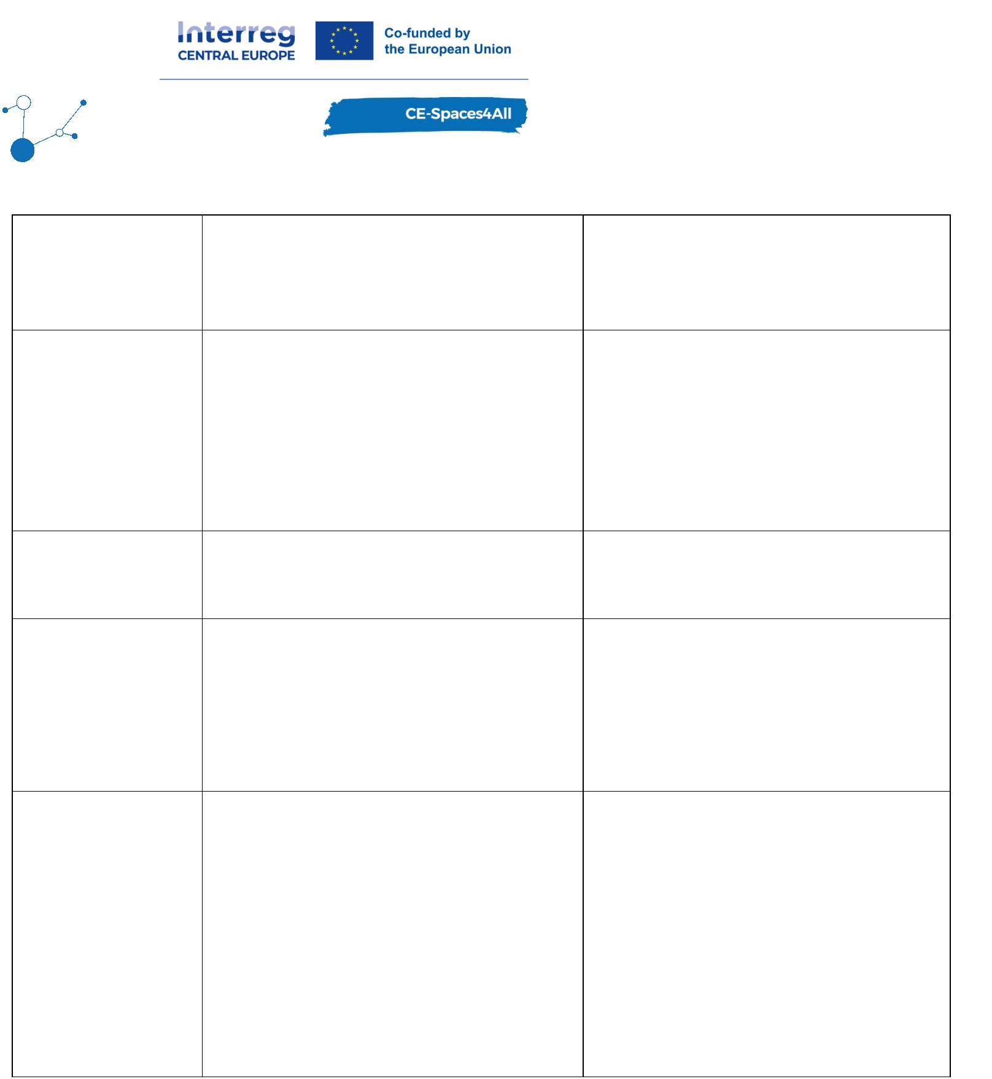

Benchmarking analyses - creation
of overview with visually clear
and simple evaluation of 1.
1
1
1/2024 -
2/2024
hotels/2. restaurants/3. other
tourism attractions. Evaluation
based on accessibility catalogue
Tourism providers from the
Znojmo region identified in WAV
-
mapping in the pilot area and
its data transcription into WAV.
Tourism providers from the
Czech site of the pilot region
where mapping of accessibility
took place and its results were
saved in the WAV database.
Telephone + email consultations
with tourism providers from the
pilot area where mapping took
place/WAV database.
1
0
1/2024 -
1/2025
Meeting for raising awareness
about WAV – aiming at data,
content, usability for agendas of
the city of Znojmo.
0
9 and
CENIA, representatives of
Znojmo
11/2024
Conference Inspirujme se -
information about the project,
raising awareness, finding
21. 11. 2024
potential partners for pilot
events. Acquiring new contacts
for further cooperation, building
networks and capacities.
CENIA project team
CENIA project team, CZEPA
project team. Developed in
cooperation with Znojmo
tourism information centres.
Creation of texts for a leaflet
with routes suitable for people
with reduced mobility.
1
0
1/2024 -
2/2025
CENIA, CZEPA, Weinviertel,
tourism providers from Znojmo
region identified in WAV +
tourism providers organised
under Tourism Authority - South
Moravia (CCRJM) +
Online webinar for tourism
providers - How to create the
Accessibility Guide for
1
0. 12. 2024,
online
customers with disabilities.
ZnojmoRegion + any tourism
provider in South Moravia and
beyond - advertising on social
media.
Page 36
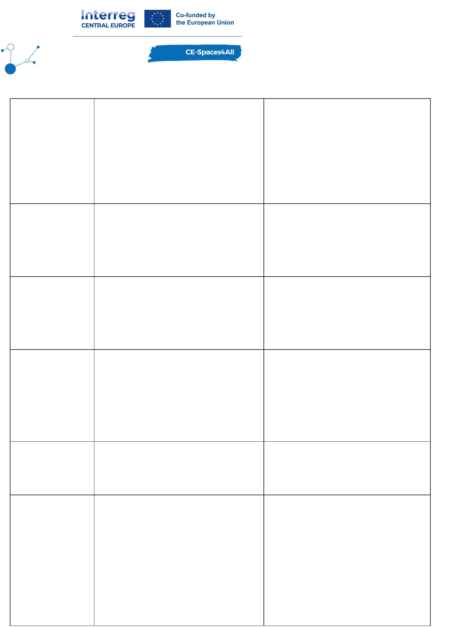

CENIA, CZEPA, Weinviertel,
tourism providers from Znojmo
region identified in WAV +
tourism providers organised
under Tourism Authority - South
Moravia (CCRJM) +
Online webinar for tourism
providers - How to create the
Accessibility Guide for
1
4. 01. 2025,
online
customers with disabilities.
ZnojmoRegion + any tourism
provider in South Moravia and
beyond - advertising on social
media.
CENIA, CZEPA, Weinviertel,
tourism providers from Znojmo
region identified in WAV +
tourism providers organised
under Tourism Authority - South
Moravia (CCRJM) +
Online webinar for tourism
providers - How to create the
Accessibility Guide for
2
3. 01. 2025,
online
customers with disabilities.
ZnojmoRegion + any tourism
provider in South Moravia and
beyond - advertising on social
media.
0
5/2025,
CENIA project team, CZEPA
project team
Znojmo and
surroundings
field work for WAV
CENIA project team, CZEPA
project team, Tourism Authority
South Moravia (CCRJM),
ZnojmoRegion, tourist
information centres in Znojmo
Final editing, print and
distribution of leaflets Znojmo
region without barriers
3
0.04.2025
4.05.2025
CENIA project team, CZEPA
project team, Weinviertel team,
BOKU team, Tourism Authority
South Moravia (CCRJM),
ZnojmoRegion, tourist
Promo campaign in Znojmo for
the Wings4Life run in Retz.
Presentation of the project at
information stand (roll-up,
distributions of leaflets with
maps of accessible trips)
0
information centres in Znojmo,
Retz
Provide summary of the online
advertising of barrier-free
destination offers in the pilot
area - this will be based on the
review of the main tourism
authority websites - CCRJM.
Tourism Authority South Moravia
(CCRJM), tourist information
centres in Znojmo, CENIA
project team, CZEPA project
team
06/2025
Page 37
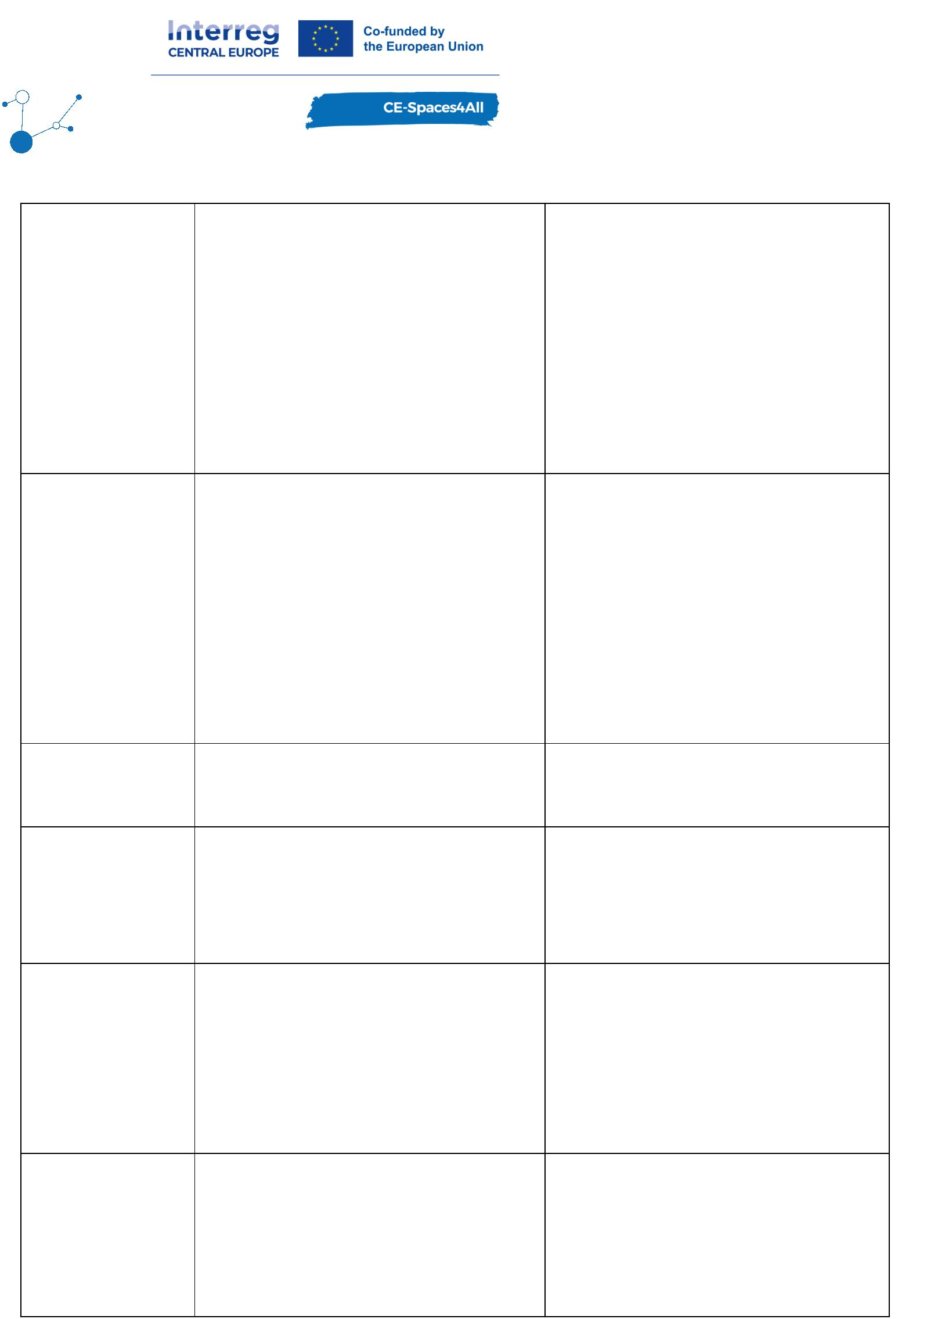

CZEPA, tourism providers from
the pilot region where mapping
of accessibility took place and
its results are kept in the WAV
database.
Consultations and sites visits at
tourism facilities listed in WAV
to assist with creation of the AG
3
/2025 -
ongoing
Online meeting with Tourism
Authority South Moravia (CCRJM)
to discuss results of the report
on publication of access.
information of their listed
venues
0
1.04.2025
6.05.2025
CENIA, CZEPA, CCRJM
Administration of the National
Park Thayatal - Mr. Bursík and
his team, CENIA & CZEPA
project team, Mendel University
Brno - Institute of Landscape
Planning
Offer solution to hard barriers in
accessibility in National Park
Podyjí - inaccessible viewing
point Iron Trails, inaccessible
resting cabins
1
Online webinar for organizations
in tourism (national, regional,
local level)
CENIA, CZEPA, Tourism
Authorities in the Czech
Republic
1
0.06.2025
9.06.2025
Online webinar for tourism
providers - How to create the
Accessibility Guide for customers
with disabilities.
CENIA, CZEPA, tourism providers
from the Czech Republic
1
CENIA project team, CZEPA
project team, Znojmo town,
CCRJM, ZnojmoRegion,
CzechTourism
Leaflet to popularize AG concept
for tourism facilities
06/2025
3.1. Event summaries -Weinviertel region
This chapter features short summaries from the most important events and workshops in the
lists above.
Online webinars
According to the Austrian Federal Disability Act, a disability is defined as the effect of a non-
temporary physical, mental or psychological impairment that makes it difficult to participate
in social or working life. According to a survey conducted by Statistics Austria in 2015 as part
of the micro-census, 18.4% of the population were affected by disabilities. Permanent
disabilities are strongly age-dependent, so this figure is constantly rising as society ages,
making it more important to make tourism, leisure, and recreational activities accessible to
this section of society.
Page 38
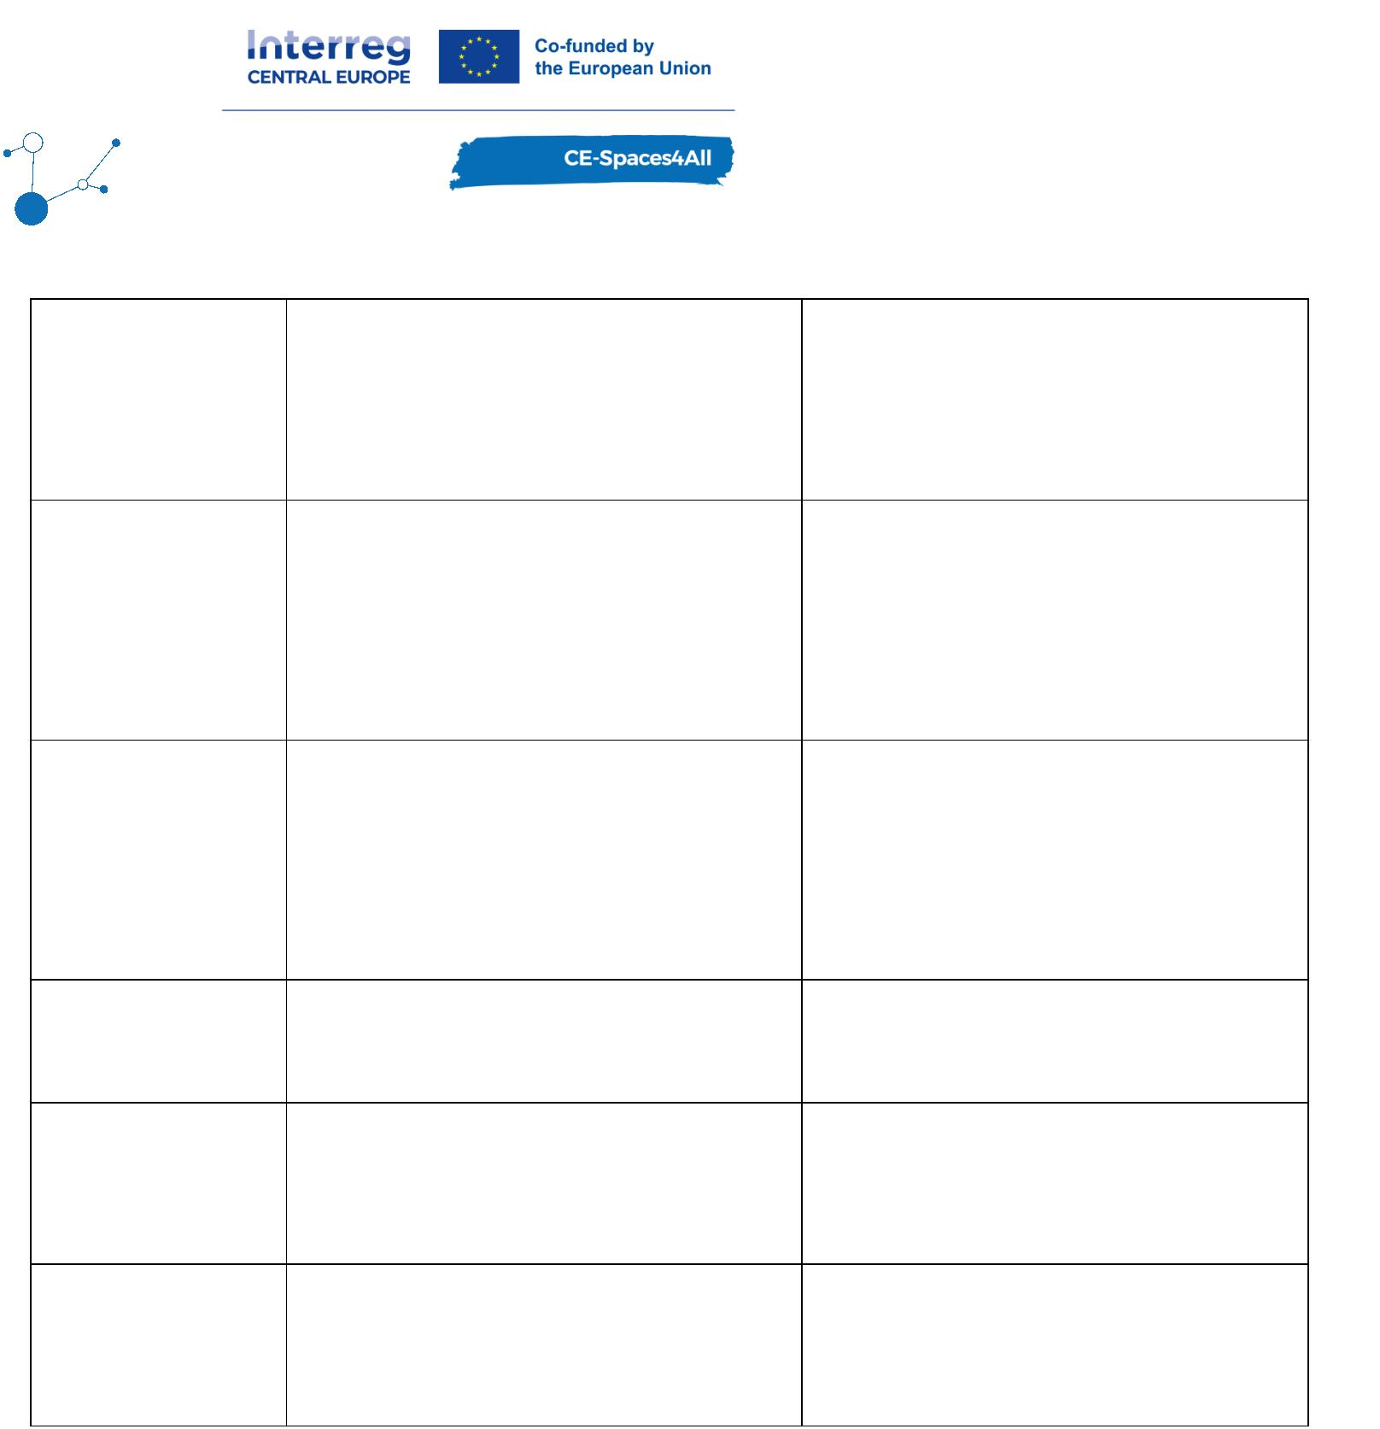

Project presentation at WMCCAU 2024 conference: paper publication
According to the Austrian Federal Disability Act, a disability is defined as the effect of a non-
temporary physical, mental or psychological impairment that makes it difficult to participate
in social or working life. According to a survey conducted by Statistics Austria in 2015 as part
of the micro-census, 18.4% of the population were affected by disabilities. Permanent
disabilities are strongly age-dependent, so this figure is constantly rising as society ages,
making it more important to make tourism, leisure, and recreational activities accessible to
this section of society.
The EU-Interreg funded project CE-Spaces4All aims at the improvement of accessibility of
tourism for persons with disabilities, concentrating on three groups with different
requirements: persons with mobility impairments (wheelchair users), blind people and
persons with visual impairments, deaf people and persons with hearing impairment. Public
authorities, tourism development stakeholders and persons with disabilities from seven
countries are working together in three European pilot regions (Poland, Austria/Czech
Republic, Slovenia/Croatia/Hungary) in a capacity building process to improve conditions for
accessible tourism development and independent tourism travel. A key element of the
project is the Web Accessibility Viewer (WAV) which serves as a data-driven platform for
recording and visualizing architectural, communication and other barriers, for developing
tourism strategies and spatial planning, and for developing tools and services for persons
with disabilities. The project partners organised field mapping events to capture barriers on-
site in the pilot regions and record them on a map.
The WAV is a Geographic Information System (GIS) based online service with a desktop and a
mobile application based on QGIS open source software to collect data according to a joint
catalogue of barriers developed together with the European Disability Forum, an umbrella
organisation of persons with disabilities that defends the interests of over 100 million persons
with disabilities in Europe. The WAV comprises tourism-related barriers (for example parking,
paths, public transport, tourism facilities, points of interest) from all pilot regions
categorised by the three groups of persons with disabilities mentioned above supplemented
by an easy-to-understand accessibility assessment with a semaphore system (red: not
accessible, orange: partly accessible, green: accessible). Photos of the mapped spots are
taken by the respective mapping teams and directly linked with the datasets. The WAV is
available in English as well as all the national languages of each project partner country.
Work with the WAV subsequently resulted in a catalogue of barriers that serves as a starting
point for further measures, for example for action plans for long-term territorial cooperation
on improving accessibility of the pilot regions. Awareness raising events with local and
regional stakeholders complement the agenda of sensitising institutions, companies and
public administration related with tourism. This will lead towards a better governance for
policy and territorial planning of accessible tourism as well as improvement of public services
for persons with disabilities.
Project presentation at WDRC conference
Page 39

Independent travel and access to leisure activities for persons with disabilities (PWD) are
both at the heart of the EU Strategy for the Rights of Persons with Disabilities 2021-2030. A
review of efforts in this regard reveals that tourism planning tends to focus on physical
accessibility of buildings. Comparatively little attention is paid to low-barrier travelling and
mobility on site. As part of the project “Accessible Spaces for All – Improving the Accessibility
of Tourism for Persons with Disabilities in Central Europe” primary data on the travel
behaviour and experiences of PWDs will be compiled. A questionnaire headed by the
European Disability Forum was set up in English language and translated into the national
languages of the project partners. In Austria, 40 national institutions, associations and PWD-
organisations as well as selected stakeholders (individual persons)were asked to support the
data collection and to distribute the link to the Microsoft Forms bilingual questionnaire via
their communication channels in order to reach not only their members living in Austria, but
also interested persons from abroad. As of March 2024, 29 respondents filled in the
questionnare; 23 persons disclosed Austria as place of residence. 9 respondents are female
and two thirds of the respondents older than 55 years, either physically or visually impaired.
For this is work in progress, the results of the descriptive data analysis using SPSS reveal the
following: about half of the respondents travel 3 to 5 times a year, mainly accompanied by
family members. Domestic and international trips are carefully planned in advance.
Accessible websites of booking platforms, recommendations, the destinations’ compliance
with accessible labels and cancellation options are important factors when planning the
journey. A lack of information on accessibility along the journey is a focal commonly
perceived barrier while traveling. Positive travel experiences increase the probability of
revisiting the destination. Based on the findings from strategies on accessible tourism and
good practice examples in Austria on the one hand and the preliminary results of the online-
survey analysis on the other hand, we understand that there is plenty room for improvement
regarding “all-round tourism packages” for PWD in Austria. A consolidation of all survey data
collected by the project partners is planned in order to find out whether and to what extent
(Austrian) rural regions may become a (more) appealing (international) travel destination for
PWD.
Special session at ISOCARP World Planning Congress
There are many people for whom cities are “invisible” in the literal sense of the word - blind
and visually impaired persons. Cities can be “invisible” but still with their fabric, their flair,
their amenities they can be very attractive for people with disabilities, even for blind and
visually impaired ones. How to make cities and regions barrier free and accessible (a
challenge especially in historic surroundings) and inclusive (including the human interactions,
e.g. qualified staff in hotels and restaurants, public institutions, awareness in general public)
and let those persons have a chance to experience, feel and enjoy the cities and regions.
Some supportive technologies might be installed in cities - but what about the areas outside
the urban conurbations - in rural areas, small towns, villages. Even though there are UN- and
EU acts and guidelines, it seems that the needs and RIGHTS of persons with disabilities are
hardly a major topic in urban and regional planning yet.
The implementation of guidelines like the UN Convention on the Rights of Persons with
Page 40

Disabilities or the EAA - European Accessibility Act into national laws and urban planning
practice will be an important part of the discussion. Blindness and visual impairment are only
one segment to deal with when talking about persons with disabilities - mobility impaired
persons, especially wheel-chair users might be more "visible" – but there is a wide range of
disabilities, and average statistics say that about 15-20% of the population are facing
disabilities - this is a topic that should not be neglected in Urban and Regional Planning.
The intention of the special session is to bring representatives of associations of people with
disabilities in contact with the “international urban and regional planning scene”, as it is
represented by ISOCARP - to raise awareness and mutual understanding, in best case even
find ways to work together in a structural way or on project basis.
Paper submission and presentation at WMCCAU 2025 conference
A paper on CE-Spaces4All titled “Creating Spaces for All: From Mapping the Barriers towards
Accessible Tourism” was accepted for presentation and publication at WMCCAU 2025
conference in Ostrava, Czech Republic, which takes places from 1 to 5 September 2025.
The paper comprises highlights from two and a half years of project experience. From the
first project idea generation over data collection, and implementation of tools and services
the paper presents the path to raising awareness using two examples from the sub-pilot
regions of Austria (video of a trip to Eggenburg) and Slovenia (Accessible Pomurje Region),
outlining the key points of the planned measures and the achievements reached with these
measures.
The paper “analysed which measures are effective in facilitating access to rural tourism for
persons with disabilities. During the work on the CE-Spaces4All project, it emerged that the
difficulties are mainly to do with a lack of information (so-called soft barriers). Many tourist
facilities are fully or partially accessible, as the data collection for the Web Accessibility
Viewer revealed.
Rather, it is the lack of information that represents one of the main barriers, in two different
aspects:
•
persons with disabilities are unable to adequately prepare themselves in the course of
their travel preparations because they are unable to find information on whether the
desired destinations or the desired tourism attractions and tourism offers are actually
accessible to the extent that is necessary for them,
•
tourism providers are not sufficiently prepared as to how they should prepare
information on accessibility so that this information can be interpreted and correctly
assessed by persons with disabilities.
The project is working on eliminating these gaps and other barriers in order to ultimately
turn rural spaces into spaces for all in terms of tourism.” (source: Beyer et al., Creating
Spaces for All: From Mapping the Barriers towards Accessible Tourism. In: Proceedings of
WMCCAU 2025 conference, 2025, [currently] unpublished).
Page 41

3.2. Event summaries - Znojmo region
Webinars
Online webinars for tourism providers on how to create Accessibility Guide (AG) have been
the main channel to introduce this new concept. When preparing the events, the project
team focused on the content to be in the form of a simple step-by-step tutorial aiming to
have attendees able to construct the AG themselves upon completion of the webinar.
Presenting examples of the completed AG on the website of a local tourism provider from
Znojmo (hotel Premium) proved to be very motivational. Case-study of the actual process of
AG production and online publication at hotel Premium demonstrated how this new concept
can be simple and straightforward with use of the Manuals. Number of tourism providers got
in touch after the webinars and requested consulting and/or assistance with AG production
for their venue.
Positive feedback from tourist service providers was expressed already at the webinar. They
appreciated the length of the webinar (60 minutes), the presenters, mainly M. Scott who
explained clearly the needs of PWD and the practical examples. Online surveys were
distributed after each webinar with a return rate about 30%. The answers from the survey
evaluated positively the content of the webinar. Some of the tourist service providers were
willing to create the Accessibility guide of their facility after the webinar.
In P5, the project team focused on incorporating the feedback and past experience to make
the process of creation of the AG as easy as possible for all interested tourism providers.
Online resource platform was set up as a place where the necessary instructional materials
can be found free of charge. Online webinar for tourism providers has the same structure of
step-by-step tutorial on how to create the AG. Some parts were adjusted, e.g. online
resource platform with new materials, more examples of tourism venues from the pilot
region. One new online webinar was put together at this monitoring period - Accessibility
Guide - publishing information on accessibility of tourism venues. This webinar was presented
to tourism organizations across the country, thus promoting the new AG concept beyond the
borders of the pilot area.
Telephone and face-to-face consultations with local tourism providers
Personal communication with tourism providers transpired to be one of the most crucial parts
of the pilot testing of the AG approach in the area. Most managers do not read emails from
unknown senders or ignore electronic invitations all together. Therefore, each tourism
provider where mapping of accessibility took place earlier in the project, were spoken to via
telephone or in person (CZEPA’s project team member resides in the pilot area).
The structure of the phone calls/face-to-face were as follows:
•
providing positive and venue-specific feedback from the mapping of accessibility
(most tourism facilities provide services for PWDs) + referring to the benchmarking
Page 42

analysis sent to them via email previously for a full review of the detailed
accessibility assessment of their place.
•
explaining what a loss of business opportunity it is to have such a wonderful barrier-
free venue yet not advertising it on the website, thus falsely presenting itself as non-
accessible.
•
•
brief explanation of what Accessibility Guide is and how it benefits customers with
disabilities and businesses in tourism.
invitation to an online webinar to get hands-on tutorial on how to create AG for their
venue + how and where to get assistance from the project team.
In RP5, the project team carried on in personal communication with tourism providers in the
pilot region. Number of providers attended our online webinars and asked for assistance with
the creation of their AG. Number of site-visits took place and CZEPA’s representatives
supported the tourism facilities in production of the AG - see above.
4. Key findings
This chapter collects text parts which underline the outcomes of these events and what we
learned for the project. It also lists first solutions with the implementation of the services
and tools or first ideas how the results will be integrated in WP3.
4.1. Weinviertel region
Tourism providers in the Retz region appear to be keen on publishing information about
barrier-free services they provide once they are given clear guidance - The Manuals on how
to create the Accessibility Guide (AG). Majority of the tourism providers from WAV preferred
hands-on assistance with production of the AG (on-site meeting of the facility’s manager with
a member of the project team, assistance with photo-documentation/following up The
Manual, transcription of data into AG format).
The aim is to make the AG concept more widely known to local tourism providers. Free
manuals are available on the project website and can be used by tourism businesses. In the
future, it will be crucial how many service providers implement AG on their websites. It will
also depend on the willingness to adopt the AG approach at regional/national/international
level. Weinviertel Tourismus supports the AG approach and will promote it through its online
channels.
Personal communication with the responsible staff of tourism service providers improves the
results of the pilot project activities.
A lack of information on accessibility along the journey is a focal commonly perceived barrier
while travelling. This was our main intent for producing a video that exactly covers this
topic.
There are several publications, for example from the Austrian Federal Economic Chamber, on
accessibility in tourism. However, what these well-designed brochures have in common is
that the group of blind and visually impaired people is underrepresented or not represented
Page 43

at all.
The state of accessibility in rural areas is sometimes challenging and still requires many
different activities. With our agendas, we can offer tourism stakeholders valuable support in
finding a position and self-determination. It is important to make stakeholders aware that
even a few small, easy-to-implement steps can be a great help.
4.2. Znojmo region
Tourism providers in the Znojmo region appear to be keen on publishing information about
barrier-free services they provide once they are given clear guidance - The Manuals on how
to create the Accessibility Guide (AG). Majority of the tourism providers from WAV preferred
hands-on assistance with production of the AG (on-site meeting of the facility’s manager with
a member of the project team, assistance with photo-documentation/following up The
Manual, transcription of data into AG format).This is still valid in RP5.
The AG approach might work on a wider scale if more providers in tourism take on this
concept and get into the habit of providing accessibility information as a standard service
offering strategy. AGs have been used in the tourism industry in the UK for years and can
help customers to explore barrier-free tourism destinations and assist businesses by tapping
into the growing market. This is still valid in RP5.
The aim is to get the AG concept in a wider community of local tourism providers - closer
alliance with the Tourism Authority South Moravia (CCRJM) - free Manuals available on their
website for the affiliated tourism business to utilize (about 50 tourism providers),
ZnojmoRegion and possibly CzechTourism? - all depends on how many AGs will be published
on websites of tourism businesses and the willingness of adoption of the AG approach on a
regional/national/international level. CCRJM has been supporting the AG approach and
promotes it via their online channels, e.g. Welcome guests with disabilities - it is easy.
Znojmo town is an associated partner in the project and they assisted in promoting the pilot
actions in the local newspaper Znojemské listy - January 2025 (page 10). In RP5, the project
team established a plan with the CCRJM on how to promote AGs in the tourism industry.
Firstly, tourism providers need to have instructional materials which enables them to
generate the AG. Online resource platform was built on the website of the largest national
database of wheelchair accessible places, VozejkMap. Many tourism providers already know
this application and, therefore, having the resources there makes sense. CCRJM is also going
to place all instructional materials on their website (summer 2025), as the local tourism
providers are used to going to the website for information.
In the Czech Republic, each region has its central tourism authority, equivalent to the CCRJM
in South Moravia. Managers of all these regional tourism authorities were contacted by
CCRJM and invited to our project webinar on the 10th June. At this webinar, AG was
introduced as a new approach in publishing accessibility information to allow travellers with
disabilities to plan travel hassle-free. All regional tourism authorities are managed by the
national tourism agency - CzechTourism. The project team established communication with
its representative and AG approach has been approved as a useful tool for promoting
accessible tourism in the country.
Page 44

Incorporating AG approach to an existing online platform of the Tourism Authority South
Moravia (CCRJM) - “Na jižní Moravu bez bariér” - some tourism venues advertised as barrier-
free fail to publish detailed information on accessibility (e.g. adapted toilets). This can be
rectified by publishing AGs of the advertised venues. Success depends on the willingness of
the tourism businesses to take an extra effort to create AGs etc. In RP5, a report on the
findings with recommendations for amendments was produced and communicated with the
representative of the CCRJM. We are expecting to see detailed accessibility information of
the listed barrier-free venues in the form of AG.
Personal communication with futurism facilities’ responsible personnel improves the
outcomes of the project pilot activities. In RP5, more tourism facilities from the pilot area
listed in WAV were contacted and AG were produced for those who showed an interest.
Personal communication and site-visits still remain the best approach, as we see it.
Page 45

